- How does the web work?

Step 1: The user accesses a web application via a web browser or mobile application, triggering a request to the web server over the Internet. Note that there may be security measures (firewalls or cloud access security brokers) and load balancers in
Step 2: The web server forwards the request to the web application server. The web application server performs the requested task – such as querying the database or processing the data – then generates the results of the requested data.
Step 3: The web application server sends the results back to the web server.
Step 4: the web server delivers the requested information to the client (desktop, mobile device, tablet, etc.) and the information appears on the user’s display.
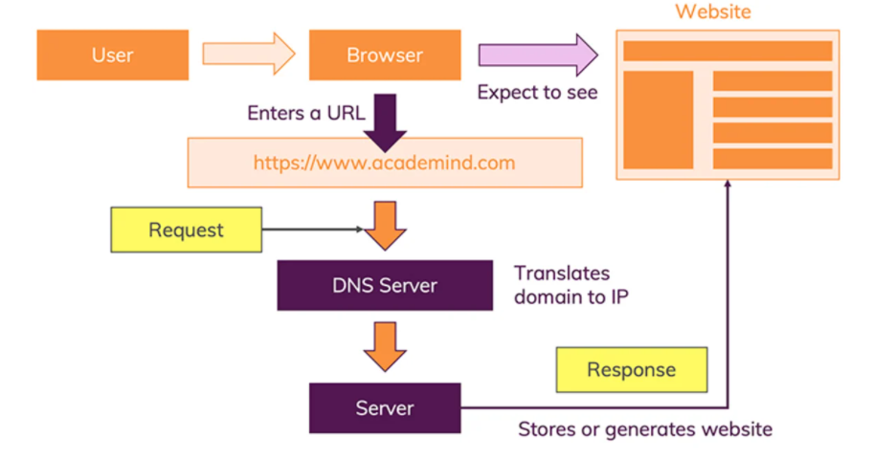

- What do you need to be a web developer?
Before you can call yourself, a web developer and start applying for jobs, you’ll need to master the following skills:
- Languages: HTML, CSS and JavaScript
It’s impossible to go into a career in web development if you’re not fluent in these three core languages.
HTML is the language used to create websites and apps; you’ll use it to describe the structure of the page.
CSS is used to describe the visual presentation of these pages, determining things like layout, colours and fonts.
JavaScript is used to make these pages interactive. These aren’t the only programming languages.
- Libraries and Frameworks: Bootstrap and jQuery
Once you’ve mastered the basic languages, you can start exploring libraries and frameworks—which have essentially been created to simplify and speed-up the way you work with HTML, CSS and JavaScript. There are tons of libraries and frameworks out there, but Bootstrap and jQuery are the most popular, so knowing these two will give you a huge advantage.
A free, open-source front-end library containing HTML and CSS-based design templates, Bootstrap will enable you to create responsive, mobile-friendly websites that display flawlessly on any device. Now remember the programming language JavaScript? Well, jQuery is simply a JavaScript library. In very basic terms, jQuery condenses common JavaScript tasks into fewer lines of code.
- Git and GitHub
Git is a version control system that enables you to keep track of all changes made to your code. GitHub is a hosting service for your Git repository, enabling teamwork and collaborative projects.
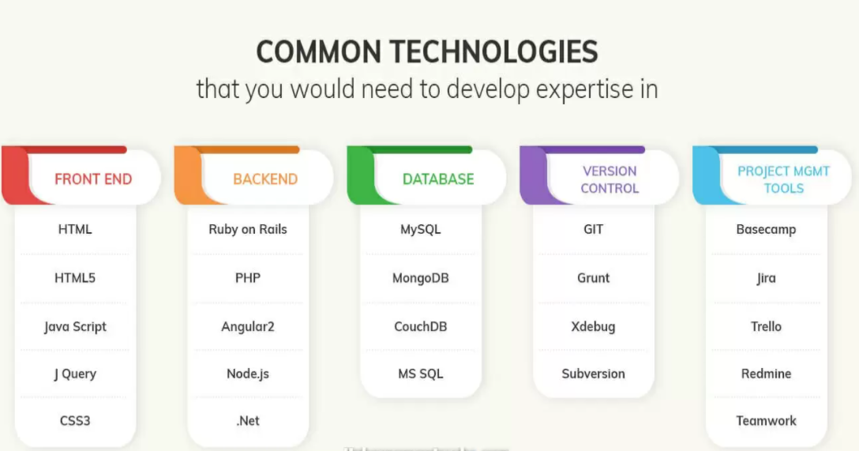

- What is the role of a web developer?
- Writing code in several programming languages such as HTML, XML, PHP, or JavaScript.
- Developing new applications and websites:
- Designing the architecture of the applications or websites;
- choosing the best programming language for the applications or websites;
- designing and developing the applications or websites;
- integrating graphics, audio, and video into the applications or websites;
- quality assurance (QA) testing and troubleshooting the applications or websites in different browsers; and
- presenting the website or application to the clients.
- Fixing bugs or problems on running websites or applications.
- Adding new features to running websites or applications:
- Designing and developing new features; and
- testing new features to ensure proper performance
- Going over colleagues’ coding to look for issues or possible mistakes.
- Creating Application Program Interfaces (APIs) to ensure performance in data exchange applications.
- Consulting with Designers, Producers, and clients to check on the project’s process:
- Working with Graphic Designers to determine the website’s layout.
- Keeping up-to-date with new programming languages, technologies, frameworks, and trends in the market:
- Looking out for new advances in programming technologies; and
- learning new programming languages and frameworks.
