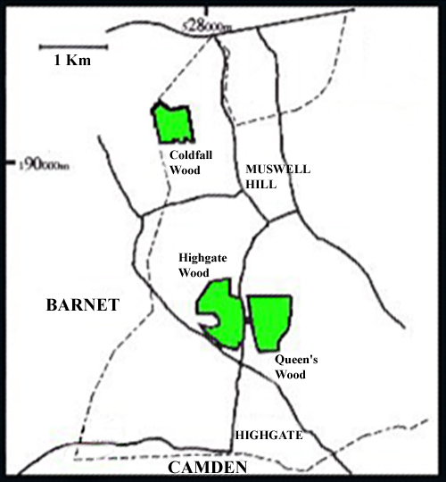
Figure 1. West Haringey, showing the location of the Woods. Broken line, Borough boundary; solid lines, major roads.

