CryptoJUnit_GFA_Test

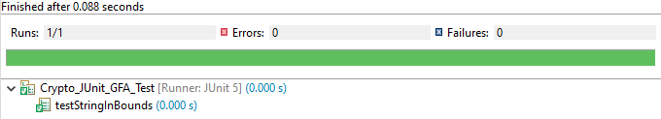

CryptoJUnitTest

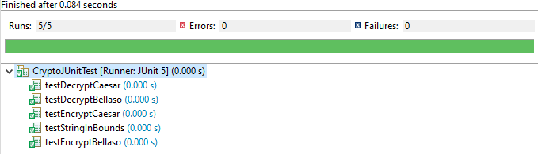

CryptoManager_GFA_Test

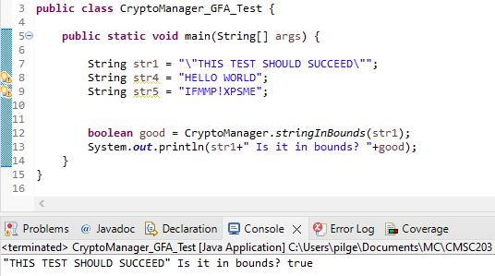

CryptoManagerTest

