**Montgomery College**

**CMSC 203**

**Assignment 4 Design**

Class: CMSC203 CRN 46519  
 Program: Assignment 4 Design  
 Instructor: Farnaz Eivazi  
 Summary of Description: Create a management company and add the properties managed by the company to its list.  
 Due Date: 7/21/2022  
 Integrity Pledge: I pledge that I have completed the programming assignment independently.   
 I have not copied the code from a student or any source.  
 Student: Philip Song

**Part 1: Pseudo Code:**

Plot.java (overlaps method)

1. START
2. Get starting point (x,y values), width and depth of first and second plots
3. Find furthest end point for both plots by adding their width to their x-value, and depth to the y-value
4. Check if x,y values of second plot’s end point is greater than the x,y values of the first plot’s starting point.  
   Then check if values of first plot’s end point are greater than the values of the second plot’s start point.
5. If yes to all the above, there is an overlap
6. END

Plot.java (encompasses method)

1. START
2. Get starting point (x,y values), width and depth of plot
3. Find furthest end point for both plots by adding their width to their x-value, and depth to the y-value
4. Check if x,y values of second plot’s starting point is greater than or equal to the other plot’s starting point.  
   Check if x,y values of the first plot’s end point is greater than or equal to the other plot’s end point.
5. If yes to all the above, second plot is inside first plot
6. END

ManagementCompany.java (addProperty method)

1. START
2. Check if added property is valid (not null value)
3. Check if added property does not encompass other properties
4. Check if added property does not overlap with other properties
5. Check if list of properties is full
6. Add new property information in first available space
7. END

**Part 2: Screenshots**

1. Setting Up

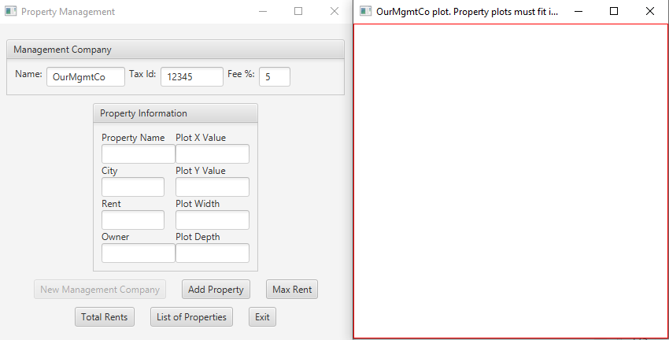

1. FirstHouse

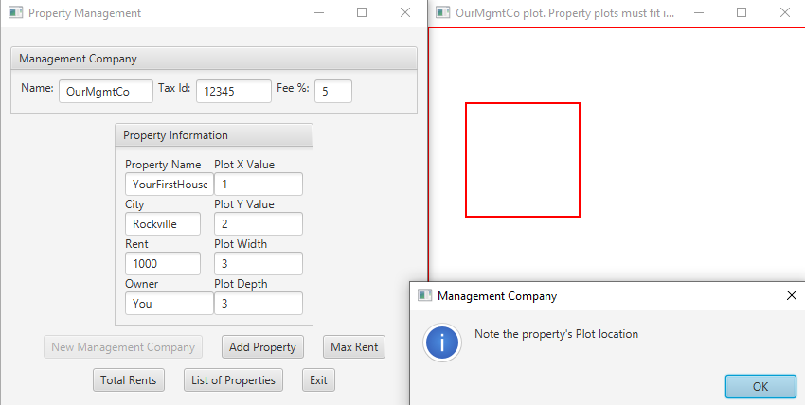 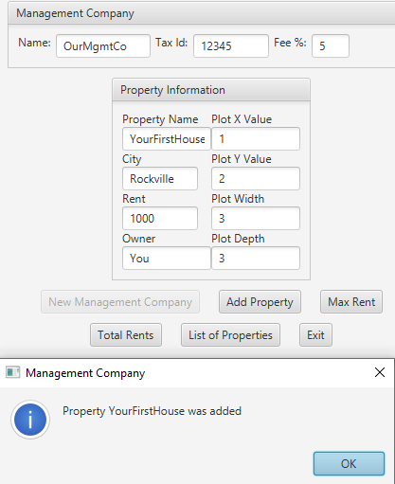

1. Guest House

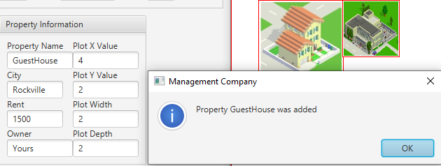

1. MySecondHouse

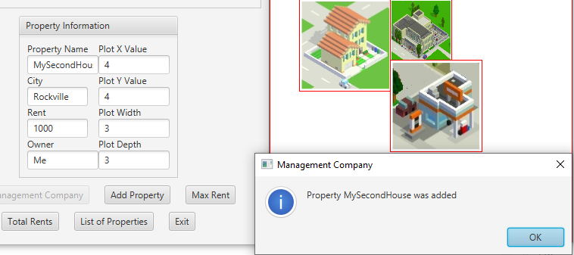

1. MyThirdHouse (failure - overlap)

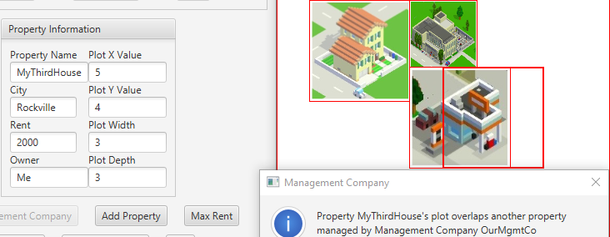

1. MyThirdHouse (failure - outside of Management window)

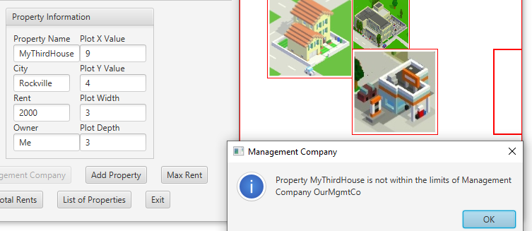

1. MyThirdHouse

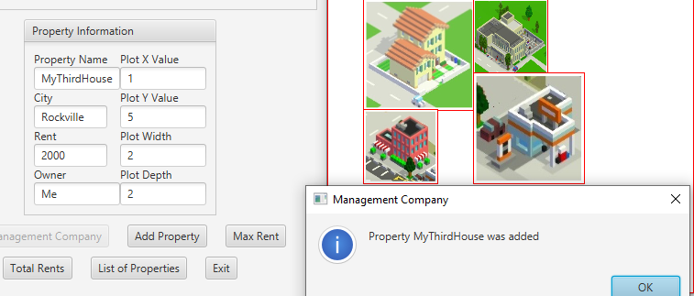

1. StorageRoom

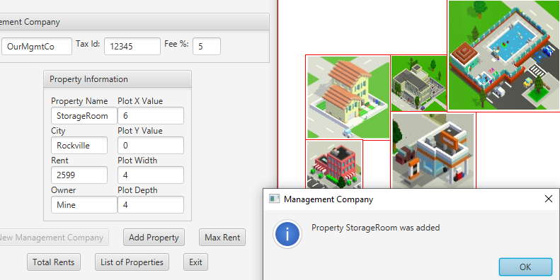

1. ShedDulwich (failure – cannot add more than 5)

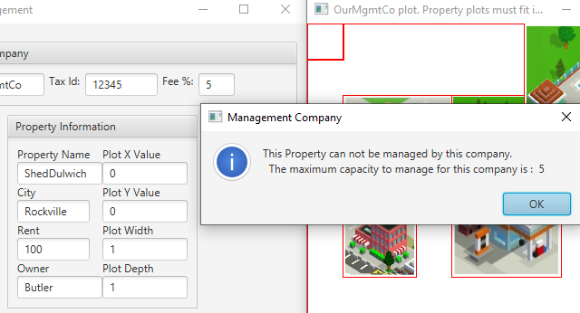

1. Max Rent   
   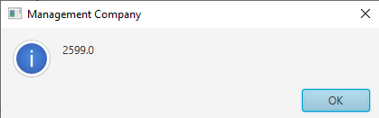
2. Total Rents  
   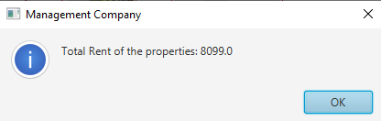
3. List of Properties  
   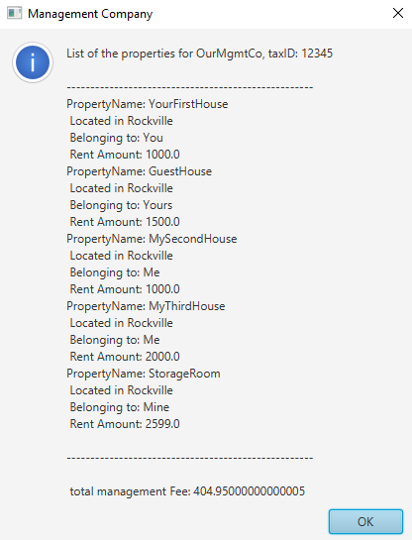

**Lessons Learned:**

Write about your Learning Experience, highlighting your lessons learned and learning experience from working on this project.

What have you learned?

* Writing UML classes
* Creating own Junit Tests

What did you struggle with?

* Writing the pseudocode
* Writing the Algorithm for the **overlaps** and **encompasses** methods in **Plot** class
* Writing the Algorithm for the **addProperty** method(s) in **ManagementCompany** class
* The above methods not being clearly explained in the Assignment 4 Description or Javadocs
* Made the careless mistake of not having my methods check if a property array was empty
* Having to write my own Assignment 4 Design

What would you do differently on your next project?

What parts of this assignment were you successful with, and what parts (if any) were you not successful with?