**Montgomery College**

**CMSC 203**

**Assignment #5 Design**

Class: CMSC203 CRN 46519  
 Program: Assignment #5 Design  
 Instructor: Farnaz Eivazi  
 Summary of Description:   
 Due Date: 7/28/22  
 Integrity Pledge: I pledge that I have completed the programming assignment independently.   
 I have not copied the code from a student or any source.  
 Student: Philip Song

**Screenshots**

District4

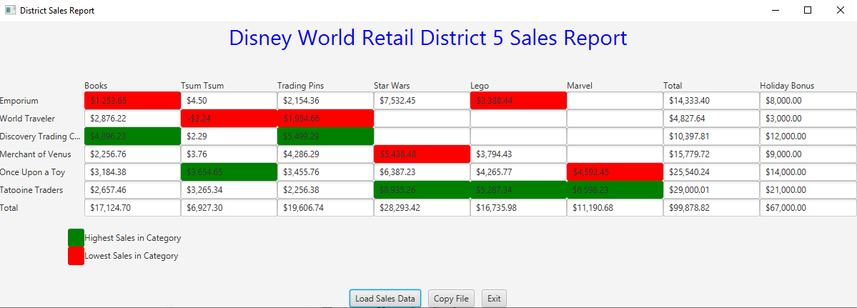

dataSet4

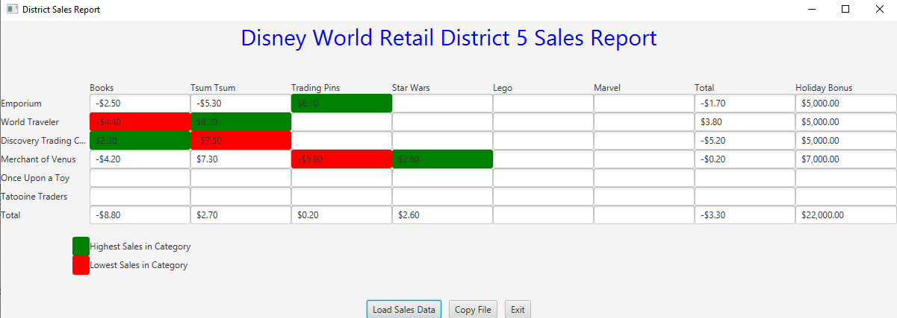

Making copy of dataSet4

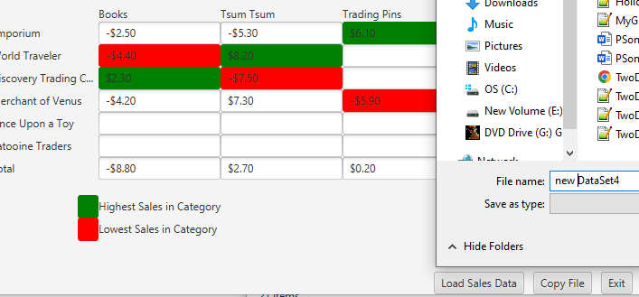

**Lessons Learned:**

Write about your Learning Experience, highlighting your lessons learned and learning experience from working on this project.

What have you learned?

* Using try/catch statement

What did you struggle with?

* Writing the pseudocode
* Passing HolidayBonusTest.java
  + Finally solved it by rearranged my if else statements
* Loading dataSet4 (negative values)
* Having to write my own Assignment Design

What would you do differently on your next project?

* Try to find a better way to initialize starting minimum and maximum values

What parts of this assignment were you successful with, and what parts (if any) were you not successful with?

**Grading Rubric**

See attachment: CMSC203 Assignment 5 Rubric.xlsx

Assignment 5 Check List (include Yes/No or N/A for each item)

|  |  |  |  |
| --- | --- | --- | --- |
| **#** |  | **Y/N or N/A** | **Comments** |
|  | **Assignment files:** |  |  |
|  | * FirstInitialLastName_ Assignment5_Moss.zip | **n/a** |  |
|  | * FirstInitialLastName_Assignment5_Complete.zip |  |  |
|  | **Program compiles** |  |  |
|  | **Program runs with desired outputs related to a Test Plan** |  |  |
|  | **Documentation file:** |  |  |
|  | * Comprehensive Test Plan |  |  |
|  | * Screenshots for each Junit Test | **Y** |  |
|  | * Screenshots for each Test case listed in the Test Plan |  |  |
|  | * Screenshots of your GitHub account with submitted Assignment# (if required) | **Y** |  |
|  | * UML Diagram | **Y** |  |
|  | * Algorithms/Pseudocode |  |  |
|  | * Flowchart (if required) |  |  |
|  | * Lessons Learned | **Y** |  |
|  | * Checklist is completed and included in the Documentation |  |  |