TwoDimRaggedArrayUtiility_GFA_Test

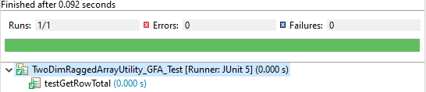

TwoDimRaggedArrayUtiilityTest

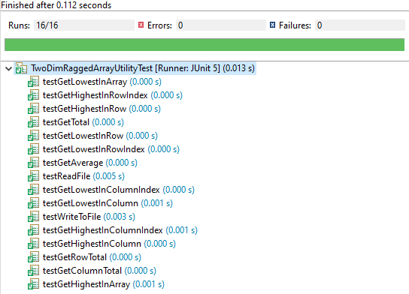

HolidayBonus_GFA_Test

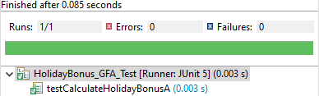

HolidayBonusTest

