**Montgomery College**

**CMSC 203**

**Assignment #6 Design**

Class: CMSC203 CRN 46519  
 Program: Assignment 4 Design  
 Instructor: Farnaz Eivazi  
 Summary of Description: Software to track monthly orders for Bradley’s Beverage Shop  
 Due Date: 8/11/2022  
 Integrity Pledge: I pledge that I have completed the programming assignment independently.   
 I have not copied the code from a student or any source.  
 Student: Philip Song

**Screenshots**

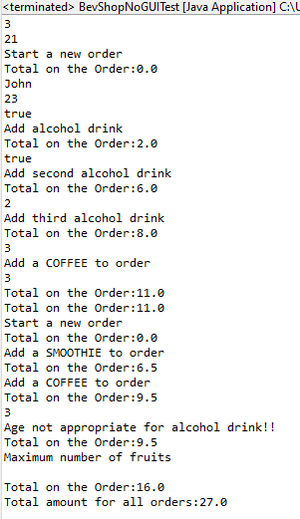

**Lessons Learned:**

Write about your Learning Experience, highlighting your lessons learned and learning experience from working on this project.

What have you learned?

* Using enumerated variables
* Inheritance, abstract class, and protected variables
* Type casting for Objects

What did you struggle with?

* Incomplete Assignment Description. I had to look at the provided JUnit tests to get specific method names
* Creating the UML
* Overriding the equals method
* Having to write my own Assignment Design
* NoGuiTest - tempCustomer

What would you do differently on your next project?

What parts of this assignment were you successful with, and what parts (if any) were you not successful with?