Philip Song  
CMSC 204 CRN 21752  
Project 3 Write up

**Approach, design & algorithm** –

* Read Project-3C Write-up and the .html docs for BasicDoubleLinkedList.java
* Created custom Exception classes from the above materials
  + UnsupportedOperationException.java
  + NoSuchElementException.java
* Coded for BasicDoubleLinkedList.java
  + Inner public class Node
    - Did not include a getter method for the T data. Instead I would use Node<T> or type cast (T) if I wanted only the Node data.
  + Inner public class DoubleLinkedListIterator
    - Got permission to start the iterator right before head. This did require odd workarounds but I found the logic it easier for me.
    - Unused methods (add, nextIndex, previousIndex, remove, set) would throw UnsupportedOperationException
  + First coded and getter methods and iterator() which only returned inner attributes/class.
  + Worked last on public Node remove method.
* Ran and passed BasicDoubleLinkedList Junit tests
  + Had trouble with try-catch blocks not throwing UnsupportedOperationException.
  + Solved by importing java.lang.UnsupportedOperationException; into Junit test
* Coded for SortedDoubleLinked.java
  + For the add method, I reused code from remove, addToFront and addToEnd methods from BasicDoubleLinkedList.
* Ran SortedDoubleLinkedList Junit tests
* Created and ran own Junit tests for Basic and Sorted Double Linked List
  + Encountered an error while running a test for remove and fixed it.
* Ran and tested DoubleLinkedListDriver

**Test Cases**

BasicDoubleLinkedList_GFA_Test

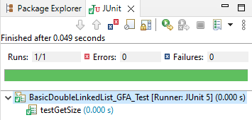

BasicDoubleLinkedListTest

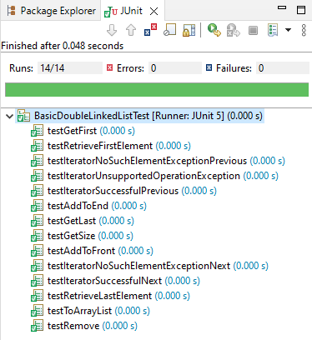

SortedDoubleLinkedList_GFA_Test

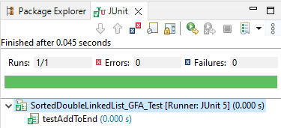

BasicDoubleLinkedListTest

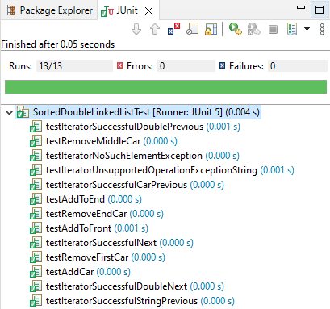

BasicDoubleLinkedList_STUDENT_Test

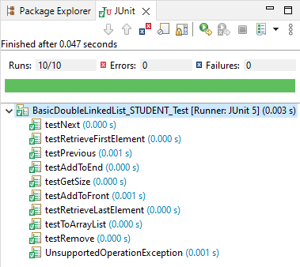

SortedDoubleLinkedList_STUDENT_Test

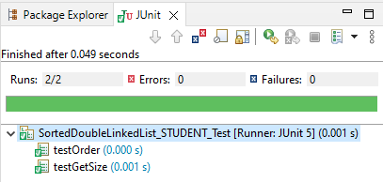

JavaFX Basic List - Added: Ben, Jerry (end), Tom (front), Hard (end)

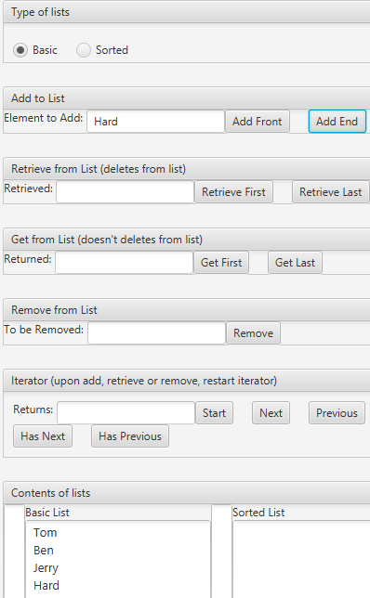

Retrieve First and Last

 

Get First and Last

 

Remove from List (Jerry)

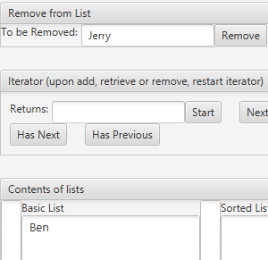

Iterator

Start 🡪 Previous

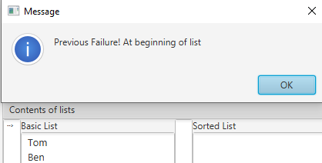

End🡪Next

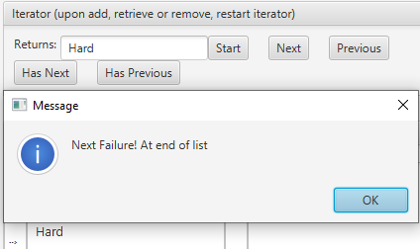

End🡪Has Previous

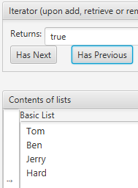

Sorted List: added as listed - Next, Hard, Tom, Jerry, Ben

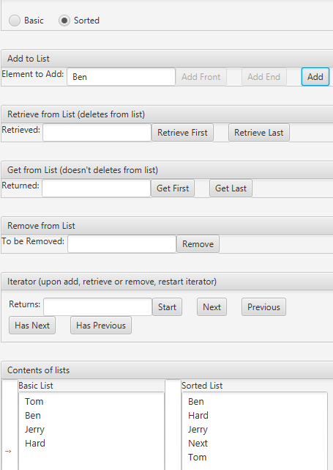

**Learning Experience**

* This is the first time I used a Comparable interface, Node class and inner classes in Java