Q) When to use (Rapid Application Development) RAD model
When not to use (Rapid Application Development) RAD model

Ans:

When to use RAD:

* In the case of waterfall model, it is very difficult to follow When the requirements becomes inconsistent.The reason is mainly because the customer doesn’t know what is the real requirements.
In such a situation only the iterative model works.So, RAD can be used since it is based on iterative model.

* When the mindset of the customer is to get the product as soon as possible,then RAD methedology can be used.Such delivery of product will have lower quality and to provide feedback regarding the delivery and their requirements.

* RAD can be used when the system can be divided or modularizing of the system can be done.

* RAD can be used if there is high availabilty of the designers for modelling.

*RAD can be used if the budget plan allows to use the automated code generating tools.

*If the domain experts with good business knowledge is available then RAD can be used.

*RAD SDLC model should be chosen only if resources with high business knowledge are available and there is a need to produce the system in a short span of time (2-3 months).

When not to use RAD:

* When the quality of the product is of prime importance,one canot use the RAD.

*When project management will not accept informal project deliverables.

*RAD can not be used when the system can not be divided or modularization is not possible to perform.

* If there is no good budget plan then it is not useful to use the RAD.

*Do not use the RAD,if there is no availability of designers for modelling.

*When the product must support or interface with other critical systems (reliability and performance are not critical).

Q)Define an ER diagram of a software Organization with all the relationship model that was discussed in the classroom

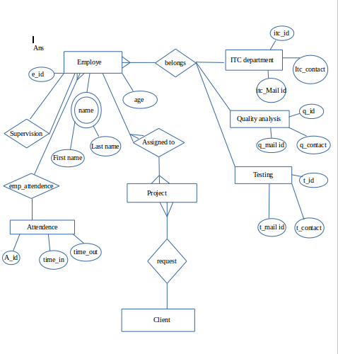

Q) Describe the Entity Relationships for the following diagram

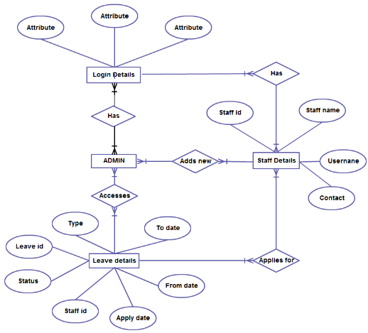

Ans:
In the above ER diagram,the entities are:
* Login Details
* Admin
* Staff Details
* Leave details

Each of these entities will have many attributes.As per the above diagram:

Entity Attributes

Login Details Attribute,Attribute,Attribute
Admin No attributes mentioned
Staff details Staff id,staff name,username,contact
Leave details leave id, status,staff id, apply date,from date,to date, type

Different type of relationships:

Has: one or more admin has one or more login details(many to many relation).
One or more staff has one or more login details(many to many relation).

Applies For: one or more staff applies for one or more leave(many to many relation).

Leave Details:one or more admin accesses one or more leave details(many to many relation).

