Q) Draw a Use Case Diagram for an online Library Management System

Ans:

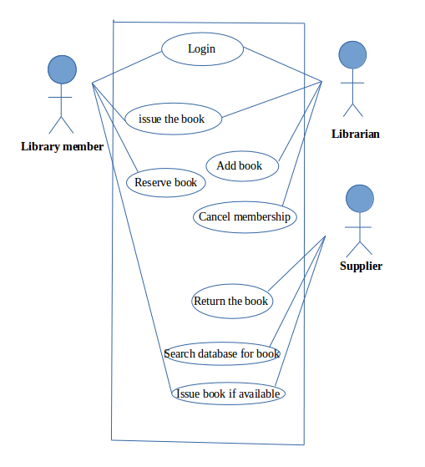

Q) List down the best practices from Agile/Scrum methodology

Ans: The best practices from agile/scrum methadology:

* Development process and practices facilitated by scrum master.

* Sprint planning mainly use to create sprint backlog.

* Burn down chart used to monitor sprint status.That is how much completed and how much remaining.

* Product backlog which contains the possible items,sprint backlog is a subset of product backlog.

* Daily meeting mainly used to know what done yestarday,what to do today,what will be the requirements.It helps to find out the problems.

* Sprint review meeting to present completed work.

* Sprint retrospective to learn from previous sprint

* Planning poker used to know when to finish the sprint.Febinocci number is a good practice for the planning poker.

* Release planning to release product increments.

Q) Collaboration
a. How does collaboration help agile development?

Ans:
Collaboration simply means to work jointly rather than independently to accomplish a task.

How collaborationhelps:

* It helps in stong communication between the business owners from whom we get the requirements and the technical team that produces the output.

* Collaboration is also important between the technical teams like in daily scrum meeting evryone should have to tell what they had done,what will do today,what requirements required.

*Two of the four values in the agile manifesto also shows the importance of strong collaboration:

customer collaboration over contract negotiation reminds us that it's more important for a development team to allow for some flexibility to please a customer
and,

individuals and interaction over process and tools reminds us of the importance of strong and respectful communication.

* It helps in increasing the involvement of clients.

* By proper meetings the organisation can achieve the goals more easily.

b. What if the team is distributed and can you achieve the same
productivity?

Ans: I don’t think if a team is distributed and can achieve the same productivity.There are some reasons:
* The best way to findout the issues and problems is through the face to face communication.If the teams are apart then it is difficult in face to face communication.

*If the team members are not together,they can not able to recognise the others skills.

*It will not be easy to handle the arguments and suggestions that would arise from the different team mates which will affect the productivity

c. What would you do to achieve the productivity for a distributed
team?

Ans: In such a situation i will arrange meetings once in a week or once in a month which actually depends on the complexity of the project. Here also importance of collaboration comes that is meeting is very important to achieve the productivity.One can able to findout the further improvements required.

Q) What is Sprint Zero in Agile? Describe the activities that are done in Sprint
Zero.

Ans: From the agile SDLC aspect the sprint 0 comes in the inception phase.It is also known as envisioning phase.It contains initial requirements envisioning and initial architectural envisioning which involves:
* identify the high level scope.
* identify initial requirements stack.
* identify an architectural vision.

Sprint Zero is is the initialization step in an agile project which is also called as Iteration Zero. It consists of certain activities that will make the team ready for the sprint 1. It is also known as a project before a project phase because at the beginnig of a project there should be a detailed analysis about how the project has to be done.

Following activities are included in the sprint zero :-
- Active stakeholder participation, obtain funding and support, start building the team
- Initial requirements envisioning,initial architecture envisioning, Set up environment
- Sprint zero is a necessary step in a project because there are certain matters that needs to be taken care before the beginning of as project such as the recruitement of the employees,assembling of the resources creating a produce backlog etc.
One of the biggest problems with having a sprint zero is that it establishes a precedent that there are certain sprints or sprint types that have unique rules.

