**Bird Classification using Pre-trained Convolutional Neural Networks**

In bird classification problem we are predicting the bird’s labels using prebuild CNN architecture, which were originally trained on image-net problem. In the project I am comparing two models VGG16 and ResNet101V2 model. For the data pre-processing we are normalizing each image using ImageDataGenerator. We are also setting the seed on top and while creating train, test and validation data for reproducibility. Once the data pre-processing is complete, we see there are 35215 images belonging to 250 classes in the train data, 1250 images belonging to 250 classes in both test and validation data. We are comparing two models: VGG16 and ResNet101V2

For both the models we are using pre-trained weights on image-net dataset, and freezing the top layer and adding a dropout of 0.5 to the base layer. We are flattening the layer and adding two dense layer 2048 and 1024 with dropout of 0.5, In between the dense layer we are adding the batch normalization to normalize the output of previous layers, to get the probability of each class label we are adding the softmax layer at the end.

**Models Hyperparameters:**

|  |  |
| --- | --- |
| Hyperparameter | Value |
| Optimizer | Adam |
| Loss Function | Sparse-Categorical Cross-Entropy |
| Epochs | 10 |

I am using sparse-categorical cross-Entropy to encode class labels as normal integers, I am running the model for 10 epochs and I am using early stopping on validation accuracy to stop the training when there is no improvement in the validation after four consecutive epochs.

To evaluate the results we are using accuracy, precision recall and confusion matrix.

**Results: Test Accuracy**

|  |  |  |  |
| --- | --- | --- | --- |
| **CNN models** | **Accuracy** | **Precision** | **Recall** |
| **VGG16Net** | 0.93 | 0.94 | 0.93 |
| **ResNet101V2** | 0.96 | 0.97 | 0.96 |

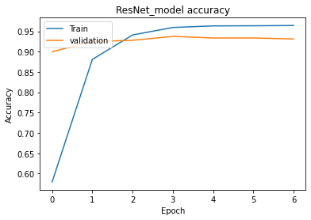 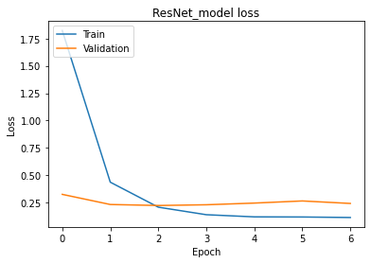 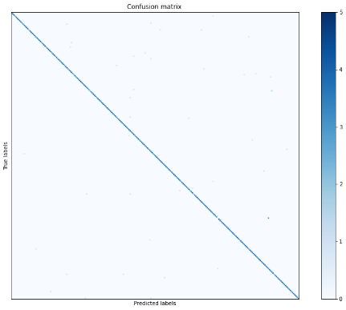

Fig 1: Plots of loss, accuracy and confusion matrix for ResNet101V2 model.