PERFORMANCE EVALUATION OF TERAPIXEL RENDERING IN CLOUD (SUPER) COMPUTING

SATISH PILLA-B210472095

## **Abstract:**

Photo-realistic terapixel visualization is computationally costly, and there have been no such visualization of urban digital twins to date, with the few terapixel visualizations that do exist focus on space rather than earth. The objective of the project was to visualize the data collected from the IoT device by urban observatory of the Newcastle. Terapixel images provide an intuitive and open way for stakeholders to present information sets, enabling audiences to interactively search big data across multiple scales. The problem we addressed here is how to offer the resources needed on a supercomputer scale to create a realistic simulation of Newcastle Tyne's city and its environmental data as gathered by the Newcastle urban observatory team. In our project we have used matplotlib and seaborn for data visualization. The platform we used for the project is juypter (google colab notebook), Pandas and numpy for data cleansing and data exploration. From the analysis of IoT data we were able to visualize which event was dominating the task run times, interplay between different GPU parameters, interplay between increased power draw and render time.

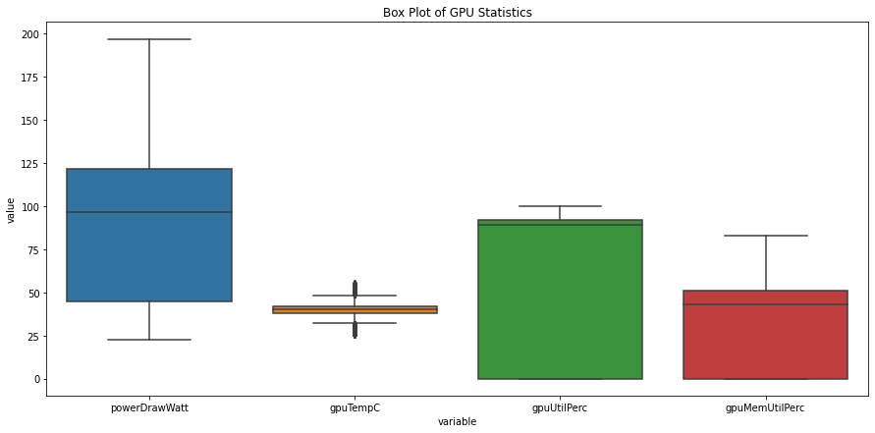

Fig 12: Box Plot of GPU Statistics