PERFORMANCE EVALUATION OF TERAPIXEL RENDERING IN CLOUD (SUPER) COMPUTING

Cloud Computing Project

SATISH PILLA

B210472095

# 1 Introduction

We live in an era where enormous datasets are continuously being used to fuel scientific discoveries. Scientists today envision a variety of data analytics and computations ranging from desktop to supercomputers, but they often struggle to design and create software architectures that can manage heterogeneous and often inconsistent data on a large scale.

Furthermore, the demand for scientific data and computational resources can fluctuate dramatically over time. Analytical demand may have broad transients in reaction to seasonal field campaigns or new breakthroughs in instrumentation [1]. Cloud computing can provide a flexible, cost-effective, and well-suited platform for some of these growing science needs. One such solution was used to present the terapixel visualization of IoT sensed environment data about the city of Newcastle, the data was collected by Newcastle Urban Observatory. Newcastle university team provided a solution which is a scalable architecture for a cloud-based visualization that can be deployed and pay for only as needed. They were able to demonstrate that it is feasible to produce a high quality terapixel visualization using a path tracing renderer in under a day using IaaS cloud and GPU nodes.

Terapixel Image:

Terapixel images are images with over one trillion pixels that, when combined with the correct toolset, give an intuitive [2], fluid user experience that allows the viewer to see an overview of the entire image or zoom into great detail.

Rendering:

Rendering, also known as image synthesis, is the automatic process of creating a photorealistic or non-photorealistic image from a 2D or 3D model (or models in what is referred to as a scene file) using computer programs. A render can also be defined as the outcome of presenting such a model.

# 2 Background

Terapixel images provide stakeholders with an intuitive and accessible way to show data sets, allowing audiences to interactively search huge data at many scales. The Newcastle Urban Observatory has been collecting IoT-sensed environmental data about Newcastle-upon-Tyne for over many years, accumulating more than 900 million records of data to date. The issue we covered here is how to offer the resources needed on a supercomputer scale to measure a realistic simulation of Newcastle upon Tyne's city terapixel image and environmental data recorded by the Newcastle Urban Observatory.

Newcastle university provided a solution which is a scalable cloud-based visualization platform that we can deployed and pay for only when it is needed [3],. The three main goals of a study of IoT-sensed environment data are to develop a supercomputer architecture for scalable visualization in the cloud, to create a terapixel 3D city visualization that can be updated on a daily basis, and to conduct a comprehensive evaluation of cloud supercomputing for compute-intensive visualization applications. They showed that combining public IaaS cloud GPU nodes and a path tracing renderer, can create a high-quality terapixel visualization in under a day. Once the terapixel image has been created, it may be used to support the city's interactive browsing and data at a variety of sensing scales, from the entire city to a single desk in a home, and it can be accessed from anywhere in the world.

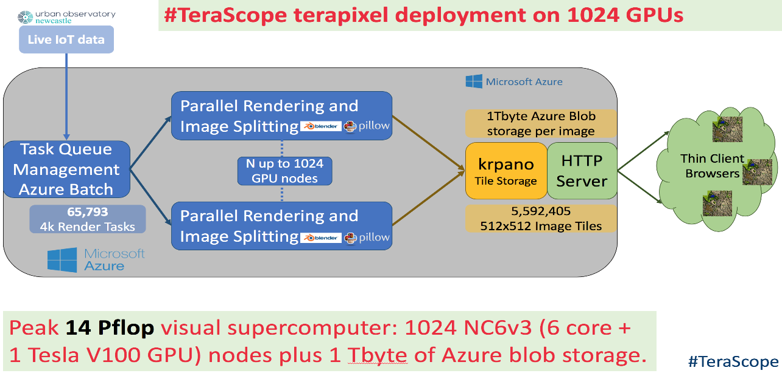

Fig 1: Block Diagram of Terapixel Rendering

The main components of terapixel rendering are Urban Observatory data which collected the data, Microsoft Azure (to deploy the solution), client. The data collected by Urban Observatory is from the live IoT devices. The data is then sent to Azure in which the task queue management Azure batch assign the data to different jobs created on the virtual machine for rendering and splitting the image. Various events are performed in each job with a unique task id for each rendering. There will be GPU nodes that collect output metrics related to the virtual machine's GPU status. The tiles are then saved in krpano after rendering, which consumes 1Tbyte per image. An http server delivers these images to visitors using client browsers.

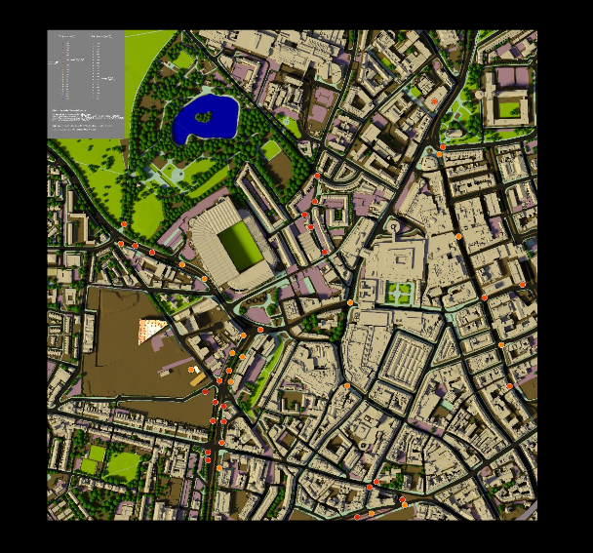

Fig 2: visualization of the realistic terapixel image of Newcastle upon Tyne city

# 3 Exploratory Data Analysis

Data scientists utilize exploratory data analysis (EDA) to study and investigate data sets and describe their key characteristics, often using data visualization techniques [4]. It assists data scientists in determining how to best manipulate data sources to obtain the answers they require, making it easier for them to find patterns, test hypotheses, and verify assumptions.

# 4 Description of Data

The dataset was collected from application checkpoint and system metric output from the production of a terapixel image during a run using 1024 GPU nodes. The data shows the performance of the GPU card, performance timing of the render application and the details of each image during rendering.

The dataset in our projects:

* Application-checkpoints.csv
* gpu.csv
* task-x-y.csv

Application-checkpoints file: This file contains application checkpoint events throughout the execution of the render job. The different schema present in the application-checkpoint data file is timestamp, hostname, eventName, eventType, jobId and taskId.

* Hostname: This is the host name of the virtual machine which is auto-assigned by the Azure batch system.
* eventName: This column consists of 5 events occurring in the application during rendering. The 5 events are:
* TotalRender is the entire task
* Render is when the image tile is is being rendered
* Saving Config is simply a measure of configuration overhead
* Tiling is where post processing of the rendered tile is taking place
* Uploading is where the output from post processing is uploaded to Azure Blob Storage
* eventType: It has two possible values START and STOP.
* jobId: This is the jobId of the Azure Job. The run is split into 3 jobs.
* taskId: This consists of unique taskId’s for each render task.

gpu.csv file: The data file contains metrics which have been generated on the virtual machine regarding the status of the GPU. The schema presents in the gpu.csv dataset is:

* gpuSerial: It consists of the serial number of each physical GPU card.
* gpuUUID: The unique device ID is allocated to the GPU unit by the Azure systems.
* powerDrawWatt: It consists of the power draw of the GPU units in watts.
* gpuTempc: this has the temperature of the GPU which is noted in Celsius.
* gpuUtilPerc: it consists of the percentage utilization of the GPU cores.
* gpuMemUtilPerc: it consists of the percentage utilization of the GPU memory.

Task-x-y.csv file: This data file contains the x, y coordinates for each task, from which part of the image was rendered. The schema in this file is:

* jobId: Id of the Azure batch job.
* taskId: ID of the Azure batch task.
* x: X co-ordinate of the image tile being rendered.
* y: Y co-ordinate of the image tile being rendered.
* Level: The visualization created is a zoomable "google maps style" map. In total we create 12 levels. Level 1 is zoomed right out and level 12 is zoomed right in. You will only see levels 4, 8 and 12 in the data as the intermediate level are derived in the tiling process.

# 5 Data Analysis

Firstly, we need to load all the necessary libraries and datafiles in the google colab.

Descriptive stats of all the three datasets are as follows:

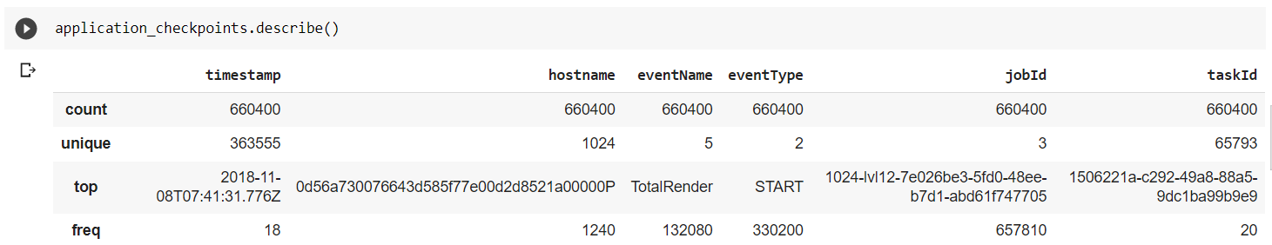

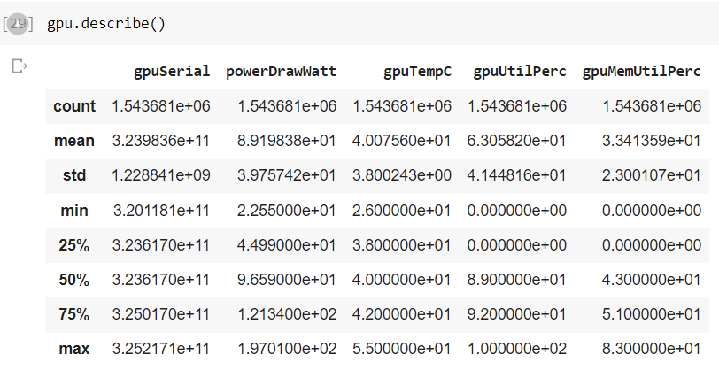

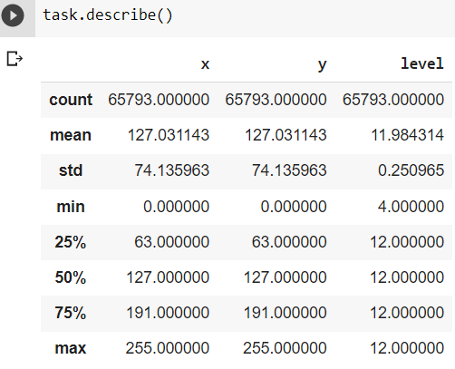

Fig 3: Descriptive stats for application checkpoint, gpu, task dataset

From above we can see the application dataset contains over 6 lakh records, gpu dataset contains over 15 lakh records and task dataset contains over 65 thousand records.

## 5.1 Analysis (Which event type dominate the task run times)

To determine which event type, dominate the task run times, we need to calculate the time difference between the events. The dataset consists of 5 events for every event there is two event type start and stop. The start is when the event was started and stop is when the event was stopped.

In the dataset we have don’t have separate start time and stop time columns, so it will be very difficult to calculate the time taken by each event. So, for easy calculation we are separating the timestamp into two columns start time and stop time based on event type start and stop for each event. The dataset is will also be reduced to half.

Reference

[1] <https://www.microsoft.com/en-us/research/publication/data-intensive-science-terapixel-modisazure-projects/>

[2] Holliman, N.S., Antony, M., Charlton, J., Dowsland, S., James, P. and Turner, M., 2019. Petascale cloud supercomputing for terapixel visualization of a digital twin. *IEEE Transactions on Cloud Computing*.

[3]

<https://github.com/NewcastleDataScience/StudentProjects202122/blob/master/TeraScope/Summary.md>

[4] <https://www.ibm.com/uk-en/cloud/learn/exploratory-data-analysis>