**Project Title : Online Contact Diary** (Servlet,JSP,Hibernate,Oracle)

**Project Requirements :**

1. Eclipse IDE
2. Jdbc and Hibernate Dependency
3. JSP Form
4. Servlet
5. Filter
6. Hibernate
7. Database.

**Summary :**

In this Mini Project we are using Java Servlet and JSP pages to perform some Operations on Oracle XE 11 Database like Adding records, Displaying All records, etc. Using Hibernate.Every user can store the contacts online and sees his own contacts separately after doing login to the website.

**Introduction about the project :**

Technology Specifications used in project ( Java Language, Eclipse IDE,Database Language , Oracle XE 11 Database & Hibernate )

**JSP Used :**

1. WelcomePage.jsp:this jsp page is Home / default page

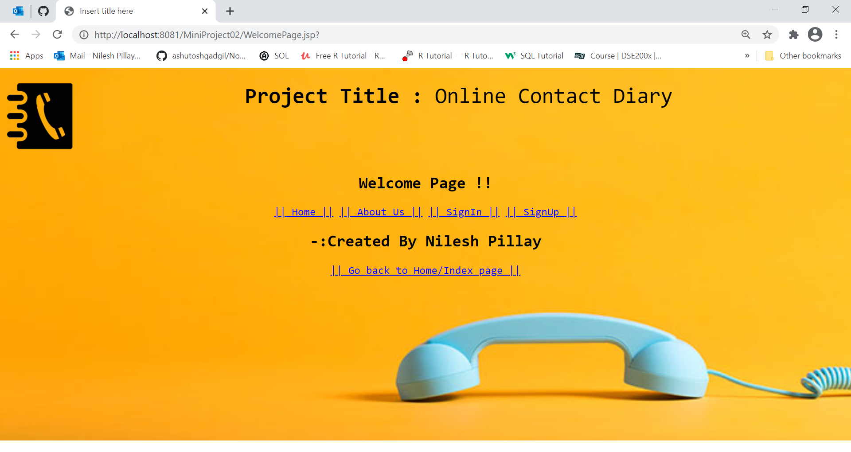

1. Home.jsp:this is Home Page



3.AboutUs.jsp:this page Display information about website and Contact Diary

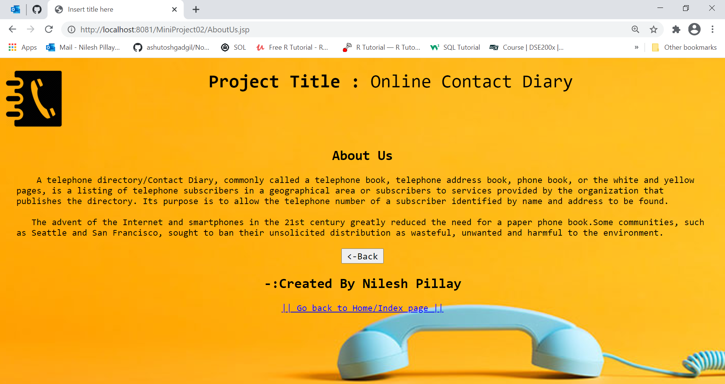

1. SignIn.jsp:this page is for SignIn in the service .

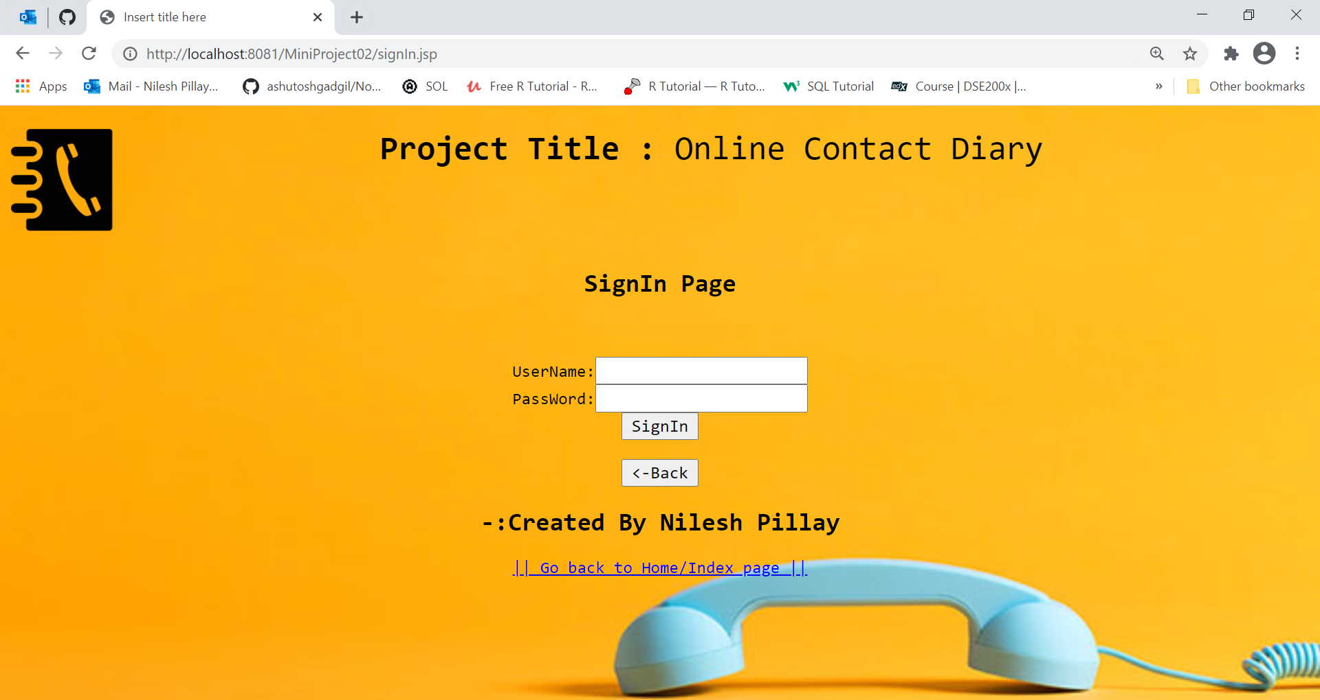

4.signUp.jsp:this page is for SignUp for the service.

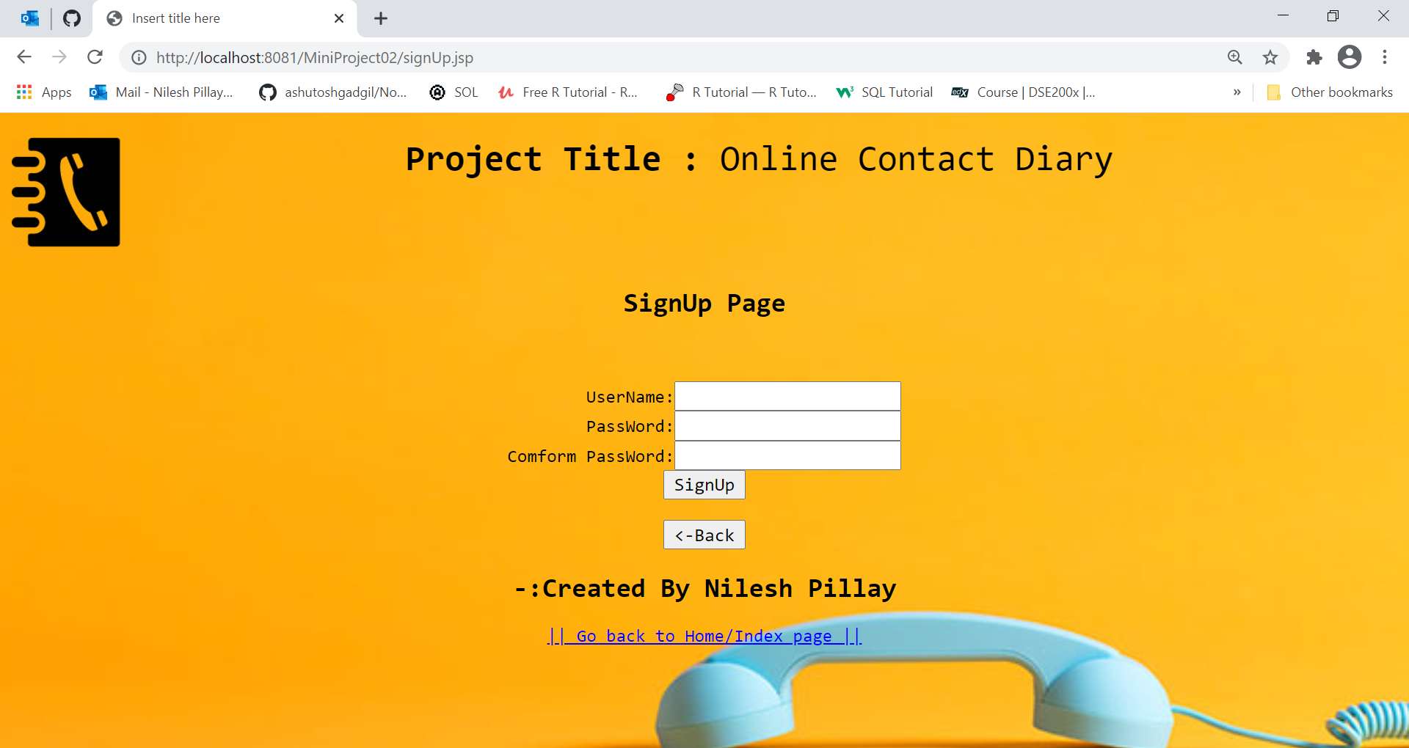

1. index.jsp:this page has all hyper link for CURD operations and other link

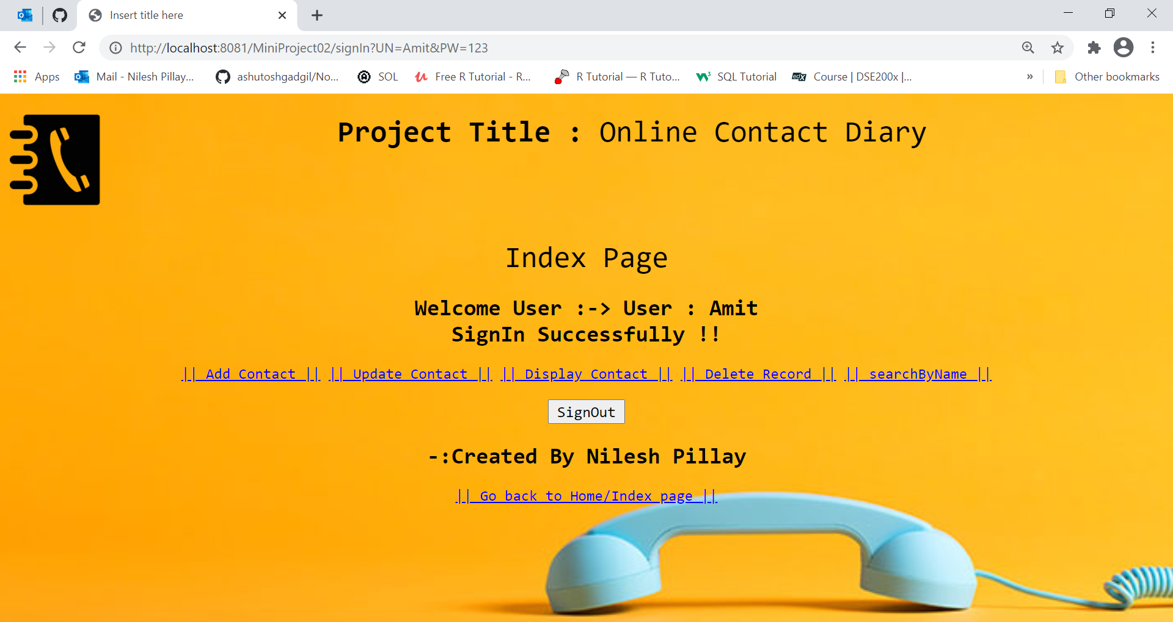

1. AddContact.jsp:this page is a form for accepting data .

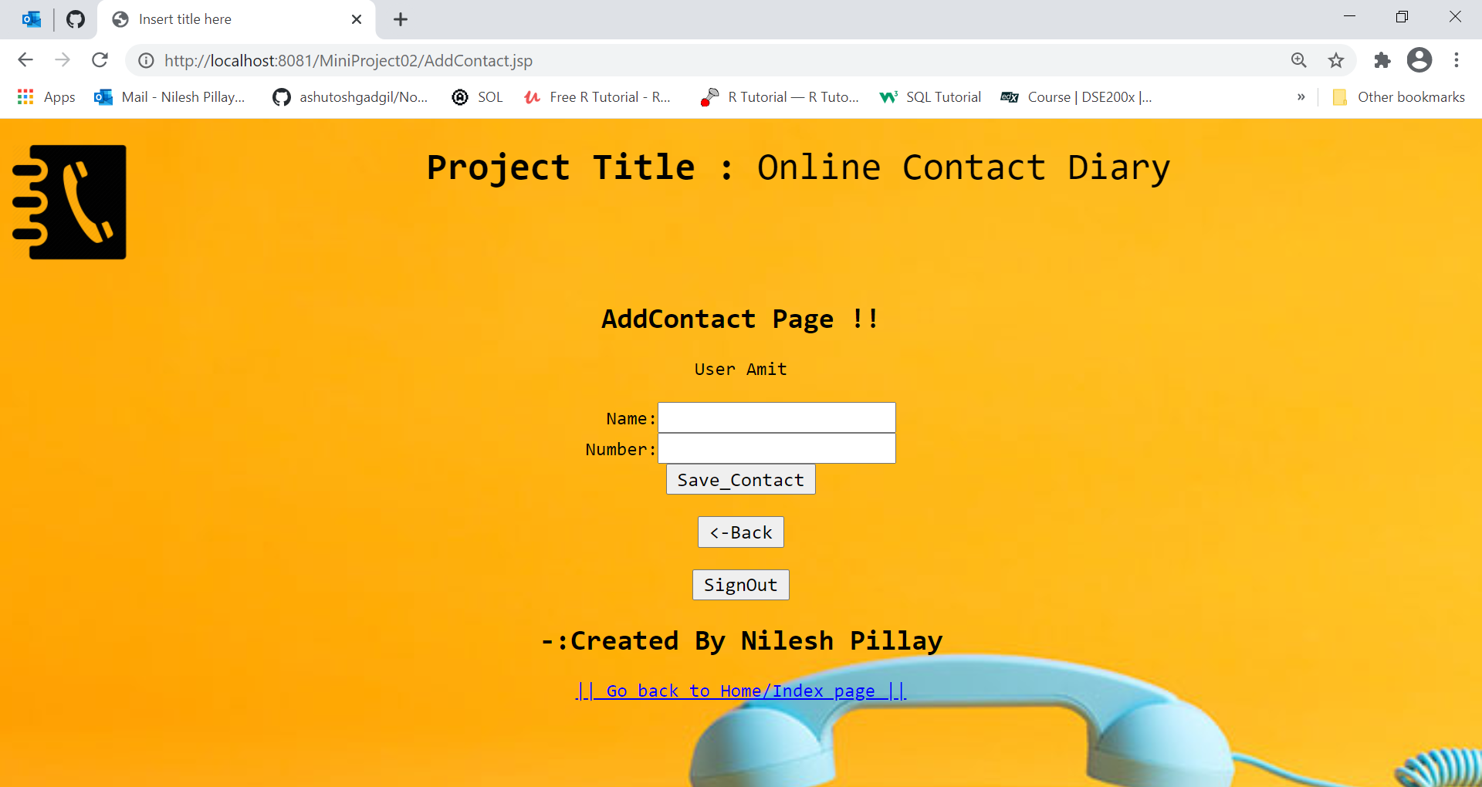

1. Update.jsp:this page Update a contact by its name.

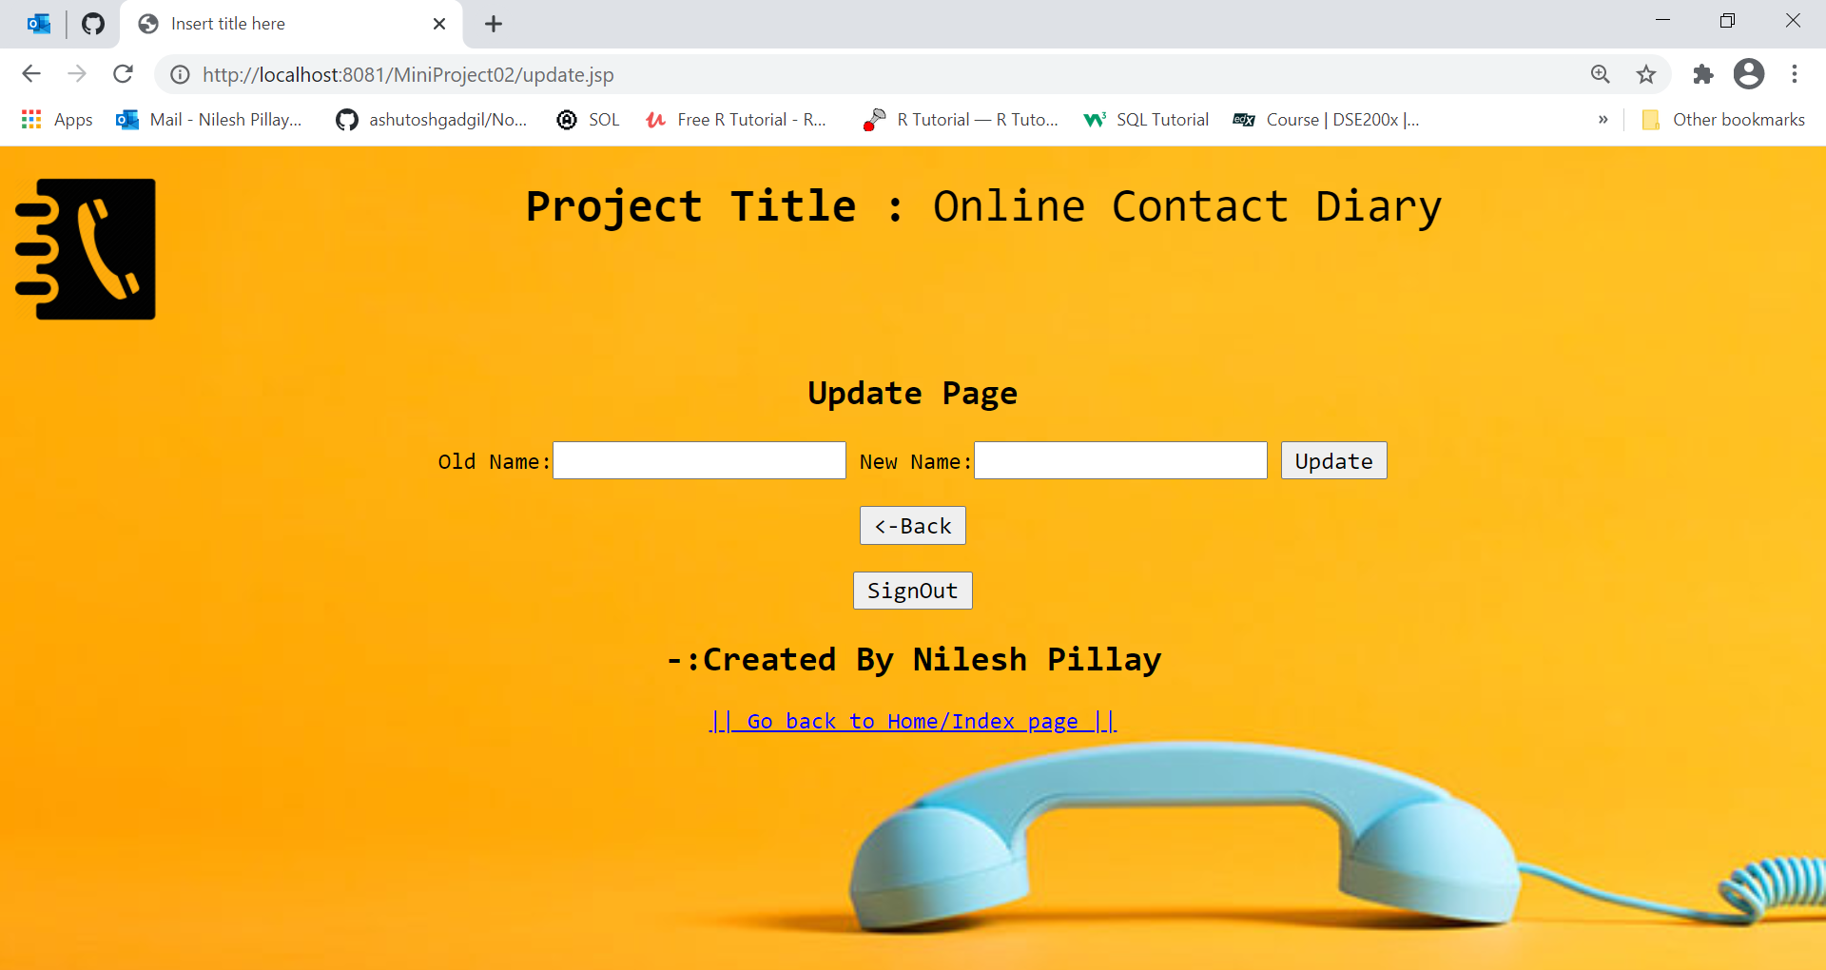

1. DisplayAllRecord:this Display All Contact .

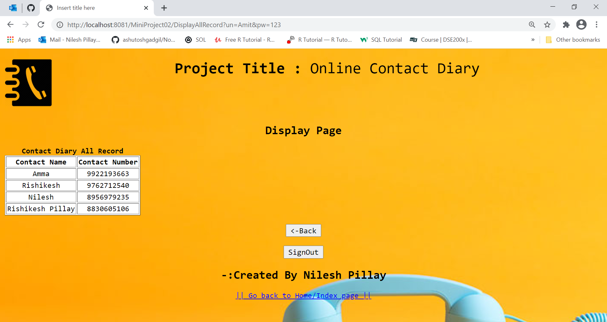

1. Delete.jsp:this page Delete a contact by its name.

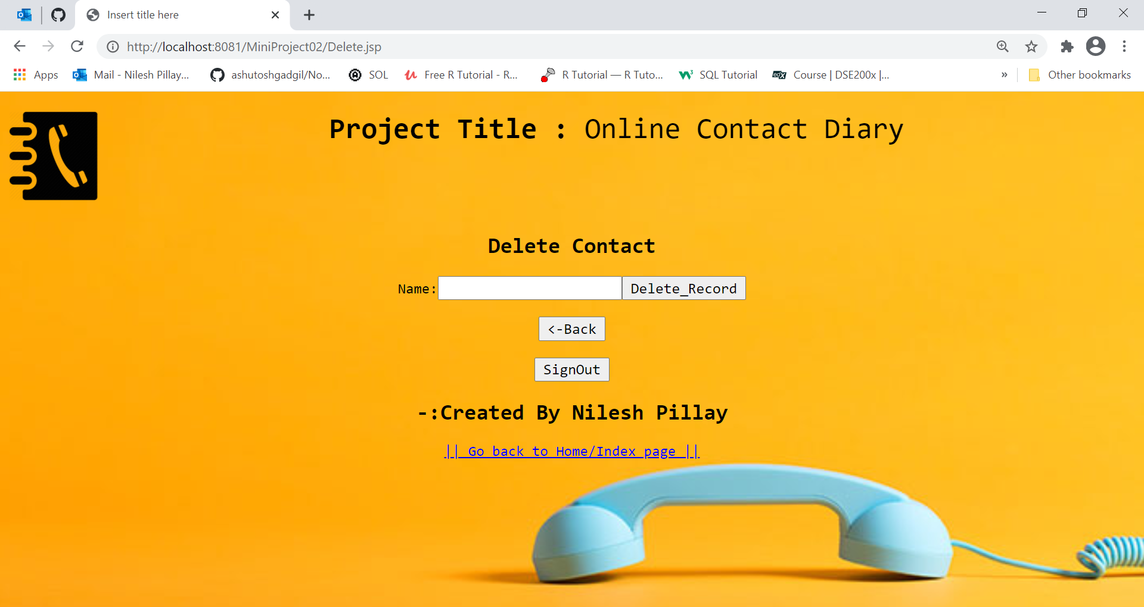

1. DisplayByName:this page Display Contact Name Wise.

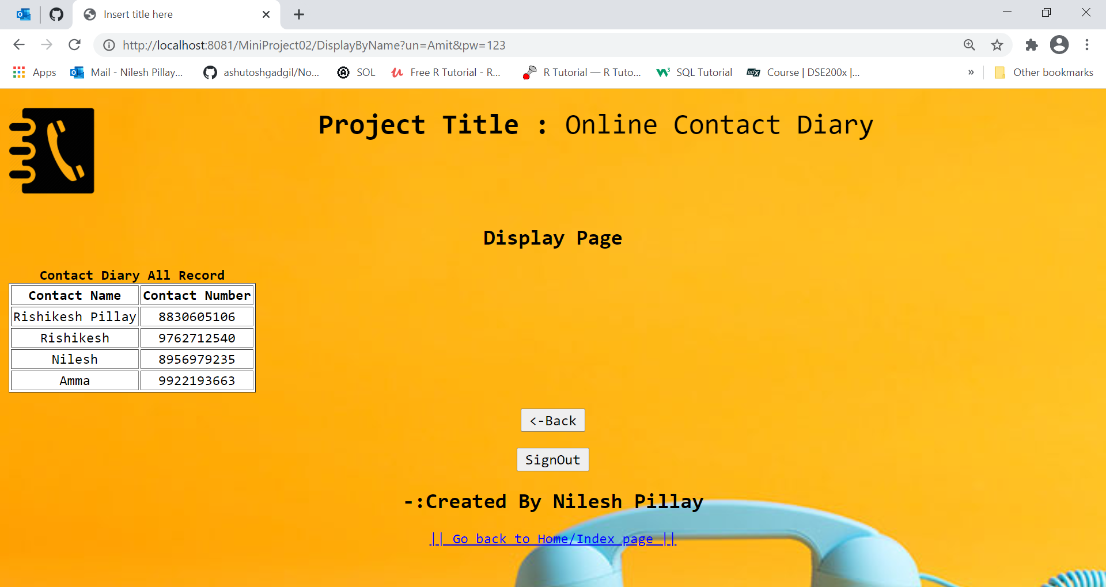

1. searchByName:this page Display specific Contact by Name.

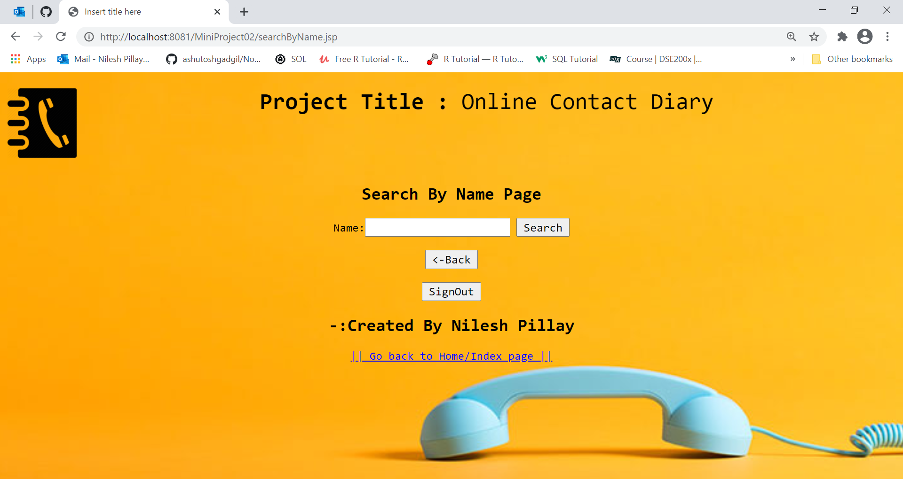

1. CountTotalContact.jsp:this page Show total number of Contact.

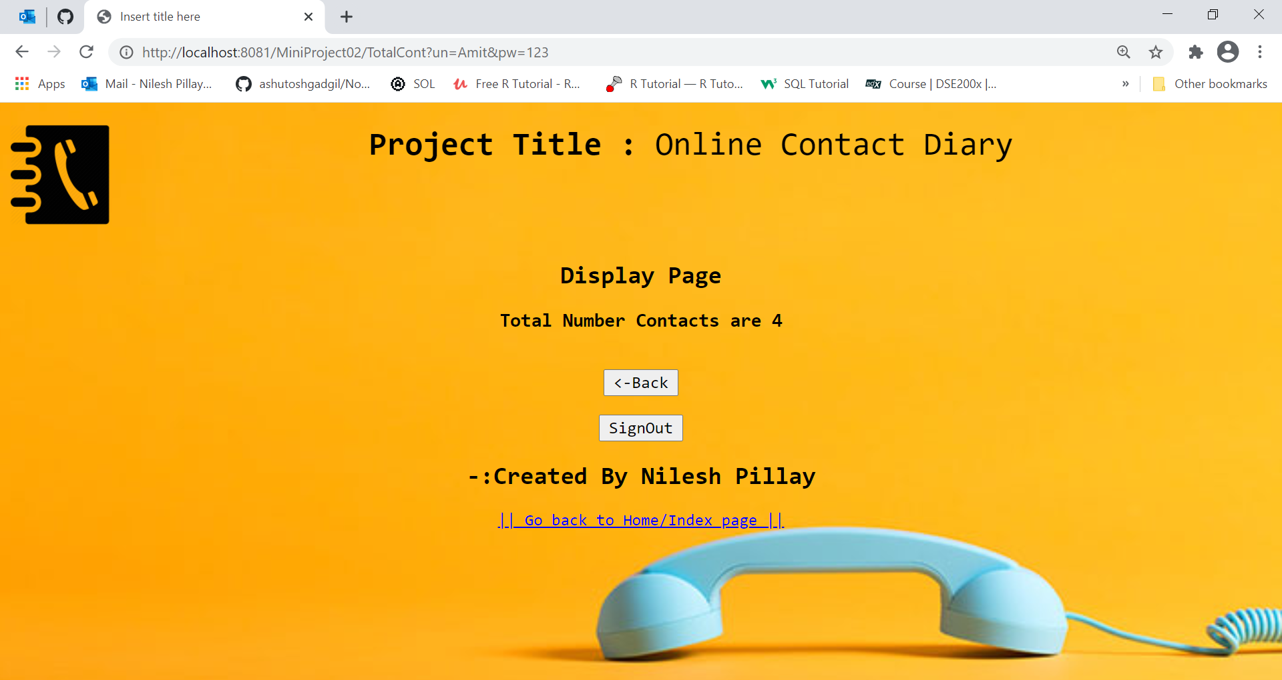

:->Created By Nilesh Pillay