**Project Title : Customer Management** (JSP,Hibernate,Spring MVC,Rest Webservice,Oracle)

**Project Requirements :**

1. Eclipse IDE
2. Jdbc ,Hibernate,Spring MVC, Spring Web,Spring Core, Spring Context, Jersey Bundle and Spring Form Dependency
3. Hibernate
4. Spring
5. Database.

**Summary :**

In this Mini Project we are using Spring MVC pattern to perform some Operations on Oracle XE 11 Database like Adding records, Displaying All records, etc. This is a Customer management App where Customer Record can be added ,deleted,updated and displayed using Hibernate

**Introduction about the project :**

Technology Specifications used in project ( Java Language, Eclipse IDE,Database Language , Oracle XE 11 Database ,Hibernate & Spring )

**JSP Used :**

1.Index.jsp:this jsp page is Home / default page

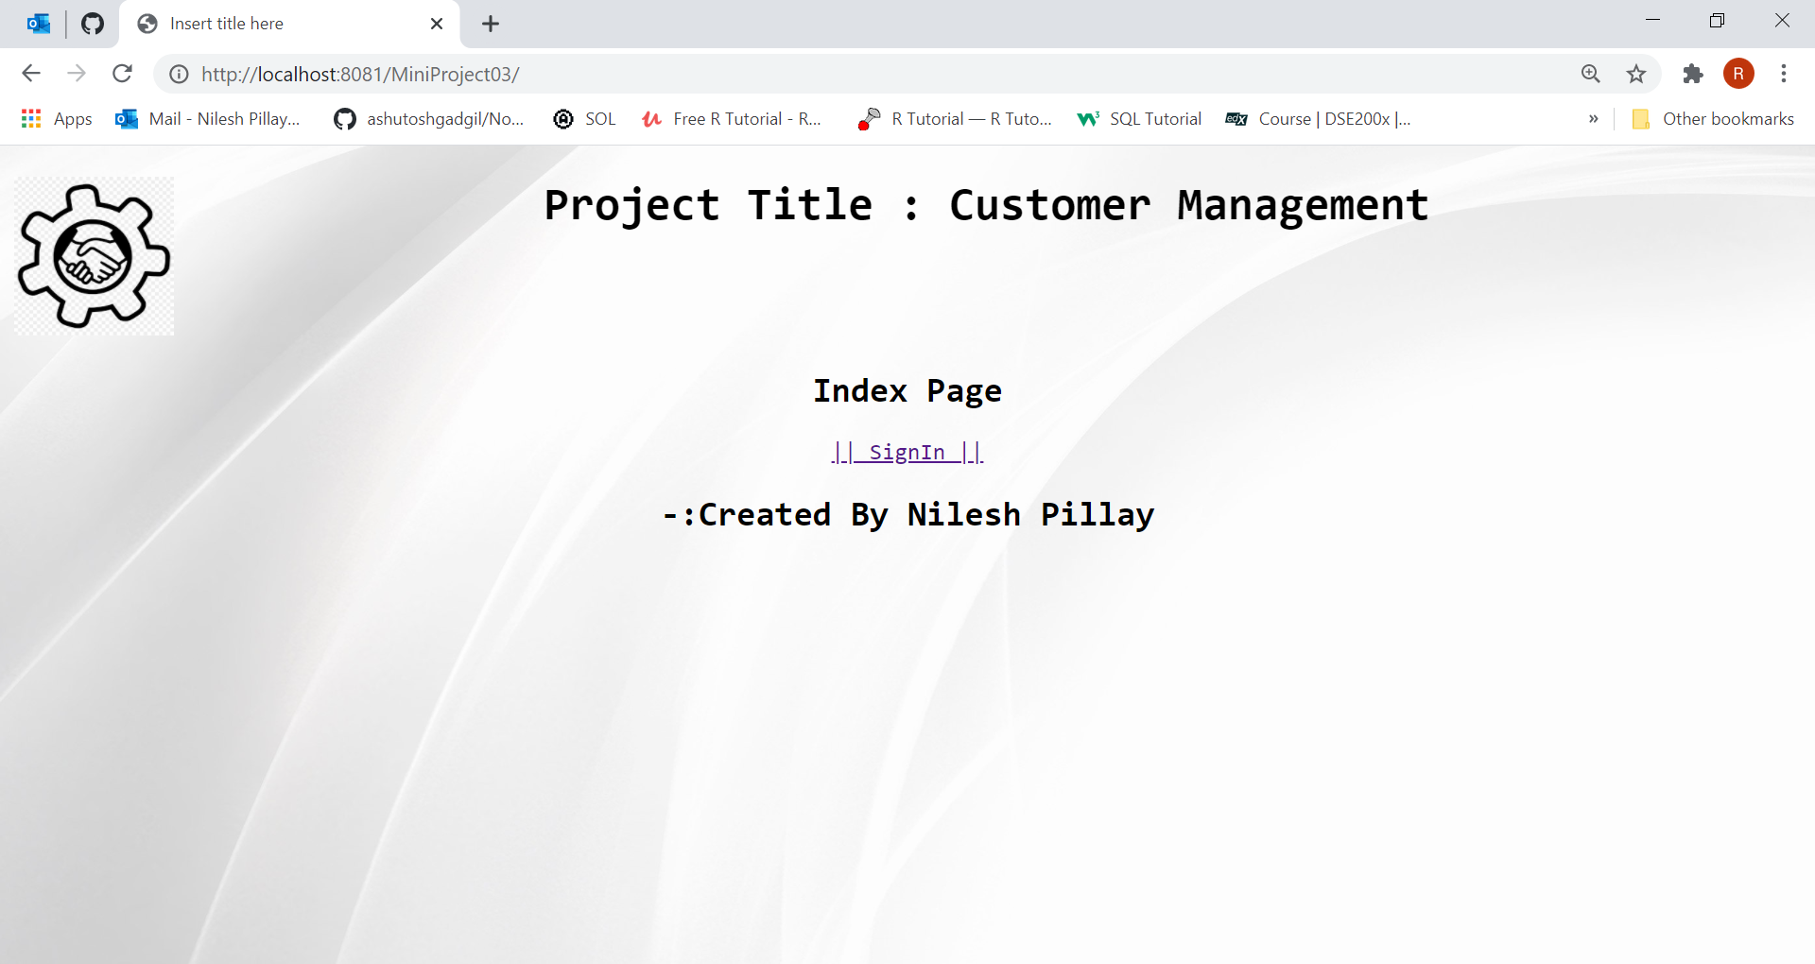

2.signIn.jsp:this page is for SignIn in the service

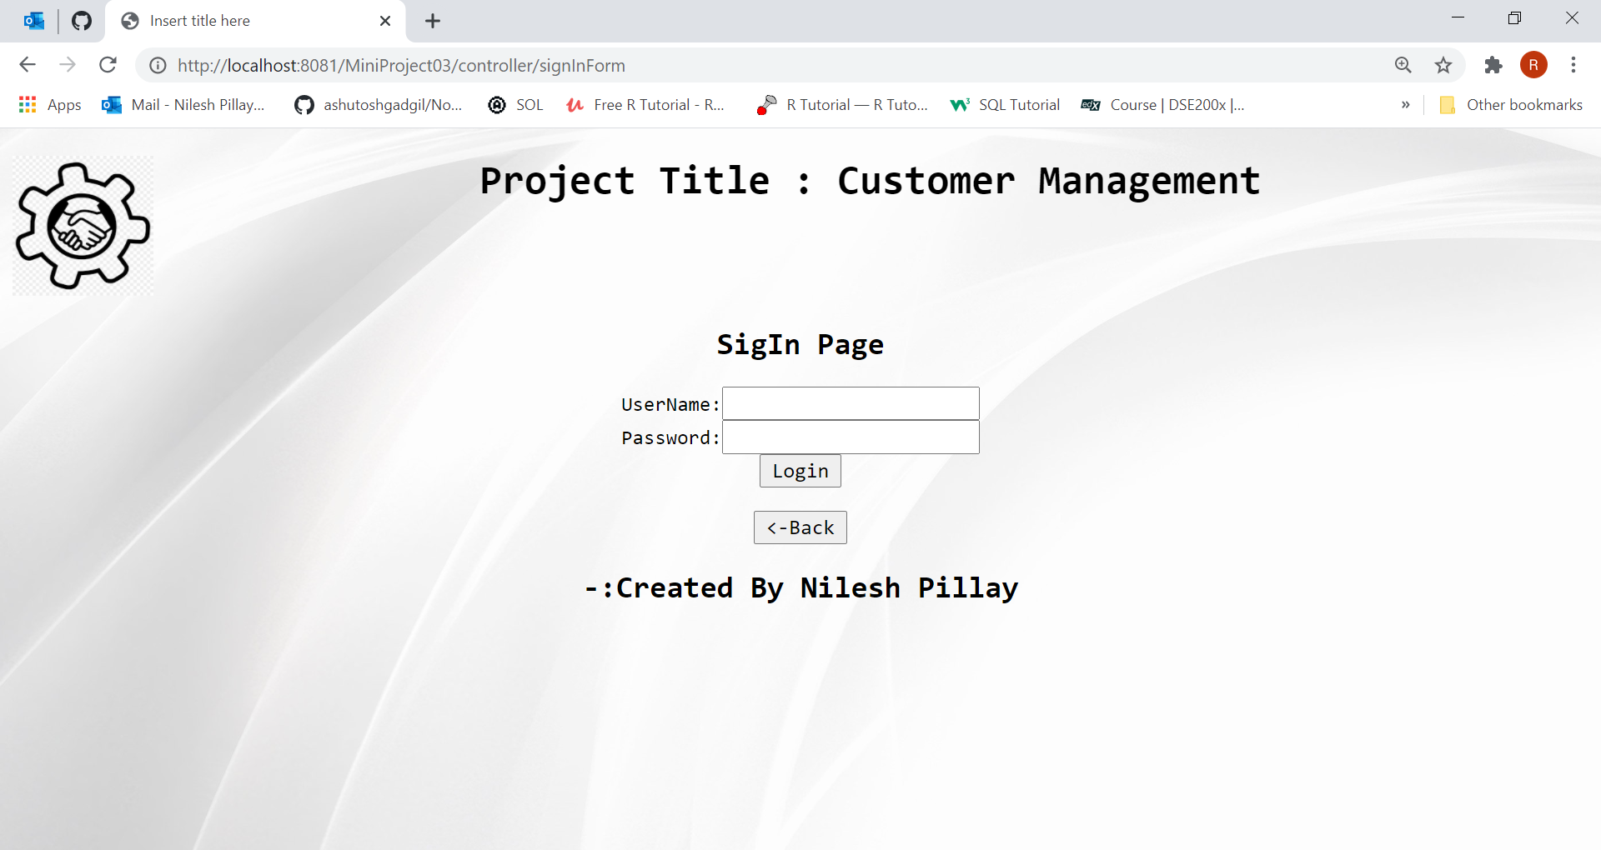

3.WelcomePage.jsp:this page has all hyper link for CURD operations and other link

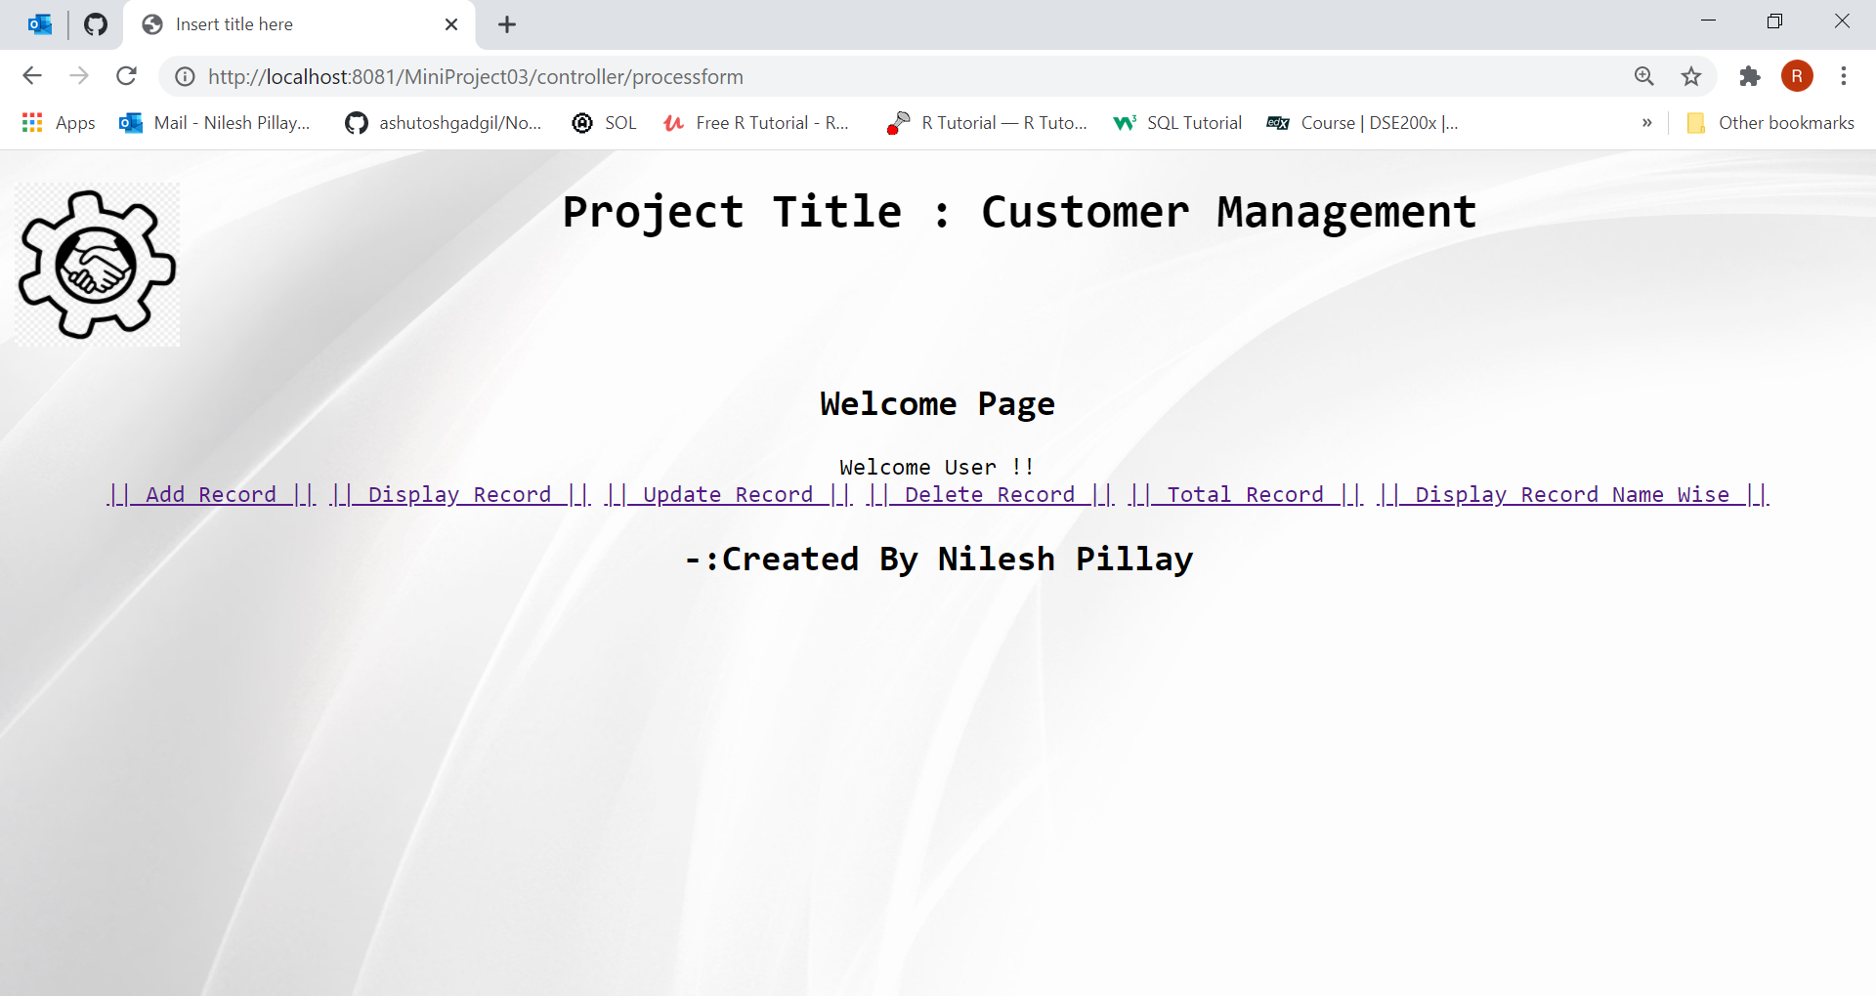

4.AddRecord.jsp:this page is a form for accepting data and saving

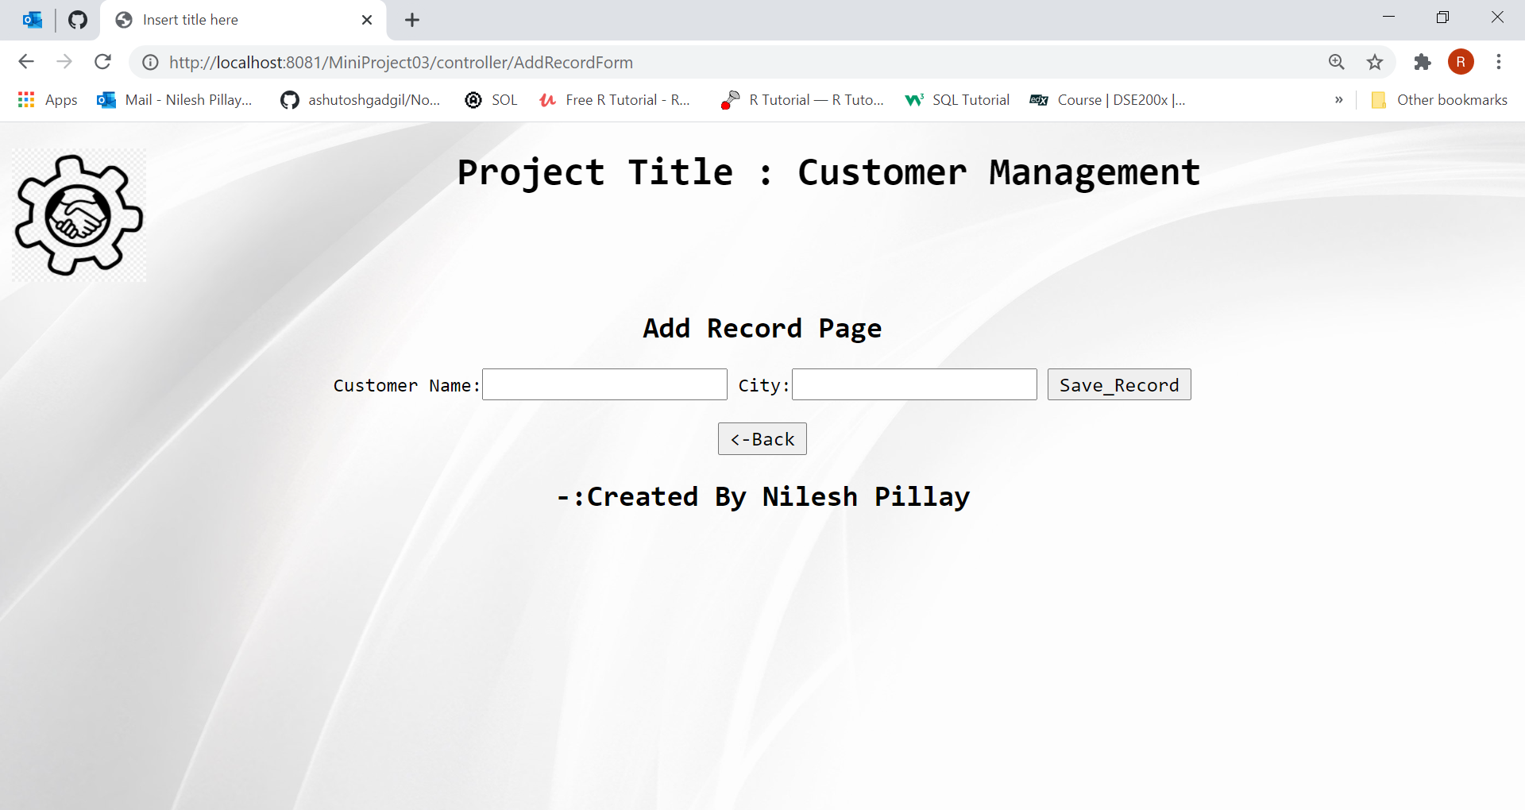

5.DisplayRecord.jsp:this Display All Record.

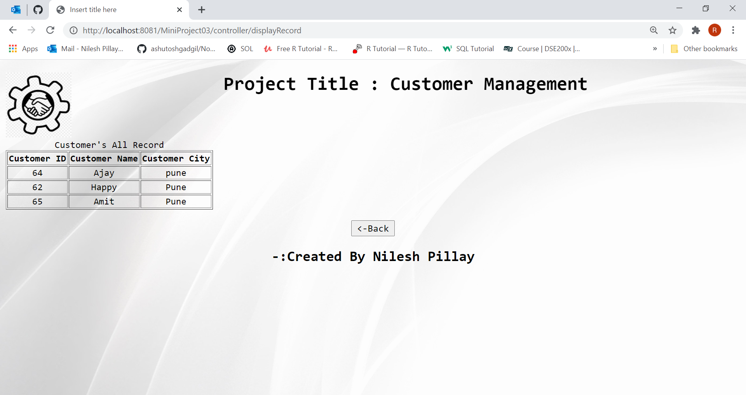

6.UpdateRecord.jsp:this page Update a Record by its Customer ID.

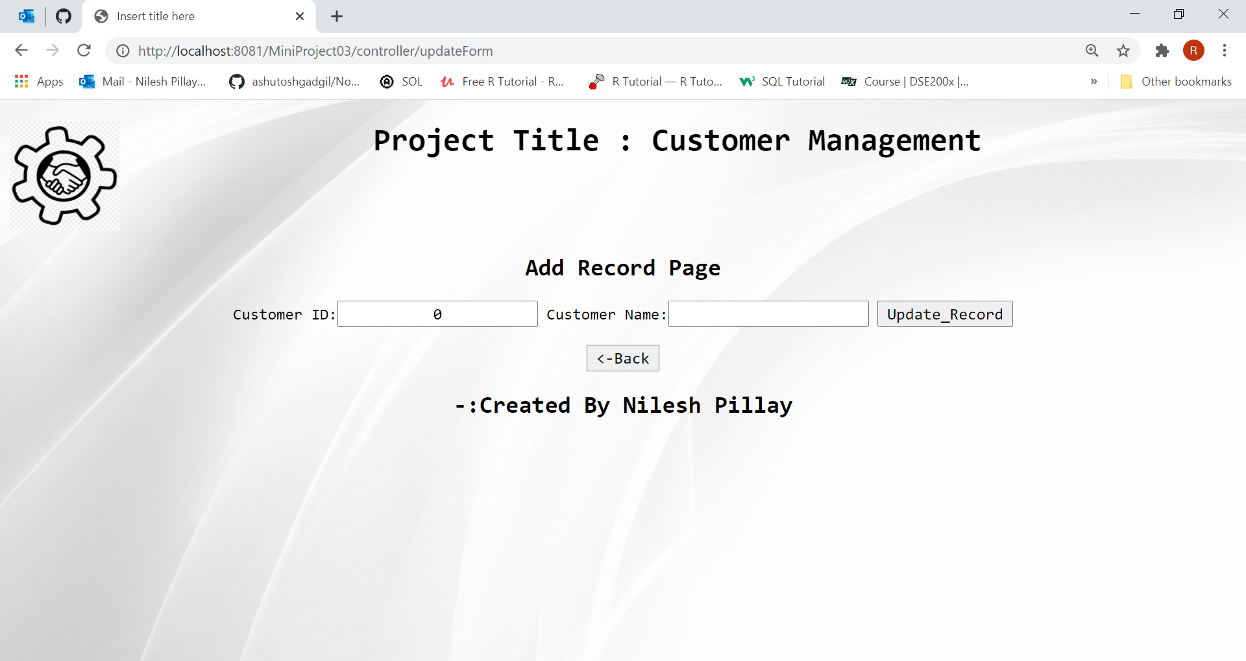

7.DeleteRecord.jsp:this page Delete a Record by its Customer ID.

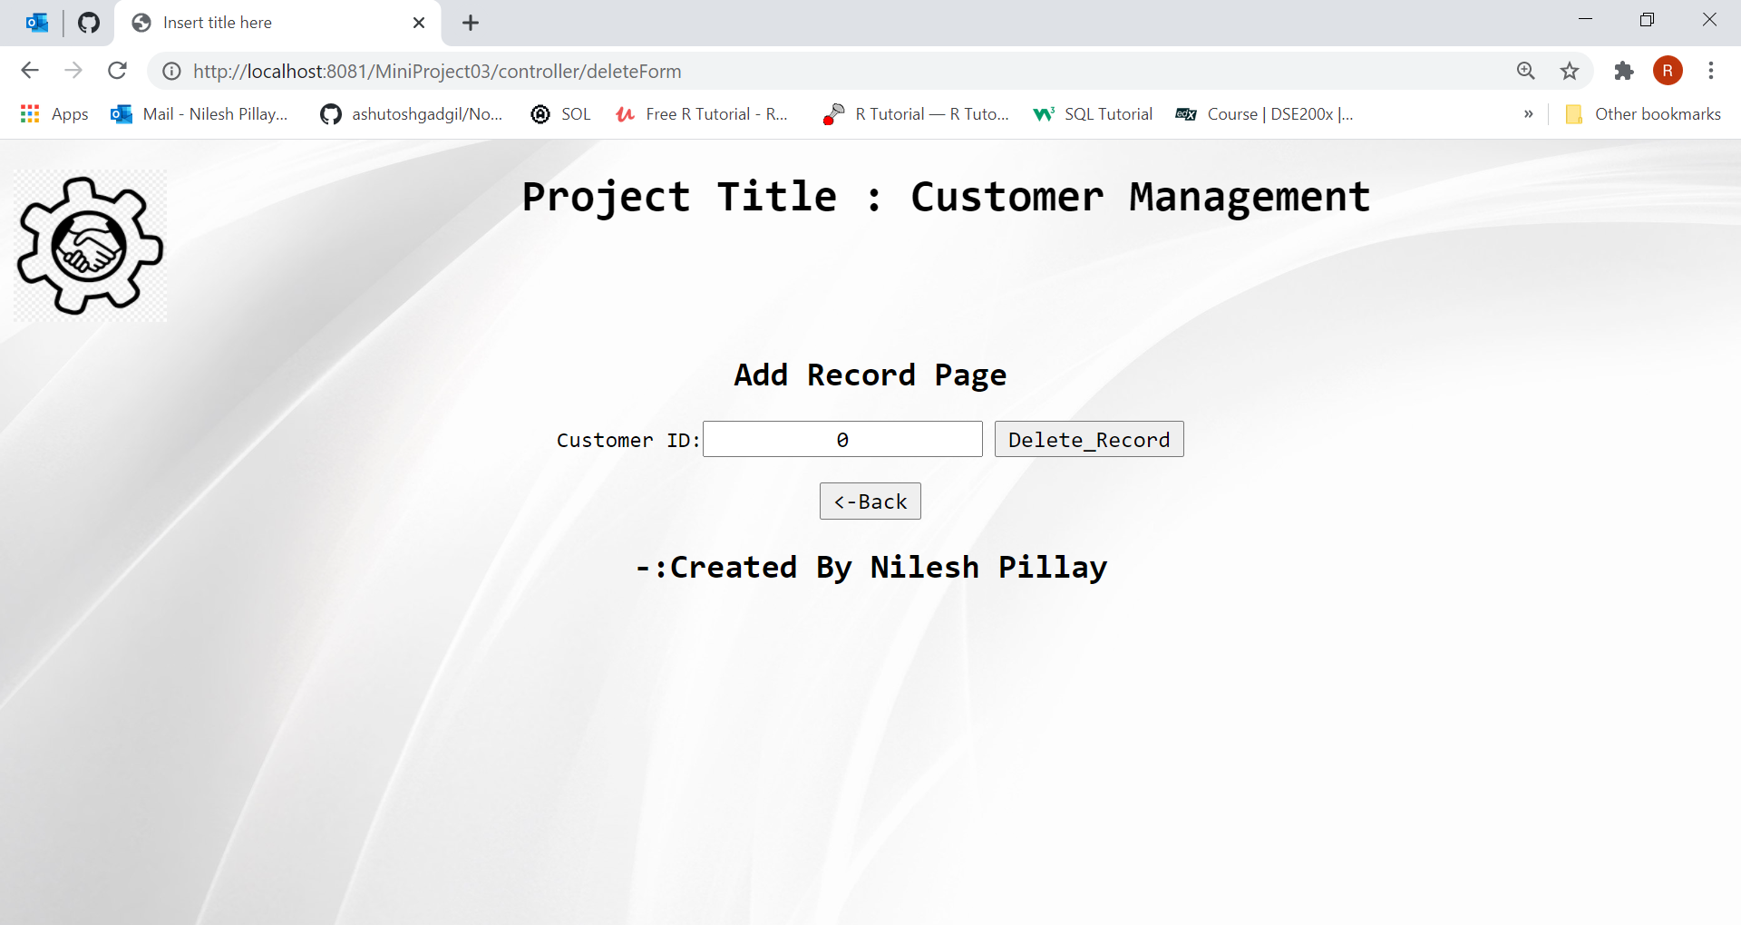

8.TotalNumberOfRecord.jsp:this page Show total number of Record 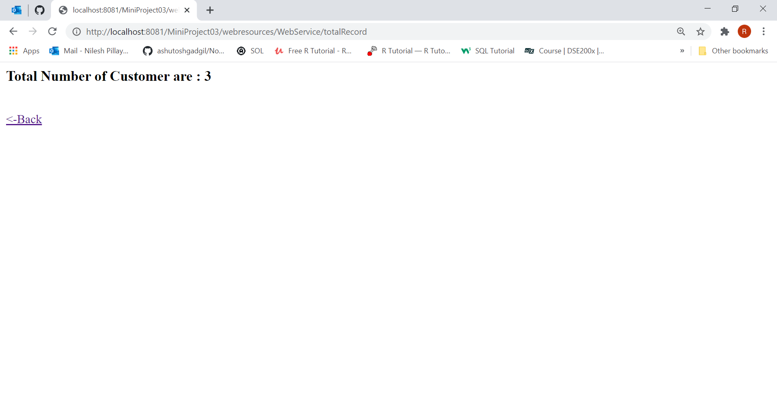

9.DisplayRecordNameWies.jsp:this page Display Record Name Wise.

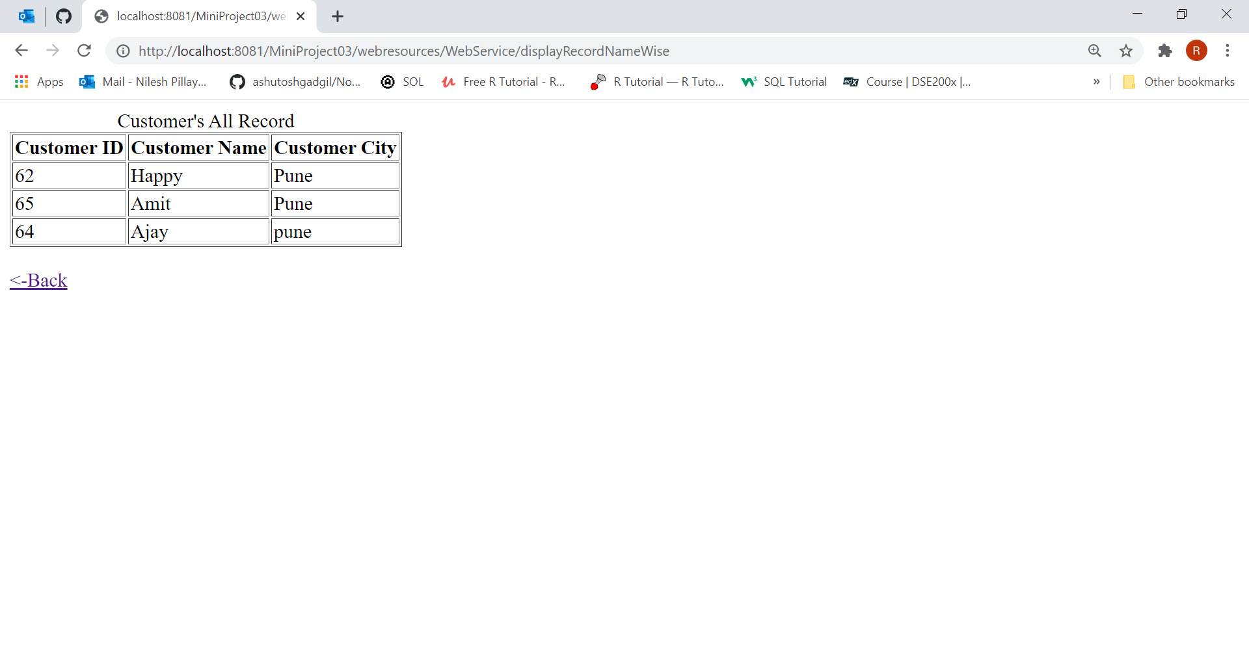

:->Created By Nilesh Pillay