- What is unix ? In Which language it is written?
Ans: UNIX is a popular multi-user, multitasking operating system (OS) developed at Bell Labs in the early 1970s. Created by just a handful of programmers, UNIX was designed to be a small, flexible system used exclusively by programmers.
Due to its portability, flexibility, and power, UNIX has become a leading operating system for workstations. Historically, it has been less popular in the personal computer market.
Unix distinguishes itself from its predecessors as the first portable operating system: almost the entire operating system is written in the C programming language, which allows Unix to operate on numerous platforms
- Explain the Unix architecture by diagram
Ans:
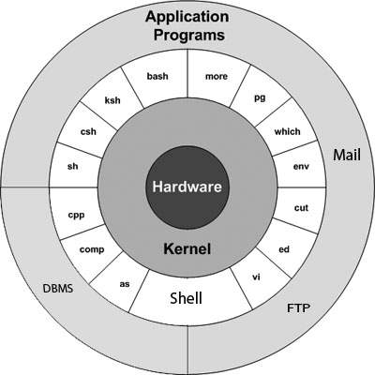

The main concept that unites all the versions of Unix is the following four basics −
- Kernel − The kernel is the heart of the operating system. It interacts with the hardware and most of the tasks like memory management, task scheduling and file management.
- Shell − The shell is the utility that processes your requests. When you type in a command at your terminal, the shell interprets the command and calls the program that you want. The shell uses standard syntax for all commands. C Shell, Bourne Shell and Korn Shell are the most famous shells which are available with most of the Unix variants.
- Commands and Utilities − There are various commands and utilities which you can make use of in your day to day activities. cp, mv, cat and grep, etc. are few examples of commands and utilities. There are over 250 standard commands plus numerous others provided through 3rd party software. All the commands come along with various options.
- Files and Directories − All the data of Unix is organized into files. All files are then organized into directories. These directories are further organized into a tree-like structure called the filesystem.
- Write difference between cd .. and cd .
Ans: By ‘cd ..’ we go to one stpe back in the path and by ‘cd .’ We go to the same path where we are (ie. we do not move )
- Write a command to copy and move a file from a folder in desktop to the home folder.
Ans: $ cp ~/Desktop/copyfile/ file.txt ~/
$ mv ~/Desktop/Movefile/file.txt ~/
- Create 2 files using single touch command and write some contents in it using cat.
Ans: $ touch file1.txt file2.txt
$cat > file1.txt
$ cat > file2.txt
- Create 5 files where 2 files as text and 3 files as docs on desktop and list all files which are text files.
Ans: $ touch 1.txt 2.txt 3.txt 4.doc 5.doc
$ grep ~/Desktop/Test/*.txt
- List all directories which starts with letter D
Ans: $ ls ~/Desktop/Test/D
- List all files which ends with letter E
Ans: $ ls ~/Desktop/Test/E
- Create 2 files A.txt and B.txt and write some contents in those files and concatenate both files and the concatenated text should be written in other file C.txt
Ans: $ cat > A.txt
A ^D
$ cat > B.txt
B ^D
$cat A.txt B.txt > C.txt

