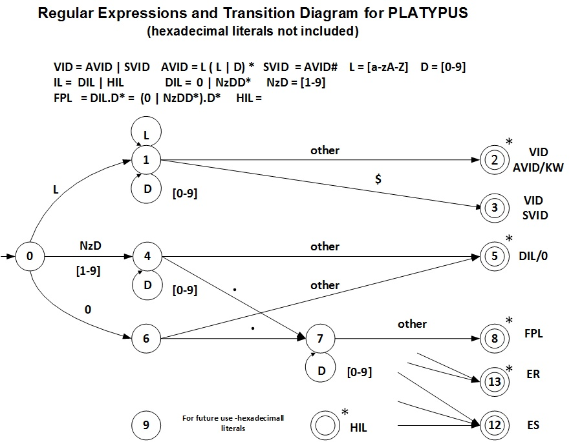

Transition Table
Current  State |  |  |  | INPUT SYMBOL |  |  |  |  |  |  | State Type  (Not Accepting or Accepting State)
Current  State | [a-zG-Z] |  | 0 |  | [x] | [A-F] | [1-9] | . | $ | other | State Type  (Not Accepting or Accepting State)
0 | 1 |  | 6 |  | 1 | 1 | 4 | IS/ES | IS/ES | IS/ES | NOAS
1 | 1 |  | 1 |  | 1 | 1 | 1 | ES/AS2 | 3 | 2 | NOAS
2 | IS |  | IS |  | IS | IS | IS | IS | IS | IS | VID AVID/KW - ASWR
3 | IS |  | IS |  | IS | IS | IS | IS | IS | IS | VID SVID - ASNR
4 | ES/AS5 |  | 4 |  | ES | ES | 4 | 7 | 5 | 5 | NOAS
5 | IS |  | IS |  | IS | IS | IS | IS | IS | IS | DIL - ASWR
6 | ES |  | 5 |  | 9 | ES | ES | 7 | ES | 5 | NOAS
7 | ES/AS8 |  | 7 |  | ES | ES | 7 | ES/AS8 | 8 | 8 | NOAS
8 | IS |  | IS |  | IS | IS | IS | IS | IS | IS | FPL - ASWR
9 | ES |  | ES |  | ES | 11 | 11 | ES | ES | 10 | NOAS
10 | IS |  | IS |  | IS | IS | IS | IS | IS | IS | HIL - ASWR
11 | ES |  | 11 |  | ES | 11 | 11 | ES | ES | 10 | NOAS
12 | IS |  | IS |  | IS | IS | IS | IS | IS | IS | ES - ASNR
13 | IS |  | IS |  | IS | IS | IS | IS | IS | IS | ER - ASWR

IS – Illegal State ES – Error State ES/AS – Error State or Accepting State
NOAS – Not Accepting State
ASWR - Accepting State With Retract ASNR - Accepting State No Retract

