**“Online Library Management System”**

Submitted by

**Pilot Kumar Mazumdar**

**ID: 171442124**

**&**

**Mridul Chandra Das**

**ID: 171442054**

A project report submitted in partial fulfilment of the requirements for the Degree of Bachelor of Science in Computer and Engineering

Supervised By

**Juthi Kundu**

Lecturer

Department of CSE

City University



**CITY UNIVERSITY**

**DHAKA, BANGLADESH**

**July 13, 2020**

**Abstract:** The project “Online Library Management System” is a web-based application that provides a smart solution of library management by the kipping track of all books (hard copy and softcopy), communication with students, admin and other users, the book reservation with a monitoring system as well as some additional feature.. The admin can be control all user and communicate with all library member. The application has login system with the strong security. The admin can easy to access all of user and manage whole part of library management such as Adding, Deleting, Updating, Messaging, Uploading new content, Creating notice, Accepting book request of all user. The student can read notice board and seen new book with other merit. The students are how much time used to the library that will be totally determined by admin or librarian. This application is developed by xammp server and with mysql database using various programming Language such **as php, JavaScript use Ajax, Jquery and html, css** and tools.

**Introduction:** Information Technology has revolutionized the life of human beings and has made lives easier by the various kinds of applications. In the light of the rapid changes with the use of Information Technology, there are many tools, technologies and systems that have been produced and invented. The main objective of this project is to develop a Library Management system (LMS) for University in order to automate the library tasks and make the library management more efficient and easy to handle. Library is place where all kind of books are available in hard copy or digital format.

The project titled “Library Management System” is a library management Application for monitoring and controlling the transactions in library. The project “Online Library Management System” is developed in PHP, JavaScript, Java Script library like jquery, HTML, CSS. We will use ajax interactions for rapid web development. The application which mainly focuses on basic operations in a library like adding new member, new book, updating new information, searching book and member to borrow and return book. The member will chat with borrower for according to requirements. The every member will get notification for new books. We will add digital clock in the head. Every member can read all newspaper in the application. The project Library Management System aims at developing a fully functional computerized system to maintain all the day to day activity of a library. This project has many features which such as the facility of student login and teachers login and admin login with other user login also on the top of all this, there is an admin who will be managing the entire application’s authorization and authentication, not any intruder can login and modify the data, as a login for admin is also available.

The Library Management System has four main modules.

1. Insertion to Database Module – User friendly input screen.
2. Extraction from Database module – Attractive Output screen.
3. Report Generation module – borrowed book list & Available book list.
4. Search Facility system – Search for books and members.

**Goal of the Project:**

The main objective of this proposed Library management system is to fully automate all the daily works of the University Library. Other Aim and objective of Online Library Management System includes:

* Create distinct users privilege based on their roles and permissions.
* Authenticate users at their login.
* Provide the list of books the users can borrow.
* Reserve books that are available.
* A status page for all users to view books borrowed by them, their
* Individual due dates and their individual penalties if any.
* An interface to view and edit the own profile.
* Mechanism to reset the password in case user forgets it.
* Providing interface to add or delete books to staffs.
* A search column to search availability of books by guest or library users.
* Reduce the workload of employee.

**Motivation:**

The library as an integral and significant part of the educational system has undergone phenomenal development in the use of ICTs which have substantial influence in the process of information resources’ acquisition, processing, storage, and use in developing countries. Consequently, libraries are required to provide access to huge information resources in a diverse format such as print (books, Journals) and electronic format-(e-books, e-journals/journal articles, Internet resources/services) as well as bibliographical information about these resources have influenced the adoption of LMS (Library Management System).

Similarly, libraries as fundamentally service-oriented units, where services are rendered to people with diverse information needs, (who are also from different) backgrounds, cultures, emotions, skills, and behaviors, are bound to meet these various information needs of its patrons in the easiest, most efficient, and most comprehensive way possible, Therefore, there is need for highly efficient technologies/systems and processing tools in order to deliver these services promptly and also accomplish the quest to meet and support the information needs of library users.

**Methodology**:

* **System Model:** The system model helps the analyst to understand functionality of the system and model are uses to communicate of users.

**Admin**

Create Account

Login

Maintenance Hard-Book

Maintenance E-Book

Maintenance Issue Book

Users Maintenance

Cancel Memberships

Message

Write Notice

Notification

Write Post

View Online Papers

**Teachers**

Create Account

Login

View Hard-Books

View E-Books

Search Catalog

Request Books

Return Books

Renew Books

Message

Notification

Write Post

View Online Papers

**Online Library Management System**

**Others Members**

Create Account

Login

View E-Books

Search Catalog

Message

Notification

View Online Papers

**Students**

Create Account

Login

View Hard-Books

View E-Books

Search Catalog

Request Books

Return Books

Renew Books

Message

Notification

View Online Papers

**System Model of Online Library Management System**

* **Use Case Diagram:**

The use case diagrams are usually referred to as behavior diagram used to describe the actions of all users in a system. All user describe in use case are actors and the functionality as action of system.

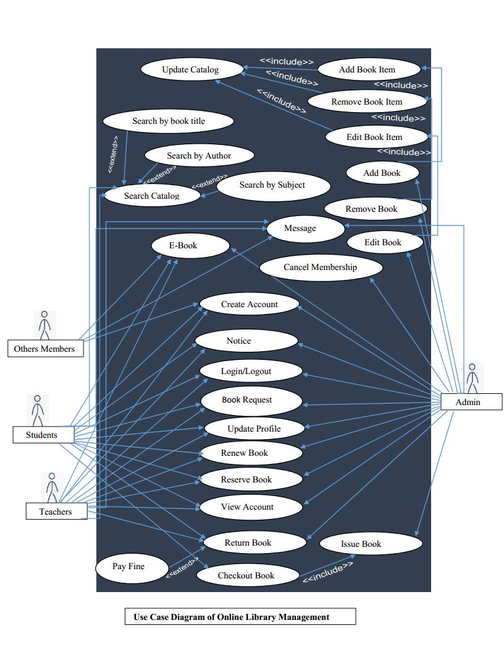

* Admin: Mainly responsible for adding and modifying books, book items, and users. The Librarian can also issue, reserve, and return book items.
* Students: All Students can search the catalog, as well as check-out, reserve, renew, and return a book.
* System: Mainly responsible for sending notifications for overdue books, canceled reservations, etc.

**Here are the top use cases of the Library Management System:**

* Add/Remove/Edit book: To add, remove or modify a book or book item.
* Search catalog: To search books by title, author, subject or publication date.
* Register new account/cancel membership: To add a new member or cancel the membership of an existing member.
* Check-out book: To borrow a book from the library.
* Reserve book: To reserve a book which is not currently available?
* Renew a book: To re-borrow an already checked-out book.
* Return a book: To return a book to the library which was issued to a member.

**Diagram of the different User’s Activity:**

**There are four category users in this system:**

1. Admin
2. Teachers
3. Students
4. Others Members

* **Diagram of The Admin User Activity:**
* Admin should be able to Add, Remove, Edit and View books etc.
* Can accept or reject a new user according to the library policy.
* Add and edit authors and publishers information.
* Can record books returned by users.
* Admin can control the whole system.
* Admin can write any post.
* Admin can update his profile.
* Admin can communication via message with each other.
* Cancel Membership.

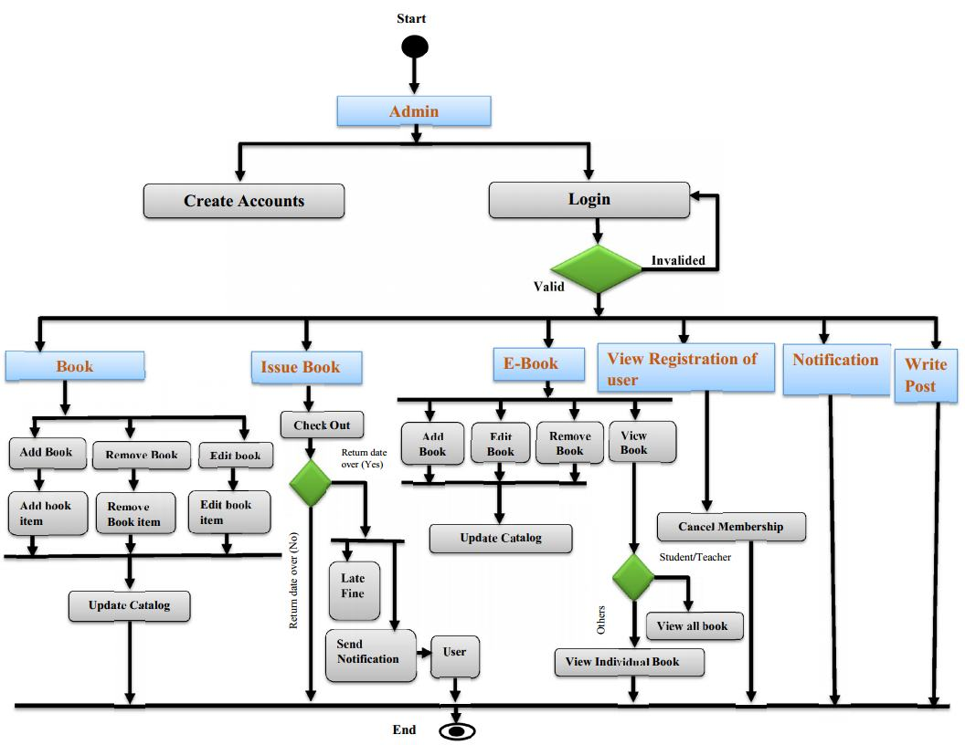

* **Diagram of The Teacher User Activity:**
* Teachers should be able to View Post, Search Book, Borrow Book, Return Book, and View books etc.
* Can Book Request according to the library policy.
* Teacher will get new notification for new book and return Book.
* Teacher will view all book and others paper without condition.
* Teacher cannot control the whole system.

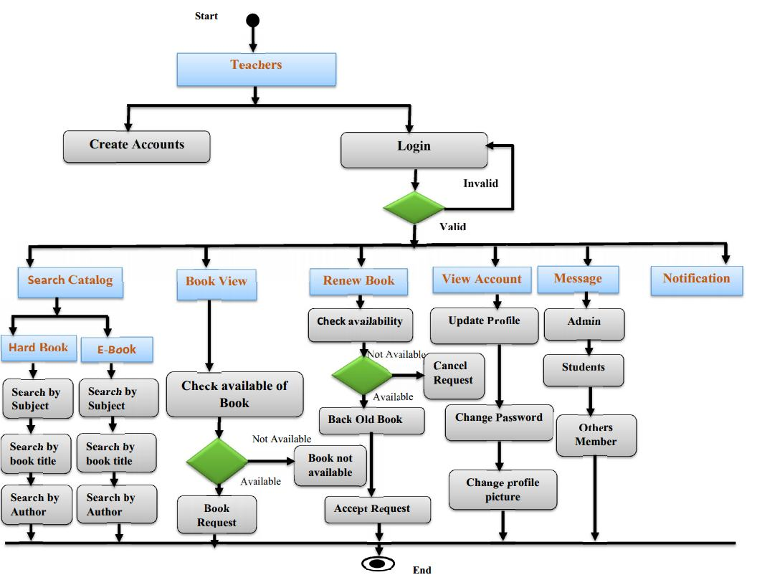

**Diagram of the Student User Activity:**

* Students should be able to View Post, Search Book, Borrow Book, Return Book, and View books.
* Can Book Request according to the library policy.
* Students will get new notification for new book and return Book.
* Students will view all book and others paper without condition.
* Students cannot control the whole system.
* Admin can communication via message only admin and teachers.

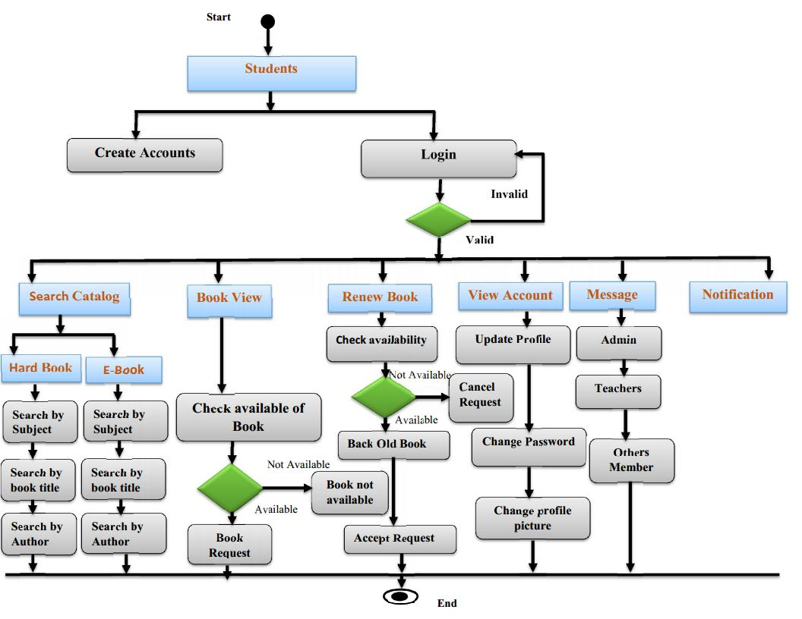

* **Diagram of the Others Members User Activity:**
* Other members should be able to View Book, View Post, Search E-Book, and Download E-Books.
* Can Book Request according to the library policy.
* Other members will get new notification for new E-Books.
* Other members will view Individual E-Books.
* Cannot control the whole system.
* Other members can communication via message only admin.

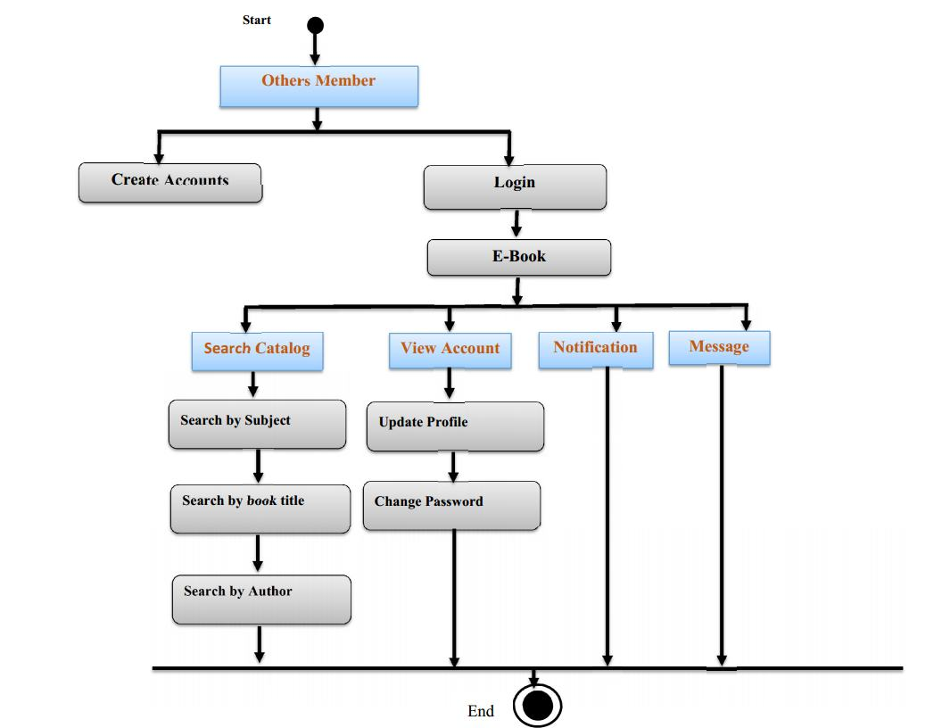

**Hardware Requirements:**

Only the recommended configuration (basic requirements of a computer (system) no other specific hardware is required to run the software**.**

**Software Requirements:**

1. Browser to load and view the web pages.
2. Operating System.
3. Tools

* Notepad++, PhpStorm, Atom, NeatBeans etc.
* Xammp Server.

**Requirements of Programming Language:**

1. HTML
2. CSS
3. JavaScript

* Jequery
* Ajax

1. PHP

**Future Scope**: This Application will be easily implemented under various situations we can add new features as and when we will require. Reusability is possible as and when require in this application. There is flexibility in the entire module.

* **Extensibility:** This software is extendable is ways that its original developers may not expect. The following principal enhances extensibility like hide data structure, avoid traversing multiple likes or methods, avoid case statements on object type and distinguish public and private operations.
* **Reusability:** Reusability is possible as and when require in this application. We can update it next version. Reusable software reduces design, coding and testing cost by amortizing effort simplifies understanding, which increases the likelihood that the code is correct. We follow up both types of reusability. Written code within a project and reuse of previously written code on new projects.
* **Understandability:** A method is understandable if someone other than the creator of the method can understand the code (as well as the creator after a time lapse). We use the method, which small and coherent helps to accomplish this
* **Cost-effectiveness:** Its cost is under the budget and make within given time period. It is desirable to aim for a system with a minimum cost subject to the condition that it must satisfy the entire requirement.

Scope of this document is to put down the requirements, clearly identifying the information needed by the user, the source of the information and output expected from the system.

**Conclusion:** The Library Management System Application keeps track of all the information about the books in the library, their cost, their complete details and total number of books available in the Library. The user will find it easy in this automated system rather than using the manual writing system. The system contains a database where all the information will be stored safely. The system is user-friendly and error free. The software will be able to handle all the necessary information.