Where do MongoDB Stand on Cap Theorem?

Overview
The scope of the article "What is CAP Theorem in MongoDB?" is to explain the concept of the CAP theorem and its implications for MongoDB. The CAP theorem, also known as Brewer's theorem, states that in a distributed system, it is impossible to simultaneously achieve consistency "C", availability "A", and partition tolerance "P". The article aims to provide an overview of the cap theorem mongodb and its relevance to MongoDB, a popular NoSQL database. It discusses how MongoDB's architecture and design choices align with the cap theorem mongodb, emphasizing its focus on partition tolerance and availability while allowing for eventual consistency. The article may also delve into the trade-offs and considerations involved in designing distributed systems using MongoDB, taking into account factors such as data replication, failover mechanisms, and consistency models.

What is the CAP Theorem?
The CAP Theorem in MongoDB, also known as Brewer's theorem, is a principle in distributed system theory that states that it is impossible for a distributed system to simultaneously guarantee three properties: consistency "C", availability "A", and partition tolerance "P".
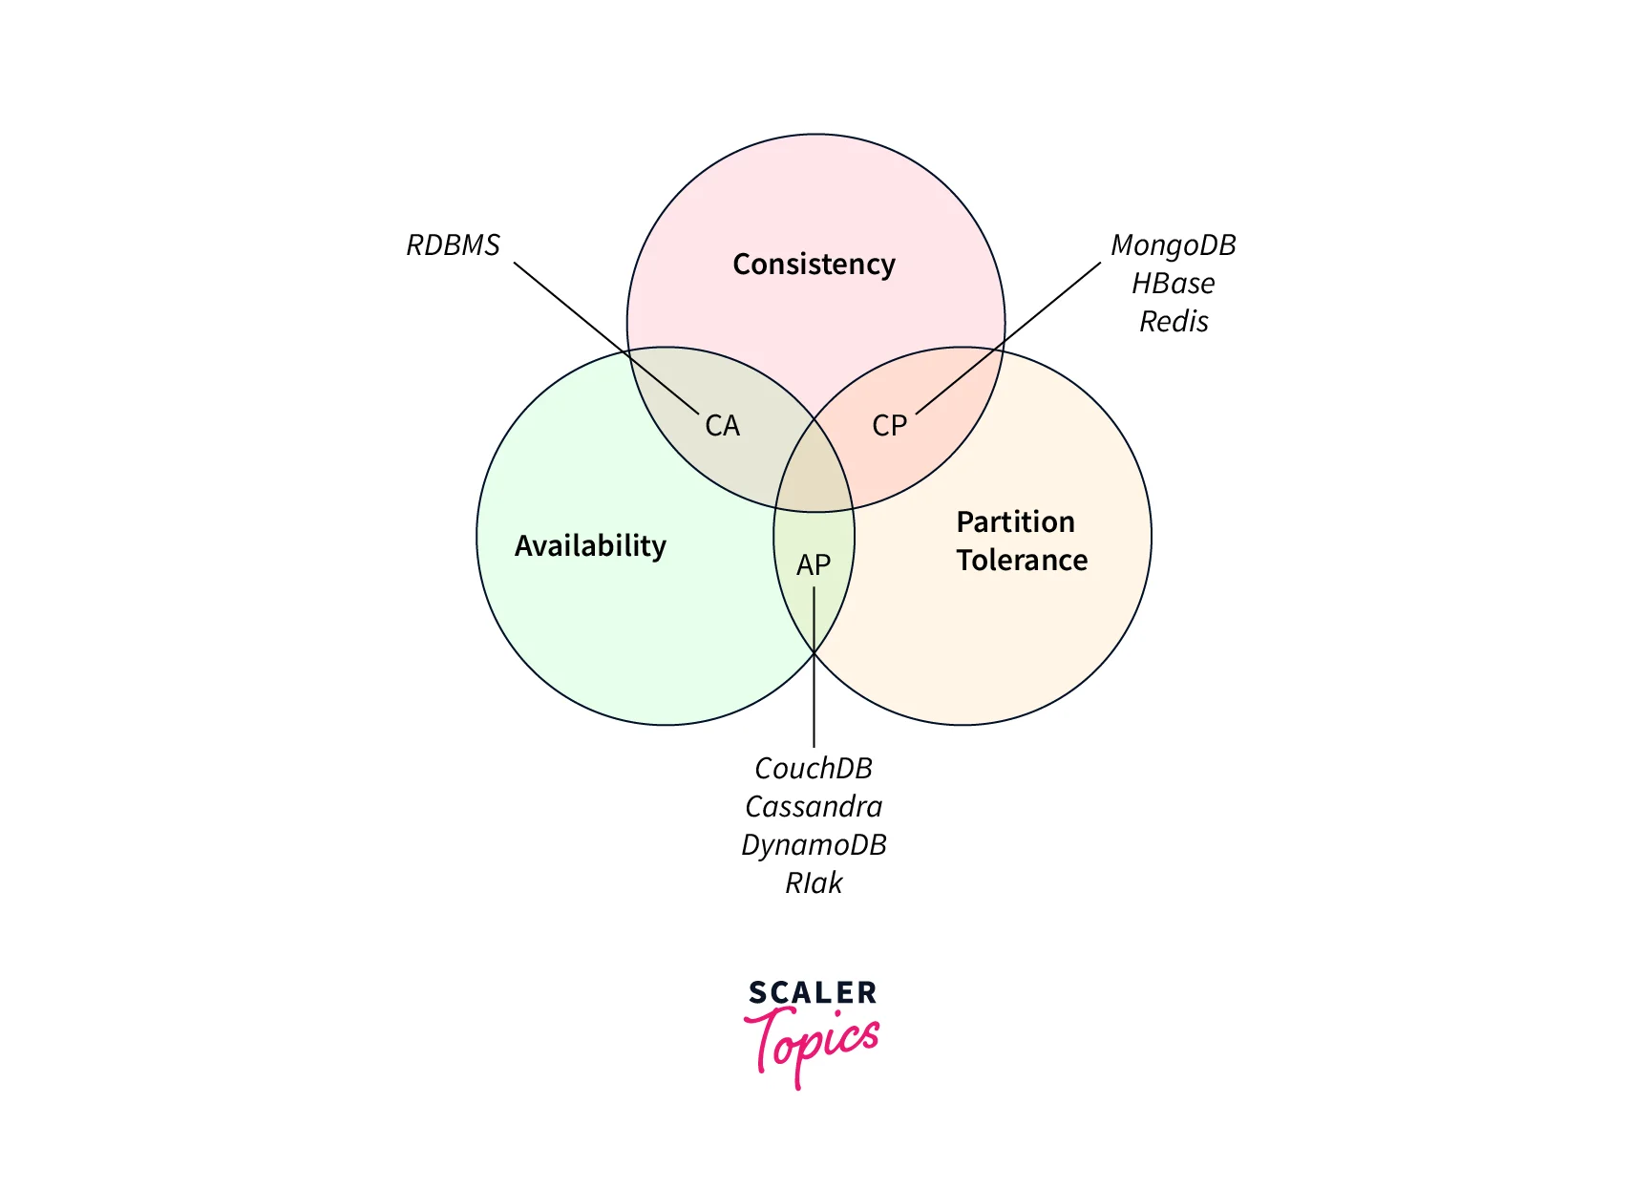

The “CAP” in the CAP Theorem
The "CAP" in the CAP Theorem MongoDB refers to the three properties that a distributed system cannot simultaneously guarantee: consistency "C", availability "A", and partition tolerance "P".
Consistency "C" means that all nodes in a distributed system have the same view of the data at the same time. Any read operation on the system should return the most recent write or an error. In other words, the data remains consistent across all nodes.
Availability "A" ensures that every request made to a distributed system receives a response, regardless of system failures or disruptions. The system remains operational and responsive to user requests, providing uninterrupted services.
Partition tolerance "P" refers to the system's ability to continue functioning and providing services even in the presence of network partitions or failures. Network partitions occur when communication between nodes is disrupted, leading to the formation of separate groups of nodes.
CAP Theorem MongoDB states that in the presence of a network partition "P", a distributed system must choose between consistency "C" and availability "A". It is impossible to have both perfect consistency and availability during a partition. The system must prioritize one over the other.
CAP Theorem MongoDB highlights the inherent trade-offs and challenges in designing distributed systems. Architects and developers need to consider the specific requirements and constraints of their systems to determine whether to prioritize consistency (CP systems) or availability (AP systems) in the event of a partition.
It's important to note that the CAP theorem assumes that network partitions are a reality in distributed systems. However, in the absence of a partition, a distributed system can achieve both consistency and availability (CA).

How Distributed Systems Breaks Availability or Consistency?
In a distributed system, the trade-off between availability and consistency arises when network partitions occur. Let's explore how distributed systems can break availability or consistency during such scenarios:
1. Availability: In a distributed system, if a component or node fails, it can impact the availability of the entire system. For example, consider a web application running on multiple servers. If one server goes down, users relying on that server will experience service disruption until the failed server is restored or replaced.
2. Consistency: Maintaining consistency across distributed nodes is challenging due to factors like network delays and node failures. For instance, in a distributed database system, ensuring immediate consistency across all nodes can be difficult. If a write operation is performed on one node and other nodes are momentarily out of sync, inconsistencies may occur, leading to different versions of data being observed by different users.
Both availability and consistency are critical aspects of distributed systems, and trade-offs often need to be made between them to meet specific requirements.

NoSQL Database Types and CAP Theorem
NoSQL databases are a category of databases that provide flexible and scalable storage solutions for handling large volumes of unstructured or semi-structured data. Various types of NoSQL databases exist, and their design choices often align with different aspects of the CAP Theorem MongoDB. Let's explore how different NoSQL database types relate to the CAP Theorem MongoDB:
- Key-Value Stores: Key-value stores, such as Redis and Riak, prioritize high availability"A" and partition tolerance "P" over strong consistency "C". They offer fast and scalable storage by maintaining a simple key-value data model. Key-value stores typically provide eventual consistency, meaning that updates are propagated eventually across the system, allowing for high availability even in the face of network partitions.
- Document Databases: Document databases, like MongoDB and Couchbase, strike a balance between consistency "C" and availability "A"*. They typically prioritize partition tolerance "P" and offer flexible schemas, allowing for dynamic and nested data structures. Document databases provide strong consistency within a single document but may have eventual consistency when dealing with relationships between documents. They allow for high availability during partitions and provide mechanisms for resolving eventual consistency.
- Column-Family Stores: Column-family stores, such as Cassandra and HBase, emphasize high availability "A" and partition tolerance "P" while providing eventual consistency "C". They organize data into column families and provide excellent scalability. Column-family stores allow for decentralized data storage across different nodes, ensuring availability even during network partitions. However, achieving strong consistency may require additional effort and coordination.
- Graph Databases: Graph databases like Neo4j and Amazon Neptune focus on providing strong consistency "C" and transactional integrity. They prioritize data relationships and offer powerful graph-based querying CAPabilities. Graph databases may sacrifice some availability "A" during partitions to maintain a consistent view of the graph data.

It's important to note that these categorizations are generalizations, and specific implementations within each type of NoSQL database may have different characteristics. Additionally, advancements in distributed systems and database technologies continue to blur the boundaries between these types, providing hybrid solutions that aim to balance the CAP theorem trade-offs more effectively.
When selecting a NoSQL database, it is crucial to consider the specific requirements of your application and the desired trade-offs between consistency, availability, and partition tolerance, keeping the CAP Theorem MongoDB principles in mind.

The CAP Theorem MongoDB
In the context of the CAP Theorem MongoDB, MongoDB is often classified as an AP (Availability/Partition tolerance) database. MongoDB prioritizes availability and partition tolerance over strong consistency.
MongoDB achieves high availability by using a distributed architecturethat allows for replica sets. A replica set consists of multiple MongoDB instances, where one acts as the primary node handling write operations and the others serve as secondary nodes replicating the data from the primary. In the event of a primary node failure or network partition, one of the secondary nodes can be elected as the new primary, ensuring continuous availability.
Regarding partition tolerance, MongoDB is designed to handle network partitions and maintain system operation even when nodes are disconnected. The data replication mechanism allows for eventual consistency across the replica set. Updates made to the primary node are asynchronously replicated to the secondary nodes, and there may be a delay before all nodes have the same view of the data.
However, it's important to note that MongoDB provides configurable consistency levels. While it prioritizes availability and partition tolerance by default, it offers options to enforce stronger consistency guarantees based on application requirements. MongoDB provides read and write concerns that allow developers to specify the level of consistency they need for specific operations.

MongoDB Vs Cassandra in CAP Theorem
Comparing MongoDB and Cassandra in the context of the CAP theorem, they exhibit different characteristics and trade-offs. The article "MongoDB vs Cassandra: A Comparative Analysis" provides an overview of their differences in relation to the CAP theorem. Here's a summary of the comparison:
- MongoDB: MongoDB is often classified as an AP (Availability/Partition tolerance) database. It prioritizes high availability and partition tolerance, making it suitable for use cases where responsiveness and scalability are crucial. MongoDB uses a replica set architecture, with one primary node handling writes and multiple secondary nodes replicating data. During network partitions, MongoDB allows for eventual consistency, meaning there may be a delay before all nodes have the same view of the data.
- Cassandra: Cassandra, on the other hand, is typically considered a CP (Consistency/Partition tolerance) database. It emphasizes strong consistency and transactional integrity, making it suitable for use cases that require strict consistency guarantees. Cassandra's distributed architecture ensures strong consistency even during network partitions. It achieves this through a peer-to-peer model, where all nodes participate in read and write operations, and hinted handoff allows writes to be temporarily stored until partitions are resolved.

FAQs
Q. What is the CAP theorem in the context of MongoDB?
A. The CAP Theorem MongoDB, also known as Brewer's theorem, states that it is impossible for a distributed system to simultaneously provide consistency, availability, and partition tolerance. In the context of MongoDB, the CAP theorem implies that in the event of a network partition "P", you have to make a trade-off between consistency "C" and availability "A".
Q. How does MongoDB handle the CAP Theorem MongoDB?
A. MongoDB is designed to provide high availability and partition tolerance. In situations where there is a network partition, MongoDB allows you to configure the system to prioritize either consistency or availability. MongoDB's default configuration favors availability over strict consistency. However, it does provide strong consistency guarantees within a single replica set.
Q. What is the impact of the CAP theorem on MongoDB's scalability?
A. The CAP Theorem MongoDB does have an impact on the scalability of MongoDB. Mongodb CAP theorem architecture focuses on horizontal scalability through sharding, where data is partitioned across multiple nodes or shards. When a network partition occurs, MongoDB's sharding strategy allows you to choose between maintaining consistency or ensuring availability, depending on your requirements.
Q. How does MongoDB handle eventual consistency?
A. MongoDB is designed to provide eventual consistency by default. In a distributed system like MongoDB, when updates are made to different replicas concurrently, there might be a slight delay before all replicas are synchronized. However, MongoDB ensures that the data will eventually become consistent across all replicas.
Q. Can MongoDB support strict consistency?
A. MongoDB's default configuration favors availability over strict consistency. However, MongoDB does provide mechanisms to enforce strict consistency within a single replica set. By configuring write concerns and read preferences, you can ensure that data consistency is maintained within a replica set.

Conclusion
- The Mongodb CAP theorem, also known as Brewer's theorem, states that it is impossible for a distributed data system to simultaneously provide consistency, availability, and partition tolerance. MongoDB, being a distributed database, is subject to the Mongodb CAP theorem.
- In MongoDB, the emphasis is on providing high availability and partition tolerance, which means that in the event of a network partition, the database will continue to operate and serve read and write requests. MongoDB achieves this through features like replica sets and automatic failover.
- However, MongoDB sacrifices strict consistency in favor of availability and partition tolerance. This means that during a network partition, different replicas may have slightly divergent data until the partition is resolved and consistency is restored.
- MongoDB allows developers to configure their preferred level of consistency based on their application requirements. It provides different read and write concerns, such as "majority" and "linearizable", to balance consistency and availability.
- The Mongodb CAP theorem highlights the trade-offs involved in designing distributed systems, and MongoDB's design prioritizes availability and partition tolerance while allowing flexibility in choosing the desired level of consistency.

В контексте теоремы CAP MongoDB часто классифицируется как база данных AP (доступность/разделение). MongoDB отдает приоритет доступности и устойчивости разделов над строгой согласованностью.
MongoDB обеспечивает высокую доступность за счет использования _распределенной архитектуры_, которая позволяет использовать наборы реплик. Набор реплик состоит из нескольких экземпляров MongoDB, один из которых выступает в качестве основного узла, обрабатывающего операции записи, а другие служат второстепенными узлами, реплицирующими данные из основного. В случае сбоя основного узла или разделения сети один из вторичных узлов может быть выбран в качестве нового основного, обеспечивая непрерывную доступность.
Что касается толерантности к разделению, MongoDB предназначен для обработки сетевых разделов и поддержания работы системы даже при отключении узлов. Механизм репликации данных обеспечивает конечную согласованность всего набора реплик. Обновления, внесенные в основной узел, асинхронно реплицируются на вторичные узлы, и может возникнуть задержка, прежде чем все узлы получат одинаковое представление данных.
Однако важно отметить, что _MongoDB предоставляет настраиваемые уровни согласованности_. Хотя по умолчанию он отдает приоритет доступности и устойчивости разделов, он предлагает возможности для обеспечения более строгих гарантий согласованности на основе требований приложения. MongoDB предоставляет возможности чтения и записи, которые позволяют разработчикам указывать уровень согласованности, необходимый им для конкретных операций.

