**Exp 6** selinum

pip install selenium

from selenium import webdriver

from selenium import webdriver

from selenium.webdriver.common.by import By

from selenium.webdriver.common.keys import Keys

import time

driver= webdriver.Chrome()

driver.get("https://www.investopedia.com/")

driver.get("https://www.Google.com/")

driver.close()

**exp 8**

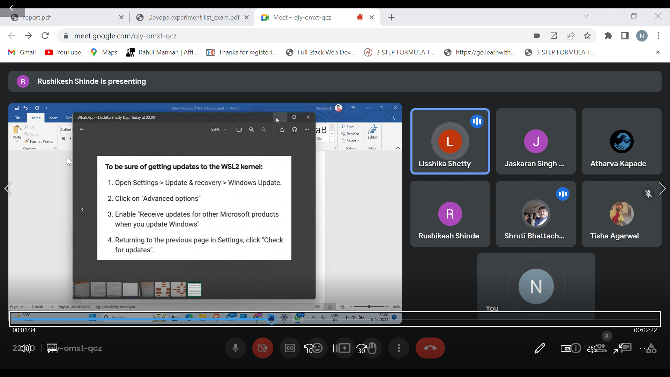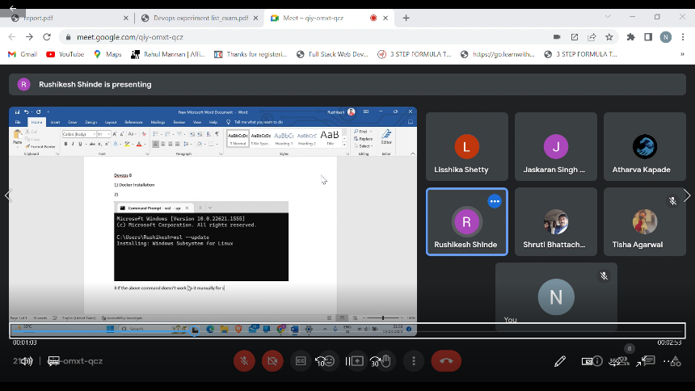

Signin into docker file

In command prompt

docker login

docker run -it -d ubuntu

docker pull ubuntu

docker images

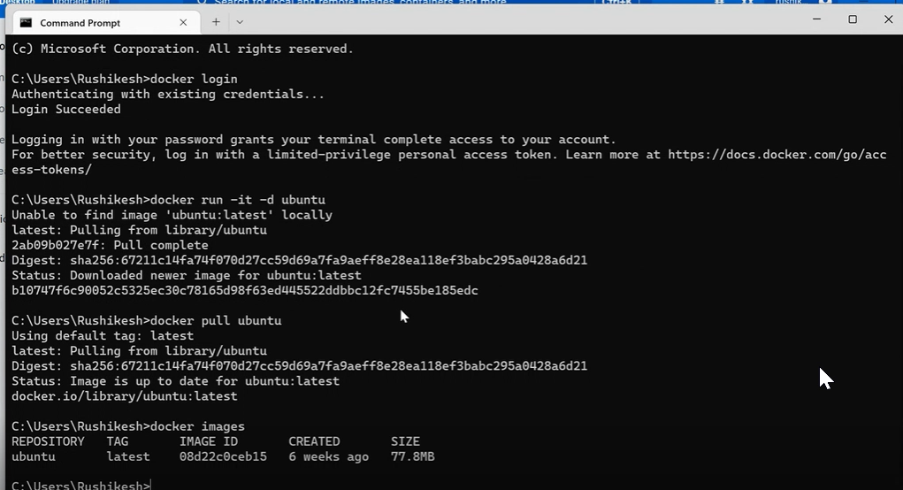

docker tag (image id0000) nirmalnallan/ubuntu

docker images

docker push nirmalnallan/ubuntu:latest

docker ps

docker stop container id

**exp 7**

make a folder in docker file in program files name it as php. Save these two files there

file type all files

1. index.php

html>

<?php echo"Hello world from php container "?>

</html>

1. “Dockerfile”

FROM php

COPY ./index.php ./

EXPOSE 3000

CMD ["php", "-S", "0.0.0.0:3000"]

Open php file in vs code all files

Now in vs code open docker code file new terminal

docker build . -t nirmalnallan/php

docker run --name=php -p=3000:3000 nirmalnallan /php

**Exp 2**

Go to Jenkins free style project.

Addition progeam and save as addition save to bin

Go to Jenkins

Save the bin file name in use custom workspace

Select none, build executive windows batch command

javac Addition.java

java Addition

apply save 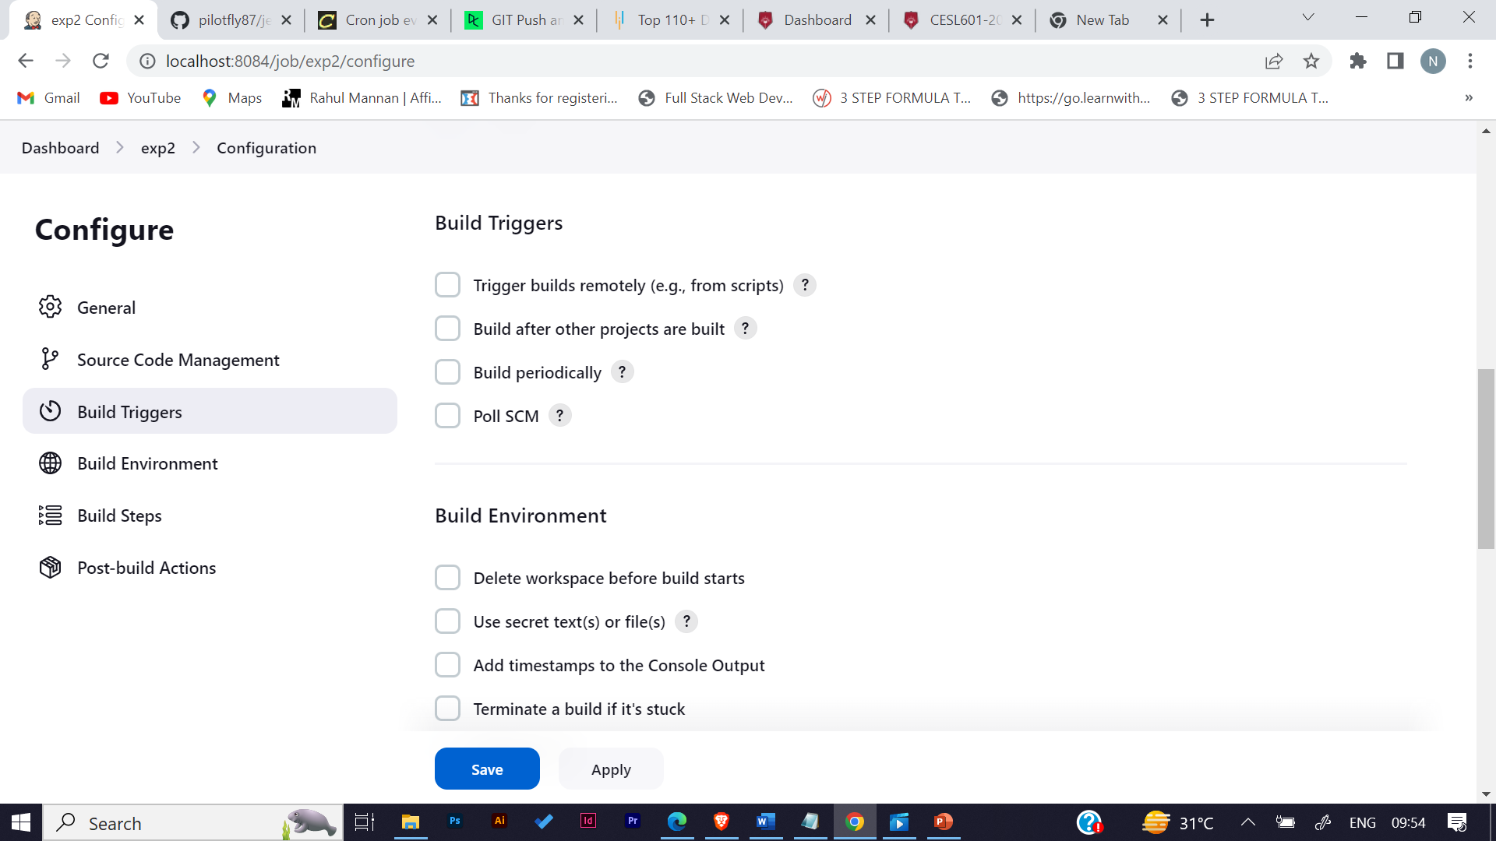 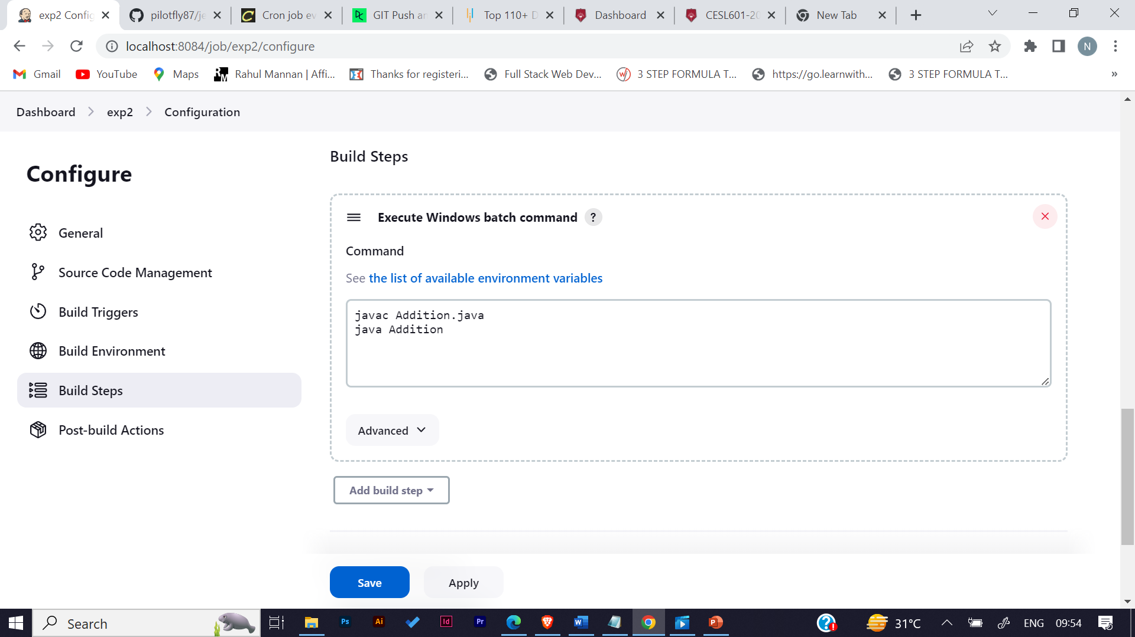 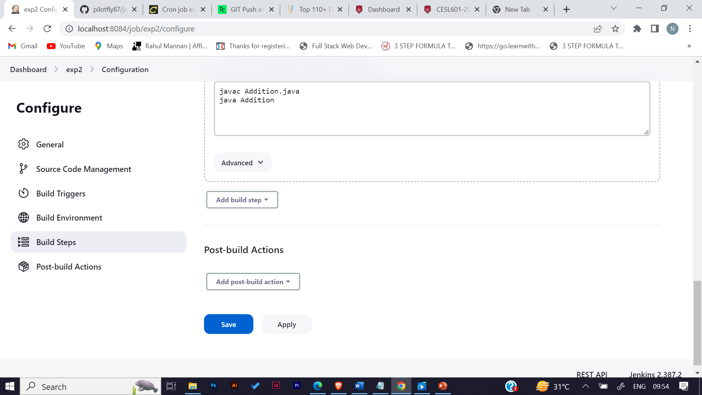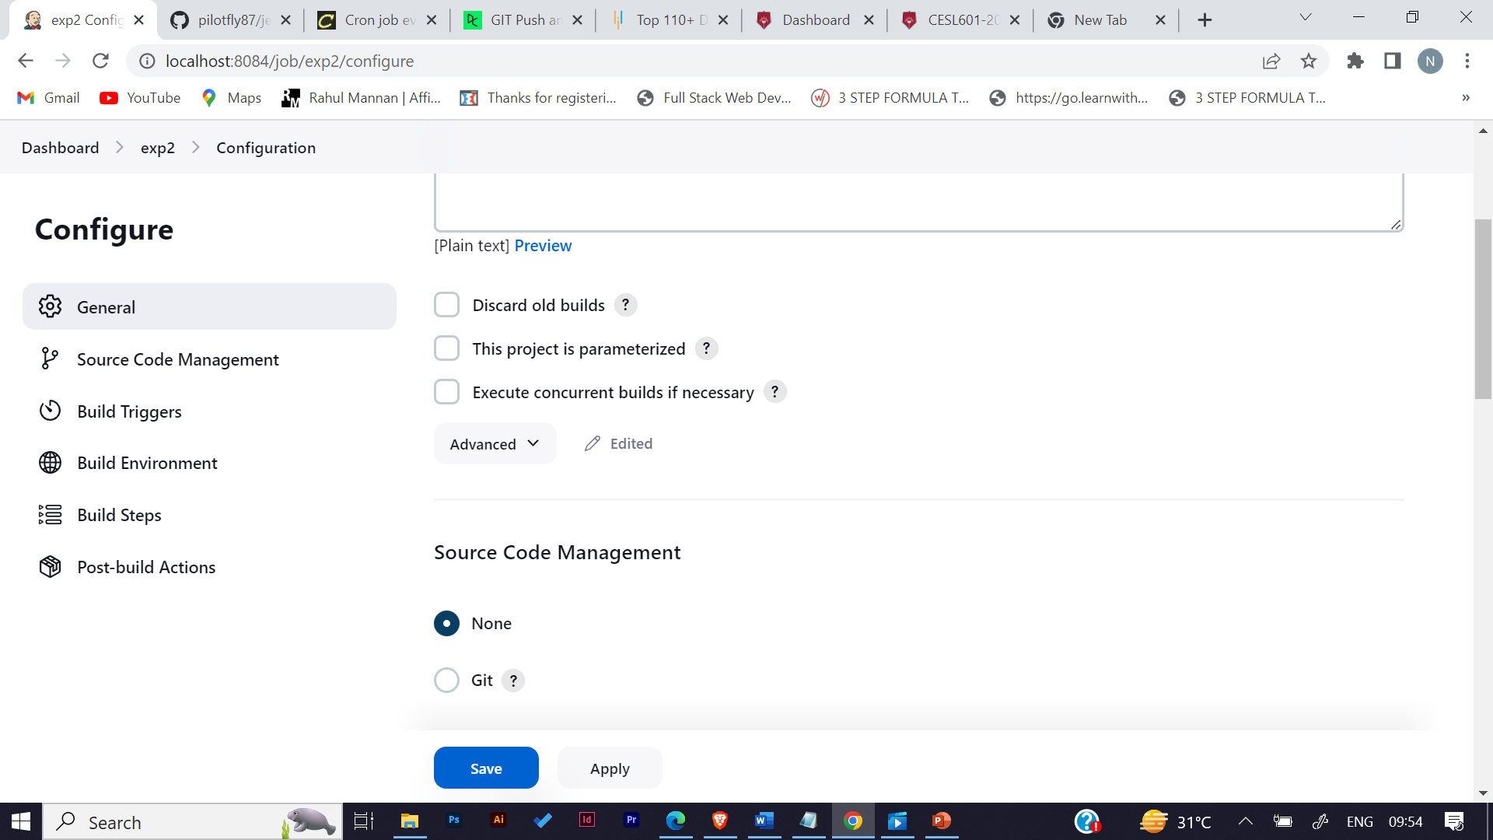

**exp3**

free style project

