HW1
Pete Mills
Sept 7, 2023

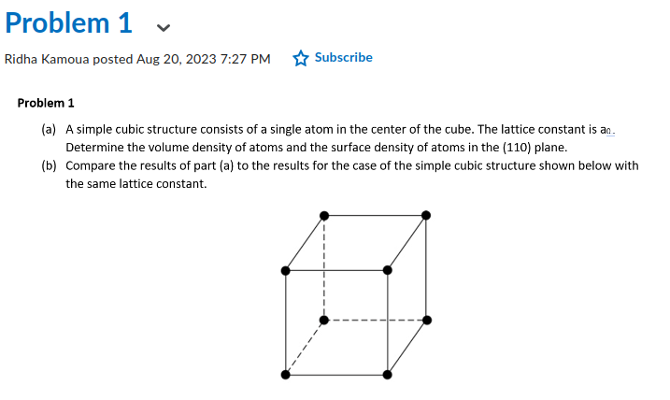
a) ρ

b)

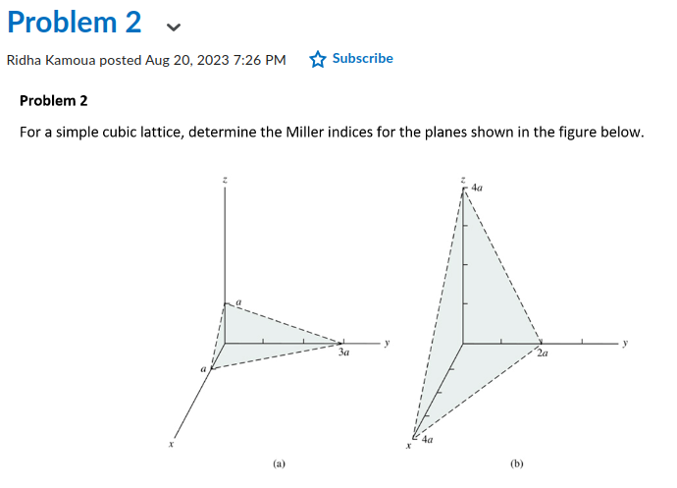

a) p=1, q=3, s=1 -> (1/1, 1/3, 1/1) -> (3/3, 1/3, 3/3) -> (3, 1, 3)

b) p=4, q=2, s=4 -> (1/4, 1/2, 1/4) -> (1/4, 2/4, 1/4) -> (1, 2, 1)

