HW1

Pete Mills

Sept 7, 2023

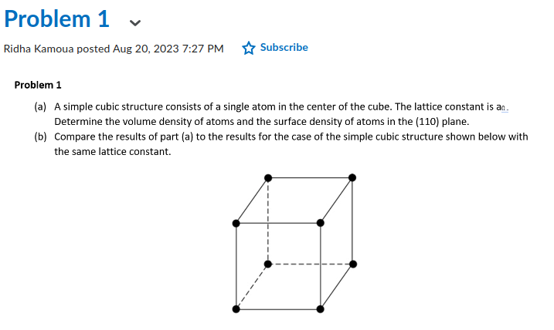

a) ρ_bcc = 2 atoms / a0^3, σ_bcc = 5atoms / a0^2

b) ρ_sc = 1 atoms / a0^3, σ_sc = 0.5atoms / a0^2,

Therefore,

BCC structure has 2x the volume density as SC structure.

BCC structure has 10x the surface density of SC structure.

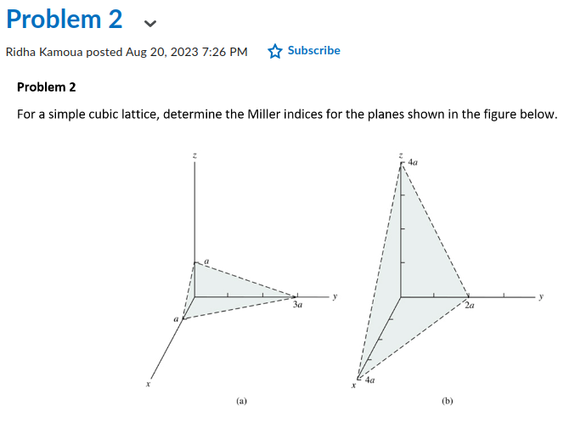

a) p=1, q=3, s=1 -> (1/1, 1/3, 1/1) -> (3/3, 1/3, 3/3) -> (3, 1, 3)

b) p=4, q=2, s=4 -> (1/4, 1/2, 1/4) -> (1/4, 2/4, 1/4) -> (1, 2, 1)

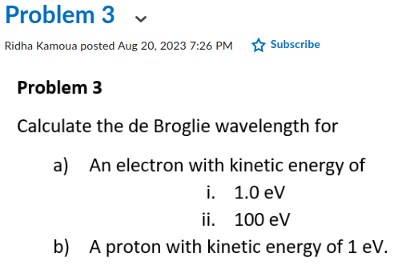

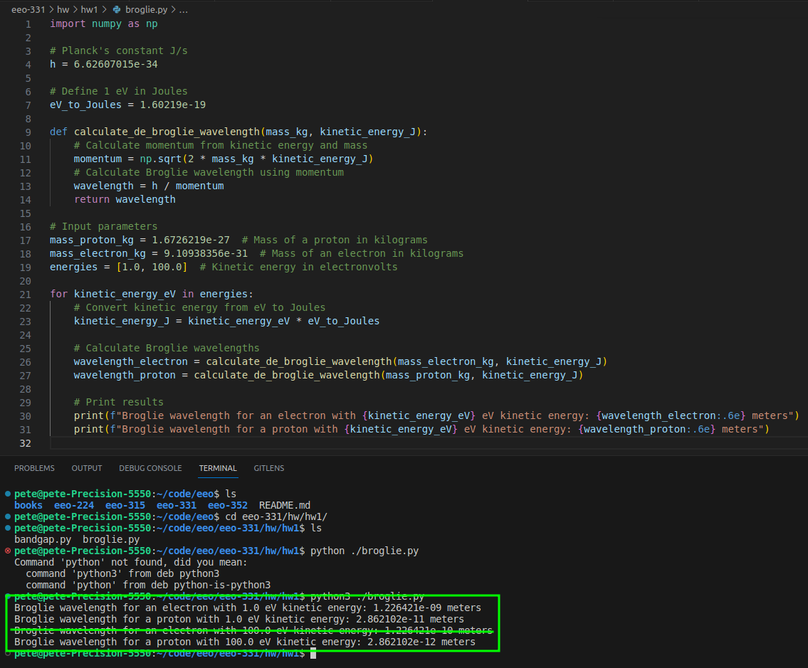

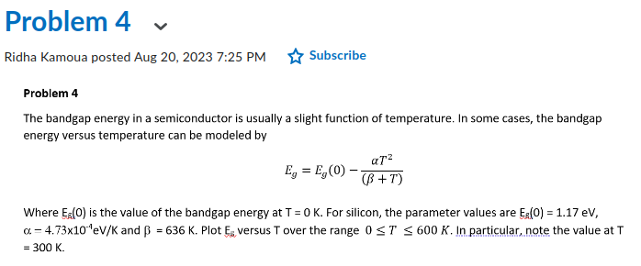

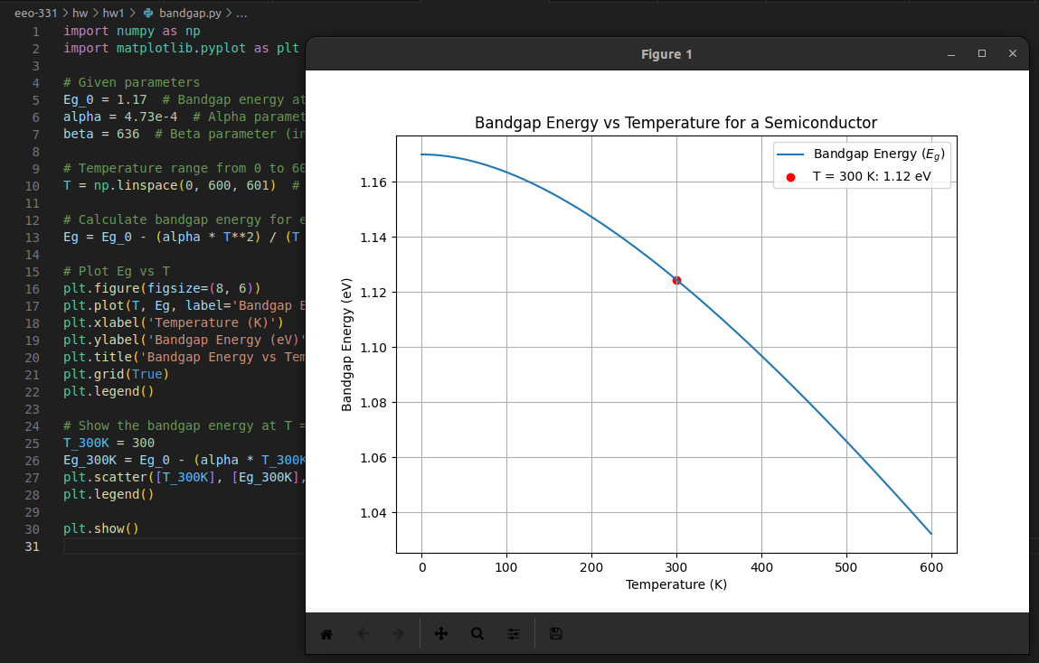

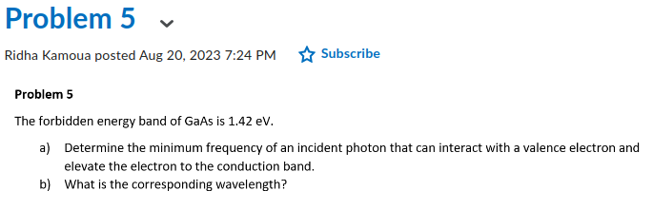

E=hf

E=1.42eV×1.60217663×10−19J/eV

f_min = E/h

f_min = E/6.62607015×10−34

f_min = 2.854×10^14Hz is the minimum frequency of an incident photon.

Lambda = c/f_min where c = 3e^8m/s

Lambda = 1.05e^-6 m is the corresponding wavelength.