Mitchell Wright
Data Mining
Project 9: KDD cup 2011 Challenge

Introduction
In this project, I attempted to build a predictive model for the KDD cup music-ratings data. Unfortunately, do to a mixture of extremely little time and maddening problems, I was not very successful in this endeavor. In particular, my efforts to put the data into a SQLite database, while it worked in the end, it was slow enough that the database was not complete before the project deadline, which makes me very disappointed.
Without the database, I believe that it is not possible to build a predictive model at this time. I will use this report to describe my thought process and illustrate what I would have done.

Exploring the Data
The KDD cup data consists of multiple relations of data, with the tuples related to each other via foreign keys in differing tables. I wanted to get an initial idea of what the data represented, and figured that the easiest place to start was to visually inspect the data. The KDD cup website (particularly this page http://kddcup.yahoo.com/datasets.php) had the overall schema of the data freely available.
The available data consists of a set of ratings that link a user, that user’s opinion, and a musical item (track, album, artist, and genre) together. A user could have rated any of these things separately, allowing a finer distinction among different musical items. For example, a user could rate an album highly even though he or she only liked one or two of the songs on it, and vice versa.
The musical items themselves are organized in a hierarchical structure, with tracks belonging to albums, artists, and genres. Albums contain tracks and belong to a genre and artist. Artists can belong to one or more genres. The genres are the ‘highest’ level of the hierarchy because they are the most abstract and overarching musical entities in the data.
Beyond this initial sense of the data’s structure, looking at walls of foreign keys was not very interesting. The next step was to transfer the data to a format that would be easier to view and query.

Transferring to SQLite
I chose to use SQLite for this project because I have had experience with it during Database Management, and was more familiar with it than any other databases. By using Ruby, SQLite, and ActiveRecord, I hoped to make working with the data easier. I was not very familiar with ActiveRecord at the time of this project, so I had to spend some time getting up to speed on how ActiveRecord works.
While using ActiveRecord, I found that I could not, for the life of me, get the 'id' value into the SQLite database. After spending a few hours trying to figure out why, I gave up and decided to do something else. I implemented several fixes I found on the internet, but nothing worked. Several days later, one of the fixes seemed to automagically work where it had not before – I am not sure why, but I suspect it was something simple like I was editing one file and executing a copy of it that hadn't been changed.
I got the database code to work Friday evening, and as I am writing, the data is slowly being transferred into my SQLite database. The speed is slow enough that I feel that it will not finish before th e

Summary Statistics
Without the data in a relational database, I decided to go ahead and use WEKA to generate some summary statistics of the user ratings. To do so, I added column headings to the sample data for track 1, 'trainIdx1.firstLines.txt'. A simple run of WEKA on the raw data led to the following statistics:
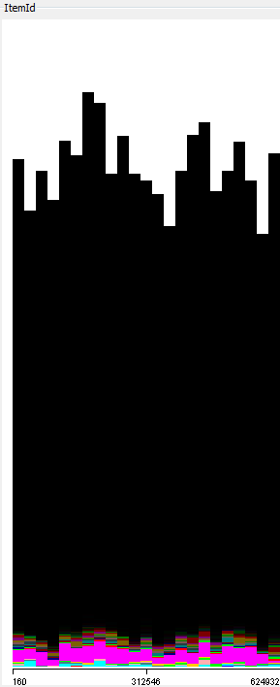
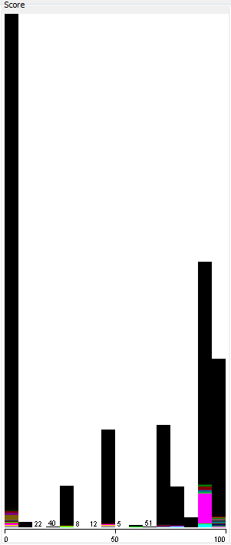

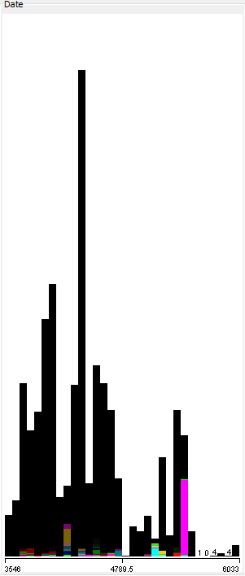

With the following statistics in addition reported by WEKA:
Score
-Minimum: 0
-Maximum: 100
-Mean: 50.014
-StdDev: 40.146
Date
-Mean: 4389.371
-StdDev: 498.242

There were also statistics generated for the ItemId and Time attributes, but neither of these were meaningful. Both of these are nominal attributes in function, and even though ItemId was represented as an integer and WEKA believed it was numeric, the statistics it generated were essentially meaningless. Time was also meaningless in this step – WEKA recognized it as an nominal attribute and performed only a count of each time value. This could be potentially interesting later, but not at this moment.
I found two interesting things about the data by this analysis. The first was that people, on average, tended to rate music items either very highly (70 or greater), or zero. Only a small number of ratings were in the 40-60 score range, and even though the mean score was 50.014, the standard deviation was very, very large.
The second interesting thing was that the times that these ratings were made seem to peak around the mean of 4389.371 days past the undisclosed date and tapered off later. I don't know if this is due to people rating less during those days (perhaps after some action by Yahoo!), or if this is simply a coincidence caused by the fact that the data was not collected with the same population or with the same vigor as it previously had.

Conclusion
Without a SQLite database, I could not think of a way to answer questions like “How highly are artists rated given their albums are rated above 70?”. I felt that answering this question illustrates the heart and soul of the project, and without the ability, I felt lost. In addition, I felt like I had thought my way into a corner and did not know how to proceed.
If I had a database, the next steps I would have taken in this project would be to:

- Continue exploring the data, answering questions like “Are albums usually rated higher or lower than individual tracks?” and “How does an artist's rating effect his or her album and track ratings?”
I don't think clustering analysis would help much on this dataset, but I would have run a few clustering algorithms to try and find hidden similarities in objects during the exploration phase. These clusterings may have helped me to find high-level differences in scoring – perhaps the 'Pop' genre would receive a higher score than 'Bluegrass' consistently in the data.
The goal of the KDD cup's challenge is to design a model to predict the score that a music item will get. The term 'predictive' makes me think that a classification model of some kind is needed. Since the outputs are numerical (scores), I feel like an ANN would have been an excellent technique to try.
I am not sure what would make a music rating an anomaly beyond gross data measurement and collection error, for example, a rating of 1000 or -54. Anomaly detection was not high on my list of tools to try on this project.
I would have also tried association analysis on this dataset by discretizing and binarizing the 'score' attribute, then seeking some associations between objects in the dataset.

