Mitchell Wright
Data Mining
Project 6

Data Exploration

I downloaded the CSV version of the winners and losers list and opened it in Weka. My main goals for the exploration of the data were to find out what percentage of the names in the data were classified as winners and what percentage were losers. In addition, I also wanted to look at the names themselves to see if I could pick any patterns out without using a data mining strategy.

By using Weka's preprocessing tab and selecting the second attribute in the data, I could make a few conclusions. The following screenshot indicates that, of the 297 instances in the CSV, 212 of them were winners and 84 were losers. I took the third label as being a typo, and assumed that it was a winner.
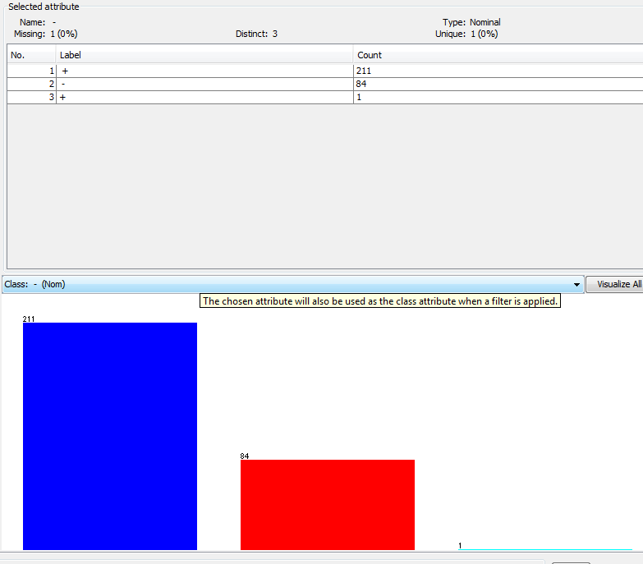

A little rudimentary arithmetic shows that about 71.4 percent of the instances were winners, with the remaining 28.6 percent being losers.

At this point, I looked at the list of names in order to find any kind of pattern I might be able to pick out. I opened the CSV in a spreadsheet program and looked the data over.
Inspecting the data as it was yielded nothing, so I sorted by, first, whether the names were winners or losers. By this, I hoped to see something that the losers had in common that was not shared with the winners. I tried a few things, including:
First name and last name first letters
Number of letters
Number of names (for example, 'Mark Staley' vs. 'Andrew Y. Ng')
Number of vowels in the name

I was able to find instances in both classes with each feature, so sorting in this manner did not reveal any interesting information.

Next, I sorted the names in alphabetical order, and noticed that weather or not a name is a loser or a winner seems to have something to do with the first name. Some names, for example, 'David' and 'Daniel', are all winners despite having a wide variety of last names. Likewise, the first names 'Steve' , 'Timothy', and 'Steven' are losers, despite having a similar variety of last names.

While interesting, I could not think of any way to go about proving or finding any specific patterns this way in a reasonable amount of time. My exploration gave me something interesting to consider – that similar first names tended to be losers together.

Data Mining

I did not really know where to begin with using Weka or Knime to try and discover patterns. Since we had covered clustering and classification in class, I assumed I would have to use one of these methods. Classification seemed like the most promising start, so I attempted to run a SimpleCart decision tree on the data. I got the following results:

=== Classifier model (full training set) ===

CART Decision Tree
: Neela Khan(1.0/296.0)

Number of Leaf Nodes: 1

Size of the Tree: 1

Time taken to build model: 0.05seconds

=== Evaluation on training set ===
=== Summary ===

Correctly Classified Instances 1 0.3367 %
Incorrectly Classified Instances 296 99.6633 %
Kappa statistic 0
Mean absolute error 0.0067
Root mean squared error 0.0579
Relative absolute error 100 %
Root relative squared error 100 %
Total Number of Instances 297

This result was bad enough that I wondered if I had set up the decision tree properly. The most disturbing thing was the fact that the tree was only one node – this is an answer that cannot possibly be correct. Switching off pruning resulted in a decision tree of 5 nodes, but no improvement in prediction. The algorithm seemed to simply classify everything the same.

At this point, I began running numerous classification and clustering algorithms on the names, including NBTree, J48, RandomTree, DBScan with varying epsilon, heirarchical and K-means clustering. None of these techniques seemed to return any useful data.

I then experimented around with Knime before discovering that I was incorrectly using the name as the class. While I corrected this, I also noticed that using Knime's decision tree learner and predictor classified every name as being a winner, regardless of what I did. I found that I made the initial mistake of using the name where I should have used the winner/loser symbol because Weka's SimpleCart did not allow me to use the class where I needed to.

I began re-running the algorithms I had run before in Weka, and, to my distress, also found that the algorithm was happy with classifying all the names as winners.

=== Run information ===

Scheme:weka.classifiers.trees.J48 -C 0.25 -M 2
Relation: winners_losers
Instances:297
Attributes:2
Ed Pednault
-
Test mode:split 66.0% train, remainder test

=== Classifier model (full training set) ===

J48 pruned tree
------------------
: + (296.0/85.0)

Number of Leaves : 1

Size of the tree : 1

Time taken to build model: 0seconds

=== Evaluation on test split ===
=== Summary ===

Correctly Classified Instances 70 70 %
Incorrectly Classified Instances 30 30 %
Kappa statistic 0
Mean absolute error 0.2759
Root mean squared error 0.3746
Relative absolute error 99.087 %
Root relative squared error 100.0189 %
Total Number of Instances 100
Ignored Class Unknown Instances 1

A re-run of all algorithms I had used before were not successful in anyway – all of them were either useless, or simple classified each instance as a winner and yielded no additional information.

I could find no useful information from Weka or Knime.

What now?

Since I wasn't able to find a pattern using Weka or Knime, I decided to go back to looking at the data. After another close look, I found that the second letter of all the first names in the winner list were vowels. Likewise, the first names of the losers had for the second letters of their first names either consonants, or a period (as in “R. Andrew McCallum”).
A closer look at the list indicates that there were some exceptions to the rule, one being that 'Dwight Schrute' was a winner despite having a consonant second letter in the first name.

In the absence of Weka or Knime, I wrote a small ruby script which I included in this project's repository. The script simply reads each data object in the CSV, then looks at the second letter of the first name. If that letter is one of 'a', 'e', 'i', 'o', or 'u', the script assigns that name to be a winner. Otherwise, the name is considered a loser.
After this assignment is done, the script evaluates its performance, which is really quite stunning:
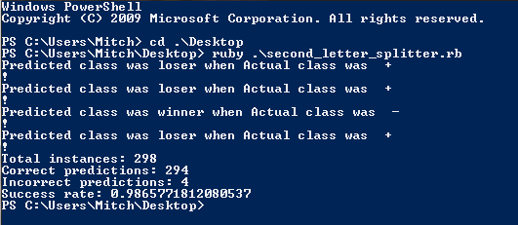

The second letter of the first name being a vowel is extremely likely to be the attribute that divides winners from losers.

Back to Knime

I also added functionality to the script to create a new CSV file, attaching the word 'winner' to those instances that it predicted to be a winner and 'loser' to the losers. I did this so I could use Weka or Knime to verify my findings.
Weka did not want to parse my CSV, but Knime did so, and I ran the following setup:
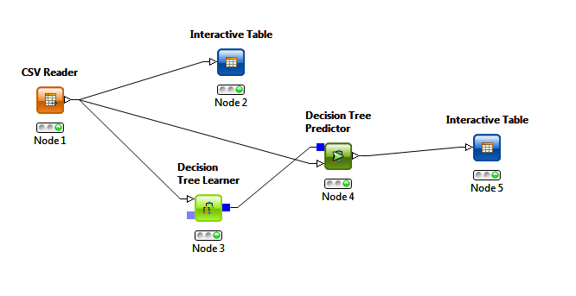
I wrote this output as another CSV, named “winners_losers_knime_out.csv”, which is included in the repository. I looked it over manually for a few cases and decided that I had found the pattern. I did not think it was necessary to look at the Knime output in more rigorous detail because I had already done so in the ruby script. A sample of the data from Knime is on the next page.

Conclusions and Lessons Learned

Through the use of Knime and my ruby script, I believe that the differentiation between winners and losers in the list is the second letter of each person's first name. If this letter is a vowel, then the person is a winner – otherwise, he or she is a loser. This criteria was able to correctly guess if someone is a winner or loser with a 98.66 percent success rate.
During the course of the experiment, I found that I was not familiar enough with Weka or Knime to reach this conclusion using those tools only. I ended up finding the pattern myself, and used a ruby script and a Knime setup to verify. I feel that this was not the intended purpose of the project, but I feel confident in my result nevertheless. The Knime setup I ran to verify indicated that Knime's decision-tree learner was able to use my 'second letter' criteria as well.
An important lesson I learned about Data Mining is that I was only able to discover the pattern by becoming more familiar with the data. Exploration helped me to notice a pattern, but the use of classifiers and clustering methods on the initial data did not. Classification did help, however, once I had a direction and a goal to try and satisfy.

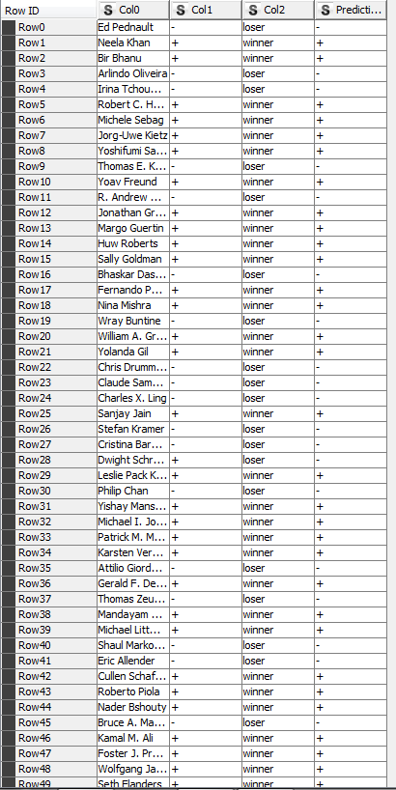
Knime output. Notice that the last column, 'Prediction', matches the second column, which is the instance's actual class, for all instances except row 28.

