Evolution of Rayleigh-Taylor instability under the influence of reflected waves

V.V. Krivets, E.I. Chebotareva, S.N. Titov, A.N. Aleshin

Krzhizhanovsky Power Engineering Institute, Moscow

At an accelerated motion of two fluids interface the conditions of Richnmyer-Meshkov (RM) and Rayleigh-Taylor (RT) instabilities occur that stimulate mixture process. The work includes an experimental study of gases mixing zone evolution under the influence of reflected compression waves which initially produced RT instability conditions. The experiments were conducted in a square cross-section tube [1], where compression waves propagated in front of accelerated flame. Reflected waves passed from heavy gas to lighter one. Initial mixing zone perturbations were generated by flat removable plate. Two gas combinations zones were studied: light non-stochiometric hydrogen-oxygen mixture mixed with heavier argon or carbon dioxide. In the experiments the distance between initial position of mixing zone and tube end-wall was varied that changed reflected compression wave packet and duration of interaction between decelerated pulse and interface. It was found out that the shorter decelerated compression wave packet the faster growth-rate of mixing zone thickness. This growth occurs after perturbations shape inversion similar to RM instability development, initiated by shock wave. If position of end-wall is far enough then a weak shock is formed inside of reflected wave. The figure shows the interferograms of mixing process during 1 ms for combustible mixture and CO₂, at the one of locations of tube end-wall.

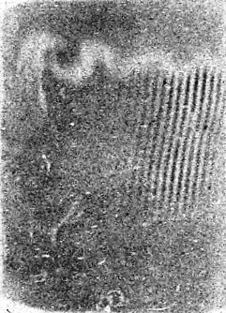 | 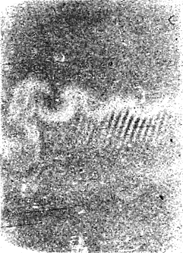 | 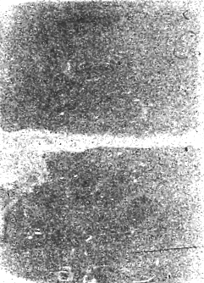 | 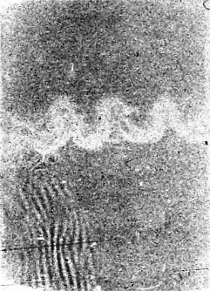 | 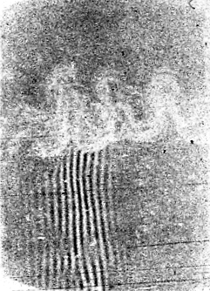 | 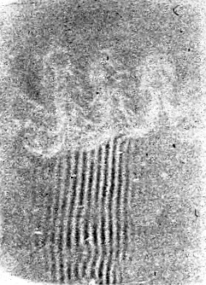

It was obtained that after shape inversion different perturbations, belonging to the same interface, have equal growth-rate. This comes to an agreement with results of research [2] conducted in a shock tube.
Comparison of dimensionless growth-rates of mixing zone thickness versus Atwood numbers and results from [3], [4] was made in the present study. The shorter decelerated pulse the better match to the dimensionless growth-rates values from [3]. At the same time mixing between uncompressible fluids [4] during deceleration stage is much slower than for compressible fluids case.
To obtain gas-dynamic parameters of flow outside of mixing zone 1D lagrange code was applied. 1D calculation was adjusted to real experiments by interface motion trajectory.
This research was supported by Grant No. 10-08-00533 of Russian Fund of Basic Researches.

REFERENCES.
1. S. Zaytsev, V. Krivets, I. Mazilin, S. Titov, E. Chebatareva, V. Nikishin, V. Tishkin, S. Bouquet, J.-F. Haas. Evolution of the Rayleigh-Taylor instability in the mixing zone between gases of different densities in a field of variable acceleration. Laser and Particle Beams , 2003, 21, 393-402.
2. E. Leinov, G. Malamud, Y. Elbaz, L. Levin, G. Ben-Dor, D. Shvarts, O. Sadot. Experimental and numerical investigation of the Richtmyer–Meshkov instability under re-shock conditions. Journal of Fluid Mechanics, 2009, 626, 449–475.
3. S. Zaytsev, V. Krivets, S. Titov, E. Chebotareva. Interaction of reflected shock and mixing zone at the late evolution stage. Proceedings of 4th Zababakhin Scientific Talks, 1995, 454-460.
4. Yu. Kucherenko, A. Pylaev, V. Murzakov, V. Popov, V. Savel’ev, A. Tyaktev, O. Komarov. Experimental Investigation into the Rayleigh-Taylor turbulent mixing evolution under shock effects. Proceedings of 7th IWPCTM, St. Petersburg, Russia, 1999, 68-74.

