EFFICIENCY OF EDDY MIXING IN STABLY STRATIFIED ATMOSPHERIC BOUNDARY LAYER
Albert F. Kurbatskiy*׳**, Lyudmila I. Kurbatskaya***

*Khristianovich Institute of Theoretical and Applied Mechanics SB RAS
630090 Novosibirsk
**Novosibirsk State University, 630090 Novosibirsk
***Institute of Computational Mathematics and Mathematical Geophysics SB RAS
630090 Novosibirsk
E-mail: kurbat@itam.nsc.ru
__________________________________________________________________________________________

Certain qualitative changes in turbulent eddy mixing in an atmospheric boundary layer (ABL) during transitional regimes towards stronger stratification are highlighted using numerical simulations with the mesoscale RANS turbulence model. The eddy mixing efficiency for the stably stratified atmospheric boundary layer is investigated as a function of the gradient Richardson number (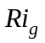). In particular, the flux Richardson number can be have non-monotonic (line 1 on Fig. 1), which has increased with increasing of the gradient Richardson number, saturates and then decreases after a value of around 1.0 (Fig. 1). Behavior of turbulent eddy mixing coefficients for momentum and heat (Fig. 3) in this study is consistent with the representation that the flow can sustain propagating internal waves that can effectively transport momentum, but not heat. This behavior is in good agreement with observational results for stably stratified nocturnal boundary layer flows.
Keywords: Thermal stable atmospheric boundary layer, Flux Richardson number, Eddy momentum and heat diffusivities, Modeling.

References
- Pardyjak, E.R. et al. J. Fluid Mech. (2002), vol. 459, pp.307-316.
- Mellor, G. L. & Yamada T. Rev. Geophysics Space Phys. (1982), vol. 20, pp. 851-875.
- Nakanishi, M. Boundary-Layer Meteorology (2001), vol. 99, pp. 349-378.
- Monti P. Journal of the Atmospheric Sciences (2002), vol. 59, pp. 2513-2534.

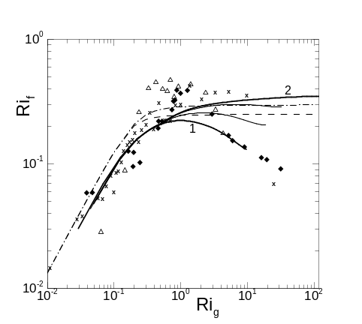
Figure 1. Mixing efficiency (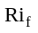) as a function of gradient Richardson number (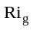): symbols are measurements data [1]; solid lines are the simulation results; dotted and dash-dot lines are the parameterizations [2, 3].
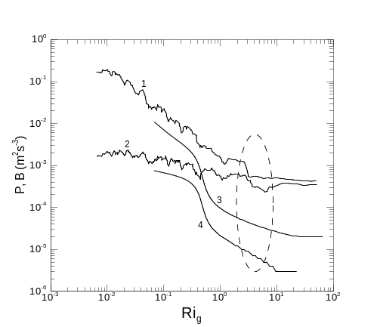
Figure 2. The variation of shear production (lines 1, 3) and buoyancy flux (lines 2, 4) with the gradient Richardson number (): the lines 1, 2 are from [1], the lines 3, 4 are the simulation results.
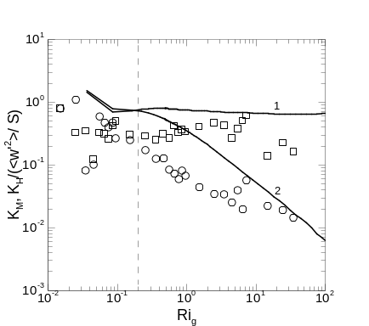
Figure 3. Scalings of turbulent eddy mixing coefficients 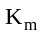(line 1) and 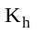(line 2) (normalized by 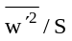) with : solid lines are the simulation results; the symbols are measurements data [4].

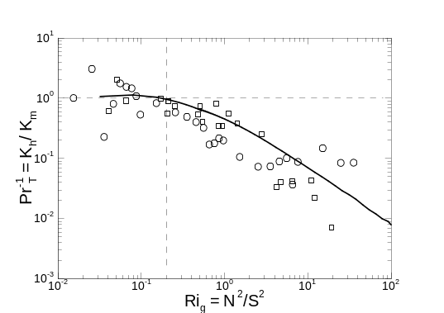
Figure 4. The ratio of heat to momentum eddy diffusivity as a function of the gradient Richardson number. The symbols are observation data [4]; the solid line is a simulation result.

