Proceedings of ICHIT- 06

26 February – 5 March 2006, Moscow, Russia

ON WAVE REGIMES IN FERROFLUID CONVECTION

A. Bozhko¹, G. Putin¹, T. Tynjälä²
¹ Perm State University, Perm, Russia, 614990
² Lappeenranta University of Technology, Lappeenranta, Finland, 53851
bozhko@psu.ru

Abstract
The investigation of Rayleigh convection in a thin cylindrical layer has been conducted for a ferrofluid containing magnetite single domain particles suspended in kerosene carrier liquid. Near the onset of convection the wave oscillatory convection was observed in experiments and numerical simulations using a two-phase mixture model. The influence of a homogeneous longitudinal magnetic field on the convective instability and structure of flows has been studied for horizontal and inclined orientations of the layer. The most fascinating effect in real ferrofluid convection is spontaneous formation of localized states, those where the convection chaotically focuses in confined regions and is absent in remainder of cavity.

introduction
By tradition, under consideration of ferrofluid convection are taken into account only temperature induced driving mechanisms such as buoyancy, magnetic and thermodiffusion [1-3]. The experiments [4, 5] in part shown that at terrestrial conditions the heat-mass transfer in magnetic colloids is essentially complicated for the most part because of uncontrollable gravitational sedimentation of magnetic particles and their aggregates. The competitive action of density gradients of thermal and sedimentation nature results in oscillatory and traveling wave, mostly spatiotemporally chaotic, convection close to threshould. Previously similar irregular behaviour near the convection onset so-called spatio-temporal chaos was revealed in gase and binary mixtures, nematic liquid crystal et cetera [6]. The disordered patterns in spatio-temporal chaos have a characteristic wave number and appreciably differ from fully developed turbulence.

wave convection in ferrofluid

Near-threshold chaos in a thermal convection

Experiments were performed with a kerosene-based magnetic fluid having the following parameters: mean particles size 10 nm, magnetic phase concentration 10 %, density 1.2510³ kg/m³, magnetic saturation M_{S} = 48 kA/m, dynamical viscosity in zero magnetic field 0,006 kg/m⋅s, Prandtl number 610².
The cylindrical fluid layer with a thickness 3.50±0.03 mm and diameter 75 mm is used for study of heat transfer and convection patterns. It was confined between copper and transparent heat exchangers from below and above. The circular sidewall of the layer was made of plexiglass. The patterns were visualized by the liquid crystal sheet. It undergoes its entire color change from brown to blue at temperature interval 24 to 27 ⁰C. The temperature difference ΔТ measured in the center of ferrofluid layer with the help of thermocouples.
In the model the ferrofluid is treated as a two-phase mixture of magnetic particles in a carrier phase. For the mixture phase are solved the conservation equations for mass, momentum and energy. In addition, a mass conservation equation for the suspended particles and an algebraic expression for the relative velocity between the fluid and particles are solved [7].
Numerical simulations were conducted using a finite volume simulation method, where the governing equations are integrated about each control volume, resulting discrete equations that conserve each quantity on a control-volume basis. Second-order upwind scheme was used for continuity, momentum and energy equations, whereas the first order scheme was used for the calculation of magnetic potential.
In contrast to the single component fluid, the convection in a horizontal ferrofluid layer appears “hard” and with hysteresis [8]. When temperature difference is increased quasistatically, the convection starts at ΔΤ > ΔΤ_{С} and ΔΤ changes within wide limits in the dependence of experiment prehistory. The reproducible critical temperature ΔT_{C} = 4,5 K turns out at decreasing ΔΤ. In the entire investigated range of temperature differences ΔΤ ≤ 4ΔΤ_{С} only oscillatory convection was observed.
The sample of typical irregular temperature oscillations and spatio-temporal convection patterns are shown in figs.1 and 2. The temperature sygnal (fig.1) consists of a superposition of low and high frequency oscillations. The wavelet-analysis revealed that along with periods 8- 15 min there are periods from 1 to 6 hours. The existence of large and small periods is typical for other values of ΔT as well.

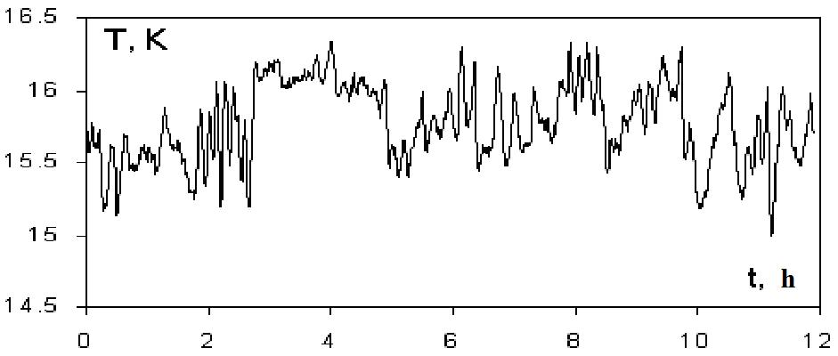

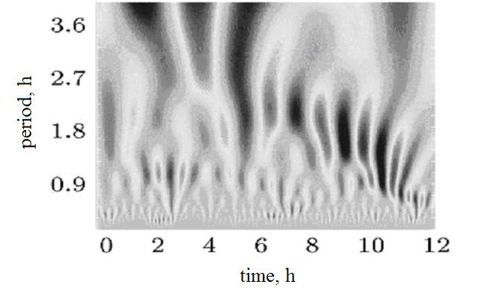
Figure 1
Temperature oscillations measured by thermocouples and corresponding them wavelet-transform at ΔΤ/ΔΤ_{С} ~ 2

As to the time evolution of patterns there are slow movement of roll systems as a whole and high-speed reconstruction of the convection rolls because of the cross-roll instability [6]. The breaking-up of the spiral roll pairs and their subsequent recombination proceed through a cellular structure (fig.2). Temperature drop from cool (black) to warm (white) liquid is approximately 3 K. Each white (black) strip in photographs corresponds to the same handedness of two neighboring rolls. Figure 3 presents the spatio-temporal structures arisen at the applied concentration gradient in numerical calculation. When ΔT is increased suddenly from below subcritical to supercritical values, the one- or two-armed giant spirals can appear [9].
In order to demonstrate that the oscillatory motions conditioned by behavior of magnetic fluid itself and not the features of heating et cetera, in fig. 4 the stationary patterns for the case of single fluid both in experiment and theory are shown.

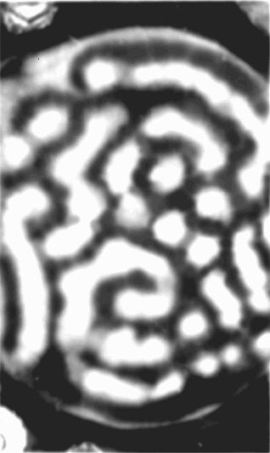 | 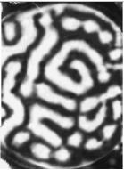
(a) | (b)

Figure 2
Liquid crystal visualization of spatio-temporal patterns in ferrofluid at ΔΤ/ΔΤ_{С} ~ 1.5. The time intervals between snapshots is 40 min

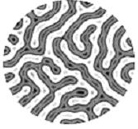 | 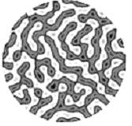
(a) | (b)

Figure 3
Numerical simulations of patterns at ΔΤ/ΔΤ_{С} ~ 2. The time interval between snapshots is 15min

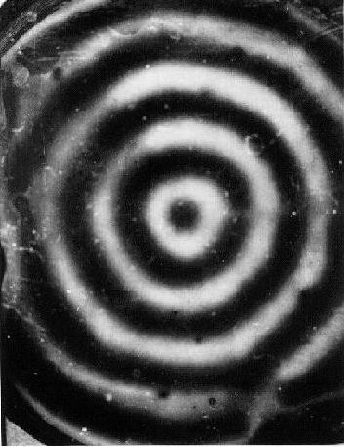 | 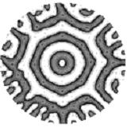
(a) | (b)

Figure 4
Convection patterns in single fluid at ΔΤ/ΔΤ_{С} ~ 2: (a) liquid crystal visualization for the transformer oil with Prandtl number 310²; (b) numerical simulation
Localized states under interaction of thermal, hydrodynamic, magnetic and concentration fields

A mean shear flow and a longitudinal magnetic field may exert identical orientation influence upon gravitational magnetic fluid convection drawing up convection rolls along the background flux [5,12] or force lines [8,10,11], respectively (fig.5). In this paragraph is discussed the situation when longitudinal magnetic field is superimposed to convection flow in an inclined layer so the direction of force lines is perpendicular to axes of Rayleigh convection rolls aligned with the upslope direction. Therefore, the interaction or the “competition” of longitudinal (fig.5(a)) and horizontal (fig.5 (a)) convection rolls are observed.

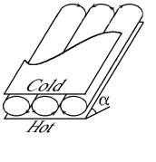 | 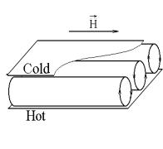
(a) | (b)

Figure 5
Schematics of roll motions: (a) in an inclined layer,
(b) in a horizontal layer in the presence of uniform longitudinal magnetic field

Figure 6 shows the stability boundaries of convection regimes in an inclined ferrofluid layer subjected to longitudinal magnetic field in the parameters ΔT/ΔT_{C}, α and M/M_{S}. Here ΔΤ⁄ΔΤ_{C} – dimensionless value of temperature difference (ΔΤ_{С} is the threshold of Rayleigh convection at α = 0⁰ and H = 0 kA/m), α - inclination angle from the horizontal, M/M_{S} –dimensionless value of magnetization. Region “a” - outside of a shaded "top-boot" space – corresponds to mechanical equilibrium at α = 0⁰ and thermally driven shear flow at α > 0⁰ (fig. 7). When α > 0⁰ within the shaded volume the secondary flows are superimposed onto the basic unicellular motion – regions “b” and “c”. As it is visible from the plot, the size of the region of secondary convection motions decreases with the increasing of inclination angle and magnetic field strength. Therefore, in the case of tilted layer the longitudinal magnetic field extinguishes the convection perturbations along the field direction and stabilizes Rayleigh flows. This is in contrast to the situation of horizontal layer where longitudinal magnetic field doesn’t influence on convective instability and only renders oriented effect [8,10].

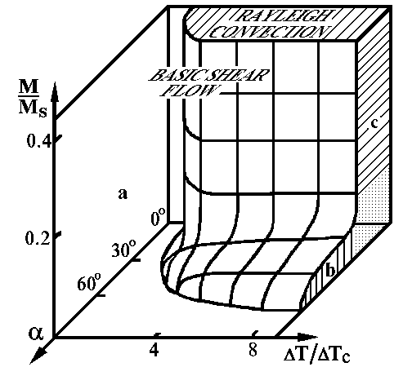

Figure 6
Stability boundaries of thermally driven shear flow in an inclined ferrofluid layer in the presence of a longitudinal magnetic field: a – shear flow; b – convection rolls aligned with the shear flow; c – convection rolls aligned with the magnetic field

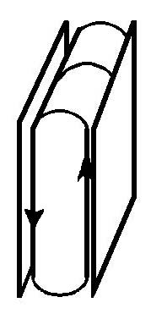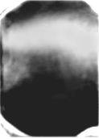

Figure 7
Shear flow: schematic and photograph from the direction of lateral wide side at α = 90⁰ and ΔT = 20 K (region “a” in figure 6)

When the magnetic field is small enough (stratum “b” of the shaded volume) the hydrodynamic orientation mechanism predominates over the demagnetising one, and the axis of convection rolls are lined up along the shear flow, i.e. perpendicular to the imposed magnetic field (schematic of flow see in fig.5(a), photograph - fig.8). At strong magnetic fields and not large inclination angles (column “c” in fig.6), the demagnetising effect increases which results in a horizontal orientation of the rolls. The schematic and the visualization of such roll structure are shown in fig. 5(b) and figs.9-11.
Among the various wave regimes which take place in the ferrofluid convection one should note apart the chaotic localized states. The shape of these states depends on values of control parameters ΔΤ, α and H.
At the beginning to consider the plane of zero magnetic fields in the stability map (fig.6). At α < 50⁰ and near-threshold ΔΤ the strong amplitude modulation of convection rolls can lead to attenuation of roll motion in the entire cell. In fig.8(a) Rayleigh convection focuses to form a localized regions of incomplete rolls on the lower part of snapshot. Then this confined state dies away, returning the cell to the base flow (fig.8(b)). After some time roll convection begins again in a qualitatively similar manner as before. During all other runs at the same control parameters repeated transients from confined Rayleigh convection to the basic unicellular motion were registered irregularly over the periods of 30 – 40 minutes. The disappearance and the post-forming of roll convection last some dozens cycles. Previously, similar repeated transients from convection to conductivity state were registered in binary mixtures [13].

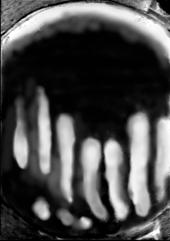 | 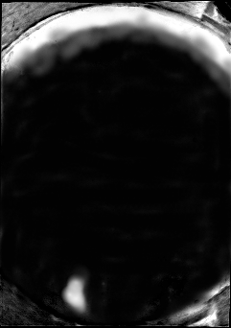
(a) | (b)

Figure 8
Localized pattern during repeated transients in an inclined layer at H = 0 for α = 15⁰, ΔΤ/ΔΤ_{C} = 1.8. The time interval between snapshots is 10 min

The tendency of the pattern to generate the “confined state” in a horizontal layer subjected to a longitudinal magnetic field is exhibited in fig.9 (the plane of α = 0⁰ in fig.6). The convection rolls arising in this situation align themselves so that their axes tend to be parallel to the imposed field. At any moment a central portion of the container is nearly free from convection and the heat transport is mainly confined to edge regions (fig.9(a)). Then, convection is excited in the central part of container and partly dies away in the top part of the snapshot (fig.9(b)).

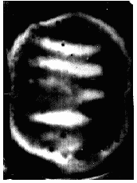 | 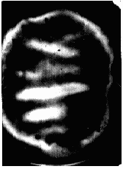
(a) | (b)

Figure 9
Confined states in a longitudinal magnetic field at α = 0⁰ for ΔT/ΔT_{C} = 1.3, H = 17 kA/m. The time interval between snapshots is 15 min. Magnetic field is directed horizontally in the plane of photos

A sharp bend on the stability surface in fig.6 corresponds to a transition between hydrodynamic and magnetic mechanisms of convection rolls orientation. A comparable contribution of both mechanisms in the area of intersection of zones “b” and “c” leads to formation of different types of chaotic localized states (or pulses) (figs.10,11).
Figure 10 demonstrates the pattern evolution with the increasing of magnetic field at fixed values of α and ΔT. At weak magnetic field the tick-like structure may form (fig.10(a)). When the applied field is larger, the localized traveling pulses occur (fig.10(b)). These pulses appear and die at irregular locations and times, have unique forms, and vary irregularly in dimension.

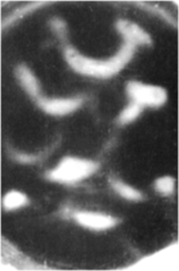 | 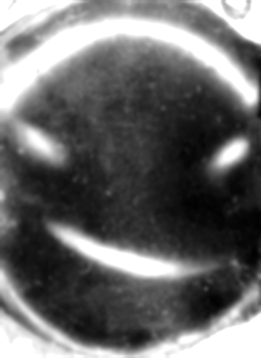
(a) | (b)

Figure 10
Evolution of localized states at α = 25°, ΔT/ΔT_{C} = 2 with the increasing of H: a) 1 kA/m; b) 5 kA/m

The time evolution of the localized pulses directed along the imposed magnetic field is shown in fig.11. In fig.11(a) only lower left quarter of the layer is occupied of half-rolls. Then, the convection rolls grow out of base unicellular motion and increase to a finite amplitude on the right quarter in fig.11(b). The procedure of appearance and disappearance of pulses is repeated in an unpredictable fashion. The dark top parts of the cavity in the photos correspond to the shear flow since the region of Rayleigh convection shifts to the bottom of the layer with the magnetic field increasing. Under boundary of the branches “c” and “a” in fig.6 only one-roll pulse twinkles near the low edge of cavity. The similar localized states also have been observed in the vicinity of stability boundary in electroconvection [14].

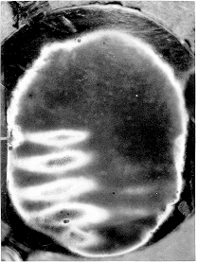 | 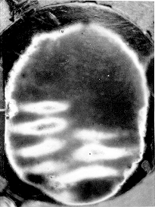
(a) | (b)

Figure 11
Localized pulses at α = 20, ΔΤ/ΔΤ_{С} = 2, H = 2.5 kA/m. The time interval between snapshots is 1 min

CONCLUSION

The experimental and numerical results have shown that the concentration gradients of solid phase due to the settling of magnetic particles and their aggregates in gravity field can have substantial effect on the character and stability of flows in magnetic colloids.
Besides, the form and the stability of secondary flows in the inclined ferrofluid layer may be controled with the help of a longitudinal magnetic field. The interaction of thermo-hydrodynamic, concentration and magnetic fields in such situation gives birth to a wealth of localized states.
As the wavelet-analysis revealed the temperature signals consist of a superposition of low and high frequency oscillations, which correspond to slow movement of roll system as a whole and high-speed reconstruction of the convection rolls due to cross-roll instability.
The research described in this publication was made possible in part by Russian Foundation for Basic Research under grant 04-01-00586, Finnish Academy grant 110852 and Award No. PE-009-0 CRDF.
REFERENCES

1. Rosensweig R.E. Ferrohydrodynamics, Cambridge University Press, New York, 1985.
2. Finlayson B.A. Convective instability of ferromagnetic fluids // J. Fluid Mech., 1970, V. 40, N 4, p. 753-767.
3. Blums E., Maiorov M.M., Tsebers A. Magnetic fluids, Zinatne, Riga, 1989.
4. Bozhko A.A., Putin G.F. Experimental investigation of thermomagnetic convection in an external uniform field // Proceedings of the Academy of Sciences of USSR, Physics, 1991, V. 55, N 6, p. 1149-1155.
5. Bozhko A.A., Putin G.F. Heat transfer and flow patterns in ferrofluid convection // Magnetohydrodynamics, 2003, V. 39, p. 147-169.
6. Getling A.V. Rayleigh–Bénard Convection: Structures and Dynamics, World scientific, Singapore a.o., 1998.
7. Manninen M., Taivassalo V., Kallio S. On the mixture model for multiphase flow, VTT Publications 288, Espoo, Technical Research Centre of Finland, 1996.
8. Bozhko A.A., Putin G.F. et al. Spatiotemporal convective patterns in a ferrofluid layer // Proceedings of the Joint 10th European symposium on physical sciences in microgravity, St. Petersburg, Russia, 1997, V. 1, p. 58 - 65.
9. Bozhko A., Tynjala T. Influence of gravitational sedimentation of magnetic particles on ferrofluid convection in experiments and numerical simulations // J. Magnetism and Magnetic Materials, 2005, V. 289, p. 281-284.
10. Bashtovoi V.G., Pavlinov M.I. Convective instability of a ferrofluid horizontal layer in the presence of longitudinal magnetic field // Research of convective and wave processes in ferrofluids, Minsk, 1975, p. 74-79.
11. Schwab L., Stierstadt K. Field-induced wavevector-selection by magnetic Benard convection, J. Magnetism and Magnetic Materials, 1987, V. 65, N 2/3, p. 315-116.
12. Gershuni G.Z., Zhuchovitsky E.M., Nepomnjashchy A.A. Stability of convective flows, Moscow, Science, 1989.
13. Ahlers G., Canell D.S., Lerman K. Different convection dynamics in mixtures with the same separation ratio // Physical Review E, 1996, V. 53, N 3, p. 2041-2044.
14. Ahlers G., Canell D.S. et al. Chaotic localized states near the onset of electroconvection // Phys. Rev. Lett., 1996, V. 77, N 12, p. 2475-2478.

