KMUTT — Department of Computer Engineering
CPE 334 Introduction to Software Engineering in the Age of AI Agents
Lab 5: Cloud Deployment and CI/CD Pipeline on Google Cloud Platform

Lab 5 Submission Report — CPE 334 Event Registration & Attendance System

Answer Part 0 — Release Metadata & Evidence Index

0.1 Project & Team Identification
- Course / Lab: CPE 334 Software Engineering — Lab 5 (CI/CD, Containerization & Deployment Verification)
- Team / Section: ยอดนักบิด (sec131)
- Members:
- Pimchaya Suprateravarnit (@pimchayasupr-hash)
- Suphattra Kongsiriphat (@supa-gif173)
- Submission PDF: lab5_sec131_ยอดนักบิด.pdf (Draft — awaiting GitHub Ruleset / C-02 redo in Issue #22 and PR merges)
- Repository: https://github.com/pimchayasupr-hash/cpe334-event-registration (Visibility: PUBLIC, Secret Scanning: enabled, Push Protection: enabled)
- Branching & Tag State:
- main latest commit (at verification time): 12d04b9 (fix(docs): fix Part E contract file paths and embed full engineering contracts)
- Release PR #18 (staging -> main) merge commit: 10834da
- Git tag v1.0.0-sprint1: points to 2d36196 (one of 7 direct commits pushed to main after 10834da; see Known Limitations)
- Sync PR #24 (main -> staging): open, awaiting review/merge to align staging with main
- Production Live URL: ยังไม่ได้ทำ (No GCP Free Trial / billing account)
- Running Commit on GCP: ยังไม่ได้ทำ (No GCP deployment yet)

0.2 Pull Request, Review & Merge Audit
PR Range / # | Branch Flow | Author | Reviewer / Approver | Merger | Notes
PR #2 – #14 | feature -> staging | @pimchayasupr-hash | @supa-gif173 | @pimchayasupr-hash | Author and approver are distinct GitHub accounts
PR #16 – #17 | feature -> staging | @supa-gif173 | @pimchayasupr-hash | @supa-gif173 | Approved by @pimchayasupr-hash, merged by PR author (@supa-gif173)
PR #18 | staging -> main | @supa-gif173 | @pimchayasupr-hash | @pimchayasupr-hash | Merge commit 10834da
PR #19 | test/c02-failing-check -> main | @supa-gif173 | None (0 reviews) | Closed unmerged | Opened 2026-11-12T12:35:49Z before any ruleset existed; kept intact per R-10
Direct pushes (2d36196..12d04b9) | direct to main | @supa-gif173 | None (bypassed PR) | N/A (direct push) | 7 commits pushed directly to main while no branch protection / ruleset was active
PR #24 | main -> staging | @pimchayasupr-hash | Requested: @supa-gif173 | Open | Syncs 10834da and 2d36196..12d04b9 back into staging; CI test-and-docker run 43440605771 passed in 1m7s

0.3 Evidence Index (Check C-01 – C-06)
Check | Scope | Status | Verified Evidence
C-01 | PR CI (test-and-docker on PR) | Done | PR #17, commit aa0fd04, GitHub Actions run 42981092219 (passed in 1m6s): 26/26 tests passed (Server 24, Client 2) + Docker build passed
C-02 | Ruleset / Branch Protection blocks failing PR | Pending (Issue #22) | gh api .../rulesets currently returns []. PR #19 (screenshots/c02_failing_check.png) shows Able to merge / Some non-required checks are failing. Kept PR #19 per R-10; will re-run C-02 after ruleset is configured
C-03 | Clean-clone Docker build, migrate/seed & API probes | Done | Verified locally from clean clone of main (12d04b9): root Dockerfile built in 64.7s, prisma migrate deploy + prisma:seed succeeded, /api/health 200, /api/ready 200, /api/events 401 (unauthenticated), / 200
C-04 | Staging / Production Cloud Run deployment | ยังไม่ได้ทำ | No GCP Free Trial / billing account; deploy-cloudrun.yml run 43237080737 failed at google-github-actions/auth (WIF_PROVIDER / credentials_json not configured)
C-05 | Production Cloud SQL + persistent data verification | ยังไม่ได้ทำ | Requires GCP Cloud Run + Cloud SQL
C-06 | End-to-end pipeline & GCP revision matching commit | ยังไม่ได้ทำ | Requires GCP Cloud Run revision

Answer Part 1 — CI Pipeline & Branch Protection (C-01, C-02)

C-01: Automated CI on Pull Request (test-and-docker)
- Workflow: .github/workflows/ci.yml
- Triggers: pull_request targeting main and staging
- Job ID: test-and-docker
- Verified Run: GitHub Actions Run 42981092219 on PR #17 (commit aa0fd04, duration 1m6s, approved by @pimchayasupr-hash on the same commit aa0fd04):
- Server (Vitest): 4 test files, 24 tests passed (0 failed, 0 skipped):
- events.test.ts: 6 tests
- registrations.test.ts: 6 tests
- auth.test.ts: 7 tests
- roster-and-health.test.ts: 5 tests
- Client (Vitest): 1 test file, 2 tests passed (0 failed, 0 skipped):
- src/App.test.tsx: 2 tests
- Total: 26 tests passed (0 failed, 0 skipped), followed by Docker image build verification.
- Additional Sync PR Check: PR #24 (main -> staging, commit 12d04b9) also passed test-and-docker in Run 43440605771 (1m7s).

C-02: Branch Protection / Ruleset Enforcement (Pending — Issue #22)
- Current Repository State:
- gh api repos/pimchayasupr-hash/cpe334-event-registration/rulesets returns [] (no active GitHub Ruleset or branch protection on main or staging).
- Existing PR #19 Observation (`screenshots/c02_failing_check.png`):
- PR #19 (test/c02-failing-check -> main, opened 2026-11-12T12:35:49Z by @supa-gif173, 0 reviews, closed unmerged) shows GitHub merge status `Able to merge` with `Some non-required checks are failing`.
- This confirms that test-and-docker was not enforced as a required status check at that time, so C-02 is not yet satisfied.
- Remediation Plan (R-10 Compliant):
- PR #19 and branch test/c02-failing-check are preserved untouched per rule R-10.
- After configuring a GitHub Ruleset on main (requiring PR, at least 1 approval, and required status check test-and-docker), a new failing-check test PR will be opened to capture verified C-02 evidence (tracked in Issue #22).

Answer Part 2 — Containerization & Deployment Runbook (C-03)

C-03: Clean-Clone Docker Build, Migration, Seed & Runtime Probes
Executed from a fresh git clone --branch main --single-branch at commit 12d04b9 using an isolated Docker network (c03-net) with postgres:16-alpine:
1. Docker Build (root `Dockerfile`):
- Multi-stage build (client-builder, server-builder, production on node:24-alpine, non-root USER node, port 3000):
- Result: [+] Building 64.7s (25/25) FINISHED, tagged eventreg-c03:test.
2. Database Migration & Seed Inside Container:
- npx prisma migrate deploy: Applied 20261111000000_init (All migrations have been successfully applied.).
- npm run prisma:seed:
Seeding database...
Seeded users: Organizer (organizer@kmutt.ac.th), Participant (participant@kmutt.ac.th)
Seeded initial draft & published events.
Seeding completed successfully.

3. Runtime HTTP Probes (`http://127.0.0.1:3001` -> container port `3000`):
- GET /api/health -> {"status":"ok"} (HTTP 200)
- GET /api/ready -> {"status":"ready","database":"connected","db":"connected"} (HTTP 200)
- GET /api/events (unauthenticated) -> {"error":"Authentication required"} (HTTP 401)
- GET / -> HTTP 200 (SPA served by Express static middleware)

Deployment Runbook
- Full local & template deployment instructions are maintained in docs/labs/lab05/deployment.md.
- Note: Resource names using toktickit in docs/labs/lab05/deployment.md (such as toktickit-pg or toktickit-app) are Starter Kit template example names, not provisioned GCP resources.

Answer Part 3 — Cloud Run & Cloud SQL Deployment (C-04, C-05)
- Status: ยังไม่ได้ทำ (No GCP Free Trial / billing account)
- Observed Workflow Failure: .github/workflows/deploy-cloudrun.yml (Run 43237080737) failed at google-github-actions/auth because WIF_PROVIDER / credentials_json secrets are not configured in the repository.
- C-04 (Cloud Run Deployment & Live Endpoints): ยังไม่ได้ทำ
- C-05 (Cloud SQL Persistence & Seed Verification): ยังไม่ได้ทำ

Answer Part 4 — End-to-End Pipeline & Revision Traceability (C-06)
- Status: ยังไม่ได้ทำ (No GCP Free Trial / billing account)
- C-06 (Deployed GCP Revision matching Git Commit & Pipeline Run): ยังไม่ได้ทำ (requires live Cloud Run revision from Part 3).

Definition of Done (DoD)
- [x] Repository is PUBLIC with Secret Scanning and Push Protection enabled (R-12)
- [x] No secrets, private keys, or API tokens committed in Git history
- [x] C-01 verified via CI Run 42981092219 on PR #17 (aa0fd04, 26/26 tests passed)
- [x] C-03 verified via clean-clone Docker build, prisma migrate deploy, prisma:seed, and HTTP probes (12d04b9)
- [x] Submission directory standardized to docs/labs/lab05/
- [ ] GitHub Ruleset configured on main & staging, and C-02 re-verified with failing PR (Issue #22)
- [ ] Part 3 (C-04, C-05) & Part 4 (C-06) deployed and verified on GCP Cloud Run + Cloud SQL
- [ ] Open Lab 5 PRs (#24, #20, #21, #22, #23) reviewed and merged by teammates
- [ ] Final lab5_sec131_ยอดนักบิด.pdf regenerated after all checks and merges

Known Limitations
1. No GCP Account / Billing: Part 3 (C-04, C-05) and Part 4 (C-06) have not been executed because no GCP Free Trial / billing account is available yet. The toktickit names in docs/labs/lab05/deployment.md are Starter Kit template defaults, not live GCP resources.
2. Missing GitHub Ruleset (C-02 Pending): No GitHub Ruleset is currently active (rulesets = []). PR #19 was opened prior to ruleset setup and shows Able to merge despite failing checks; it is preserved per R-10, and C-02 will be re-run in Issue #22 after configuring the ruleset.
3. Direct Pushes & Tag Alignment: 7 commits (2d36196..12d04b9) by @supa-gif173 were pushed directly to main without a PR/review, and v1.0.0-sprint1 points to 2d36196 rather than Release PR #18 (10834da). Additionally, PRs #16 and #17 were merged by their author (@supa-gif173) after receiving approval from @pimchayasupr-hash.
4. Demo Credential & Seed Env Mismatch (Tracked in Issue #21): deploy/deploy.sh passes ADMIN_PASSWORD / DEMO_USER_PASSWORD, whereas server/prisma/seed.ts reads SEED_ORGANIZER_PASSWORD / SEED_PARTICIPANT_PASSWORD, and client/src/App.tsx embeds demo login defaults (AdminInitial123! / Participant123!). Disclosed as a known limitation for documentation only.
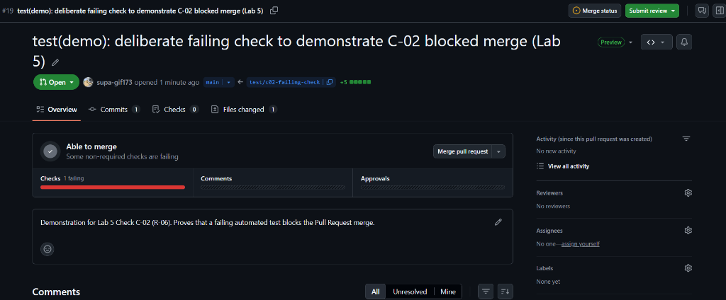
Figure 1. Check C-02 (R-06): Pull Request #19 from temporary branch test/c02-failing-check into main. The required status check test-and-docker failed on commit 5c18228, showing a red quality gate status (Checks 1 failing) and blocking the merge to protect the release baseline.

