NETCOOL / Event Generator

v. 1.0

Users Guide

Author: Kliment Stefanov

TABLE OF CONTENTS

- Purpose

- Terminology and Deployment
  - Terminology
  - Deployment

- Supported Operating Platforms

- Configuration
  - Configuration Files
    - generator.prp
    - <event_table>.xml
  - Object Server Section
  - Event Table Section
  - Event Table Configuration
  - Logging

- GUI (Graphical User Interface)

  - Main Window
    - Menu Bar
    - Button Bar
    - Tabbed Panel
      - Configuration Panel
      - Events Table Panel
      - Status Panel

    - Info Bar

  - “Add event” Window

  - “Add column” Window

1. Purpose

NETCOOL/Event Generator aims to provide all NETCOOL users with the ability to send simulated custom defined events to an existing Object Server. This tool is very useful for testing automations, triggers, etc as well as feeding demo software with fake events.

The user can define the format and the content of the events via a graphical tool or directly into an XML file. Unlimited number of event tables for different projects can be created.

2. Terminology and Deployment

2.1 Terminology

OS – Object Server

Event Table – Table representing the set of events to be send to the Object Server. Each column represents a column in the Object Server database; each row represents a single event.

Thread Table – Table showing statistic for each event (running/paused/completed) and pause/re-start each of the events.

2.2. Deployment

NETCOOL/Event Generator can be used only with NETCOOL/Object Server.

3. Supported Operating Platforms

The following operating systems are supported:

- Microsoft Windows NT, 2000, XP
- Linux

4. Configuration

4.1. Configuration Files

4.1.1. generator.prp

This file contains all properties for the normal operation of the NETCOOL/Event Generator. Having wrong properties could result in non-functioning software.

- GENHOME – Defines the location of the NETCOOL/Event Generator installation. This property is set automatically during the installation process.

- messagelevel - Defines the logging level - the amount of the information sent to the log file describing the operation of the NETCOOL/Event Generator. Available values in incrementing order are: CRITICAL, MAJOR, MINOR, DEBUG. This is usually used for development purposes or determining the point of failure. (For detailed information refer to 4.5. Logging).

- messagelog – File to which the NETCOOL/Event Generator will send its logging information. Only a filename should be specified, not the full path. If STDOUT is selected instead of filename, the NETCOOL/Event Generator will send all its information to the screen. (For detailed information refer to 4.5. Logging).

- OS_Name – The name of the OS to which the NETCOOL/Event Generator sends the events.

- OS_Host – The host name of the machine to which the events are sent.

- OS_Port – The port number of the machine to which the events are sent.

- OS_User – The username with which the connection to the OS is authenticated.

- OS_Pass – The password with which the connection to the OS is authenticated.

- Table – The name of the default event table. A table with this name will be loaded automatically at start-up time if no user settings are defined. The name of the table must not include the path. Changes into this section will take affect only if "usersets.prp" file does not exist or is empty.

    - <event_table>.xml

Every single <event_table>.xml file contains all properties of a single
event table and is located in the properties directory.

- Section ‘<table name=”xxx”>’ specifies the name of the table.
- Section ‘<column …>’ specifies attributes of each column as follow:
- name – The name of the column.
- position – The position in the table
- minWidth – The minimal width of the column.
- prefWidth – The preferable width of the column.
- maxWidth – The maximal width of the column.
- type – The type of the data in the column:

Type | Meaning
0 | Normal Integer
1 | Incremented number as Integer
2 | Random number as Integer
3 | Timestamp as Integer
4 | String
5 | Incremented number as String
6 | Random number as String
7 | Timestamp as String
8 | GIS Coordinates as String

- Section ‘<cell value=”xxx”/>’ specifies the value to be send to the Object Server.

Type | xxx
0 | 12345
1 | Start:0, Step:10
2 | From:0, To:1000
3 | Current Time.
4 | 12345
5 | Start:100, Step:10
6 | From:10, To:100
7 | Current Time.
8 | minLat:43.00, maxLat:45.00, minLong:5, maxLong:7

Example:

<table name="template">
<column name="_ID" position="00" minWidth="30" prefWidth="35" maxWidth="40" type="4">
<rows>
<cell value="Hello World"/>
.
.
</rows>
</column>
.
.
</table>
4.2. Object Server Section

This panel provides the user with the ability to configure the network settings of the Object Server to which the events will be sent to. A “Test” button is provided for testing the availability of the specified Object Server.

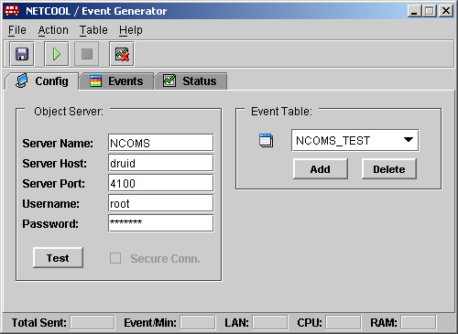

- Server Name – The name of the OS to which the NETCOOL/Event Generator sends the events.
- Server Host – The host name of the machine to which the events are sent.
- Server Port – The port number of the machine to which the events are sent.
- Username – The username with which the connection to the OS is authenticated.
- Password – The password with which the connection to the OS is authenticated.
- “Test” – Test the availability of the Object Server.

4.3. Event Table Section

This panel gives the user the following options:

- “Add” and “Delete” buttons for creating and deleting tables.
- Drop down list of existing tables. The table which is currently selected is the one which the NETCOOL/Event Generator uses for generating the events.

Creating a new event table will create a new <event_table>.xml file. See section 4.1.2.
4.4. Event Table Configuration

This panel provides the user with front-end graphical interface for modifying the currently selected events table.
The first four columns in the events table are reserved for setting the properties of each single event:

- ID – Identification number of the event. By this number the user can monitor the status of this event generation from the “Status” table.
- Act – On/Off option for activating and deactivating the event generation. After pressing the “Start” button the generator reads the events table and starts to generate only events which “Act” option is selected.
- Poll – This is the polling interval of each event. It is measured in events per minute. The minimum value is “1”, which is 1 event/min. If “0” (zero) is selected the generator tries to send events at a maximum speed.
- Stop – This option is used if the user wants to send exact number of events. For example if “50” is entered, the generator will send exactly 50 events after which will pause. The generation of each paused event can be restarted for another session via the “Status” table.

The rest of the columns are the event fields. Each field can be of type “Char” or “Integer”. It can be set also to auto-generate incremented values, random numbers in a specified by the user boundary, and the current time.

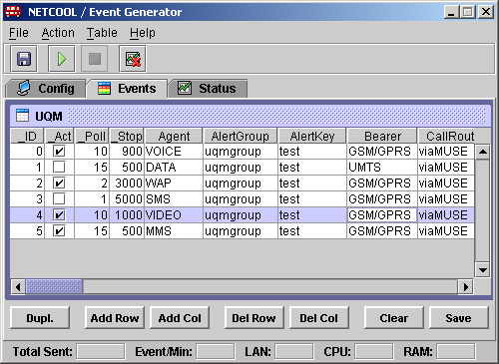

Buttons:
- Dupl. – Duplicates the selected row (event).
- Add Row – Adds new row (event). See 5.2.
- Add Col – Adds new column (event field). See 5.3.
- Del Row – Deletes the selected row (event).
- Del Col – Deletes the selected column (event fields).
- Clear – Deletes the entire table (all rows, all columns).
- Save – Saves the table.

  - Logging

NETCOOL/Event Generator does produce logging information during its operation, describing the internal functionality of the software. This is mainly used for debugging purposes.
The depth (the amount of information, which the NETCOOL/Event Generator produces, is specified by the “messagelevel” property, defined in the “generator.prp” file. The possible values in incrementing order are:

- CRITICAL – NETCOOL/Event Generator will print out only events, which are fatal for the operation of the software, then will exit.
- MAJOR – NETCOOL/Event Generator will print out only the events, which prevent the software to perform normally, as well as CRITICAL messages.
- MINOR – NETCOOL/Event Generator will print out the events, which decrease the performance of the software, but do not stop it from sending events, as well as MAJOR and CRITICAL messages.
- DEBUG – NETCOOL/Event Generator will print out every step of its operation. This includes MINOR, MAJOR, and CRITICAL events. This level is not recommended for long use, as the log file could grow without any limits.

The output for the logging events could be selected between a file with a specified name, or directly to the screen. This is specified by the “messagelog” property, defined in the “generator.prp” file. The possible values are:

- STDOUT – NETCOOL/Event Generator will print its logging information directly to the screen. No LOG file will be created.
- <filename> - NETCOOL/Event Generator will forward its logging information to a file with the specified <filename>. <filename> is a name of the file, NOT including the path. For example “messagelog=C:\Program Files\Event Generator\log\generator.log” is WRONG. The correct will be: “messagelog=generator.log”.

5. Graphical User Interface

5.1. Main Window

5.1.1. Menu Bar

- File
  - Save – Saves current configuration as well as the event table.
  - Exit – Exits the NETCOOL/Events Generator

- Action
  - Start – Starts the event generation
  - Stop – Stops the event generation
  - Clear – Clears the current status fields

- Table
  - Insert -> Row – Inserts new row (event) to the event table. See 5.2.
  - Insert -> Column - Inserts new column (event field) to the event table. See 5.3.
  - Remove -> Row – Removes selected row (event) from the event table.
  - Remove -> Column – Removes selected column (event field) from the event table.
  - Table -> Save – Saves the table.
  - Table -> Clear – Deletes all fields and columns from the table.

- Help
  - Users Manual – Shows this user manual in a PDF format.
  - About – Displays information about the NETCOOL/Event Generator

5.1.2. Button Bar

The button bar contains a set of buttons for quick access to the main and most often used commands.
- Save button
- Start button
- Stop button
- Clear button

5.1.3. Tabbed Panels

5.1.3.1. Config Panel

The “Config” panel contains two sections: “Object Server” and “Event Table”. In the Object Server section, the user specifies the details of the OS to which he wants to send the events (See p.4.2.). From the “Event Table” section the user can select between different event tables. The selected one will be used by the NETCOOL/Event Generator for generating the events.

5.1.3.2. Events Panel

The “Events” panel contains the currently selected event table and the buttons for manipulating with it. (See p.4.3.)

5.1.3.3. Status Panel

The “Status” panel contains two sections: “Event Thread” table and “Status” panel.

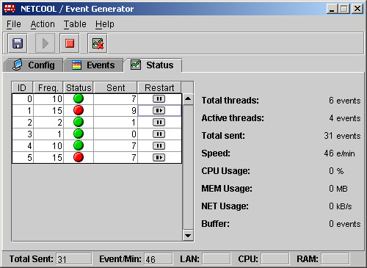
- Event Thread table

Event thread table gets build/rebuild when the generator is started. The table gives the current status for each thread and can be used to pause/restart each of the threads. The columns of the table are:

- ID – This is the event ID matching the event ID from the event table.
- Freq. – This is the poll interval of the event thread. Measured in events per minute. This field is equivalent to the “Poll” column from the event table.
- Status – this is the current status of the event thread. “Green” means that the event is active and the sending is in process, “Red” is if the event thread is not activated, paused, or completed its set of events.
- Sent – Information about the number of events sent by the event thread.
- Restart – Contains buttons for pausing or restarting each single event thread.

- Info Panel

The info panel shows dynamically the current status of the overall performance of the NETCOOL/Event Generator.

- Total Thread – Total number of events in the event/thread table.
- Active Threads – The number of the events currently active.
- Total Send – Total number of events send by the NETCOOL/Event Generator.
- Speed – Current sending speed, measured in event per minute.
- CPU Usage – The current CPU usage of the NETCOOL/Event Generator (currently not implemented).
- MEM Usage – The current memory usage by the NETCOOL/Event Generator (currently not implemented).
- NET Usage – The current network usage of the server on which the NETCOOL/Event Generator is running (currently not implemented).
- Buffer – The number of events waiting to be sent by the generator. The NETCOOL/Event Generator should maintain this buffer not to grow without limits. If the buffer grows rapidly, the speed of each single thread gets decreased automatically.
Info Bar

The info bar displays the current status information for the overall performance of the NETCOOL/Event Information:

- Total Sent – Total number of events send by the NETCOOL/Event Generator.
- Event/Min - Current sending speed, measured in event per minute.
- LAN – The current network usage of the server on which the NETCOOL/Event Generator is running.
- CPU – The current CPU usage of the NETCOOL/Event Generator (currently not implemented).
- RAM – The current memory usage by the NETCOOL/Event Generator (currently not implemented).

“Add event” window

“Add event” window appears when the user presses the “Add Row” button from the “Events” tab, or selects “Table -> Insert -> Row” from the menu bar.

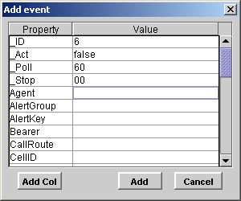

The “Add event” window has two sections:

- Event fields table
  - Property – Specifies the name of the column
  - Value – Specifies the value of the event for this column.

- Buttons panel.
  - Add Col – Launches the “Add column” window to add an additional column (event field) to the event table.
  - Add – Adds the currently configured event to the event table.
  - Cancel – Discard the changes and closes the window.
  - The user is allowed only to change/enter values in the values column.
“Add column” window

The “Add column” window is launched when the user presses the “Add Col” button from the “Events” tab, or selects “Table -> Insert -> Column” from the menu bar.

The “Add column” window has two sections: Column parameters section and buttons section. Column parameters section gets changed when the user selects different Options/Value Type.

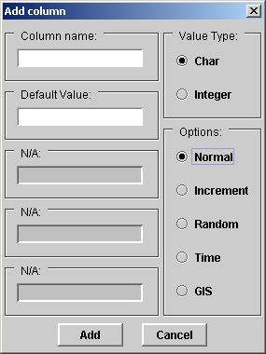 | 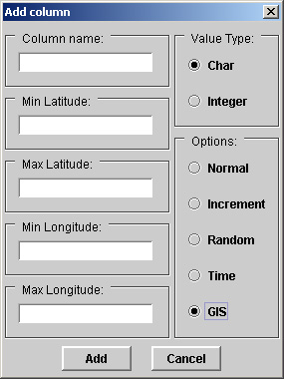
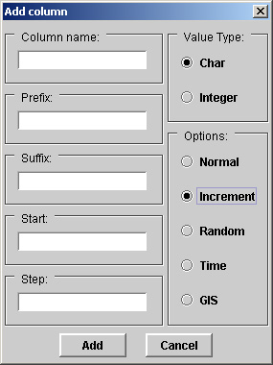 | 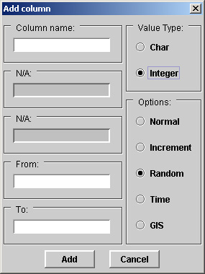

Column parameters section has the following fields:

- Column Name – This is the name of the column (event field)
- Default Value/Prefix/MinLat – Depending on the Value Type (Char/Integer) and the Option (Normal/Increment/Random/GIS), this field is:
  - Default Value - The default value for the new column if the ‘Normal’ Option is selected.
  - Prefix – A prefix can be added to a random generated or incremented value when the value type is set to “Char”.
Example: Generated value - “359”
Prefix: - “Phone:”
Result value to OS - “Phone:359”
  - Min Latitude - The lower Latitude border for the GIS Coordinates generator.

- Suffix/MaxLat – This field is active only when Value Type is set to ‘Char’. Depending on the selected Option (Increment/GIS), this field is:
- Suffix – A suffix can be added to a random generated or incremented value when the value type is set to “Char”.
Example: Generated value - “100”
Suffix: - “ apples.”
Result value to OS - “100 apples”
- Max Latitude - The top Latitude border for the GIS Coordinates generator.

- From/Start/minLat – Depending on the Value Type (Char/Integer) and the selected Option (Increment, Random, or GIS) this filed can be:
  - From – The lower border for the random number generator.
  - Start – The start point of the incremental value generator.
  - Min Longitude - The lower Longitude border for the GIS Coordinates generator.

- To/Step/maxLat – Depending on the Value Type (Char/Integer) and the selected Option (Increment, Random, or GIS) this filed can be:is ether the top border for the random number generator, or the step value for the incremental value generator, or the top border for the Latitude generator.
  - To - The top border for the random number generator.
  - Step – The step value for the incremental value generator.
  - Max Longitude – The top Longitude border for the GIS Coordinates generator.
The column value types and options are:

- Value type – This sets the type of the value to be sent to the NETCOOL/Object Server
  - Char
  - Integer

- Options – This sets the behaviour of the value for the entire column. The possible options are:
  - Normal – Static value
  - Increment – Incremented number with starting value set in the “Start” field, and incrementing each time by the value set in the “Step” field.
  - Random – Random number generated in the boundaries set in the “From” and “To” fields.
  - Time – sends as a value the current time in seconds.
  - GIS – Generates a GIS coordinate in a specified botder.

Note 1: If the value type of the event field is set to “Char” no matter that the “Option” is set to generate random/incremented numbers, it will be sent as a string (Char).
Note 2: Prefix and/or Suffix cannot be set if the value type is set to “Integer”. The GUI does not allow that. However if the user sets it manually directly to the XML file or the table, the NETCOOL/Event Generator will produce error.

