**SIMULATION CASE NUMBER: 2**

Detumbling w/o magnetorquer. Initial conditions are w = [0.7, 0.4, 0.3]. Tuning: K = 0.5,0.5,0.2

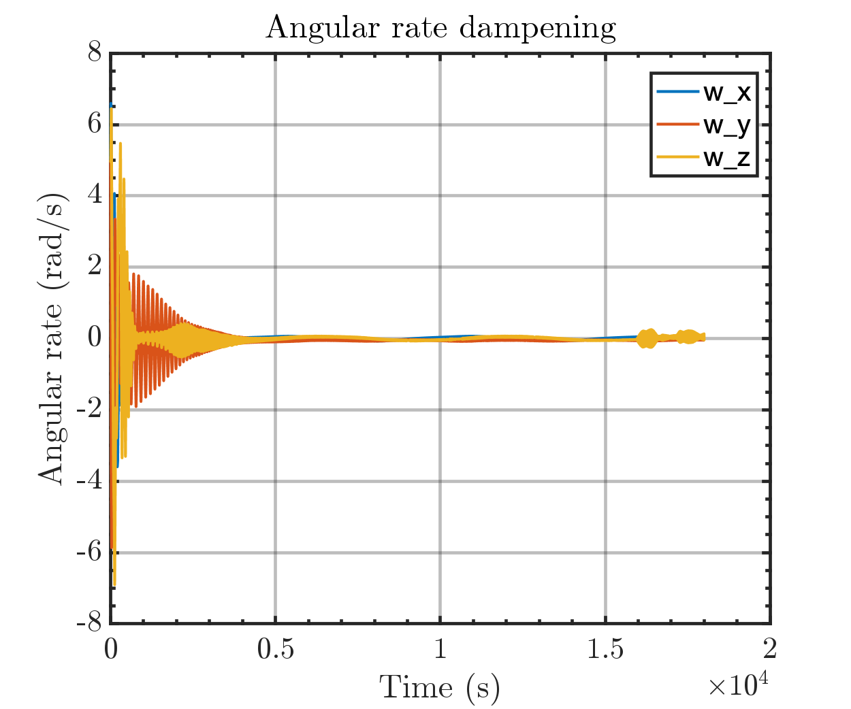

Same plot but with orbital periods

