**SIMULATION CASE NUMBER: 10**

Detumbling w/o magnetorquer. Initial conditions are: w = [5,0,0]. Tuning: K = [0.6,0.4,0.3]

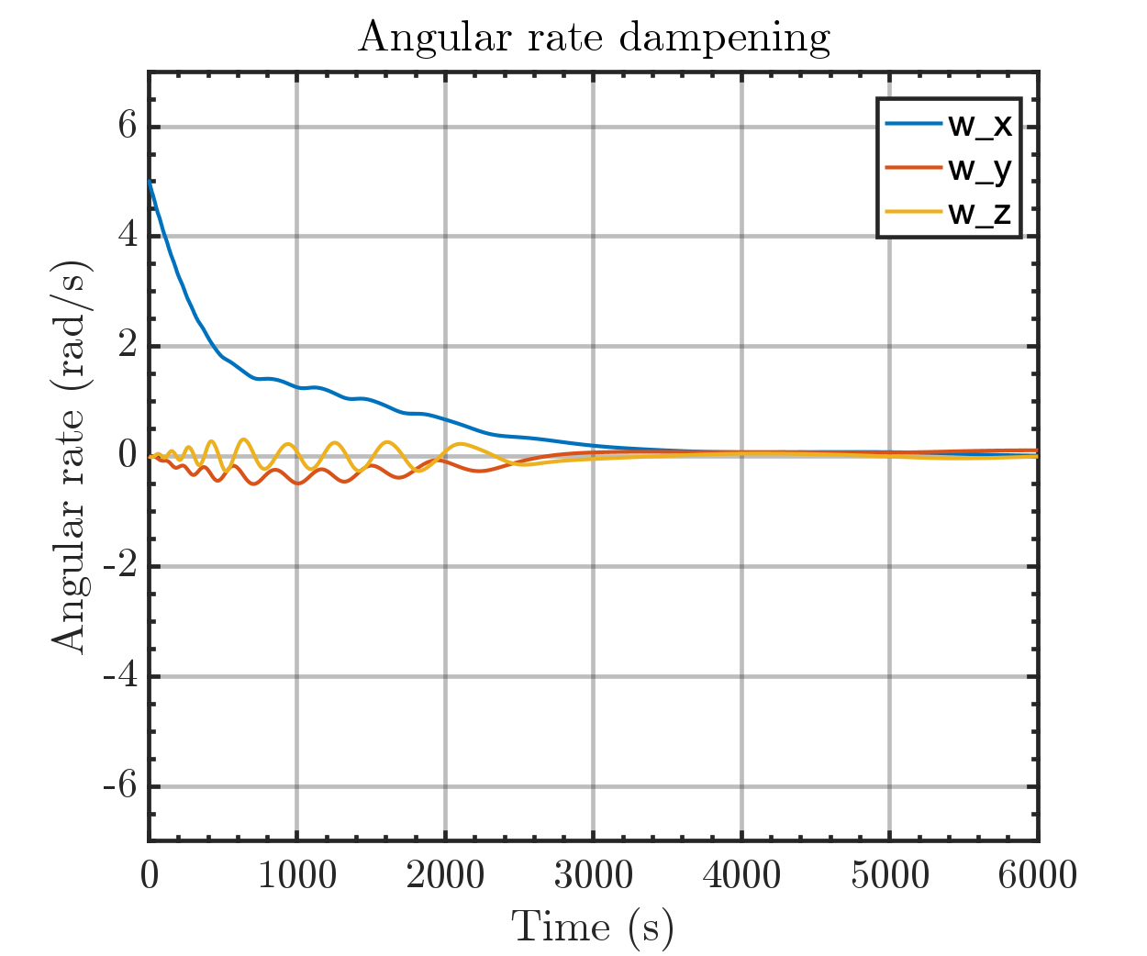

Same plot but with orbital periods

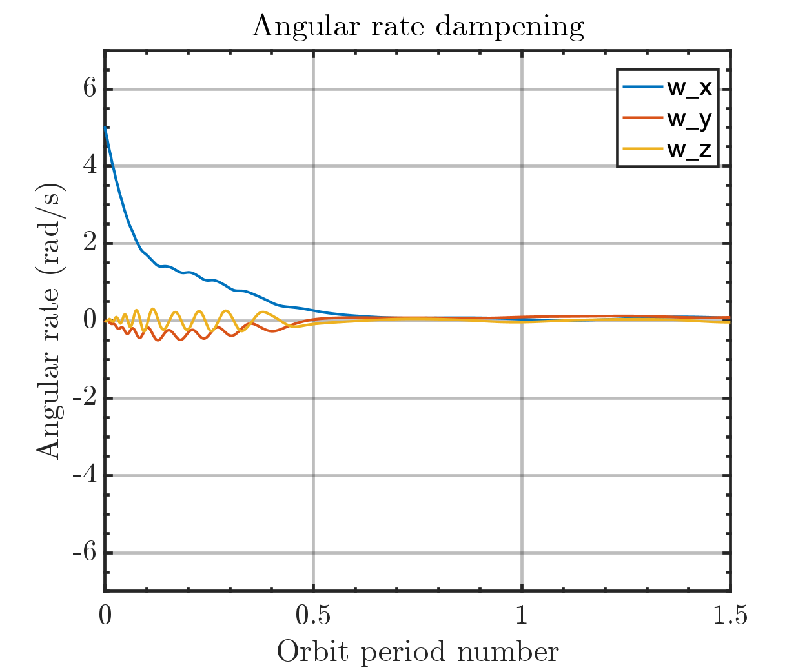

Output magmetic moment of Bdot controller

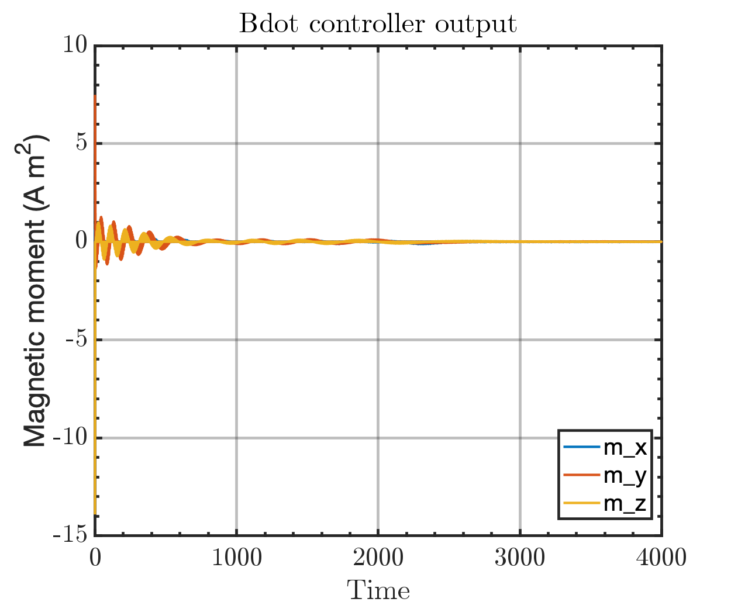

Run time: ???