**SIMULATION CASE NUMBER: 11**

Detumbling w/o magnetorquer. Initial conditions are: w = [5,5,5]. Tuning: K = [0.7,0.3,0.2]

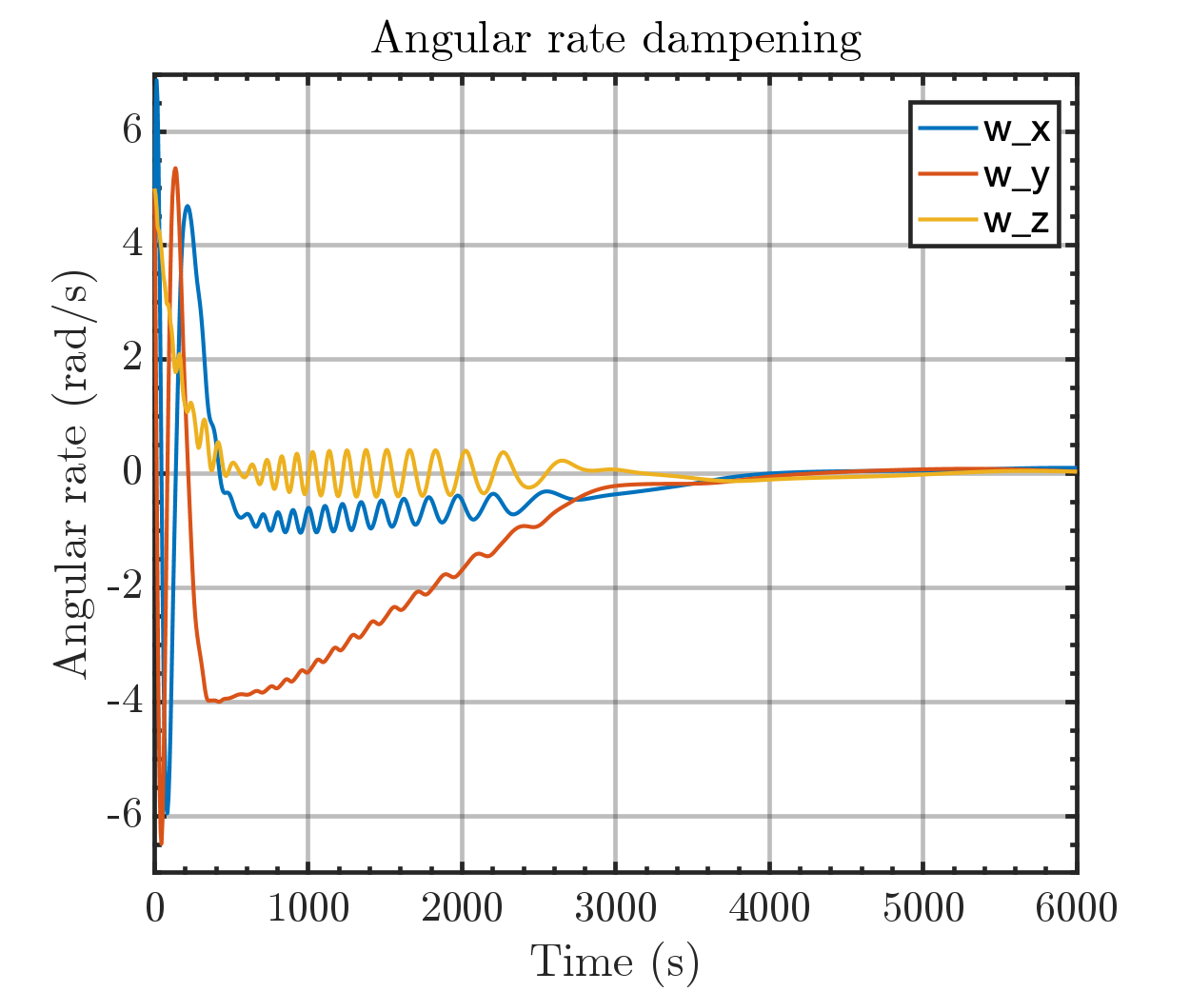

Same plot but with orbital periods

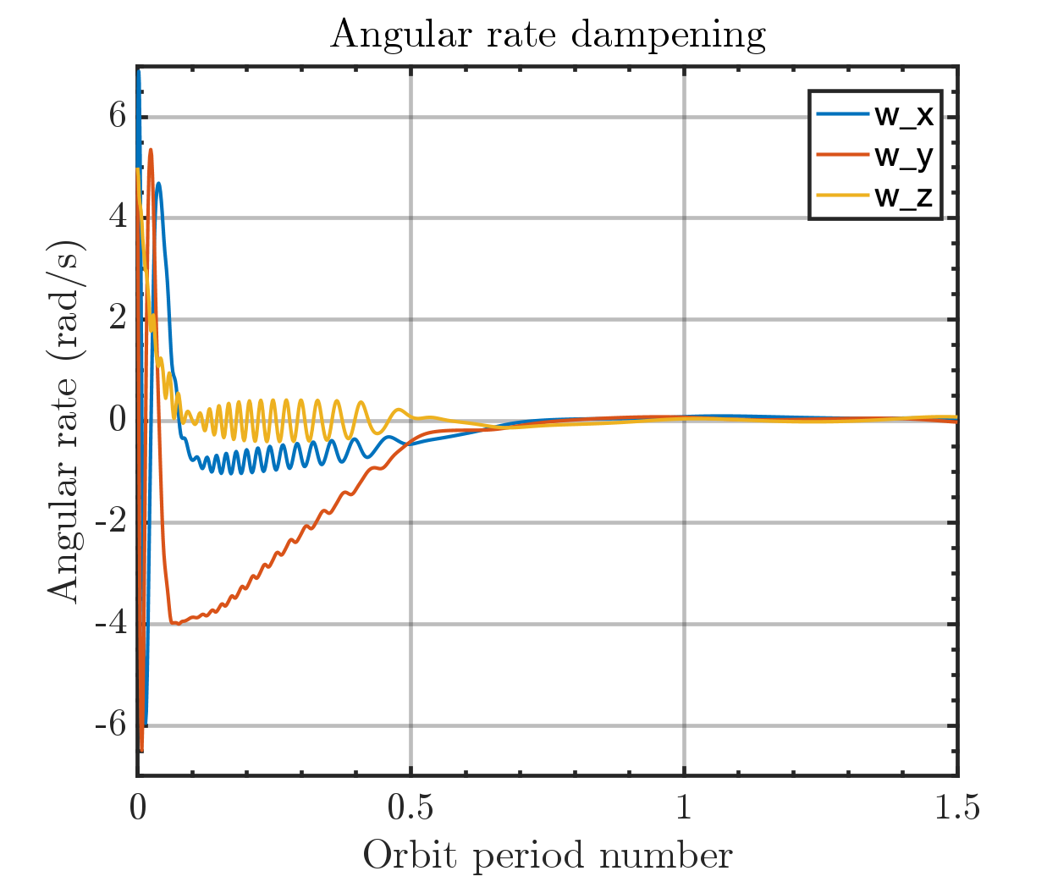

Output magmetic moment of Bdot controller

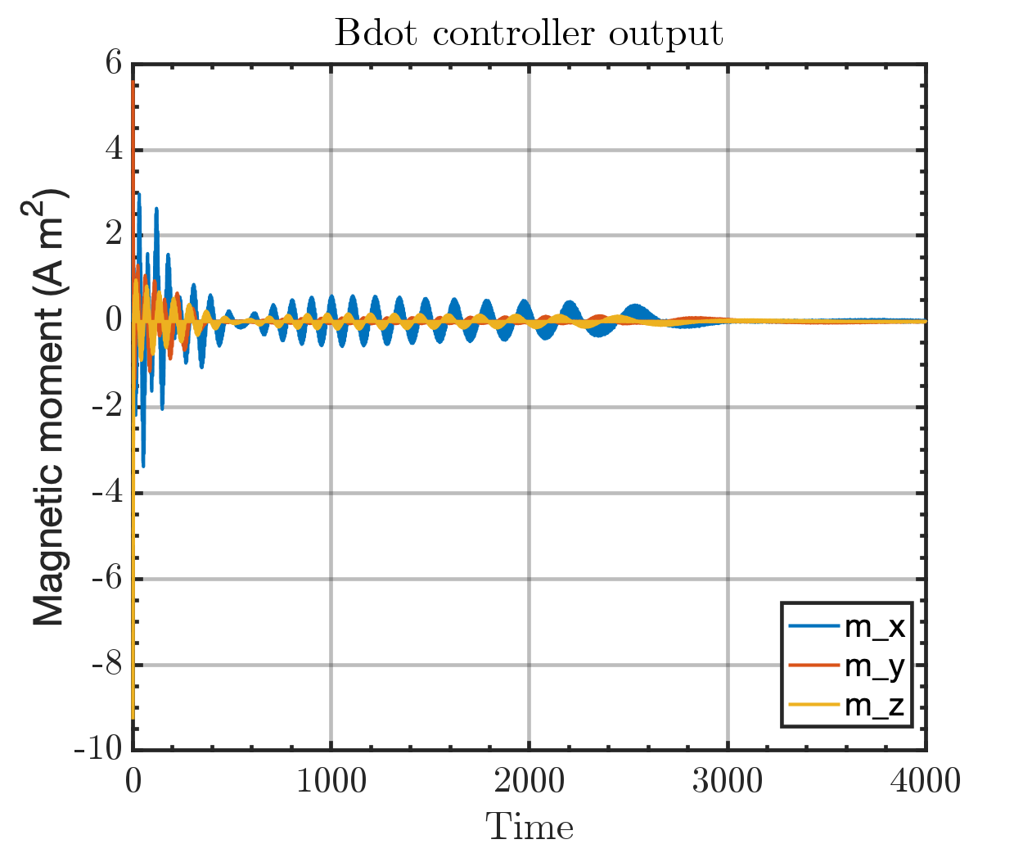

Run time: 2:34 min