**SIMULATION CASE NUMBER: 12**

Detumbling w/o magnetorquer. Initial conditions are: w = [7,2,0]. Tuning: K = [0.4,0.5,0.6]

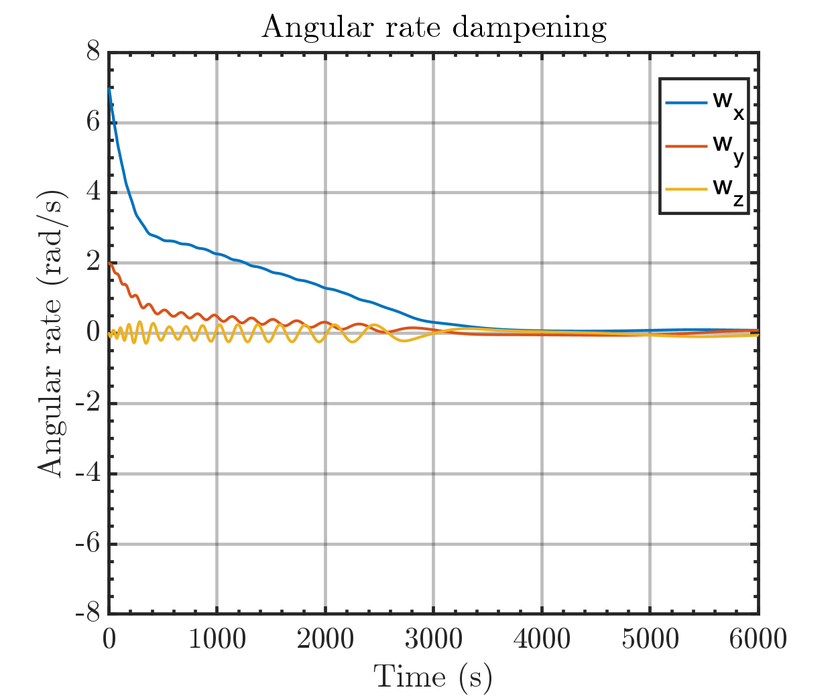

Same plot but with orbital periods

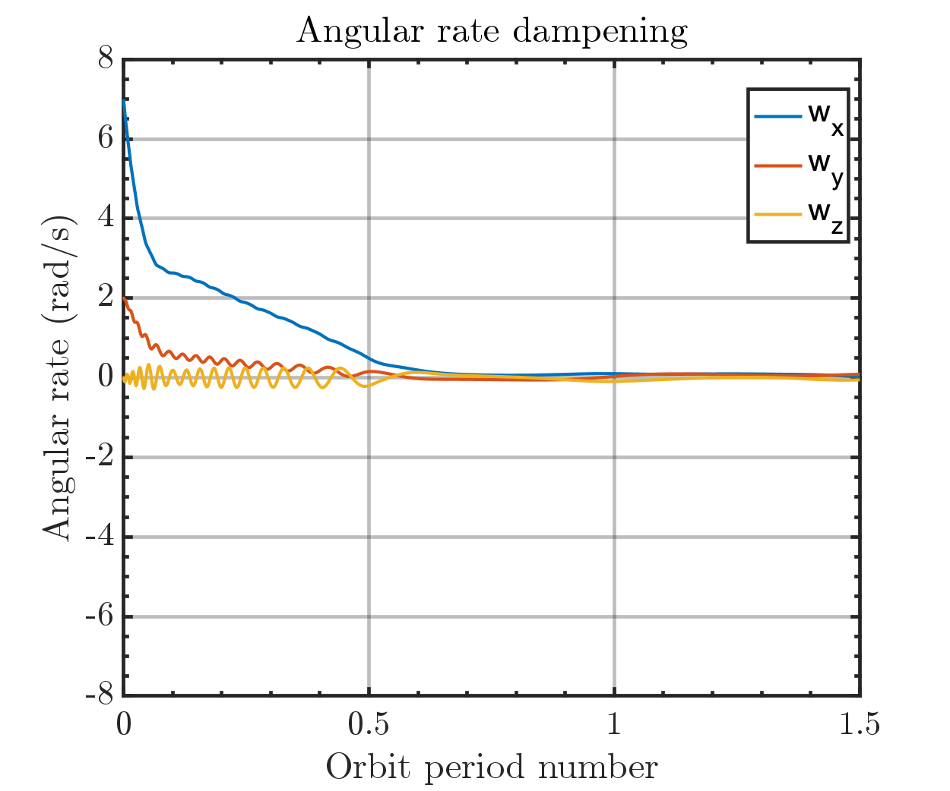

Output magmetic moment of Bdot controller

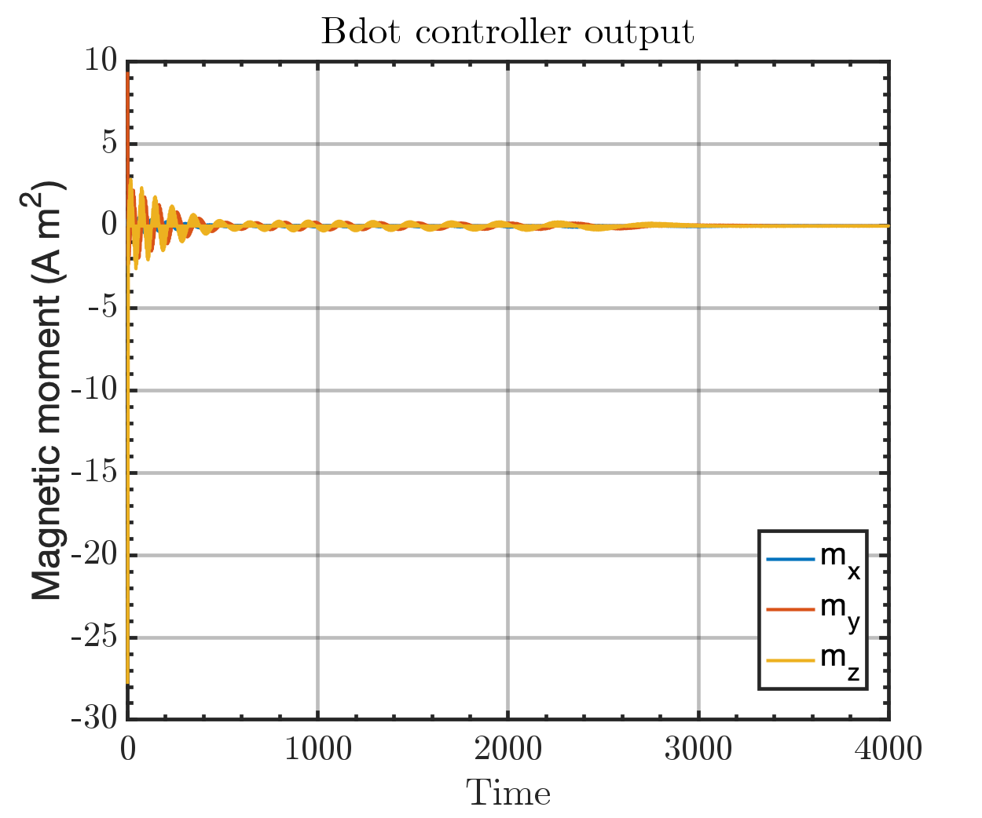

Run time: 2:34 min