**SIMULATION CASE NUMBER: 13**

Detumbling w/o magnetorquer. Initial conditions are: w = [5,0,-5]. Tuning: K = [0.6,0.5,0.2]

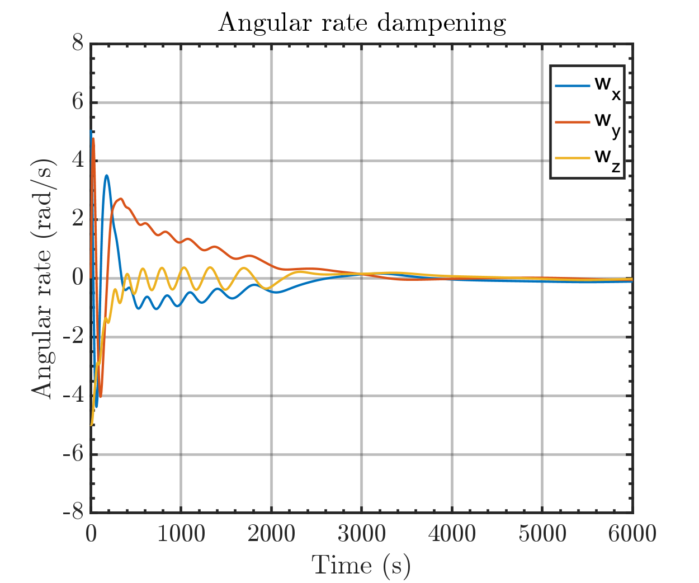

Same plot but with orbital periods

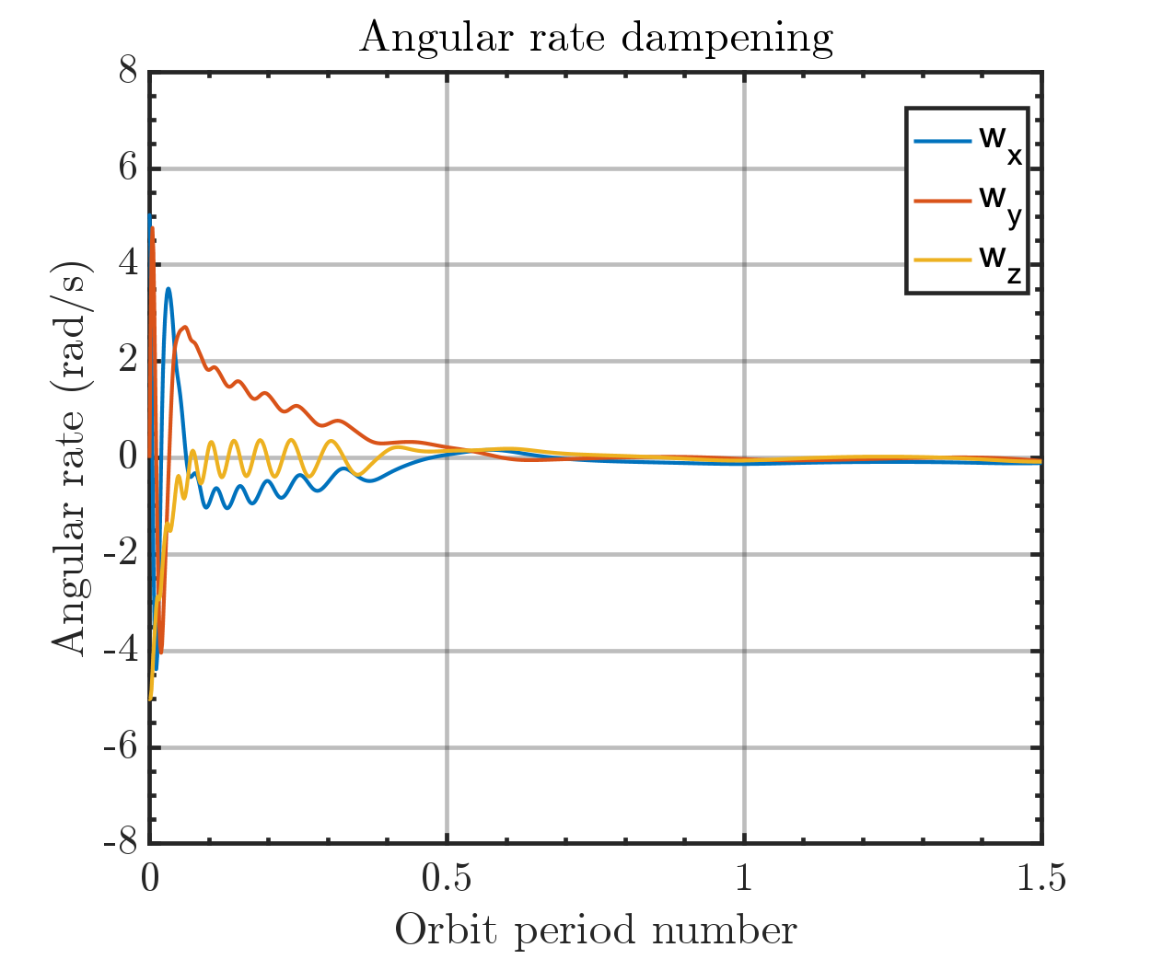

Output magmetic moment of Bdot controller

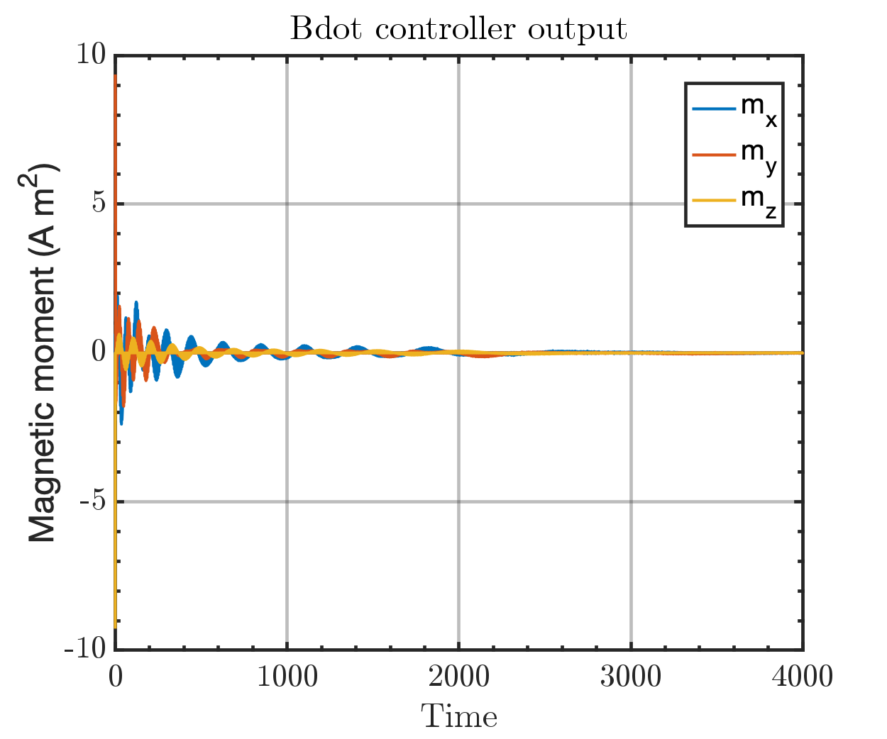

Run time: 2:55 min