**SIMULATION CASE NUMBER: 14**

Detumbling w/o magnetorquer. Initial conditions are: w = [10,0,0]. Tuning: K = [0.8,0.4,0.2]

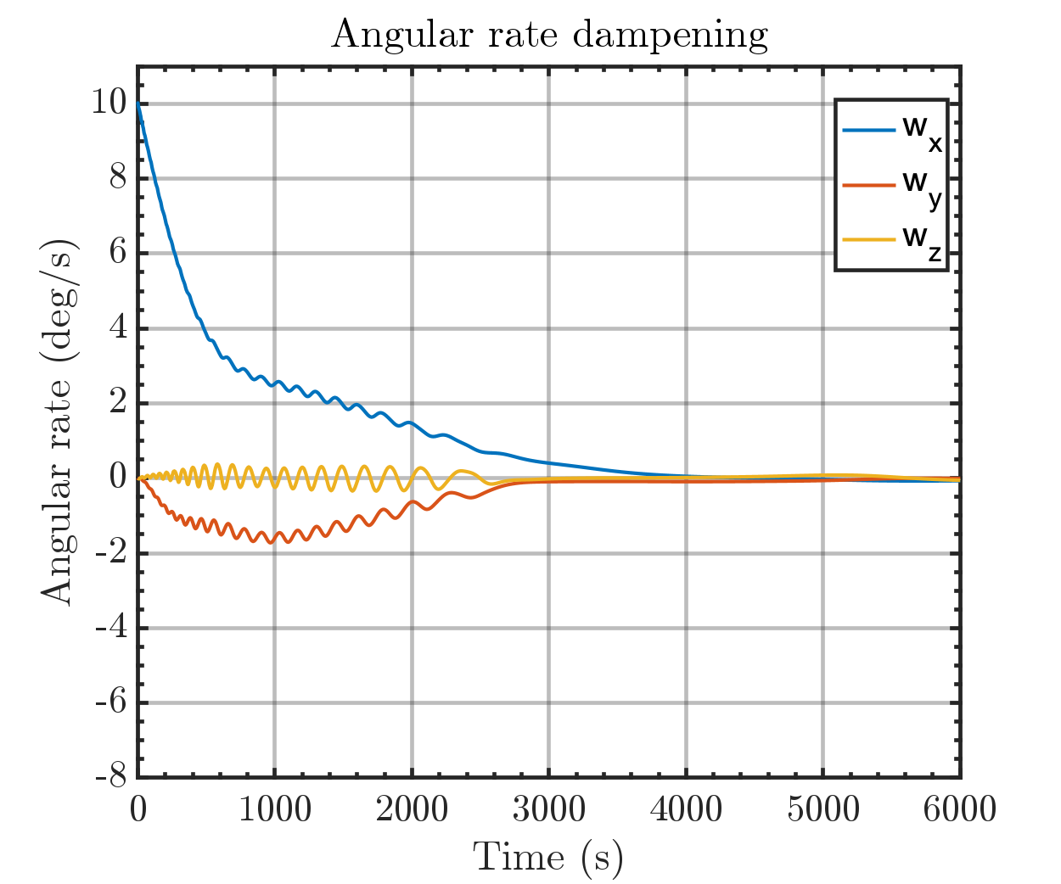

Same plot but with orbital periods

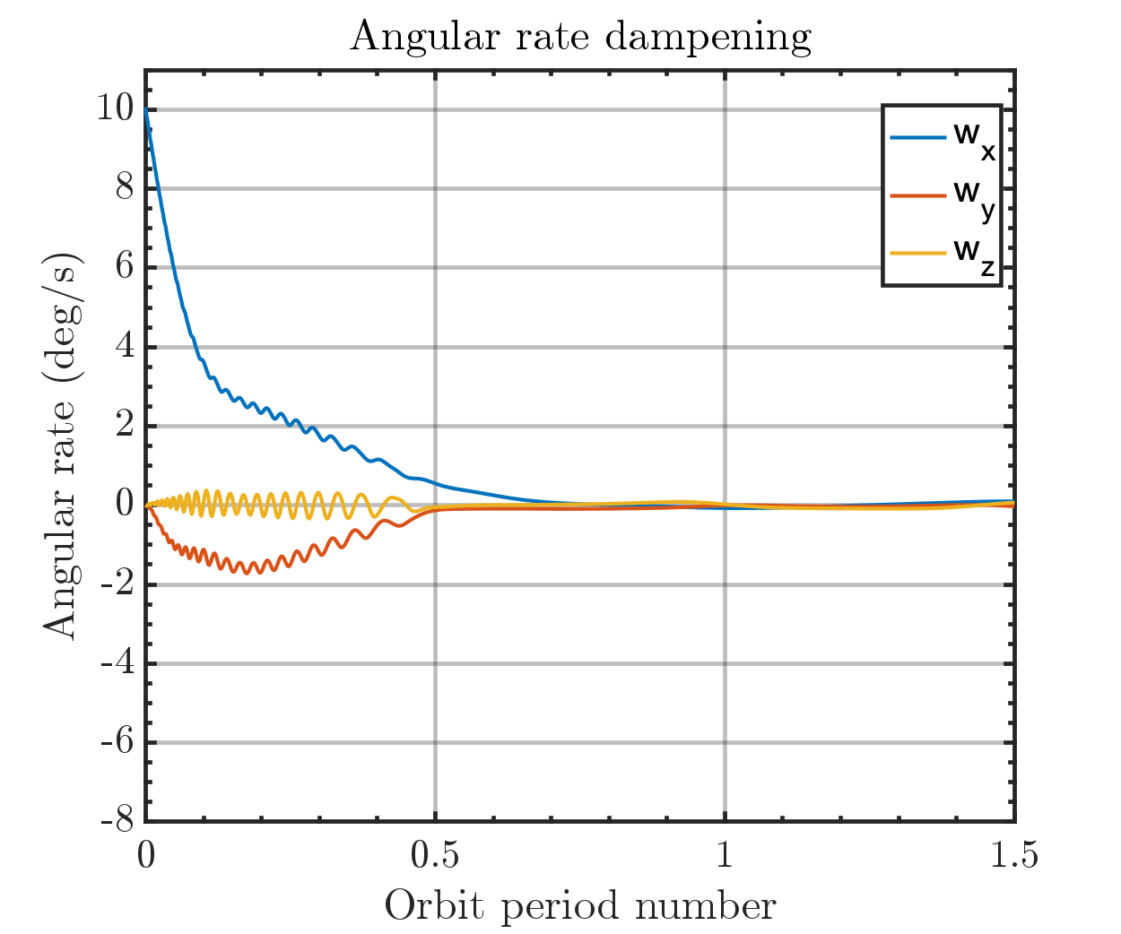

Output magmetic moment of Bdot controller

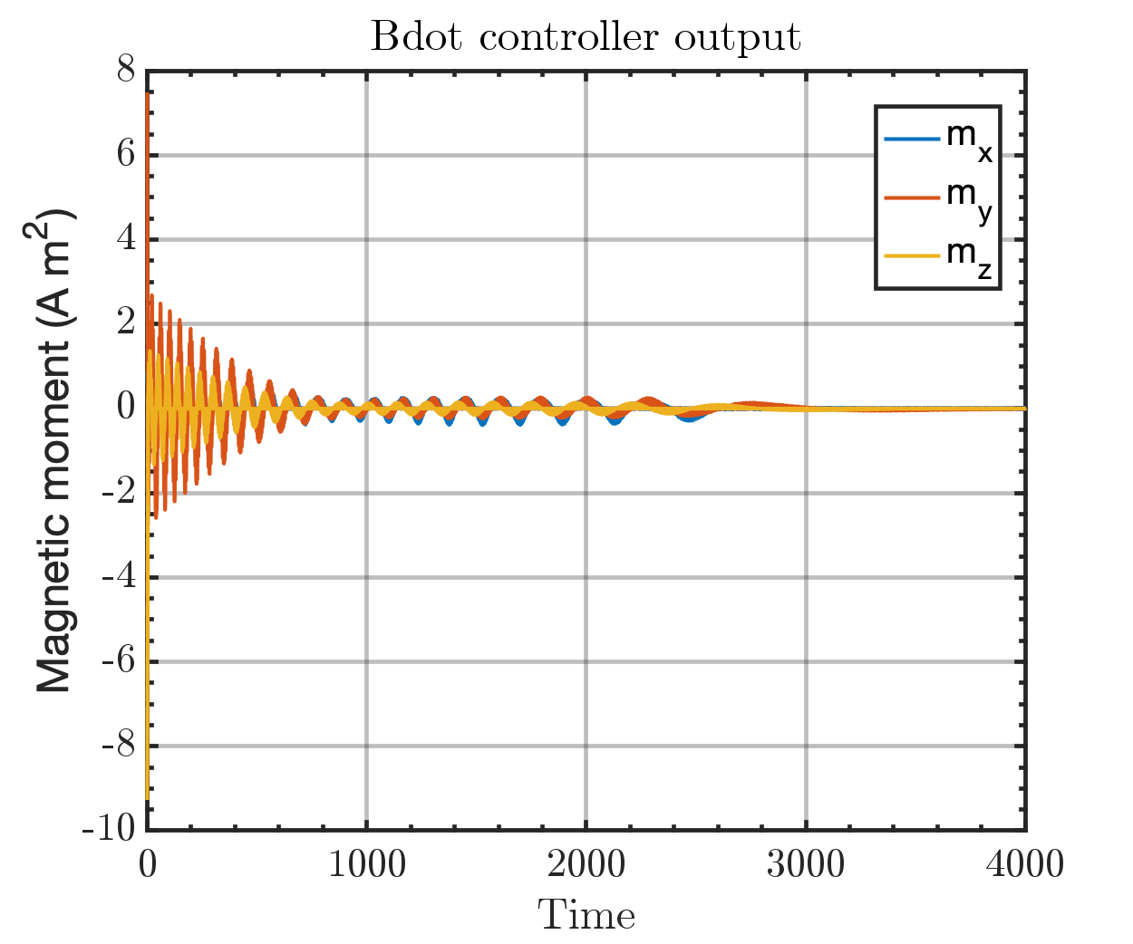

Run time: 2:57 min