**SIMULATION CASE NUMBER: 15**

Detumbling w/o magnetorquer. Initial conditions are: w = [7,7,7]. Tuning: K = [0.5,0.6,0.3]

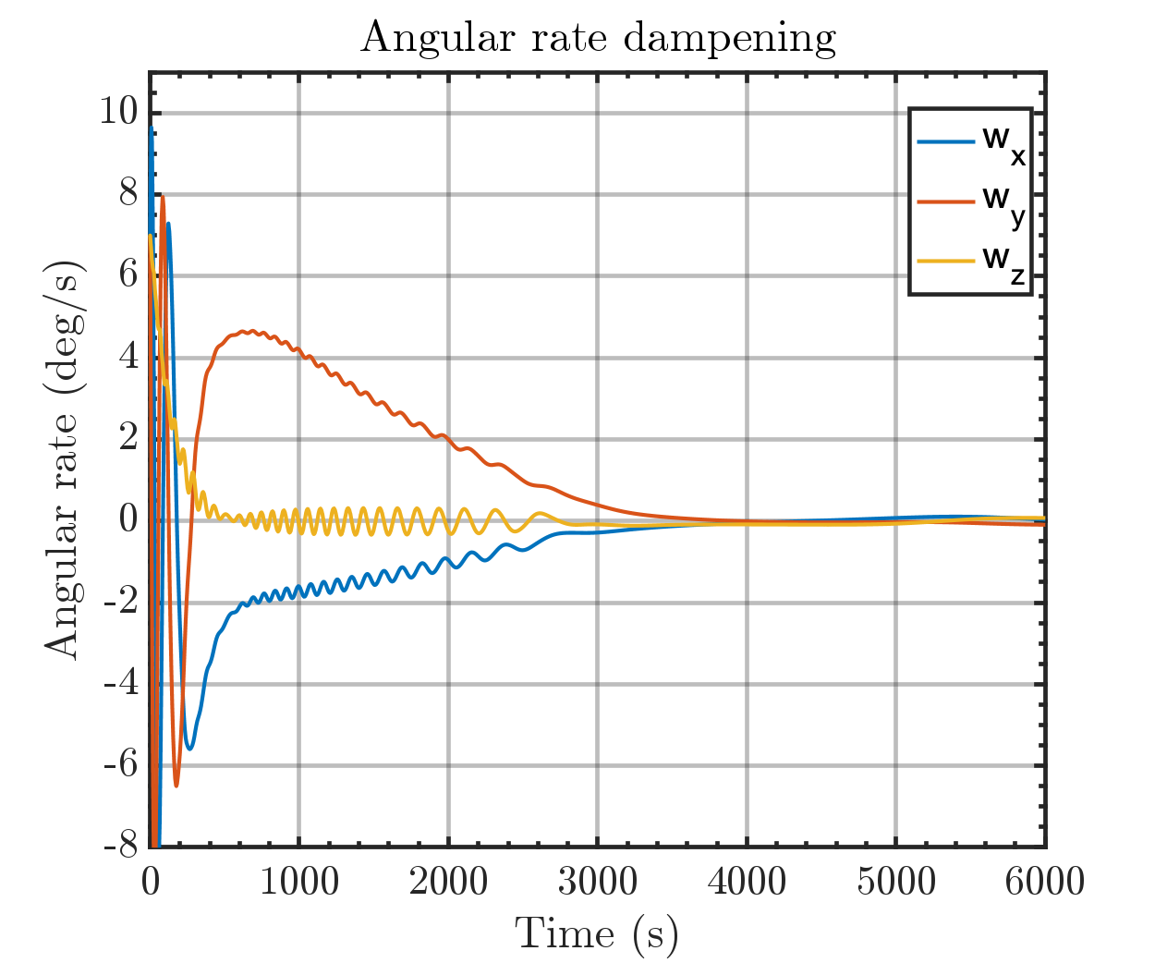

Same plot but with orbital periods

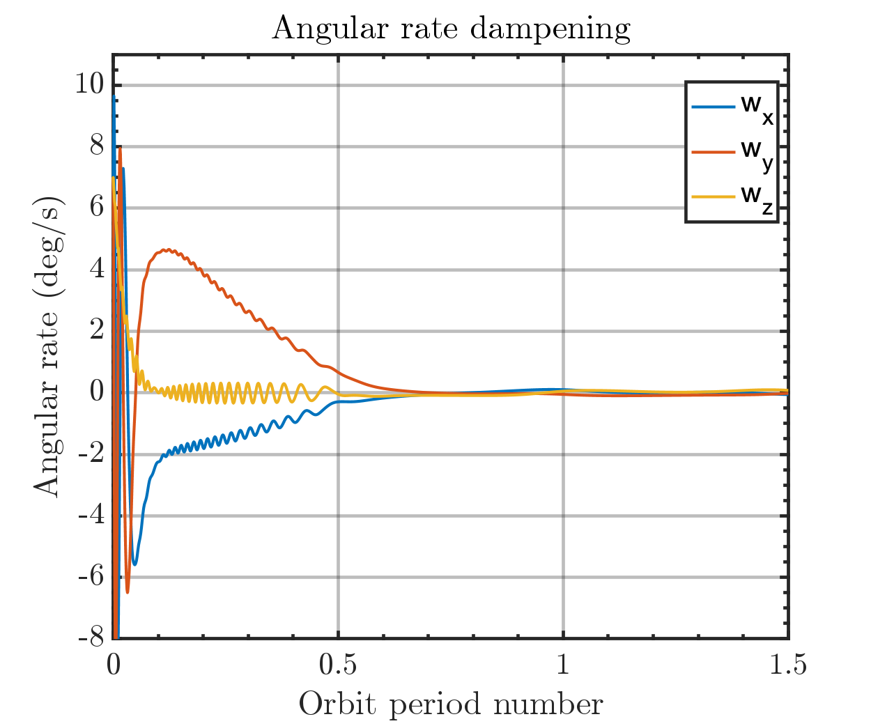

Output magmetic moment of Bdot controller

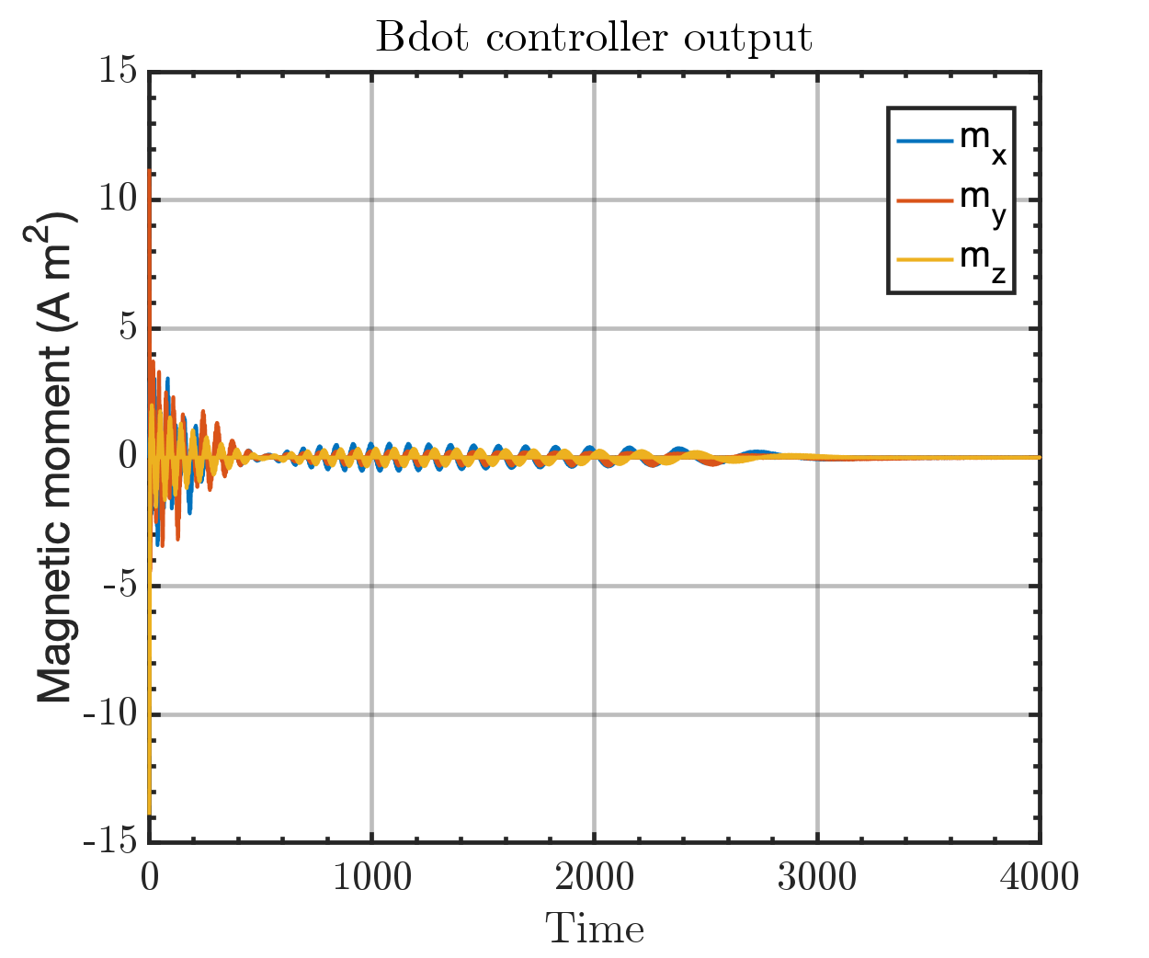

Run time: 2:57 min