**SIMULATION CASE NUMBER: 1**

Detumbling w/o magnetorquer. Initial conditions are: w = [5,1,2]. Tuning: K = 0.5,0.5,0.2

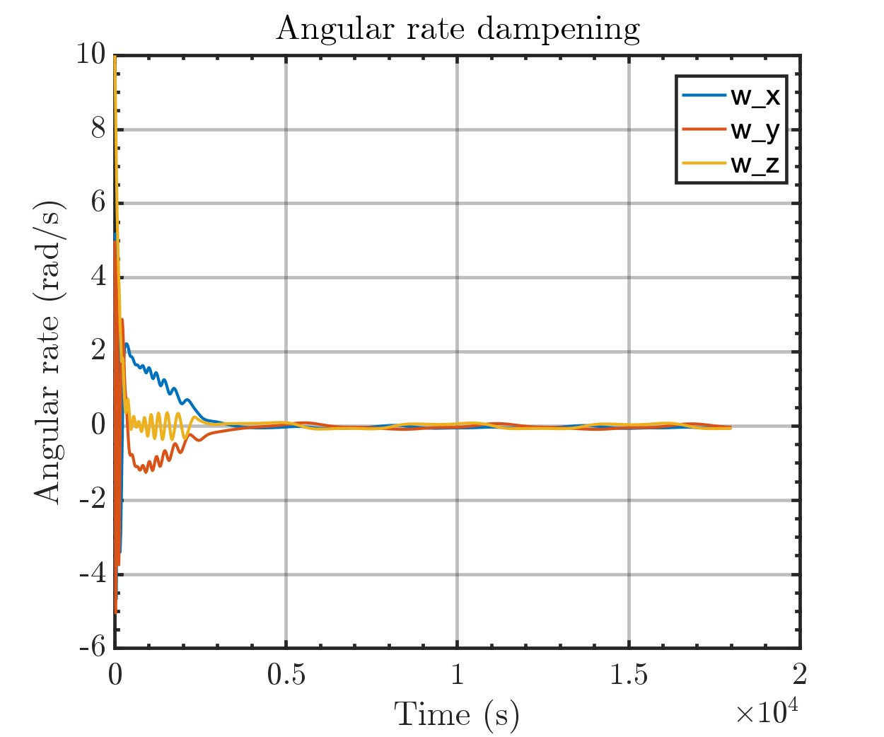

Same plot but with orbital periods

