1. Login:

Business function

Login only authorised user.

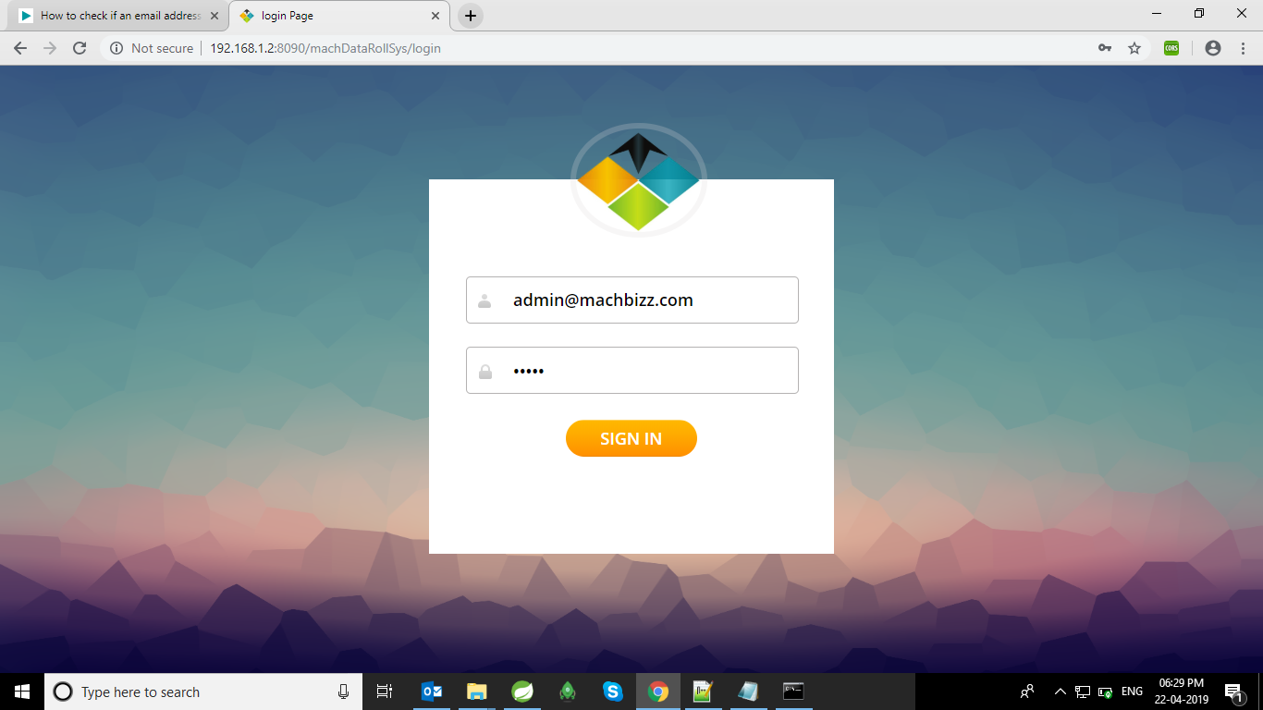

Put username & password. When user authentication is done then authorization process is start. User gives only access of url which is permitted by developer. Request forward to the dashboard.

Technical details:

1. Login-- username && password.
2. Call URL on LoginController-- /login(loginUser(@RequestParam("email")String, userName,@RequestParam("password")String password))
3. Call Service on LoginService : loginUser(userName, password)

Check the credential and return user or null.

1. DashBoard:

Business function

Display all Dashboard

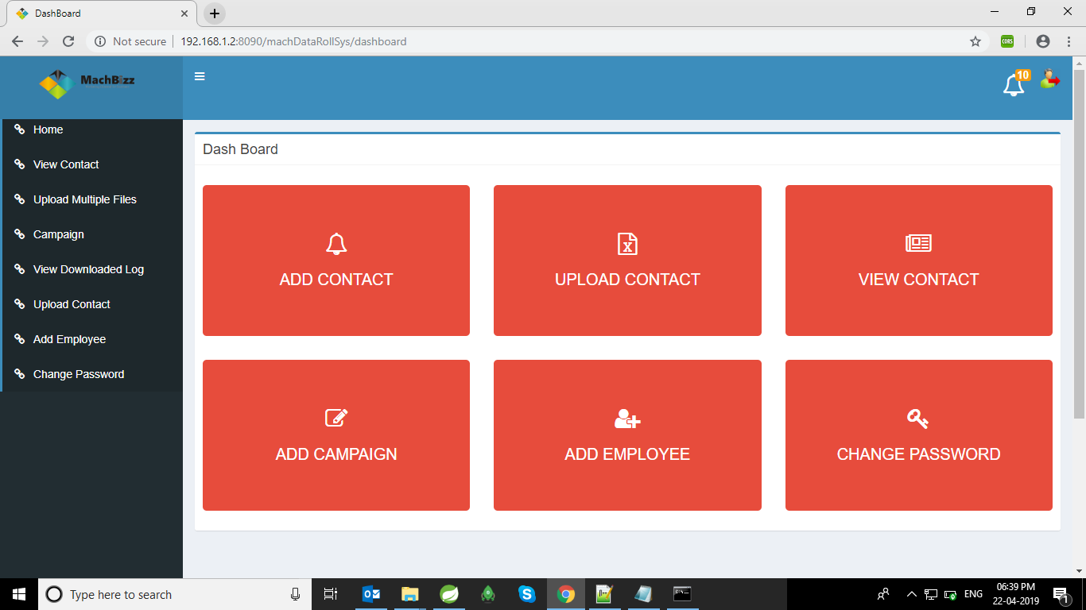

Display only menu which is accessible or allow to that particular user.

Technical details:

View - dashboard

Call URL on LoginController-- /login

(loginUser(@RequestParam("email”) String, userName,@RequestParam("password")String password))

Call Service on LoginService : loginUser(userName, password)

Check the credential and return user or null.

1. Add-Campaign:

Operation: Create, Update, Delete Campaign, Display All Campaign

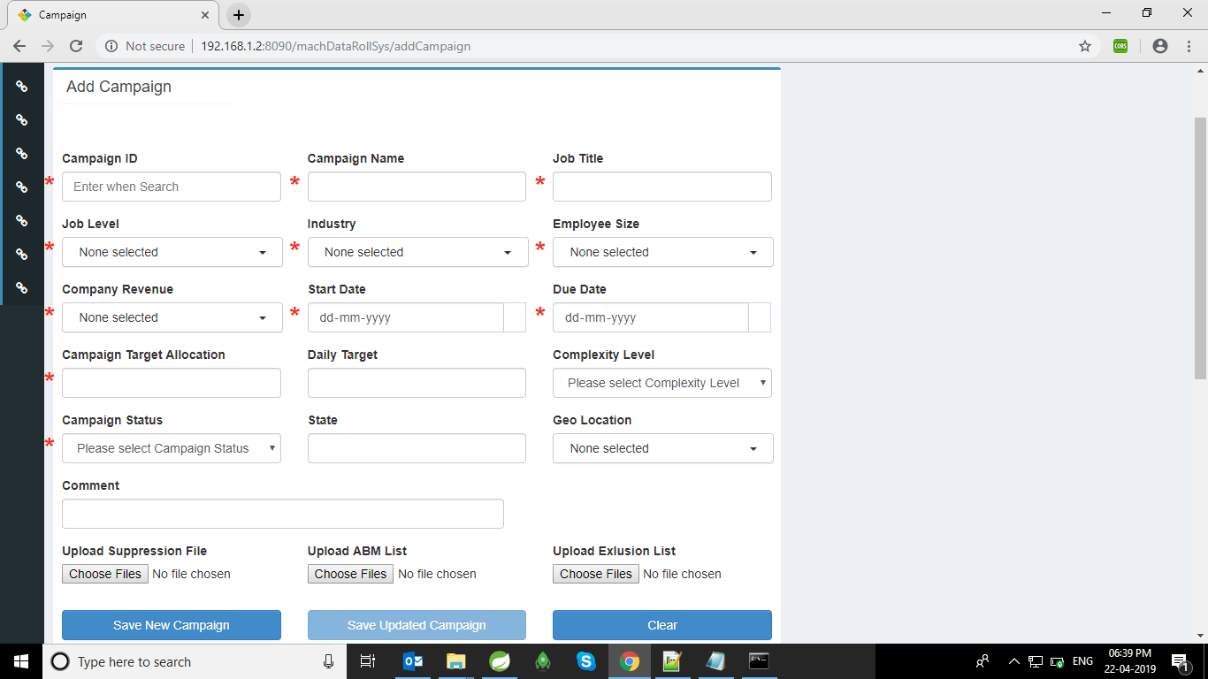

DMA && DMA-TL create new campaign, update existing Campaign, delete existing Campaign

Technical details:

View - AddCampaign

Call URL on CampaignController-- /addCampaign

**public** @ResponseBody String addCampaign(@RequestParam("campaignIdByUser") String campaignIdByUser,@RequestParam("campaignName") String campaignName, @RequestParam("jobTitle") String jobTitle,@RequestParam("industries") String industryType,@RequestParam("employeeSizes") String employeeSize, @RequestParam("revenues") String companyRevenue) {

Call Service on CampaignService : campaignService.insertCampaign(campaign);

save employee in DB.

Input: Campaign Specification

Output: Save the Campaign Changes

1. Verify-Campaign:

Operation: Save Status

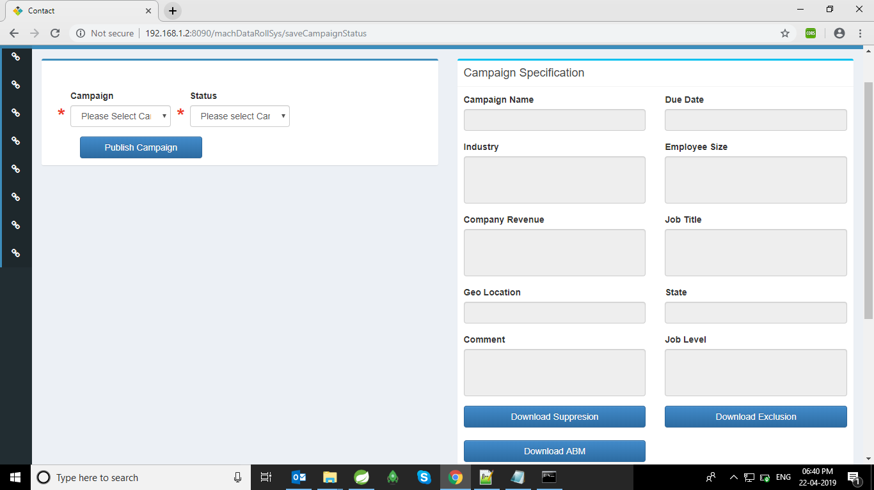

DMA && DMA-TL check all campaign specification, abm , exclusion , suppression detail and Start campaign.

Technical details:

View - verifyCampaignSpecification

Call URL on CampaignController-- /saveCampaignStatus

public ModelAndView verifyCampaignSpecification(HttpServletRequest request)

Call Service on CampaignService :

campaignService.update(oldCampaign);

1. Upload-Multiple-Files:

Operation: Upload files

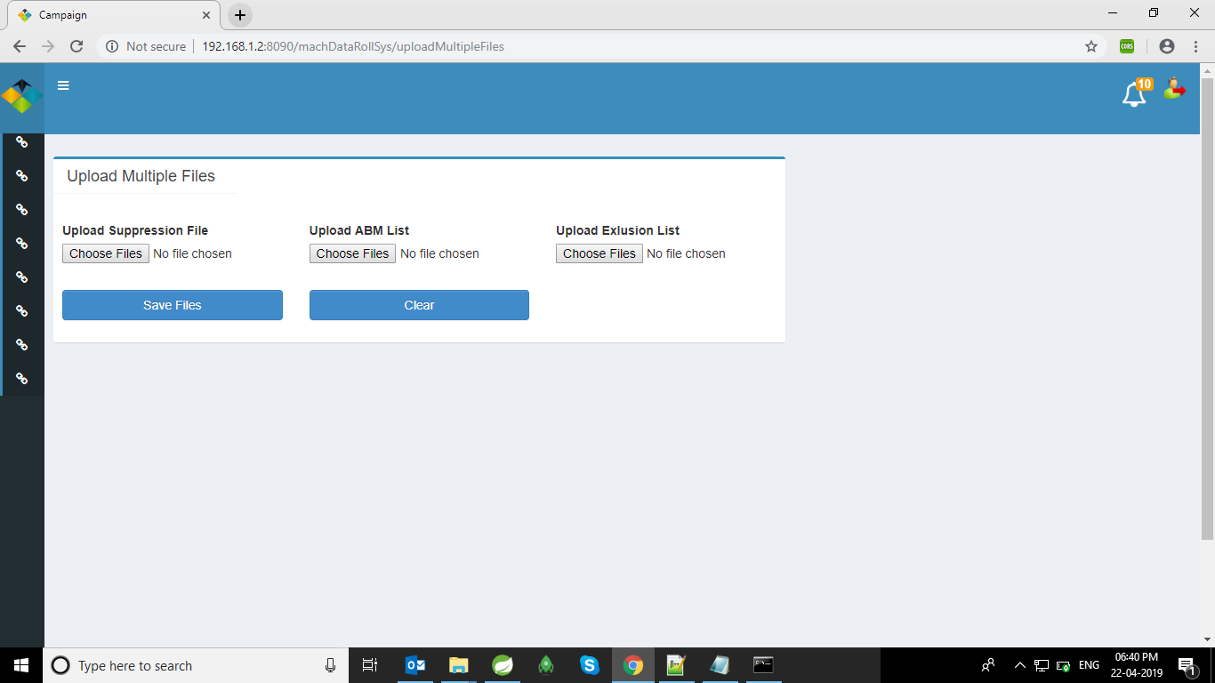

DMA && DMA-TL check upload multiple abm , exclusion , suppression Files & that file will be visible for search criteria in View-Contact.

Technical details:

View - uploadMultipleFiles

Call URL on dmaController-- /uploadMultipleFiles

**public** ModelAndView uploadMultipleFiles(

@RequestParam(value = "suppressionFile", required = **false**) MultipartFile[] suppressionFile,

@RequestParam(value = "ABMFile", required = **false**) MultipartFile[] ABMFile,

@RequestParam(value = "exclusionFile", required = **false**) MultipartFile[] exclusionFile,

HttpServletRequest request)

Call Service on dmaService :

dmaService.saveMultipleFiles(uploadMultipleFiles);

1. View-Contact:

Operation: Searching Contact from DB

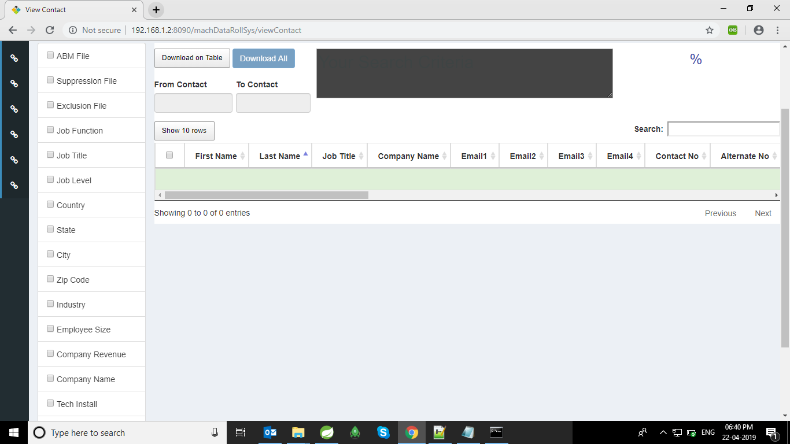

DMA && DMA-TL, Admin, RA-Manger set the criteria as per need & search contact from database.

Technical details:

View - viewContact

Call URL on dmaController-- / viewContactPagination

**public synchronized @ResponseBody List<Contact> fetechContactPagination(**

**@RequestParam(value = "jobTitle", required = false) String jobTitle,**

**@RequestParam(value = "jobLevels", required = false) List<String> jobLevels,**

**@RequestParam(value = "countries", required = false) List<String> countries,**

**@RequestParam(value = "states", required = false) String state,**

**@RequestParam(value = "industries", required = false) List<String> industries,**

**@RequestParam(value = "employeeSizes", required = false) List<String> employeeSize,**

**@RequestParam(value = "revenues", required = false) List<String> revenues,**

**@RequestParam(value = "departments", required = false) List<String> departments,**

**// @RequestParam(value="domains",required=false)String domain,**

**// @RequestParam(value="abmFile",required=false) MultipartFile abmFile,**

**@ModelAttribute(value = "pageNumber") int pageNumber, @ModelAttribute(value = "nPerPage") int nPerPage,**

**@RequestParam(value = "companyName") String companyName,**

**@RequestParam(value = "techInstall") String techInstall, @RequestParam(value = "cart") Boolean cart,**

**@RequestParam(value = "city") String city, @RequestParam(value = "zipCode") String zipCode,**

**HttpServletRequest request)**

Call Service on dmaService :

dmaService.findContactByCriteria(countries, industries, employeeSize, state,

jobLevels, revenues, departments, jobTitle, emails, pageNumber, nPerPage, abmCompanyList, abmDomainList, clientSeparationList, exclusionCompanyList, exclusionDomainList, companyName, techInstall, cart, city,zipCode);

1. View-Download-Log:

Operation: Download contact Existed Criteria

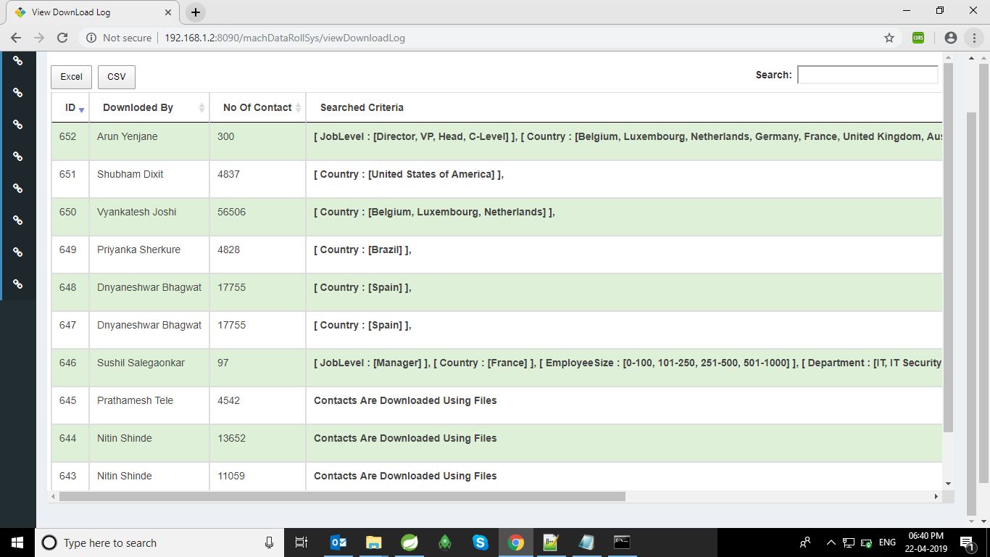

DMA && DMA-TL, Admin use existing search criteria for downloading contact from Database

Technical details:

View - viewDownloadLog

Call URL on dmaController-- / viewDownloadLog

**public ModelAndView viewDownloadLog(HttpServletRequest request)**

Call Service on dmaService :

dmaService.viewDownloadLog()

1. DMA-Campaign-Report:

Operation: find contact by campaign wise

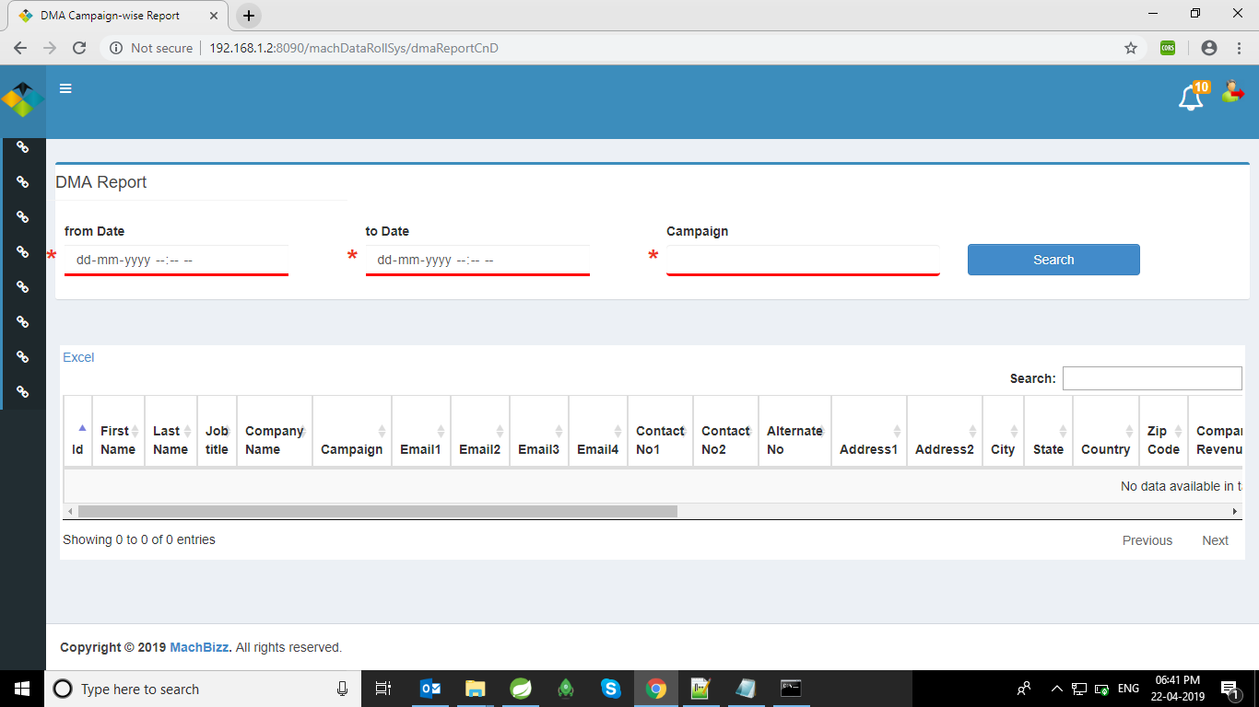

DMA && DMA-TL , Admin search campaign-contact Report on given range.

Technical details:

View - DMAReport

Call URL on dmaController-- /dmaReportCnD

**public** ModelAndView dmaReportCnD(@RequestParam("fromDate") String fromDateStr,

@RequestParam("toDate") String toDateStr,

@RequestParam("campaignId") Integer campaignId, HttpServletRequest request)

Call Service on dmaService :

dmaService.dmaReportCnD(fromDate, toDate, campaignId, null);

1. Change-Password:

Operation: Changes Password

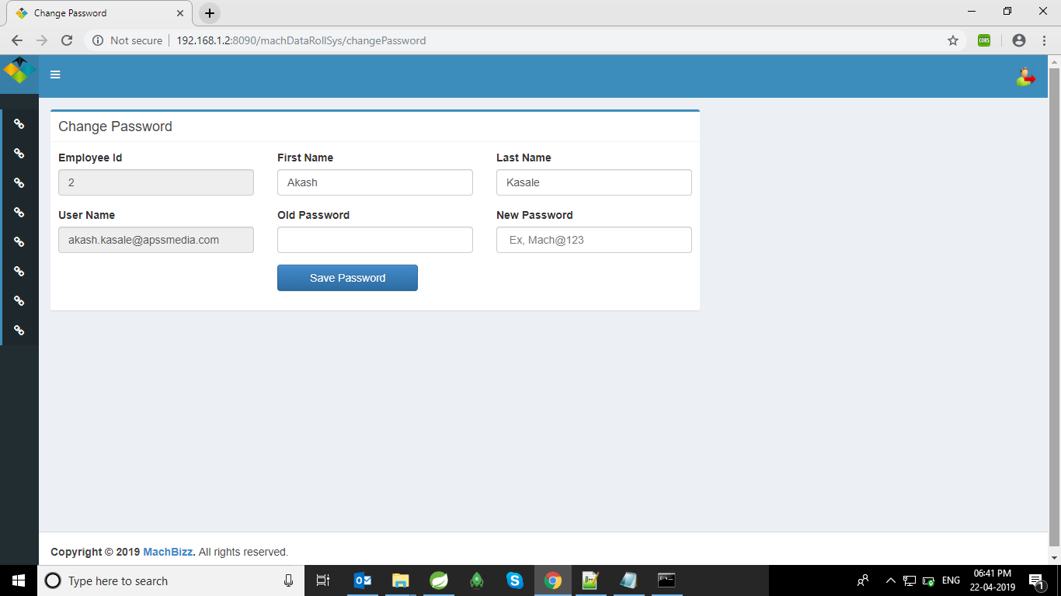

All user can access this page & change existing credential.

Technical details:

View - changePassword

Call URL on loginController-- / changePassword

**public** ModelAndView changePassword(@RequestParam("employeeId")Integer employeeId,@RequestParam("oldPassword")String oldPassword, @RequestParam("firstName")String firstName,

@RequestParam("lastName")String lastName,

@RequestParam("username")String userName,

@RequestParam("password")String password,

@RequestParam("newPassword")String newPassword,

HttpServletRequest request)

Call Service on loginService :

loginService.updateEmp(employee);

1. Add Contact:

Operation: Add, Edit Contact,Add to Campaign

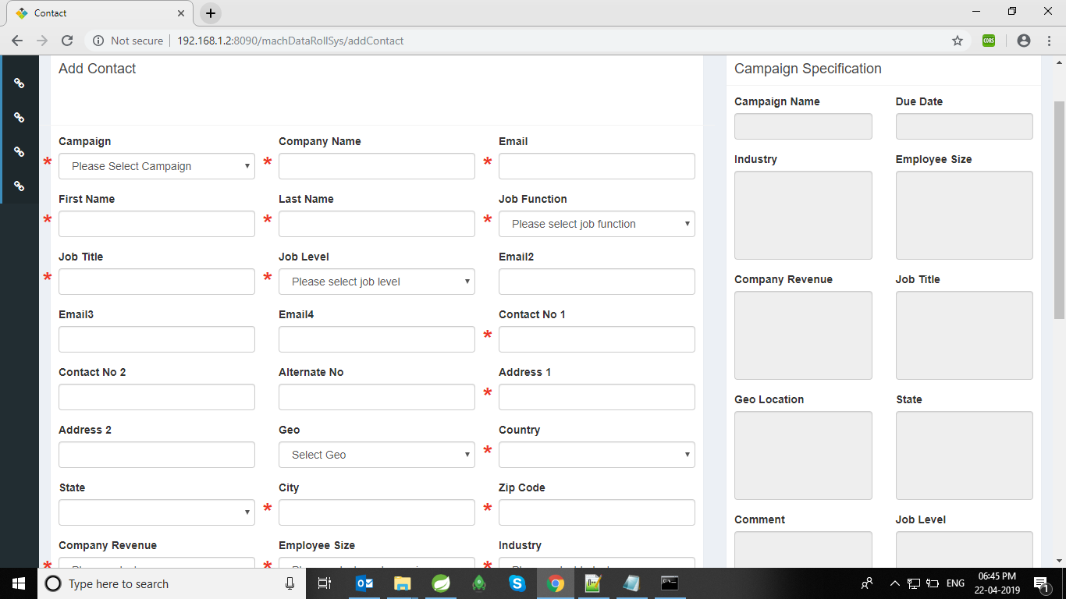

RA & RA-TL add new contact and also update existing contact as per the campaign specification.

Technical details: View - addContact

Call URL on raController-- /addContact or /updateContact

**public** @ResponseBody String addContact(

@RequestParam("contactFirstName") String firstName,

@RequestParam("contactLastName") String lastName,

@RequestParam("contactJobTitle") String jobTitle,

@RequestParam("contactCompanyName") String companyName,

@RequestParam("contactEmail1") String email1,

@RequestParam("contactEmail2") String email2,

@RequestParam("contactEmail3") String email3,

@RequestParam("contactEmail4") String email4,

@RequestParam("contactNo1") String contactNo1,

@RequestParam("alternateNo") String alternateNo,

@RequestParam("contactAddress1") String address1,

@RequestParam("contactCity") String city,

@RequestParam("contactState") String state,

@RequestParam("contactCountry") String country,

@RequestParam("contactZipcode") String zipCode,

@RequestParam("contactCompanyRevenue") String companyRevenue,

@RequestParam("contactCompanyEmpSize") String companyEmpSize,

@RequestParam("contactCompanyLink") String companyLink,

@RequestParam("contactProspectLink") String prospectLink,

@RequestParam("contactIndustryType") String industryType,

@RequestParam("contactDepartment") String department,

@RequestParam("contactCampaignName") Integer campaignId, @RequestParam("contactJobLevel") String jobLevel,

@RequestParam("contactNo2") String contactNo2,

@RequestParam("contactAddress2") String address2,

@RequestParam("contactGeo") String geo,

@RequestParam("prospectWorkLocation") String prospectWorkLocation,

@RequestParam("prospectHeadquarterLocation") String prospectHeadquarterLocation,

// @RequestParam("installBase") String installBase,

@RequestParam("domain") String domain,

@RequestParam("cart") Boolean cart,

@RequestParam("dmaComment") String dmaComment,

@RequestParam("techInstall") String techInstall,

@RequestParam("emailVerifyLink") String emailVerifyLink,

HttpServletRequest request)

// for Update

**public** @ResponseBody String updateContact(@RequestParam("contactId") Integer contactId,

@RequestParam("contactFirstName") String firstName, @RequestParam("contactLastName") String lastName,

@RequestParam("contactJobTitle") String jobTitle, @RequestParam("contactCompanyName") String companyName,

@RequestParam("contactEmail1") String email1,

@RequestParam("contactEmail2") String email2,

@RequestParam("contactEmail3") String email3,

@RequestParam("contactEmail4") String email4,

@RequestParam("contactNo1") String contactNo1,

@RequestParam("alternateNo") String alternateNo,

@RequestParam("contactAddress1") String address1,

@RequestParam("contactCity") String city,

@RequestParam("contactState") String state,

@RequestParam("contactCountry") String country,

@RequestParam("contactZipcode") String zipCode,

@RequestParam("contactCompanyRevenue") String companyRevenue,

@RequestParam("contactCompanyEmpSize") String companyEmpSize,

@RequestParam("contactCompanyLink") String companyLink,

@RequestParam("contactProspectLink") String prospectLink,

@RequestParam("contactIndustryType") String industryType,

@RequestParam("contactDepartment") String department,

@RequestParam("contactCampaignName") Integer campaignId, @RequestParam("contactJobLevel") String jobLevel,

@RequestParam("contactNo2") String contactNo2,

@RequestParam("contactAddress2") String address2,

@RequestParam("contactGeo") String geo,

@RequestParam("prospectWorkLocation") String prospectWorkLocation,

@RequestParam("prospectHeadquarterLocation") String prospectHeadquarterLocation,

@RequestParam("domain") String domain,

@RequestParam("cart") Boolean cart,

@RequestParam("dmaComment") String dmaComment,

@RequestParam("techInstall") String techInstall,

@RequestParam("emailVerifyLink") String emailVerifyLink,

HttpServletRequest request)

// For AddtoCampaign

@RequestMapping(value = "addToCampaign", method = RequestMethod.POST)

public @ResponseBody String addToCampaign(@RequestParam("contactId") Integer contactId,

@RequestParam("contactFirstName") String firstName, @RequestParam("contactLastName") String lastName,

@RequestParam("contactJobTitle") String jobTitle, @RequestParam("contactCompanyName") String companyName,

@RequestParam("contactEmail1") String email1, @RequestParam("contactEmail2") String email2,

@RequestParam("contactEmail3") String email3, @RequestParam("contactEmail4") String email4,

@RequestParam("contactNo1") String contactNo1, @RequestParam("alternateNo") String alternateNo,

@RequestParam("contactAddress1") String address1, @RequestParam("contactCity") String city,

@RequestParam("contactState") String state, @RequestParam("contactCountry") String country,

@RequestParam("contactZipcode") String zipCode,

@RequestParam("contactCompanyRevenue") String companyRevenue,

@RequestParam("contactCompanyEmpSize") String companyEmpSize,

@RequestParam("contactCompanyLink") String companyLink,

@RequestParam("contactProspectLink") String prospectLink,

@RequestParam("contactIndustryType") String industryType,

@RequestParam("contactDepartment") String department,

@RequestParam("contactCampaignName") Integer campaignId, @RequestParam("contactJobLevel") String jobLevel,

@RequestParam("contactAddress2") String address2,

@RequestParam("contactGeo") String geo, @RequestParam("prospectWorkLocation") String prospectWorkLocation,

@RequestParam("prospectHeadquarterLocation") String prospectHeadquarterLocation,

@RequestParam("domain") String domain, @RequestParam("cart") Boolean cart,

@RequestParam("dmaComment") String dmaComment, @RequestParam("techInstall") String techInstall,

@RequestParam("emailVerifyLink") String emailVerifyLink,@RequestParam("updatedJobTitle") String updatedJobTitle,

@RequestParam("revenueLink") String revenueLink,

@RequestParam("NAICSCode") String NAICSCode,

@RequestParam("NAICSCodeLink") String NAICSCodeLink,

@RequestParam("SICSCode") String SICSCode,

@RequestParam("SICSCodeLink") String SICSCodeLink,

@RequestParam("specificRevenue") String specificRevenue,

HttpServletRequest request)

Call Service on dmaService :

raService.addContact(contact);

//for Update

raService.updateContact(contact);

1. RA-Report:

Operation: Download RA (own) Contact Report.

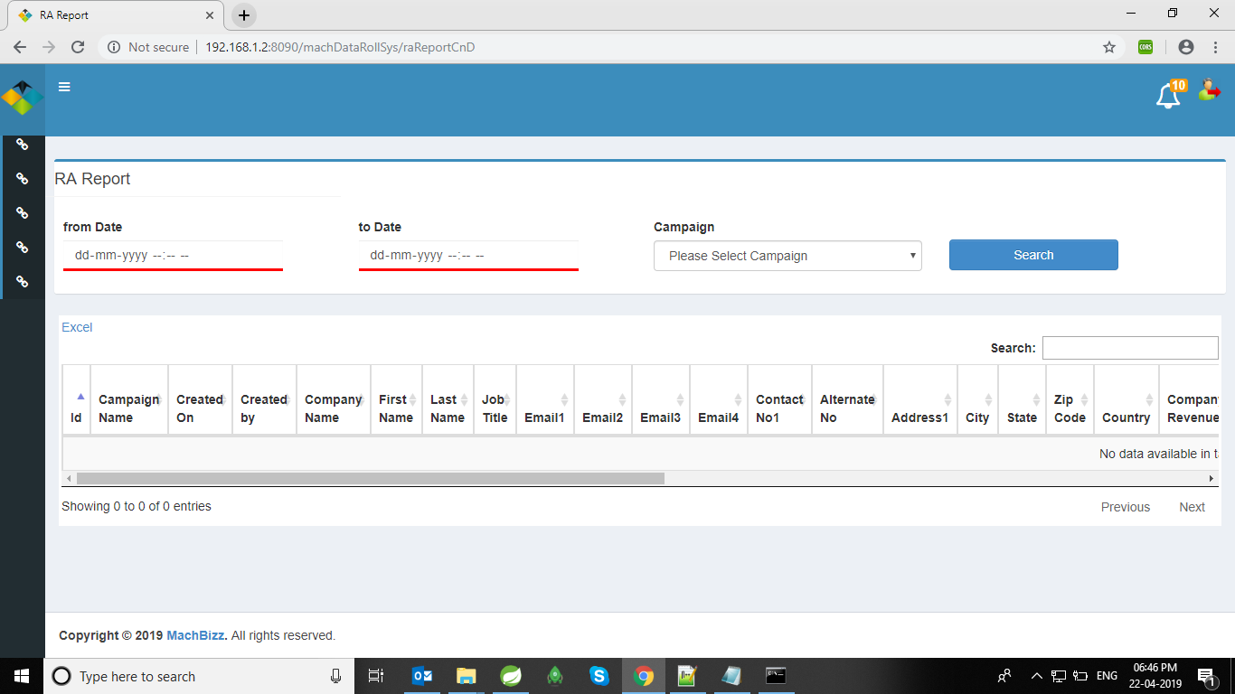

RA has download Campaign-wise-report. Ra has displayed Campaign only which is work by him(RA).

Technical details:

View - RAReportCnD

Call URL on RaController-- / raReportCnD

**public** ModelAndView raReportCnD(@RequestParam("fromDate") String fromDateStr,

@RequestParam("toDate") String toDateStr, @RequestParam("campaignId") Integer campaignId,HttpServletRequest request)

Call Service on RaService :

raService.raTLReportCnDLazyLoading(fromDate, toDate, campaignId, employeeId,employee))

1. Search-Existing-record:

Operation: Search existing record

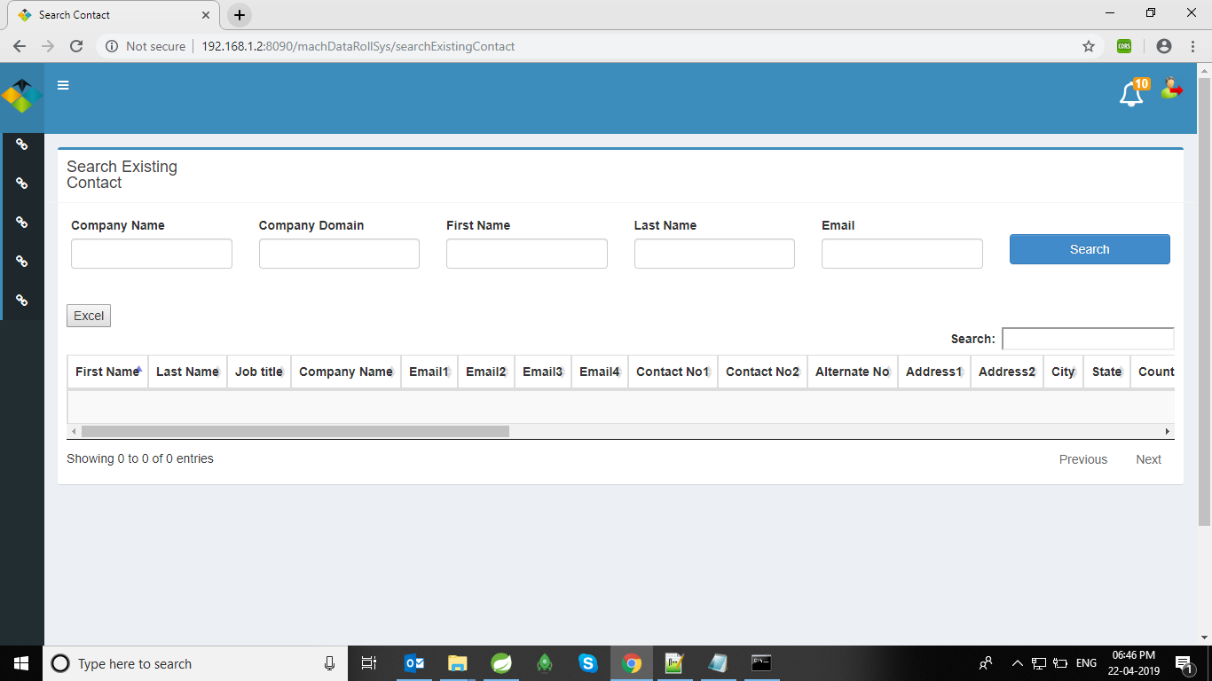

RA & RA-TL check the existing data by firing the search criteria company-name, company-domain, First-name, Last-Name, Email.

Technical details:

View - searchExistingContact

Call URL on RaController-- / searchExistingContact

**public** ModelAndView viewExistingContact(

@RequestParam("companyName") String companyName,

@RequestParam("companyDomain") String companyDomain,

@RequestParam("firstName") String firstName,

@RequestParam("lastName") String lastName,

@RequestParam("email") String email,HttpServletRequest request)

Call Service on RaService :

raService.findExistingContactByRa(companyName, companyDomain, firstName, lastName,currentCompany,email))

1. View-Allocate-RA-on-Campaign:

Operation: Check current working campaign of RA

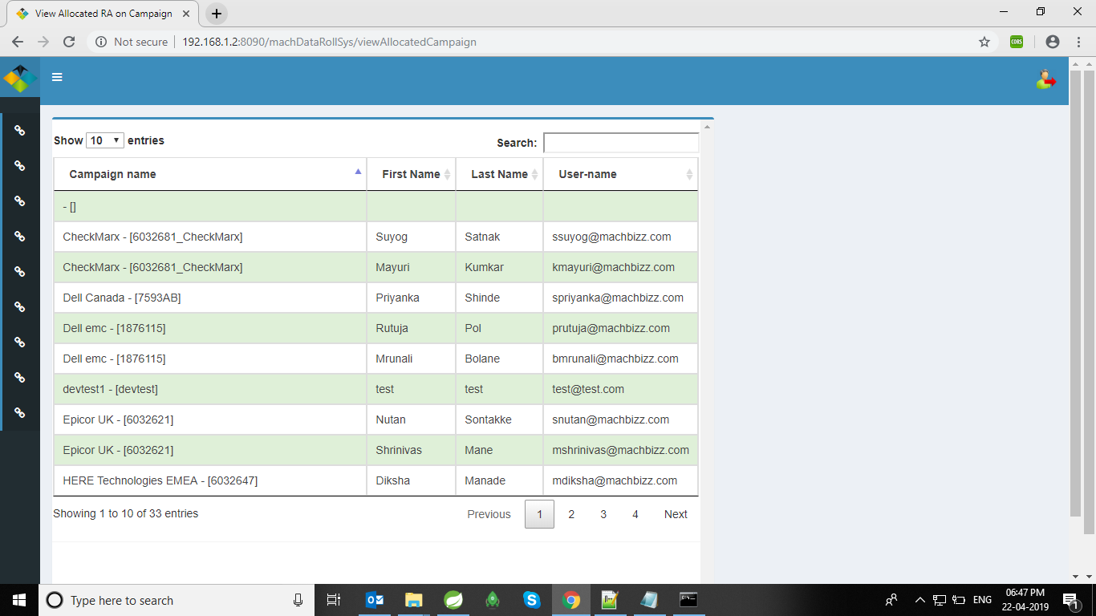

RA-TL has checked currently working campaign of any RA.

Technical details:

View - viewAllocatedCampaign

Call URL on CampaignController-- / viewAllocatedCampaign

**public ModelAndView viewAllocatedCampaign(HttpServletRequest request)**

Call Service on CampaignService :

campaignService.findAllAllocatedRAOnCampaign()

1. Allocate-RA-On Campaign:

Operation: Allocate RA on Campaign

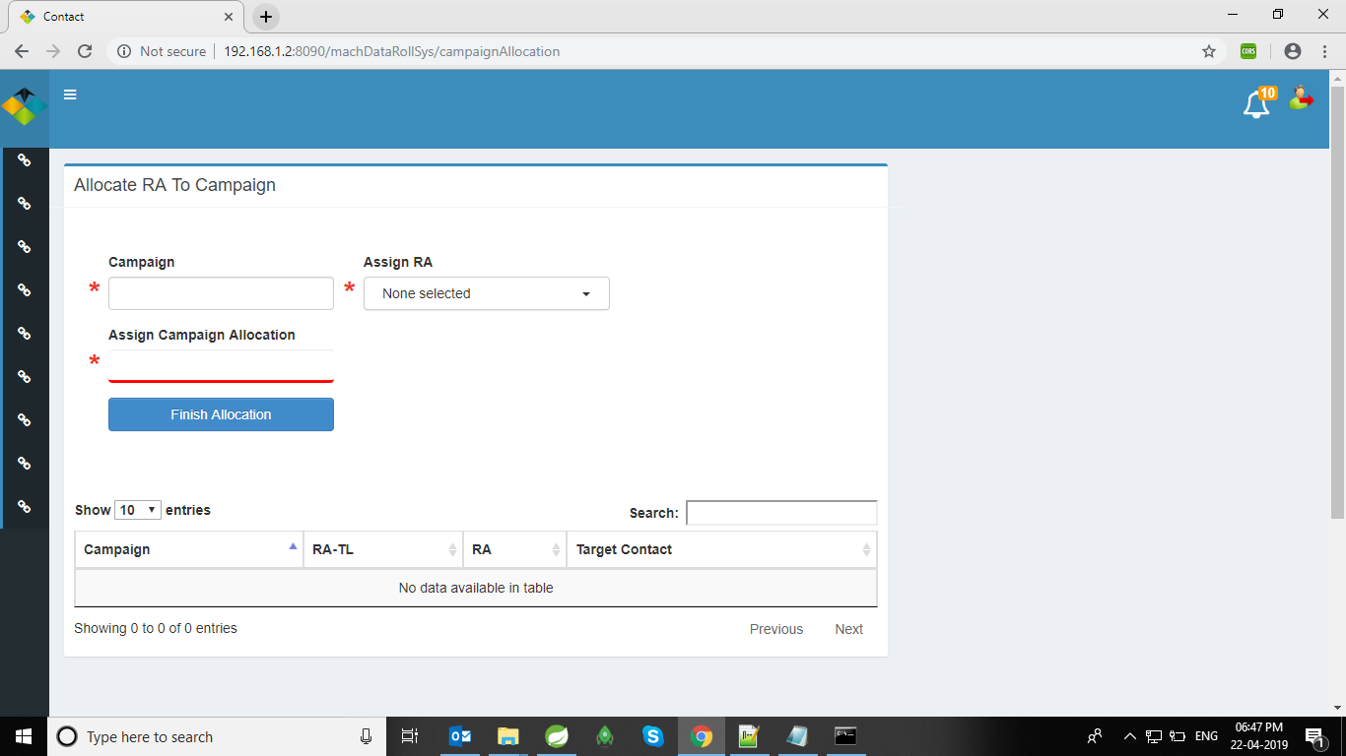

RA TL allocate RA on Campaign. In the List Assign RA, display only Un-allocated RA.

Technical details:

View - campaignAllocation

Call URL on campaignController-- / campaignAllocation

**public** ModelAndView campaignAllocationed(

@RequestParam("campaignId") Integer campaignId,

@RequestParam("researchAnalystList") List<String> researchAnalystList,

@RequestParam("targetContactPerRA") Integer targetContactPerRA,

HttpServletRequest request)

Call Service on campaignService :

campaignService.allocateRa(campaignallocation)

1. Campaign-Deallocation:

Operation: Deallocate RA on Campaign

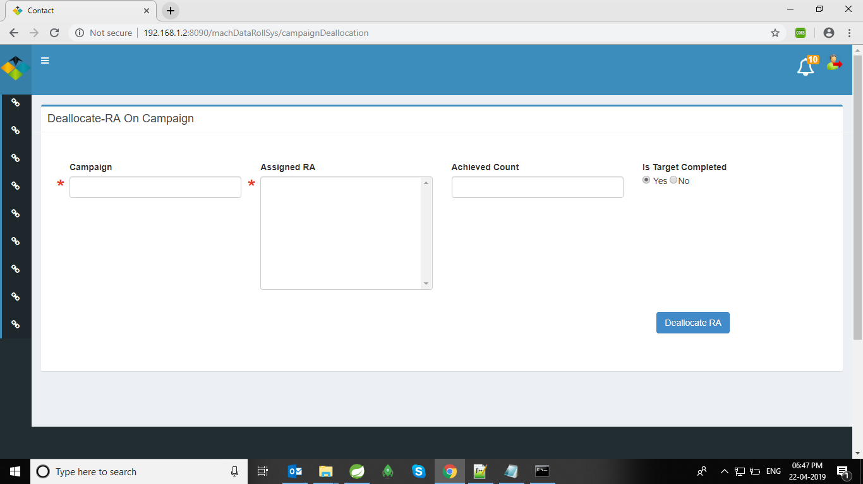

RA TL de-allocate RA on Campaign. In the List Assign RA, display only allocated RA on that particular Campaign.

Technical details:

View - campaignDeallocation

Call URL on campaignController-- / campaignDeallocation

**public** ModelAndView campaignDeallocationed(

HttpServletRequest request,

@RequestParam("campaignId") Integer campaignId,

@RequestParam("researchAnalystList1") List<Integer> researchAnalystList1,

@RequestParam("contactAchived") Integer contactAchived, @RequestParam("isCompleted") Boolean isCompleted)

Call Service on campaignService :

campaignService.deallocateRa(campaignDeallocation);

1. RA-TL-ReportCnD:

Operation: get Contact Report of Ra-wise and Campaign-Wise.

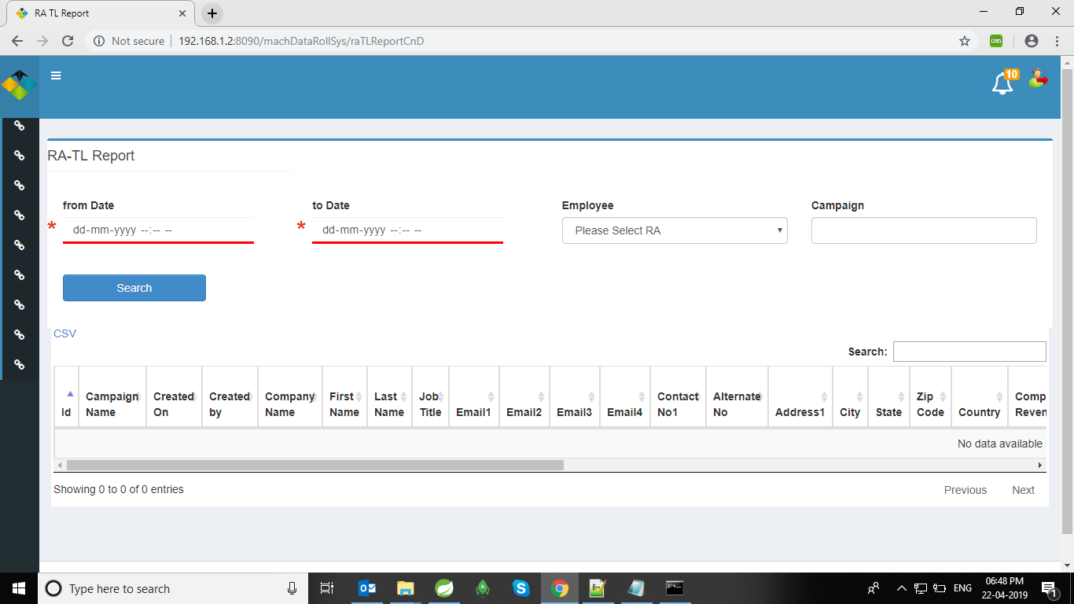

RA_TL get Contact Report of Ra-wise or Campaign-wise.

Technical details:

View - raTLReportCnd

Call URL on RaController-- / raTLReportCnd

**public** ModelAndView raTLReportCnD(@RequestParam("fromDate") String fromDateStr,

@RequestParam("toDate") String toDateStr, @RequestParam("campaignId") Integer campaignId,

@RequestParam("employeeId") Integer employeeId, HttpServletRequest request)

Call Service on raService :

raService.raTLReportCnDLazyLoading(fromDate, toDate, campaignId, employeeId, employee)

1. RA-TL-Update Report

Operation: get updated Contact Report of Ra-wise and Campaign-Wise.

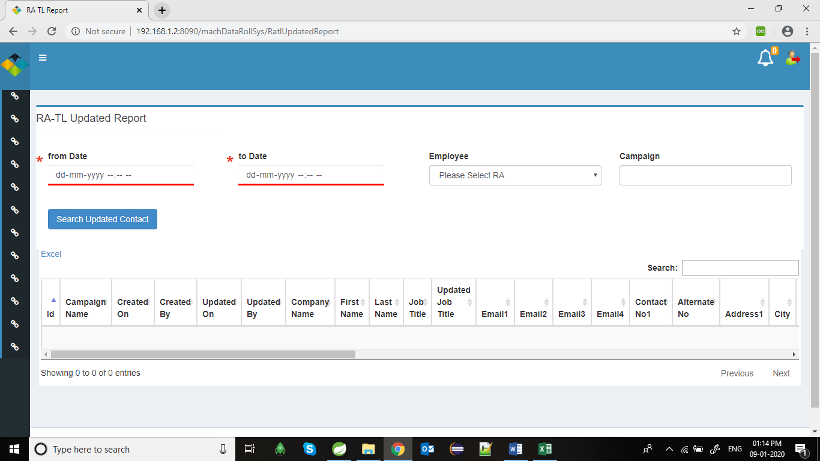

RA-TL Only gets contacts reports that is updated by Ra team.

Technical details:

View - raTLUpdatedReport

Call URL on RaController-- / RatlUpdatedReport

public ModelAndView RatlUpdatedReport(@RequestParam("fromDate") String fromDateStr,@RequestParam("toDate") String toDateStr, @RequestParam("campaignId") Integer campaignId,

@RequestParam("employeeId") Integer employeeId, HttpServletRequest request

Call Service on raService :

raService.raTLUpdatedReportCnDLazyLoading(fromDate, toDate, campaignId, employeeId, employee));

1. RA-TL-Company Report:

Operation: Show unique count of campaign, show total count of campaign, show company wise count is table

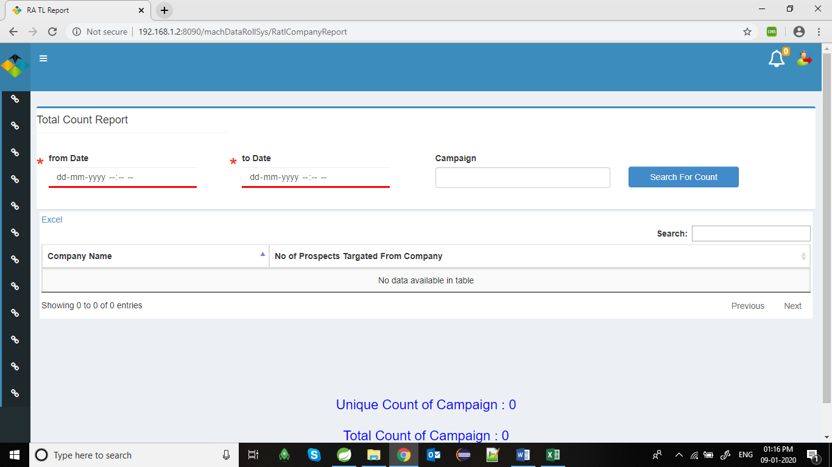

This page is used by RA-TL to download company wise unique count report. And also showing Unique count of campaign and Total count of campaign. table consists of company name and number of prospects targeted from company.

Technical details:

View – RatlCompanyReport

Call URL on RaController-- / RatlCompanyReport

public ModelAndView RatlCompanyReport(@RequestParam("fromDate") String fromDateStr, @RequestParam("toDate") String toDateStr, @RequestParam("campaignId") Integer campaignId,

HttpServletRequest request)

Call Service on raService :

raService.raTLCompanyReportCnDLazyLoading(fromDate, toDate, campaignId);

19.DmaTL data Upload:

Operation: Upload contacts into database.

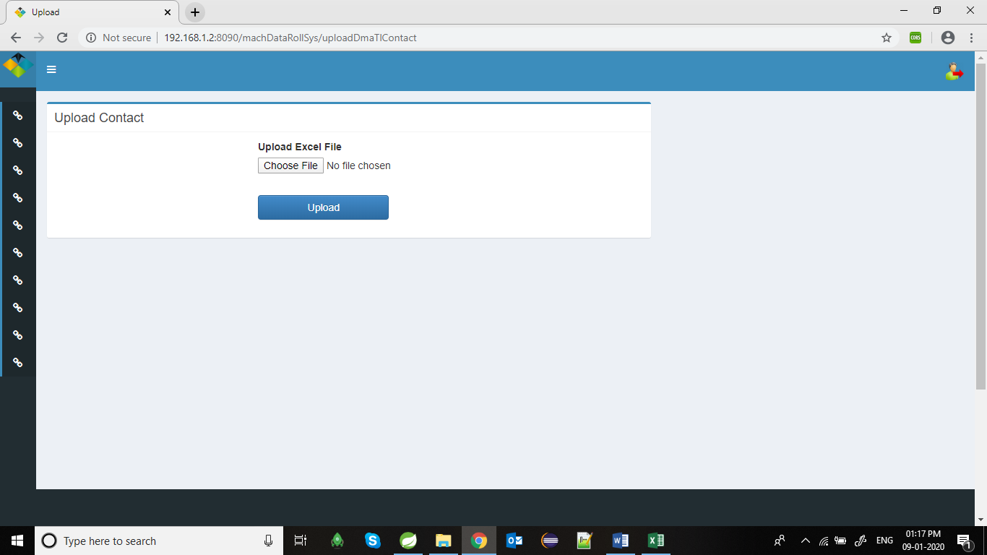

This page is used by DMA-TL to upload contact into database.

Technical details:

View – UploadDmaTlContact

Call URL on RaController-- /uploadDmaTl

public ModelAndView fileUploadDmaTl(@RequestParam("excelfile2007") MultipartFile excelFile)

Call Service on raService :

raService.readExcelWithoutFormat(excelFile);

raService.addToCampaignReportCnDLazyLoading(fromDate, toDate, campaignId, employeeId,employee));

20.Admin Add to Campaign Report:

Operation: get add to Campaign Contact Report of Ra-wise and Campaign-Wise.

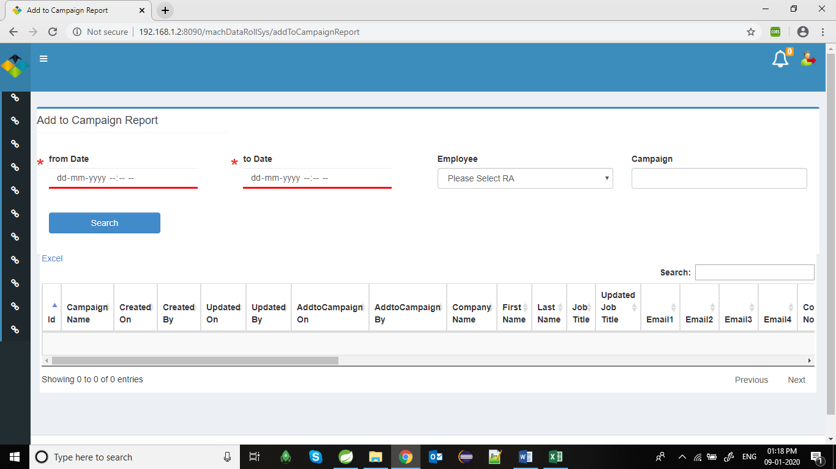

This page is used by admin to fetch add to campaign contact report.

This page is only accessible for admin.

Technical details:

View – addToCampaignReport

Call URL on RaController-- /addToCampaignReport

public ModelAndView AddToCampaignReport(@RequestParam("fromDate") String fromDateStr, @RequestParam("toDate") String toDateStr, @RequestParam("campaignId") Integer campaignId,

@RequestParam("employeeId") Integer employeeId, HttpServletRequest request))

Call Service on raService:

raService.addToCampaignReportCnDLazyLoading(fromDate, toDate, campaignId, employeeId, employee));

21.Notification Module:

Operation: Show notification to particular user.

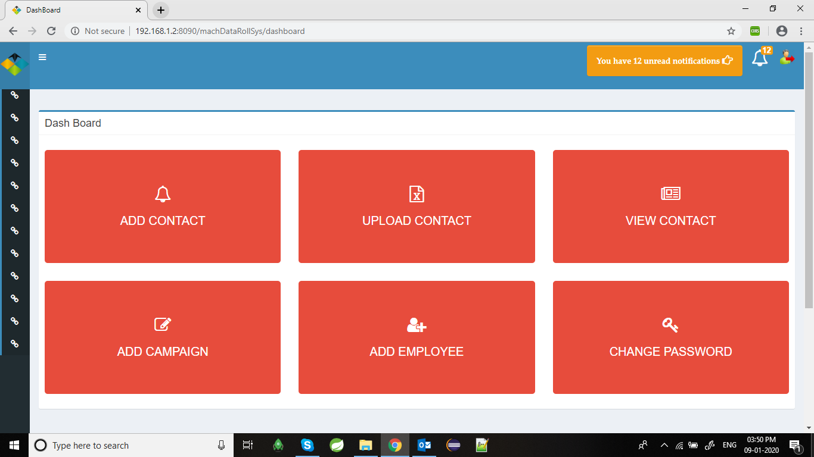

RA, RA-TL, DMA-TL can see notification about campaign. RATL can see all campaign notification means after campaign is created and after campaign is updated by DMA’s, but RA only see campaign notification that he/she is working or assign on that campaign by RA-TL.

Technical details:

Calling JavaScript function on page load

function notificationStart()

notificationAlert()

interval=setInterval("notificationAlert()", 1000*60*3);

}

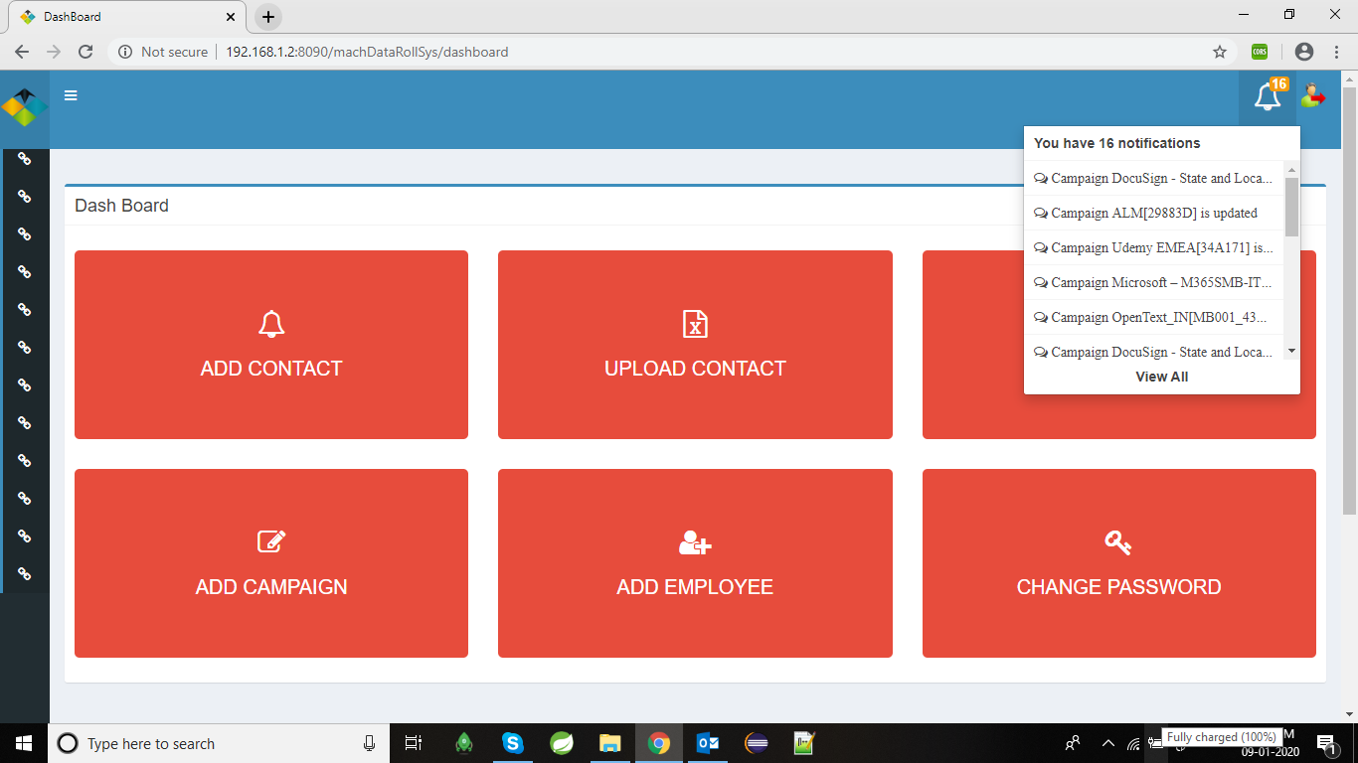

User can see number of unread notification came when login to the portal.

If user is not read that notification within 24 hours, then that notification automatically marked as read and then after user is not able to see that notification again.

Technical details:

Call java controller using ajax ‘GET’ call

url: "/machDataRollSys/getUnreadNotification"

public List<CampaignNotification> getUnreadNotification(HttpServletRequest request)

Call Service on campaignService:

campaignService.getUnreadNotification(employeeId););

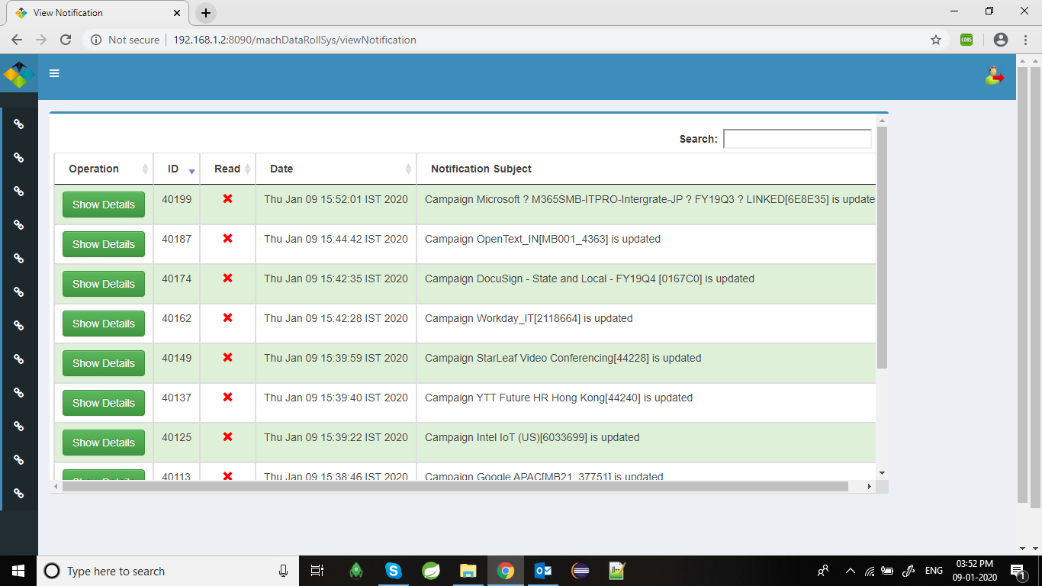

After clicking on View Notification option user can able to see all unread notification in table.

In view notification table user can see only date and time of notification creation and notification subject.

If you want to see All details about notification and want to read that notification you have to click on Show Details button in table

Technical details:

View – viewNotification

Call URL on CampaignController-- /viewNotification

public ModelAndView viewNotification(HttpServletRequest request)

Call Service on raService:

campaignService.getAllNotifications(employeeId)

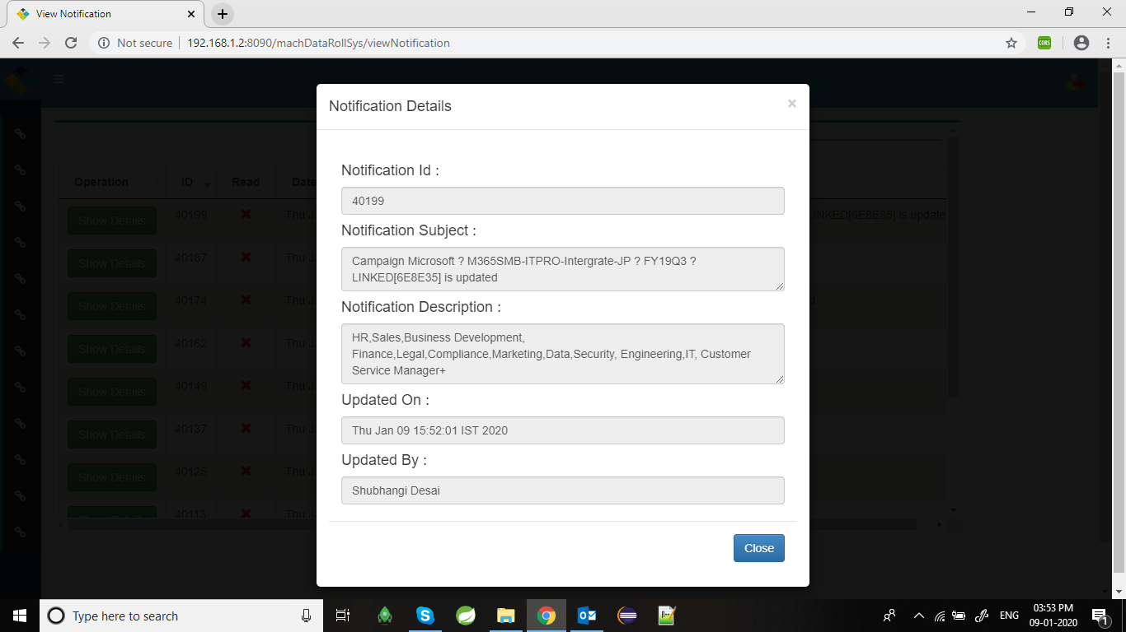

After clicking on show details button user can see all about of notification like notification subject, notification description, who created this notification and date.

In notification Description there are two type of notification come, one is when campaign is created and second is when campaign is updated. Campaign created notification is for RA_TL and DMA_TL.

And when campaign is updated then that notification is for allocated RA’s and RA_TL

After reading notification about campaign user can mark the notification as a Read, by clicking on Close button.

Technical details:

View – viewNotification

Call URL on CampaignController-- /updateReadOnlyStatus

public ModelAndView updateReadOnlyStatus(HttpServletRequest request,

@RequestParam(value = "page") String page,

@RequestParam(value = "notiId", required = false) Integer notiId)

Call Service on raService:

campaignService.findNotificationById(notiId);