

INFORMATION TECHNOLOGY PROGRAMME

COMP701 INFORMATION TECHNOLOGY PROJECT MANAGEMENT Group Assignment: Trimester 2, 2025

Group 1
Ronniel Barangan – 20240755
Helena Taufa – 20232106
Uddhav Sharma –20220423

Case Study: New Century Health Clinic
The following case is a modified version of New Century Health Clinic case study.
Reference: Rosenblatt H. J. (2014). Systems Analysis and Design (10th ed.). Boston, USA : Course Technology, Cengage Learning

New Century Health Clinic offers preventive medicine and traditional medical care. In your role as an IT project manager, you will help New Century to develop a new information system.
Background
Seven years ago, cardiologists Dr Jolly Hikkins and Dr Kelvin Moore decided to combine their individual practices in Auckland and Wellington, to form New Century Health Clinic. They wanted to concentrate on preventive medicine by helping patients maintain health and fitness and by providing traditional medical care. Dr Jolly recently asked you to work with him as an IT project manager. He wants you to help New Century manage the development of an information system that will support the clinic’s operations and future growth. At your initial meeting, he provided you with some background information and asked for your suggestions about how to begin. At your desk, you begin to review New Century’s situation. The clinic is located near a new shopping mall in a busy section of the city.
New Century’s staff includes four doctors, three registered nurses, four physical therapists, and six office staff workers. The clinic currently has a patient base of 4,500 patients from 275 different employers, many of which provide insurance coverage for employee wellness and health maintenance. Currently, New Century accepts 34 different insurance policies. Sara Clinton, who has been with New Century since its inception, is the office manager. She supervises the staff, including Dempsy Young, Darsee Smith, Woo Yang, Nick Brown, and Dave Fleming.
Dempsy Young handles office payroll, tax reporting, and profit distribution among the associates. Darsee Smith is responsible for the maintenance of patient records. Woo Yang handles most of the paperwork concerning insurance reporting and accounting. Nick Brown has the primary responsibility for the appointment book, and her duties include making reminder calls to patients and preparing daily appointment lists. Dave Fleming is concerned primarily with ordering and organizing office and clinic supplies. Each of the six office staff people has one or more primary responsibilities; however, all members of the staff help out whenever necessary with patient records, insurance processing, and appointment processing. In addition to their regular responsibilities, all six office workers are involved in the preparation of patient statements at the end of each month.
Dr Jolly believes that a new information system is required to support its business and health information management needs. The new system would replace a mix of paper-based and fragmented computer systems. Dr Jolly wishes an information system to support the scheduling, billing, accounting and payroll functions of the practice as well as a system to support the clinical applications of Electronic Medical Records (EMR), Computerized Provider Order Entry (CPOE) and a Clinical Decision Support System (CDSS).
Dr Jolly explains that they are looking for a system from the perspective of a patient who comes into the office. Nick Brown schedules a patient’s appointment, and the patient comes into the office for the first time. On this appointment, an EMR is started for the patient that includes the patient’s demo-graphic information, medical history, and insurance information. A patient may be coming in to see any one of the health care providers, including a physician, nurse practitioner, physical therapist or the nutritionist. These providers would entry any orders or prescriptions into the EMR with the CPOE system. The providers who use the EMR and CPOE system are supported by the CDSS. Patients often schedule a follow-up appointment before leaving the practice office. After a patient’s visit, Darsee Smith, who maintains the patient medical records, reviews the record to ensure they are complete. Dave Fleming orders any supplies needed to replace items used by the patient. Woo Yang begins billing the patient’s insurance provider for services that were rendered to the patient and follows up on the billing to ensure the practice is getting paid for all claims.
An estimate of costs for the entire project is $350,000. The company decides the discount rate of 8% for the financial analysis. The initial cost estimates also include $20,000 for purchasing software and services from suppliers. Annual maintenance costs of $44,000 are also included. After three years of regular maintenance, the company also gets a 50% discount on the maintenance cost for the coming years. The projected benefits of this project would be approximately $150,000 in the second year and an expected growth of $50,000 for every succeeding year.
Dr Jolly successfully convinced Dr Kelvin Moore, the CEO who would sponsor this project, which they think could be completed within ten months and the new system will have a useful life of at least seven years after the deployment. However, they also realize some potential issues like security, process orders, payments and so on, that can cause serious problems in the success of this project. Dr Jolly asked you and your team to manage the project.
NOTE:
- Company website is www.ncwg.co.nz and the staff email is <first name followed by the first letter of the last name @ wfc.co.nz >

TASK 1 (Initiating Process)
- Identify at least three business processes that New Century performs and explain who is responsible for the specific tasks. (9 Marks)

Business Processes

- Patient Appointment Scheduling
This process involves coordinating both new and follow-up appointments, preparing the daily schedule for all healthcare providers, and making reminder calls to patients. It is essential to ensure smooth daily operations and effectively manage the clinic’s workload. Nick Brown, an administrative staff member, is responsible for managing the appointment book, preparing the daily schedule, and contacting patients with reminders.
- Patient Record Management (Electronic Medical Records – EMR)
Maintaining accurate and up-to-date electronic patient records—including demographic details, medical history, diagnoses, prescriptions, and progress notes—is critical for safe and continuous care. Darsee Smith takes charge of reviewing and verifying patient records after each appointment to ensure completeness and accuracy.
- Insurance Billing and Claims Processing
This process covers preparing and submitting claims to insurance providers, tracking payments, managing billing documents, and following up on unpaid claims. It is vital for the clinic’s financial health, especially as claims are processed for 34 different insurance plans. Woo Yang handles insurance and accounting paperwork, ensuring accurate billing and timely collection of payments.

- Prepare a Stakeholder Register and Stakeholder Management Strategy for the above project. Present your answer in the format as shown in Appendix C - Figure 1 and 2 or any of your
preferences. (24 Marks)

S. No. | Name | Position | Role | Contact Information
1 | Dr. Jolly Hikkins | Cardiologist / Owner | Project initiator and key user | jollyh@wfc.co.nz
2 | Dr. Kelvin Moore | CEO | Project sponsor / final approver | kelvinm@wfc.co.nz
3 | Sara Clinton | Office Manager | Oversees admin staff, power user | sarac@wfc.co.nz
4 | Dempsy Young | Accountant | Manages payroll and finance reporting | dempsyy@wfc.co.nz
5 | Darsee Smith | Records Clerk | Maintains patient medical records | darsees@wfc.co.nz
6 | Woo Yang | Insurance Processor | Manages billing and insurance claims | wooy@wfc.co.nz
7 | Nick Brown | Receptionist | Handles appointments and reminders | nickb@wfc.co.nz
8 | Dave Fleming | Inventory Clerk | Manages supply ordering | davef@wfc.co.nz
9 | IT Project Team | External Consultants | System analysis, design, deployment | it@wfc.co.nz
10 | Patients | End Users | Recipients of care, system interaction | N/A (via patient records)
Figure 1 – Stakeholder Register

S. No. | Name | Level of Interest | Level of Influence | Potential Management Strategy
1 | Dr. Jolly Hikkins | High | High | Engage regularly, involve in decisions, provide status reports
2 | Dr. Kelvin Moore | Medium | High | Provide executive summaries, request approval at key stages
3 | Sara Clinton | High | Medium | Include in testing, get feedback on workflows and usability
4 | Dempsy Young | Medium | Low | Keep informed about financial system changes
5 | Darsee Smith | High | Low | Train on EMR use, gather input on record system improvements
6 | Woo Yang | High | Low | Collaborate for insurance/billing module testing
7 | Nick Brown | High | Low | Involve in scheduling interface design
8 | Dave Fleming | Medium | Low | Ensure ordering system integration meets needs
9 | IT Project Team | High | High | Coordinate closely with clinic stakeholders
10 | Patients | Medium | Low | Gather feedback via surveys, ensure user-friendly interfaces
Figure 2 - Stakeholder Management Strategy

- Prepare a Project Charter for this project discussed in class using the format in Appendix C - Figure 3 or any of your preferences. (24 Marks)

Project Title |  | New Century Health Clinic Integrated Information System
Project Start Date |  | May 26, 2025 |  | Project Finish Date |  | January 16, 2026
Budget  Information |  | Estimated total cost: $350,000(includes $20,000 for software/services and $44, 000annual maintenance, 50% maintenance cost reduction after year 3)
Project Manager/s |  | Helena Taufa [IT Project Manager]  Ronniel Barangan [IT Project Manager]  Uddhav Sharma [IT Project Manager]
Project Objectives |  | To create, implement, and launch a comprehensive Information System that facilitates clinical and business functions, which include Electronic Medical Records (EMR), Computerized Provider Order Entry(CPOE), Clinical Decision Support System(CDSS), Scheduling, Billing, Accounting, Payroll. To remove dependence on paper-based systems and disjointed software. To enhance the overall patient experience, improve data precision, boost operational effectiveness, and ensure financial oversight. To guarantee data protection, intuitive user interfaces, and adherence to healthcare IT regulations.
Project Main  Success Criteria |  | Implementation of a completely integrated and operational information system within the 10-month project duration. User adoption by all personnel with minimal interference to routine clinic activities. Safe, precise, and efficient management of medical records and financial data. Economical execution that achieves anticipated advantages (ROI) within 2-3 years.
Approach |  | Utilized a phased implementation approach (combining waterfall with agile principles)  Phase 1: Requirement Analysis and System Design  Phase 2: Development and Vendor Integration  Phase 3: System Testing  Phase 4: Training and Documentation  Phase 5: Go-Live and Support  -Involve stakeholders from both medical and administrative teams.  -Conduct a risk analysis, focusing particularly on security, payment, and data integration.  -Hold regular project reviews with the CEO and sponsors.
 |  | ROLES AND RESPONSIBILITIES
 | Name | Role | Position |  | Contact Information
1 | Dr Kelvin Moore | Project Sponsor | CEO |  | kelvinm@wfc.co.nz
2 | Dr Jolly Hikkins | Project Owner/Medical Lead | Co-founder |  | jollyh@wfc.co.nz
3 | Helena Taufa | Project Manager | IT Project Manager |  | helenat@wfc.co.nz
4 | Sara Clinton | Admin Lead | Office Manager |  | sarac@wfc.co.nz
5 | Woo Yang | Billing & Insurance SME | Office Staff |  | wooy@wfc.co.nz
6 | Darsee Smith | Medical Records Lead | Office Staff |  | darsees@wfc.co.nz
7 | Dave Fleming | Procurement Coordinator | Office Staff |  | davef@wfc.co.nz
8 | Nick Brown | Appointment Scheduling Lead | Office Staff |  | nickb@wfc.co.nz
Sign-Off |  | Dr Kelvin Moore( Project Sponsor )
Comments |  | - Security and compliance will be overseen via encryption, access controls, and practices aligned with HIPAA.  - The migration of data and training will be essential for the successful adoption of the system.  - Frequent check-ins and milestone assessments will be conducted to guarantee timely delivery and alignment with the requirements of the clinic.
Figure 3 – Project Charter

TASK 2 (Planning Process)

- Prepare a team contract according to the format discussed in class as shown in Appendix C Figure 4 or any of your preferences. Minimum two points under each topic are expected.
(10 marks)
Project Title | New Century Health Clinic Integrated Information System
Code of Conduct:
- Treat every team member—clinical, administrative, and technical—with courtesy and professional respect.
- Keep patient confidentiality and data-security requirements in mind in all discussions and documents.
Participation:
- Attend and contribute to all scheduled meetings and project activities unless prior notice is given.
- Complete assigned tasks by the agreed-upon due dates and notify the PM immediately if delays arise.
Communication:
- Use the project Slack channel (or Microsoft Teams) for daily updates; reply to direct questions within one business day.
- Escalate critical issues to the project manager by phone within two hours of discovery.
Problem Solving:
- Raise potential risks or defects as soon as they are identified; include a brief description and suggested mitigation.
- Evaluate solutions using impact-effort analysis and choose the option that best supports patient care, data security, and the project schedule.
Meeting Guidelines:
- Weekly status meeting every Monday, 3:00 p.m.-4:00 a.m. (Auckland time), chaired by the IT project manager; agenda circulated 24 hours in advance.
- Keep minutes with action items, owners, and due dates; publish within 24 hours after each meeting.
Sign-Off:
Name / Role | Signature | Date
Dr Kelvin Moore – CEO / Sponsor |  | 21/07/2025
Dr Jolly Hikkins – Medical Lead |  | 21/07/2025
Ronniel Barangan – IT Project Manager |  | 21/07/2025
Helena Taufa – IT Project Manager |  | 21/07/2025
Uddhav Sharma – IT Project Manager |  | 21/07/2025
Sara Clinton – Office Manager |  | 21/07/2025
Woo Yang – Billing & Accounting |  | 21/07/2025
Nick Brown – Scheduling |  | 21/07/2025
Dave Fleming – Supplies |  | 21/07/2025
Dempsy Young – Payroll & Tax |  | 21/07/2025

Figure 4 – Team Contract

- Analyse financial projections provided in the case study and perform ‘financial analysis’ as discussed in class for the project management purpose using Excel file. Provide proper recommendations based on your analysis.

Financial Analysis for New Century Health Clinic Project

Year | Benefit | Cost | Net Cash Flow | Discount Factor (8%) | Present Value (PV)
0 | $0 | $350,000 | -$350,000 | 1.0000 | -$350,000.00
1 | $0 | $44,000 | -$44,000 | 0.9259 | -$40,740.74
2 | $150,000 | $44,000 | $106,000 | 0.8573 | $90,877.91
3 | $200,000 | $44,000 | $156,000 | 0.7938 | $123,837.83
4 | $250,000 | $22,000 | $228,000 | 0.7350 | $167,586.81
5 | $300,000 | $22,000 | $278,000 | 0.6806 | $189,202.13
6 | $350,000 | $22,000 | $328,000 | 0.6302 | $206,695.64
7 | $400,000 | $22,000 | $378,000 | 0.5835 | $220,559.37
Figure 5 - Cash Flow Summary Table

Key Financial Metrics
- Net Present Value (NPV): $608,018.95
A strong positive NPV means the project is expected to generate more value than it costs, even after accounting for time and risk.
- Return on Investment (ROI): 189.47%
This ROI suggests that the clinic will nearly double its investment — a very healthy return.
- Payback Period: Year 4
The investment will be fully recovered in the 4th year, which is reasonable for a healthcare information system.

Recommendations
Proceed with the project. The NPV is strongly positive and the ROI shows high profitability. Initial costs are high, but long-term benefits outweigh expenses. Monitor maintenance costs closely because annual expenses are substantial. Enforce supplier discounts starting in year 4 to protect profitability.
Address security and operational risks such as data breaches and process disruptions. Invest in cybersecurity, train staff, and prepare contingency plans. Phase in EMR, CPOE, and CDSS modules early to deliver benefits ahead of schedule, improve cash flow, and strengthen financial performance in the first years.

- Prepare project scope statement to understand and discuss the scope of the project.
(10 Marks)
Project Name | New Century Health Clinic Integrated Information System | Project Manager/s | Ronniel Barangan  Helena Taufa  Uddhav Sharma
Project Sponsor | Dr. Kelvin Moore
Scope Description | This project involves the development of an integrated and secure health information system to replace paper-based and fragmented digital systems at New Century Health Clinic. The system will manage:  - Appointment scheduling and management  - Electronic Medical Records (EMRs) management  - Computerized Physician Order Entry (CPOE)  - Clinical Decision Support System (CDSS)  - Billing and insurance claim processing  - Payroll and inventory management  Out of Scope:  - Integration with external hospital systems  - Mobile application development  - Legacy data migration (unless part of future phases)
Project Deliverables | - Requirements analysis documentation  - Functional and technical design specifications  - Developed and tested software system  - Secure backed-up central database  - Staff training completion and training manual  - Deployment plan and final testing report  - Support plan and handover documentation of the system
Acceptance Criteria | - System is free from major bugs or crashes  - Employees can perform day-to-day tasks effectively  - Patients' information is stored and protected securely  - All primary functions operate correctly  - Workers adopt and support system use following training and piloting
Constraints | -Budget of $350,000  - To be finished within10months  - Has to be run on current clinic infrastructure  - Has to comply with New Zealand health data standards
Assumptions | - Staff will conduct user testing and training  - Required hardware and internet access will be offered  - Clinic management will provide timely input and guidance  - Third-party vendors will supply components/tools according to schedule
Figure 6 – Project Scope Statement

- Identify and justify the appropriate SDLC model for this project. Relate and justify the phases of your chosen SDLC model to project management process. (15 Marks)
Why opt for the Iterative/Incremental SDLC Model?
The Iterative model is particularly suitable for the New Century Health Clinic because of its adaptability, staged delivery, and capacity to accommodate complex and evolving requirements. The clinic’s system must support EMR, CPOE, billing, payroll, feedback-oriented implementation.
Key reasons:
1. Complexity and Evolving Requirements
-The system comprises several modules. Iterative development facilitates prioritization, allowing for the early delivery of essential features such as EMR and scheduling, enabling the clinic to realize benefits sooner.
-Regular feedback loops from users (including doctors, nurses and office staff) assist in aligning the system with practical needs.
2. Risk Mitigation & Compliance with Security Standards
-Early iterations permit consistent testing for HIPAA compliance and data security (for instance, access control and encryption).
-This approach minimizes the risk associated with integrating multiple modules simultaneously.
3. Financial Adaptability
-The project budget stands at $350,000, with phased releases simplifying cost management and return on investment.
-Continuous savings are realized by prioritizing the implementation of high-priority modules early and applying a 50% maintenance discount after Year 3.
4. Staged Delivery with Prioritized Features
This strategy allows the clinic to gradually adopt modules without interrupting daily operations.
SDLC | Project Management Phase | Explanation
Planning | Initiation & Planning | Establish the scope, objectives and timeline, prioritize features (for instance, EMR first)
Analysis | Scope Definition | Gather comprehensive requirements, evaluate existing workflows and pinpoint pain points.
Design | Design & Development Planning | Create the system architecture incrementally, ensure alignment with security and user requirements.
Implementation | Execution & Monitoring | Develop core features initially (EMR, scheduling), gather feedback following each release.
Testing | Quality Control | Evaluate each iteration for usability, security and compliance, address early issues.
Deployment | Deployment & Implementation | Implement modules progressively, train personnel, reduce disruptions.
Maintenance | Post-Implementation & Support | Offer updates, resolve issues, and uphold compliance over time.
Figure 7 - Table Linking SDLC Phases to Project Management Phases
Why This Model is Effective for Security?
-Integrates a security-first approach to development, incorporating encryption, access control and audit trails in every iteration.
-Compliance is verified and validated incrementally, minimizing the risk of significant security breaches.
Conclusion
The Iterative/Incremental model facilitates:
-Managing a complex system through phased development.
-Receiving ongoing feedback to guarantee usability and effectiveness.
-Progressively meeting security and regulatory standards.
-Controlling expenses and demonstrating early returns on investment.
By implementing this model, the clinic acquires a scalable, user-friendly, and secure system that adapts to its evolving needs.
- Prepare the work breakdown structure (WBS) for this project at an appropriate level as discussed in class. WBS should be based on the project charter, scope statement, and other
relevant information in the case study. (15 Marks)
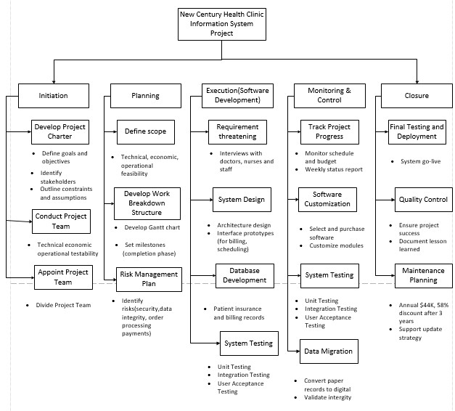
Figure 8 – Work Breakdown Structure
- Using WBS from the previous question, prepare a Gantt chart for this project that covers the following:
  - Estimate activity durations
  - Allocate activity resources
  - Sequence activities

To develop a comprehensive project schedule for the New Century Health Clinic Information System, I used the WBS from the previous task to build a Gantt chart in Microsoft Project. The Gantt chart covers the estimated durations, resource assignments, and logical sequencing of project activities.
a. Estimated Activity Durations
Each activity’s duration was estimated based on project scope complexity, staff availability, and dependencies. For example:
- Planning phase tasks (e.g., “Define Scope”) were estimated at 20 days based on team discussions and stakeholder input.
- Development tasks such as “System Design” and “Software Customization” were given 20 days each, based on developer capacity and past experience.
- Continuous tasks like “Track Project Progress” span the entire project duration (170 working days), reflecting ongoing management oversight.
Milestones such as “Project Kickoff” and “Go-Live” were set with zero duration to signify fixed events rather than tasks.
b. Activity Resource Allocation
Resources were assigned according to each task’s needs and staff roles at the clinic. For example:
- The Project Manager and Business Analyst were assigned to most planning and coordination tasks.
- Clinical staff (e.g., Nick Brown, Darsee Smith) were assigned to data migration, testing, and requirement gathering tasks.
- Developers and Database Developers handled technical tasks like system design, customization, and database setup.
- Resource units were adjusted to avoid overallocations — for instance, the Business Analyst was limited to 50% involvement on overlapping tasks.
c. Sequencing of Activities
Activities were logically sequenced using dependencies (Predecessors column). Finish-to-Start relationships were used by default, while Start-to-Start links were added to allow overlapping tasks (e.g., “System Design” can begin once “Requirement Gathering” starts). Key milestones such as “Go-Live” were scheduled after completion of “System Testing” and “Data Migration.”
The result is a Gantt chart that spans approximately 170 working days (from 26 May 2025 to 16 January 2026), visualizing the full project timeline with tasks, resources, and dependencies.

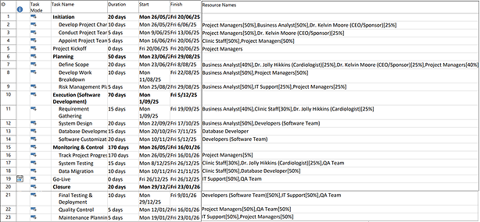
Figure 9 – Project Task View
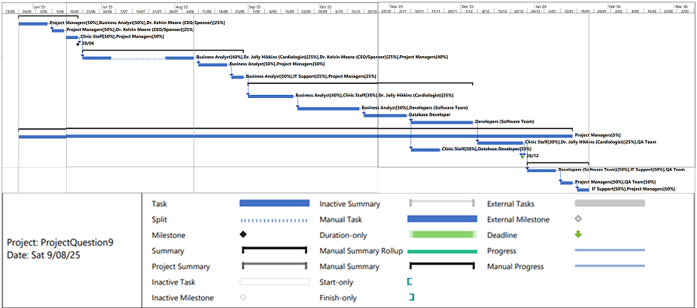
Figure 10 – Project Gantt Chart View

(20 Marks)

- Apply Critical Path Method (CPM) to find the earliest possible time by which the project can be completed. Display critical path in your Gantt chart. (5 Marks)

What is CPM?
The Critical Path Method helps to identify the longest sequence of dependent activities in the project. This path tells us about the minimum amount of time required to finish the entire project.
ID | Activity | Duration (days) | Predecessors | ES | EF | LS | LF
2 | Develop Project Charter | 10 | — | 0 | 10 | 0 | 10
3 | Conduct Project Team | 5 | 2 | 10 | 15 | 10 | 15
4 | Appoint Project Team | 5 | 3 | 15 | 20 | 15 | 20
7 | Define Scope | 20 | 4 | 20 | 40 | 20 | 40
8 | Develop WBS | 10 | 7 | 40 | 50 | 40 | 50
9 | Risk Management Plan | 5 | 8 | 50 | 55 | 50 | 55
11 | Requirement Gathering | 15 | 9 | 55 | 70 | 55 | 70
12 | System Design | 20 | 11 | 70 | 90 | 70 | 90
13 | Database Development | 15 | 12 | 90 | 105 | 90 | 105
14 | Software Customization | 20 | 13 | 105 | 125 | 105 | 125
17 | System Testing | 15 | 14 | 125 | 140 | 125 | 140
21 | Final Testing & Deployment | 10 | 17,18 | 140 | 150 | 140 | 150
22 | Quality Control | 5 | 21 | 150 | 155 | 150 | 155
23 | Maintenance Planning | 5 | 22 | 155 | 160 | 155 | 160
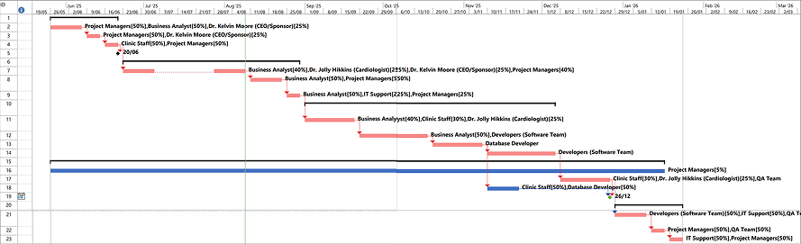
Figure 11 – CPM Table
Figure 12 - Gantt Chart with Critical Path
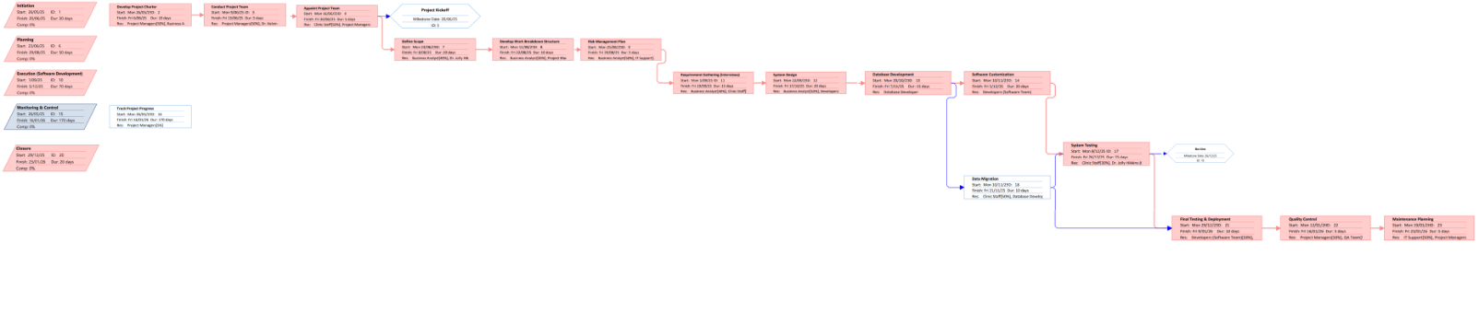
Figure 13 – PDM/Network Diagram

Comments:

CPM analysis provides insight into the key aspects of the project timeline. Once the longest path through the project's tasks and their dependencies is identified, this method helps project managers concentrate on the vital activities that will affect the project's completion time. Effective management of the critical path reduces delays and keeps the project on schedule. These tasks are marked in the Gantt chart, offering a clear view of the critical path for monitoring and prioritizing resources by stakeholders.

- Use the critical path from the previous question to make Schedule Trade-Offs. Find the float for at least ten activities. (5 Marks)

What is Float?
Float (also referred to as slack) informs us the length of time we can postpone a task without changing the project completion date.
ID | Activity | Duration (days) | Float (days)
1 | Initiation | 20 | 140
2 | Develop Project Charter | 10 | 0
3 | Conduct Project Team | 5 | 0
4 | Appoint Project Team | 5 | 0
5 | Project Kickoff (milestone) | 0 | 140
7 | Define Scope | 20 | 0
8 | Develop WBS | 10 | 0
9 | Risk Management Plan | 5 | 0
11 | Requirement Gathering (Interviews) | 15 | 0
12 | System Design | 20 | 0
13 | Database Development | 15 | 0
14 | Software Customization | 20 | 0
17 | System Testing | 15 | 0
18 | Data Migration | 10 | 25
19 | Go-Live (milestone) | 0 | 20
21 | Final Testing & Deployment | 10 | 0
22 | Quality Control | 5 | 0
23 | Maintenance Planning | 5 | 0
Figure 14 – Float Table

Selected Trade-Off Method: Combined Fast Tracking and Crashing
In the CPM of Q10, most of the activity execution is on the critical path (float = 0) and slippage in any would directly impact the completion of the project. Four activities have positive float (Initiation, Project Kickoff, Data Migration, Go-Live) and can be moved without affecting the finish date but moving them individually does not decrease the project. In meeting a request to finish earlier, we made the following changes:
- Fast-Tracking – Start System Testing (ID 17) 5 days earlier by rescheduling its dependency on Software Customization (ID 14) from Finish-to-Start to Start-to-Start with a 5-day lead. This overlaps testing with the final work on development, and it saves 5 days.
- Crashing – Reduce Database Development (ID 13) from 15 → 12 days by using an additional developer and/or overtime. This saves 3 days of activity on the critical path.

Scenario | Earliest Finish Date | Days Saved
Baseline | 2 Nov 2025 | –
Fast-Track Only | 28 Oct 2025 | 5
Crash Only | 30 Oct 2025 | 3
Combined (Chosen) | 25 Oct 2025 | 8
Figure 15 – Schedule Trade-Off Analysis (Impact on Earliest Finish Date)

Risks and Costs
• Fast-Tracking: Increases risk of rework in case defects are found in modules under development. Mitigation: allocate QA lead to oversee initial testing and stabilize modules before test initiation.
•Crashing: Increases cost by additional labour or overtime. Mitigation: limit overtime to budget sanctioned; consider short-term contract staff.

The joint strategy of crashing and fast-tracking reduces 8 days from the duration, shifting the earliest completion date to 25 Oct 2025. It weighs time saved against risk and cost, and is recommended if the sponsor authorizes additional resources and the risk of overlapping activity rework.

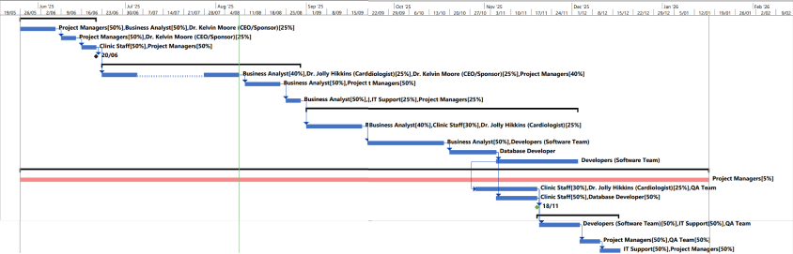
Figure 16 - Modified Gantt Chart after applying fast-track (5 days) and crash (3 days)

- Prepare a communication management plan for this project according to the format discussed in the class as shown in Appendix C - Figure 5. (20 Marks)

No. | Stakeholder | Document Name | Document Format | Contact Person | Due Date
1 | Dr. Kelvin Moore (CEO/Sponsor) | Project Charter | PDF | Project Manager | 06/06/2025
2 | Dr. Jolly Hikkins (Cardiologist) | Scope Statement | Word | Business Analyst | 08/08/2025
3 | Project Managers | Kickoff Meeting Summary | Email/PDF | Dr. Jolly Hikkins | 20/06/2025
4 | Business Analyst | Requirements Documentation | Word | Project Manager | 19/09/2025
5 | Developers (Software Team) | System Design Specification | PDF | Business Analyst | 17/10/2025
6 | Database Developer | Database Schema & ERD | Word | Project Manager | 07/11/2025
7 | IT Support | Deployment Instructions | PDF | Project Manager | 09/01/2026
8 | QA Team | Testing Plan & Test Results | PDF | QA Team Lead | 26/12/2025
9 | Clinic Staff | User Training Guide | PDF/Printout | IT Support | 19/12/2025
10 | Clinic Staff | Data Migration Summary | Excel/PDF | Database Developer | 21/11/2025
11 | All Stakeholders | Status Reports (Bi-weekly) | Email/PDF | Project Manager | Bi-weekly
12 | Project Team | Risk Management Plan | Word | Project Manager | 29/08/2025
13 | Office Manager (Sara Clinton) | Appointment System Walkthrough | PDF | Business Analyst | 30/10/2025
14 | Dempsy Young (Payroll, Tax) | Payroll Module Specs | Word | Business Analyst | 31/10/2025
15 | Darsee Smith (Patient Records) | EMR System Guide | PDF | Project Manager | 07/11/2025
16 | Woo Yang (Insurance) | Billing Workflow & Process Doc | PDF | Business Analyst | 07/11/2025
17 | Nick Brown (Appointments) | Scheduling System User Guide | PDF | Project Manager | 31/10/2025
18 | Dave Fleming (Supplies) | Inventory Integration Instructions | PDF | Business Analyst | 03/11/2025
19 | Dr. Kelvin Moore (CEO/Sponsor) | Financial Summary Report | Excel/PDF | Project Manager | 23/01/2026
20 | All Stakeholders | Final Go-Live Announcement | Email | Project Manager | 26/12/2025
Comments:
- All emails use <firstname><first initial of last name>@wfc.co.nz (e.g., jollyh@wfc.co.nz).
- Standard tools: Microsoft Word for editable docs, PDF for finalized content, and Excel for tabular reports.
- Communication methods include Email (Outlook), printed copies for internal clinic staff, and status meetings.
- All reports are archived in the internal SharePoint system or local server.

Figure 17 – Communication Management Plan

TASK 3 (Executing Process)

- Consider the following situations:
  - You discovered in week 20 that the user interface is too complex for the users and that can result in users conducting substantial user training before they make the system live. It is estimated that the training material needs 3 working days to be developed and 3 days to actual conduct the training session.
  - During the testing phase, on the second day of the testing activity, a bug is found in the parts of the ordering process. The system is not showing any exceptions, but it is not processing the orders as it should. It is estimated that it will take approximately 3 days to fix the bug but that fix results in updating the order form and related processes. This new change requires 2 days to be fixed.
Manage the above situations in your project and make the necessary changes to the Gantt chart without changing the deadline. Propose the required changes using the format discussed in the
class. (34 Marks)

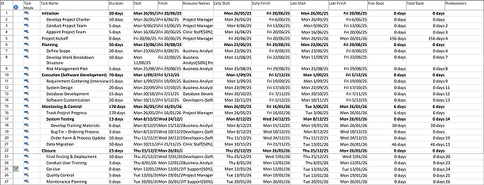
Figure 18 – Updated Project Table
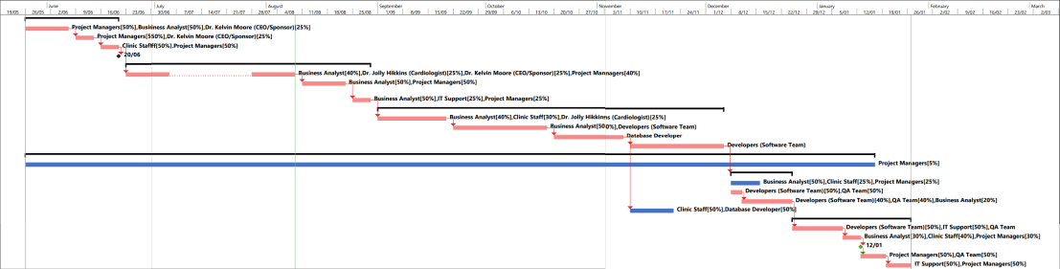
Figure 19 – Updated Project Gantt Chart
Comments:
The project schedule was updated to address two critical findings: a complex user interface requiring additional user training, and a defect in the ordering process identified during system testing. New tasks for developing training materials, conducting training, bug fixing, and order form updates were added. Task dependencies were restructured so the Closure phase now flows logically from Final Testing to User Training, then Go-Live, followed by Quality Control. These adjustments ensure operational readiness and system stability while maintaining the original final completion date.
Project Title | New Century Health Clinic Integrated Information System
Submitted by | Ronniel Barangan  Helena Taufa  Uddhav Sharma |  |  | Date: 16/08/2025
Title of Change Request | Addition of Training & Bug Fix Tasks Without Changing Go-Live Date
Change Category | ○ Scope ○ Schedule ○Cost ○ Technology ○Other
Description of Change
- Add “Develop Training Materials” (3 days) and “Conduct User Training” (3 days) tasks to address complex user interface.
- Add “Bug Fix – Ordering Process” (3 days) and “Order Form & Process Update” (2 days) tasks within System Testing to resolve a critical ordering issue.
- Adjust task dependencies so Final Testing, Training, Go-Live, and Quality Control are in logical sequence while maintaining the original project deadline.

Events that made this change necessary or desirable
- Week 20 usability review identified the system’s UI as overly complex for end-users.
- A critical defect in the ordering process was discovered during System Testing (not processing orders correctly).
- Both issues could impact operational efficiency and patient care if not addressed before launch.
Justification for the change
- Additional training will reduce operational errors and reliance on ad-hoc support after launch.
- Bug resolution and form updates are essential to ensure safe and reliable order processing in the live environment.
- These changes align with project quality objectives without extending the Go-Live date.

Impact of the proposed change on
- Scope: Adds four new tasks and modifies dependencies in Closure phase.
- Schedule: Maintains final deadline of 21 Jan 2026 by overlapping tasks and managing resources.
- Cost: Minor increase due to extra resource hours for training and bug fix tasks.
- Technology: Improves system reliability and user experience before launch.

Suggested implementation if the change request is approved:
- Insert new training and bug fix tasks into the Execution and Closure phases with parallel work to avoid delaying Go-Live.
- Link tasks so sequence flows: Order Form Update → Final Testing & Deployment → Conduct User Training → Go-Live → Quality Control → Maintenance Planning.
- Assign resources per updated plan (BA, Developers, QA, Clinic Staff, PMs) and monitor critical path to ensure zero slack for Go-Live milestone.

Required approvals
Name/Title |  | Date | Approve/Reject
Dr Kelvin Moore – CEO/Sponsor
Project Managers
Figure 20 – Change Request Form
- Identify five potential risks in the project and prepare Risk Register for this project according to the format provided in Appendix C – Figure 8 (40 Marks)

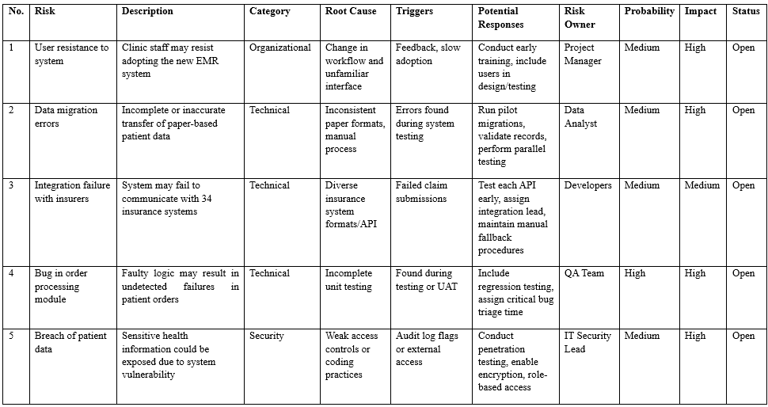
Figure 21 – Risk Register Table

TASK 4 (Monitoring & Controlling Process)

15. Weekly progress report: To monitor and control the project success, prepare and report weekly progress, in Appendix C – Figure 7, of the project according to the template provided in chapter 3 of the textbook. One report (for different weeks) is required. This report must be in the context of the case study and assuming your group is part of the development team. Before submitting your group assignment, each member needs to complete a peer-evaluation form provided in the Appendix D for each member and submit individually to Moodle.

(13 Marks per Student)

TASK 5 (Closing Process)

16. Presentations: Each team is required to present the project work in the submission week. The presentation’s duration is 15 to 20 minutes. Teams will be marked according to the criteria in
Appendix E Task 05. (32 Marks)

References

Kerzner, H. (2022). Project management: A systems approach to planning, scheduling, and controlling (13th ed.). Wiley.

Marchewka, J. T. (2016). Information technology project management: Providing measurable organizational value (5th ed.). Wiley.

Pressman, R. S., & Maxim, B. R. (2020). Software engineering: A practitioner’s approach (9th ed.). McGraw-Hill Education.

Rosenblatt, H. J. (2014). Systems analysis and design (10th ed.). Cengage Learning.

Schwalbe, K. (2022). Information technology project management (10th ed.). Cengage Learning.

Sommerville, I. (2016). Software engineering (10th ed.). Pearson.

Wager, K. A., Lee, F. W., & Glaser, J. P. (2022). Health care information systems: A practical approach for health care management (5th ed.). Jossey-Bass.

