Q4.

For this problem you need to do some operations on matrices.

**You must use the template to finish this assignment.**

Read the data from the text file.

You should implement **3** functions by yourself in this class:

1. Multiply two matrices.

2. Given a matrix m, calculate the classic adjoint matrix of m.

3. Use the classic adjoint matrix to calculate the determinant of m.



See the template for the details.

You can also create additional functions to support your program if needed.

# Input Format

The first line is an integer n, which means the number of matrices.

The following lines are the values of the matrices.

* Each line represents a matrix, e.g., v1 v2 v3 v4 v5 v6 v7 v8 v9

which means the matrix is

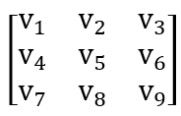

# Output Format

Print the **determinant** of each given matrix.

# Sample Input & Output.

Input:

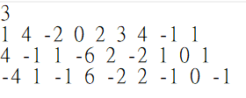

Output:

