**Site Design Document**

**RIT E-Sports**

## Client:

**Evan Hirsh** ([exh7928@rit.edu](mailto:exh7928@rit.edu))

## Design by:

**Rogue Six** (ISTE646 – Spring 2017)

Pinaj Basutkar ([pb3266@rit.edu](mailto:pb3266@rit.edu))

Chris Branch ([cb3741@rit.edu](mailto:cb3741@rit.edu))

Andy Fagan ([amf5707@rit.edu](mailto:amf5707@rit.edu))

Bruce Morton ([bjm4054@rit.edu](mailto:bjm4054@rit.edu))

Margaret Ricotta ([mmr4431@rit.edu](mailto:mmr4431@rit.edu))

Nikita Tribhuvan ([nst2785@rit.edu](mailto:nst2785@rit.edu))

# Site Goals

Our team will build a website for RIT’s student **eSports** organization. The site will contain gaming news, updates, and scores. The users will be able to view the schedule of upcoming games, watch video of ongoing and past contests, see the results of completed matches, and access information about the various teams, managers and players. Designated administrators will be able to edit information pertaining to news items, teams, and matches. The site will be designed to accommodate future enhancements, such as blog posts and scores, to new platforms (e.g., messaging and mobile devices).

# User Experience

## Audience

The primary audience is RIT students in the eSports organization, as well as students from other competing colleges, along with System administrators (typically managers and coaches).

## Scenarios

**Persona** - Richard “Ritchie” Roberts is a second year mechanical engineering student at RIT. He has recently decided to become more involved with campus clubs, and is exploring the eSports group out of curiosity and his interest in video games. As a busy student, he is interested in all things flexible and efficient, and likes staying informed so he can plan ahead.

**Scenario** - Ritchie navigates to the RIT eSports website URL in order to learn more about eSports at RIT, and determine if he is interested in the group.  A blend of visually appealing graphics, well-organized information, and easy-to-navigate modules is critical to this user. Appealing visuals weaved into a simple interface will keep his attention and interest.

-----

**Persona** - Trent Iverson is a first-year student of economics at Harvard University.  He participated in eSports throughout high school, and has been enjoying gaming with the team at Harvard ever since the summer he moved to campus.  Trent thrives on competition, and sees video games as an excellent outlet.  He loves the thrill of a white-knuckled Mario Kart tournament, and loathes the feeling of defeat when a last-minute blue shell takes his character from 1st place to 2nd.

**Scenario** - He has an upcoming League of Legends match against the RIT team, and has decided to scope out his competition ahead of time by viewing the team’s website.  He is interested in viewing some current matches, player bios, and statistics from recent matches.

-----

**Persona** - Jordyn James is a fourth-year graphic design student at RIT.  She enjoys participating in pick-up soccer games and drawing, but her true passion is in leadership and eSports competition.  She has honed her skills at Counter Strike: Global Offensive (CS:GO) during her time at RIT, and currently leads a team of six students during competitive eSports matches.  She joined the club as a freshman, and used her natural leadership tendencies to gain respect and admiration in the eSports world.

**Scenario** - As a leader and coach for the CS:GO team at RIT, Jordyn needs to access the backend admin portal of the website to create and post event announcements, adjust the match schedules, and perform general updates to the site content.

-----

**Persona** - Eric Anderson is a third-year communications student at RIT.  He lives and breathes social media, and is working on gaining practical experience as a content writer for the RIT eSports club.  He is an extroverted and detail-oriented perfectionist, with a proactive personality and constant engagement in social media environments.

**Scenario** - Eric has been put in charge of the main “News” page of the RIT eSports website, and needs to login to update new postings with text and images.  He is required to provide weekly updates, and will often contribute multiple items per week, based on the level of activity and match frequency.

## Competitive Analysis Summary

|  |  |  |  |
| --- | --- | --- | --- |
| Website Name | UCI E-Sports | Columbia E-Sports | Gosu Gamers |
| Logo |  |  |  |
| Description | The University of California, Irvine (UCI) eSports organization “strives to be the best collegiate eSports program in the world”, and claims to be “at the forefront of game-related education and research” ([www.esports.uci.edu/about.php](http://www.esports.uci.edu/about.php)). | An organization at Columbia University for people to play competitive games across all platforms. The purpose of this organization is to foster competitive teams to compete in eSport gaming competitions. | GosuGamers is a global gaming community (since 2002) with a strong focus on competitive games. The people behind the website – also known as ‘GosuCrew’ – are hailing from all over the world. With more than 50 contributors publishing and polishing information the services offered are up to day every day of the year. |
| Features | * Background video on home page * Hamburger (hidden) menu * Social Media links in the header * Option to subscribe * An about page containing detailed info about the teams, infrastructure, achievements etc. * News blog * A staff page containing pictures and info about 4 main authorities of the community. * A google form for people who want to join the community * Link to Facebook events page * FAQ page | * Top navigation takes you to Columbia’s activities/events website and contains a link for sign-in * Has a banner image on the home page with a link on it for joining the organization which leads to sign-in page * A local navigation bar is present below it which contains links to news, about, events, gallery, documents and forms. * Primary contact person’s email id is provided upfront on the home page. * Also, 3 counters are present which show the count of total members, events and photo-albums * A brief description, news posts and photos are present below it * Brief info about the community is provided in the About section * News section contains news in article layout * Events section has a calendar and is supposed to display past and upcoming events * The gallery has photo albums of various events * The forms section requires you to sign-in | * Has an exhaustive navigation bar that shrinks on scrolling. The top portion containing categories of games and the second one containing links to Events, Matches, Rankings, Streams, Trading, etc. * Login link is provided on the top right corner of the header. * Social media links in the header. * Home page contains sections of articles, news, ongoing events and links to live streaming videos. * The Events page consists of a list of events categorized by Current, Past and Upcoming. * The Matches page displays the schedule of upcoming matches and results of past matches. * The Rankings page displays team rankings categorized by games. * The Streams page contains YouTube videos that can be sorted based on various categories and languages. * Remaining sections on the website contain game trading options for teams, replay options and forums for gamers. |
| Strengths | * Clean, minimal and responsive design * Colors go with the University’s color theme * Has a favicon * Navigation is easy * Subtle animations are used on interactions * The top navigation bar includes quick links to the Facebook, Twitter, and * The “About” page describes the four components of the program: Competition, Academics, Community, and Entertainment; and includes an extensive history of gaming development and participation at the university. * YouTube accounts for the UCI eSports program. * The “UCI eSports Arena” page describes the facility used for gaming and includes a comprehensive list of games. | * The content layout is simple and clean * Decent colors scheme * Fonts are readable and have a hierarchy * Links are styled | * The visual design and color scheme of the website matches with the purpose of this website. * A number of images and icons are used to style the pages. * Navigation is intuitive and efficient. * Interactions are smooth and intuitive. * Lot of functionality has been provided. * Live streaming links of matches are available. * There is a lot of information and it is up to date. |
| Weaknesses | * No specific logo for the community * The site appears to be optimized for mobile viewing, since the layout does not change when viewed with a web browser on a larger format screen – it just shows a larger version of the mobile layout. Note, however, that when viewing on a mobile device, the image shown above is used, while on a web browser, a short (20 second) repeating video is used as the background. * The “Tryouts” page resulted in a permission error – it may only be accessible from within the university network? A message stating “If you have trouble accessing the form, click here” leads to a Google document which results in the same permission error as above. The “Events” page is not natively developed as part of the site, but simply redirects to the UCI eSports Facebook page (@Anteateresports).   + So, there is no “Match” page; possibly the process is to use Facebook events to arrange matches.   + There is no category system and no way to filter events to view only selected games. * The “FAQ” page has only 8 questions, most of which seem to be intended to address criticism of the program, possibly by parents of students (for example: “How does UCI justify spending money on an eSports program when tuition is so high and other campus resources are underfunded?”). * There are no “Team” pages. * There is no “Live stream” for viewing currently ongoing matches. | * No specific logo for the community * The banner image does not go with the website’s purpose * Sign-in links are provided thrice on the home page creating ambiguity * There is only one post in the News section * There are no events on the Events page * Information is not up to date * The Members section just contains the member’s name and their designation * The information about team members is only available if you sign-in * You are required to sign-in to view the Forms section | * The layout of the website looks a little crowded. * There is an overuse of dark grey color which prevents the separation of different sections from each other. * There is an information overload on some pages * Ads are distracting |

# Site Content and Functions

## Content Grouping and Labeling

**Home Page**

The body of the landing page will contain a dynamic list of briefly summarized news items, in reverse chronological order.  Each item may include a link to the full story.

The news section will provide a variety of general information pertaining to the world of competitive video gaming, at both the collegiate and professional levels.  Here is where users will find the most recent updates on key issues, such as the following:

* Tournament play (e.g., [*League of Legends* World Championship](https://en.wikipedia.org/wiki/League_of_Legends_World_Championship), [Battle.net World Series](https://en.wikipedia.org/wiki/Battle.net_World_Championship_Series), [Evolution Championship](https://en.wikipedia.org/wiki/Evolution_Championship_Series), [Intel Extreme Masters](https://en.wikipedia.org/wiki/Intel_Extreme_Masters))
* Details on the hottest games
* Feature upgrades
* New leagues being formed
* Reports of superior achievements at the team or individual level

**Admin Page**

The Admin page will allow privileged users to add or edit news items, team information, and match data.

**Matches Page**

A high priority for the customer is the matches page, which will feature a list of scores and manager reports from past match results, as well as the time, location, and other pertinent details about the upcoming competition schedule.  Where applicable, the customer has also requested access to real-time live streaming of ongoing matches.

**Teams Page**

The teams page will consist of a series of thumbnails, each functioning as a link to a page specific to that team.  To be determined - the teams may be listed alphabetically, ordered by performance ranking, or separated by genre.

**Team Pages**

The individual team pages are also of high importance, and should contain as much specific information as possible.  The following areas of focus may be included:

* List of manager(s) and captain(s)
* Membership roster with player bios
* Notes on new members
* Developing strategies
* Blog-style notification of team events, new hardware releases, gaming techniques

**Contact Page**

This page will list contact information for the eSports principals - league president, vice president, site administrators and team captains, as well as providing a form to submit for anyone interested in joining one or more teams.

## Functional Requirements

1. A secure individual login must be provided for any league member designated as having write permission to the site.
2. Write permission should be limited to just team managers and site administrators.
3. Privileged users must be able to perform the following tasks:
4. Add a news item
5. Edit a news item
6. Add a team
7. Edit team information
8. Add a match
9. Edit match results
10. The app will be run on multiple platforms - PC, tablet, and mobile, and will require a highly responsive design.
11. The gaming world is a very fluid environment - this site must be open for extension, allowing new games to be integrated quickly and seamlessly.
12. The site must provide a means by which new members can sign up to become part of a team.

Potential enhancements:

1. Users may be given the ability to sort and/or filter the displayed match results, by team, game, or date range.
2. The site may offer an API, to allow external apps to pull from the results, news and messaging data.

# Site Structure

## Site Structure Summary

**Home**

The site will be designed with a consistent look-and-feel across the various pages.  The full-width header will display a custom logo, along with text identifying the current page.  Directly beneath the header, the following navigation menu links will be laid out in a horizontal line:

* Matches
* Teams
* Contact

The footer will show copyright information, the last updated time, and a button linked to the Admin login screen.

**Administration Page**

The Admin page will be a form-driven single page application, with tabs or buttons across the top with options for **Add a News Item**, **Edit a News Item**, **Add a Team**, **Edit Team Info**, **Add a Match**, or **Edit Match Results**.  Selecting an option will bring up the appropriate form for the user to fill out and submit.

**Matches Page**

The matches page will use a tabbed layout to display detailed information pertaining to past, current, and future competitions.

Results of completed matches will be laid out in tabular form, with the following fields:

* Date
* Location
* Team A
* Team B
* Game Title
* Final Score (where applicable, the result will function as a link to video from the match)

The schedule of future matches will likewise be a table, containing the first five of the above columns.

The current tab will list the ongoing matches (if any), and provide a link to streaming video where such content is available.

**Teams Page**

The team thumbnails may be displayed in grid format, or stacked vertically, depending on screen real estate.

Assumption - the teams will be listed alphabetically, with the Division 1 team shown before the Division 2 team for a given game.

**Team Pages**

The top of each team page will feature the logo, alongside a listing of the team manager and captain(s).  Beneath that will be a vertical listing of pictures and bios for the individual team members, followed by a scrollable blog area for team news.

**Contact Page**

The top of the page will contain static contact information for the league officials and team captains.  Below that will be a transactional form to allow the user to sign up and join a team.

## Architectural Blueprints



## Global and Local Navigation Systems

The global navigation of the eSports site will contain links to the home, matches, teams, contact, and admin login pages. The matches page will display links to past, current, and future matches. The teams page will contain links to individual team pages and within those individual pages will be the team name and logo, captain, and roster information. The Admin Login button, located on the footer section, will bring up a login screen.  The Admin page will contain links to the following pages: Add News, Edit News, Add Team, Edit Team, Add Match, and Edit Matches.

# Visual Design

## Layout Grids

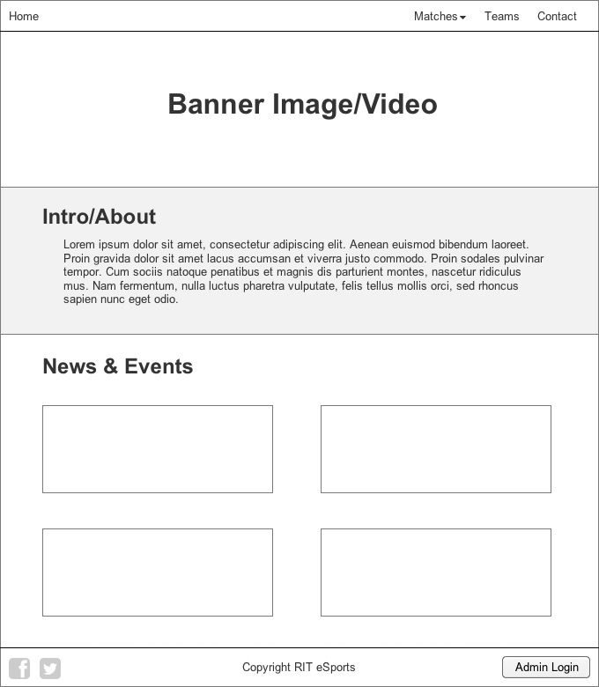

Figure 1: Home / News Page

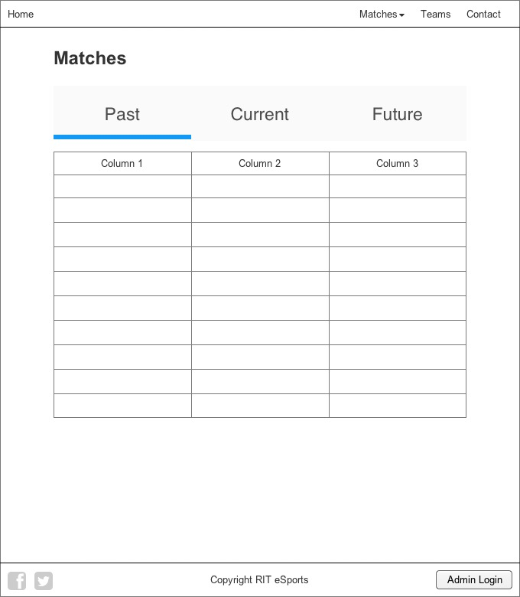

Figure 2: Matches Page

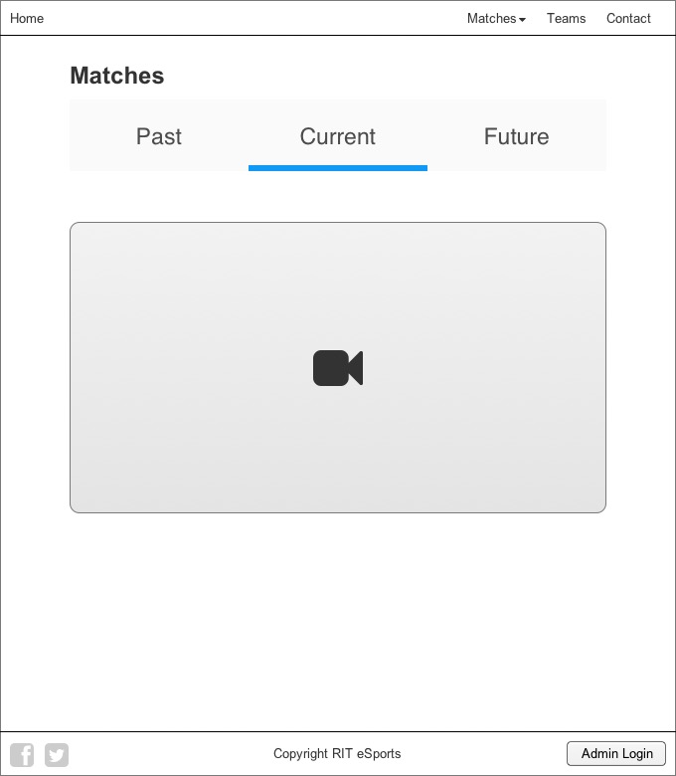

Figure 3: Current Match (Live Stream) Page

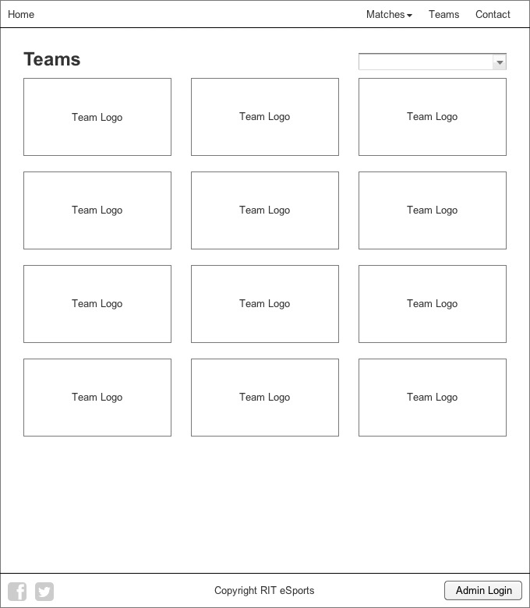

Figure 4: Teams Page

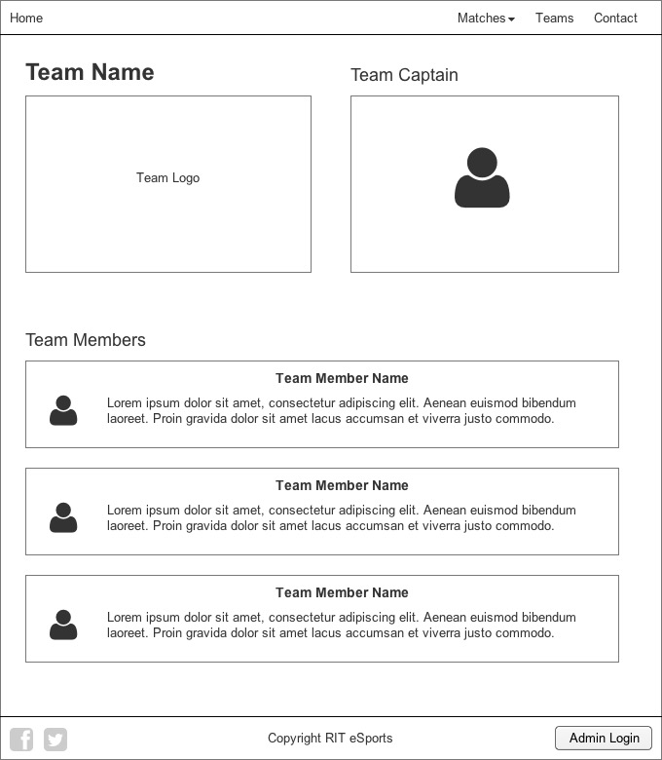

Figure 5: Team Page

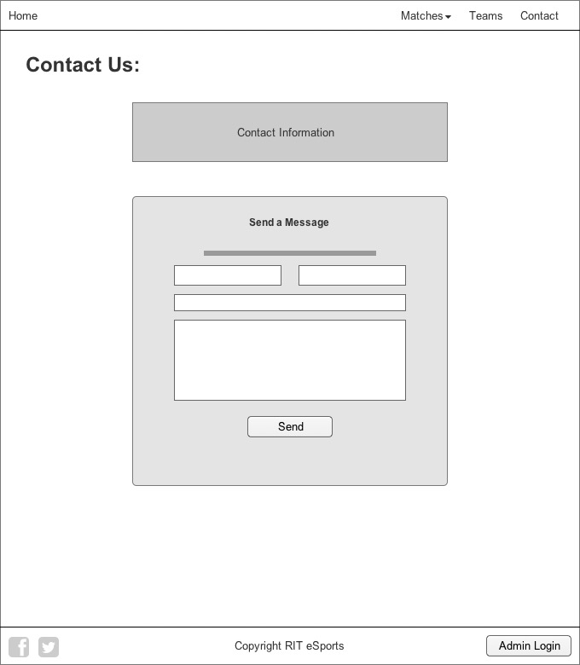

Figure 6: Contact Page

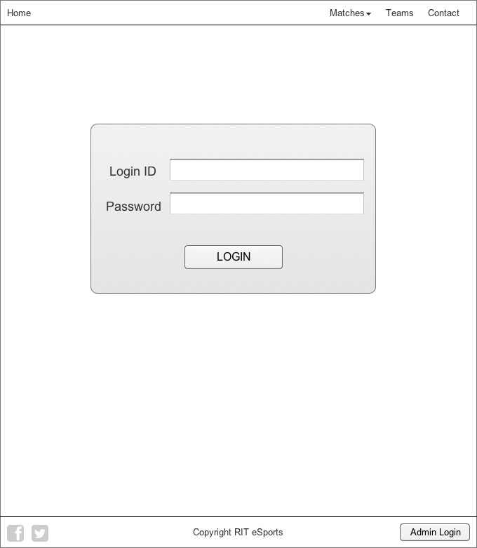

Figure 7: Admin Login Page

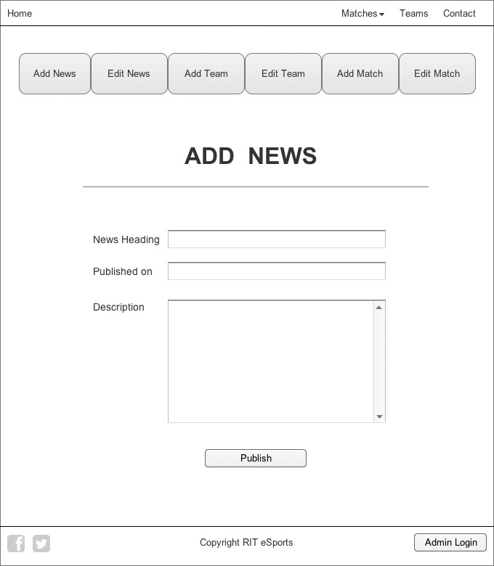

Figure 8: Admin Page

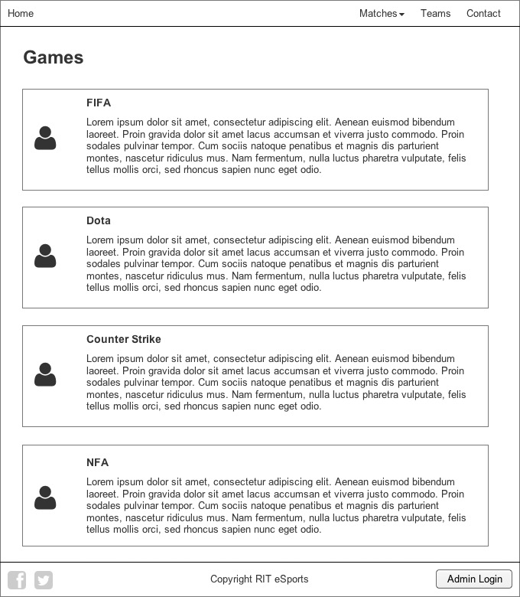

Figure 9: Games Page

## Page Mock-ups

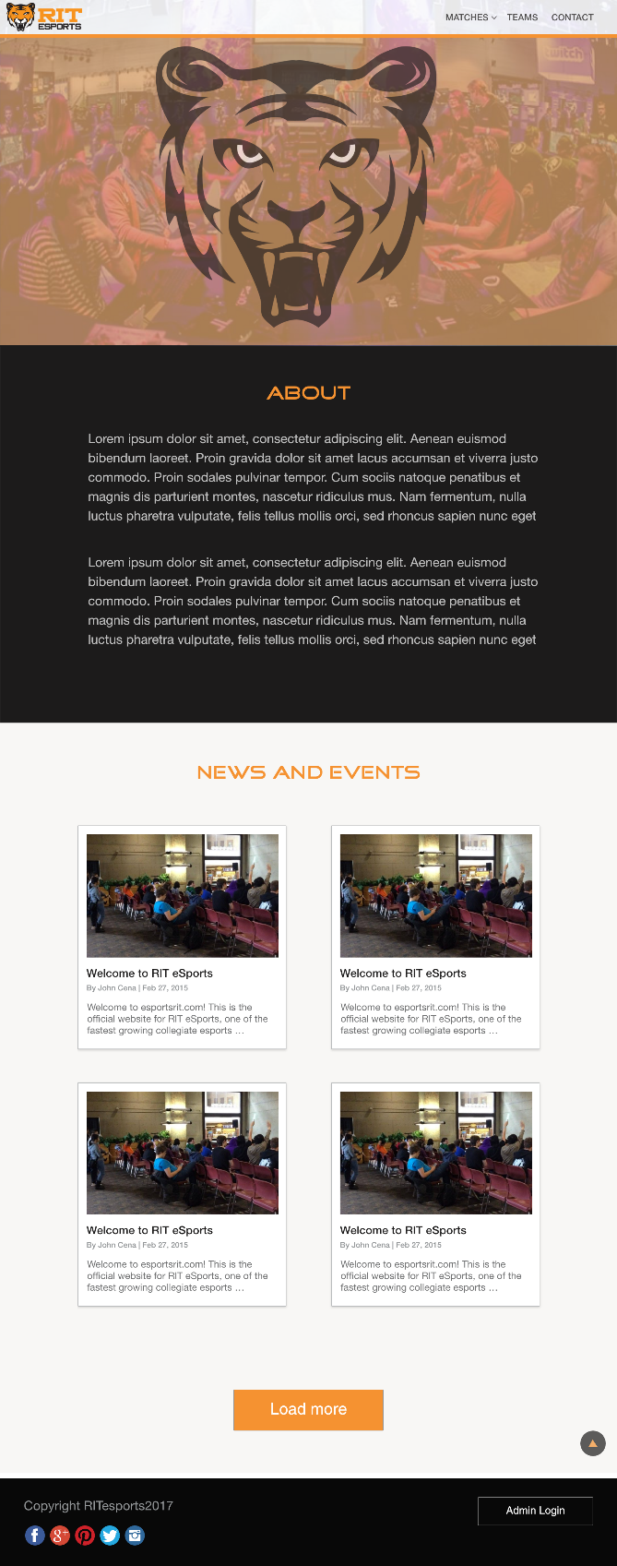­

Figure 10: Home / News Page

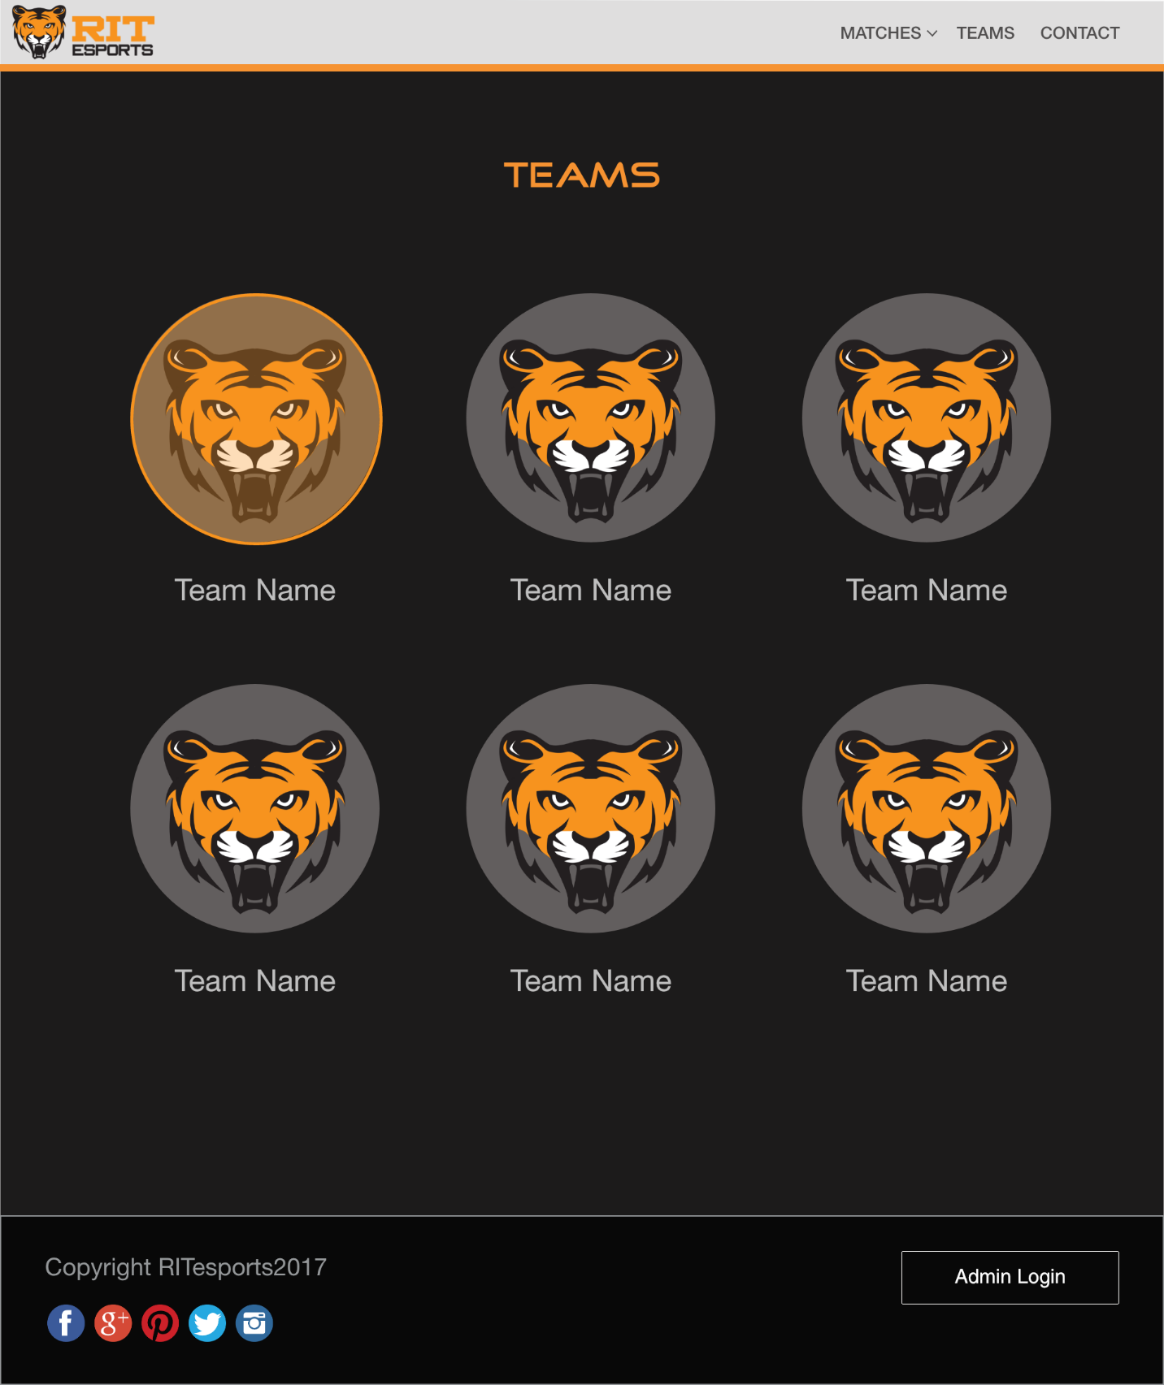

Figure 11: Teams Page

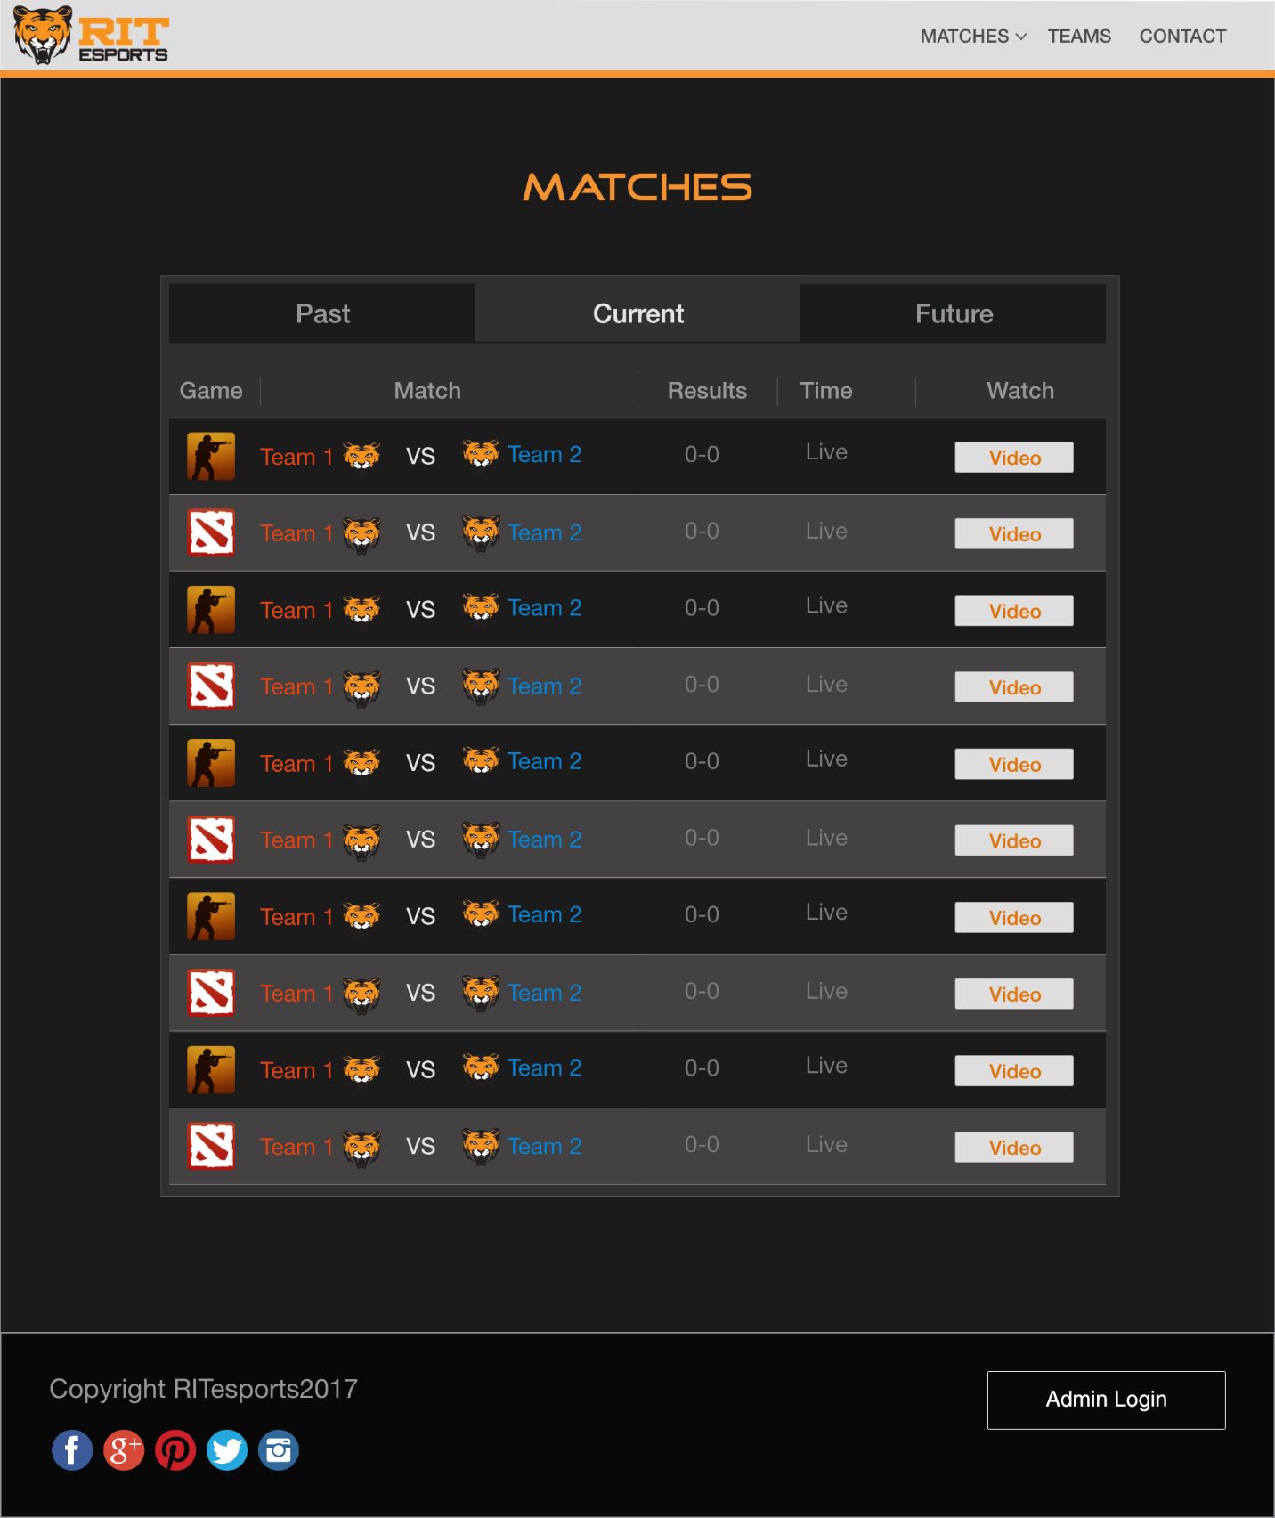

Figure 12: Matches Page

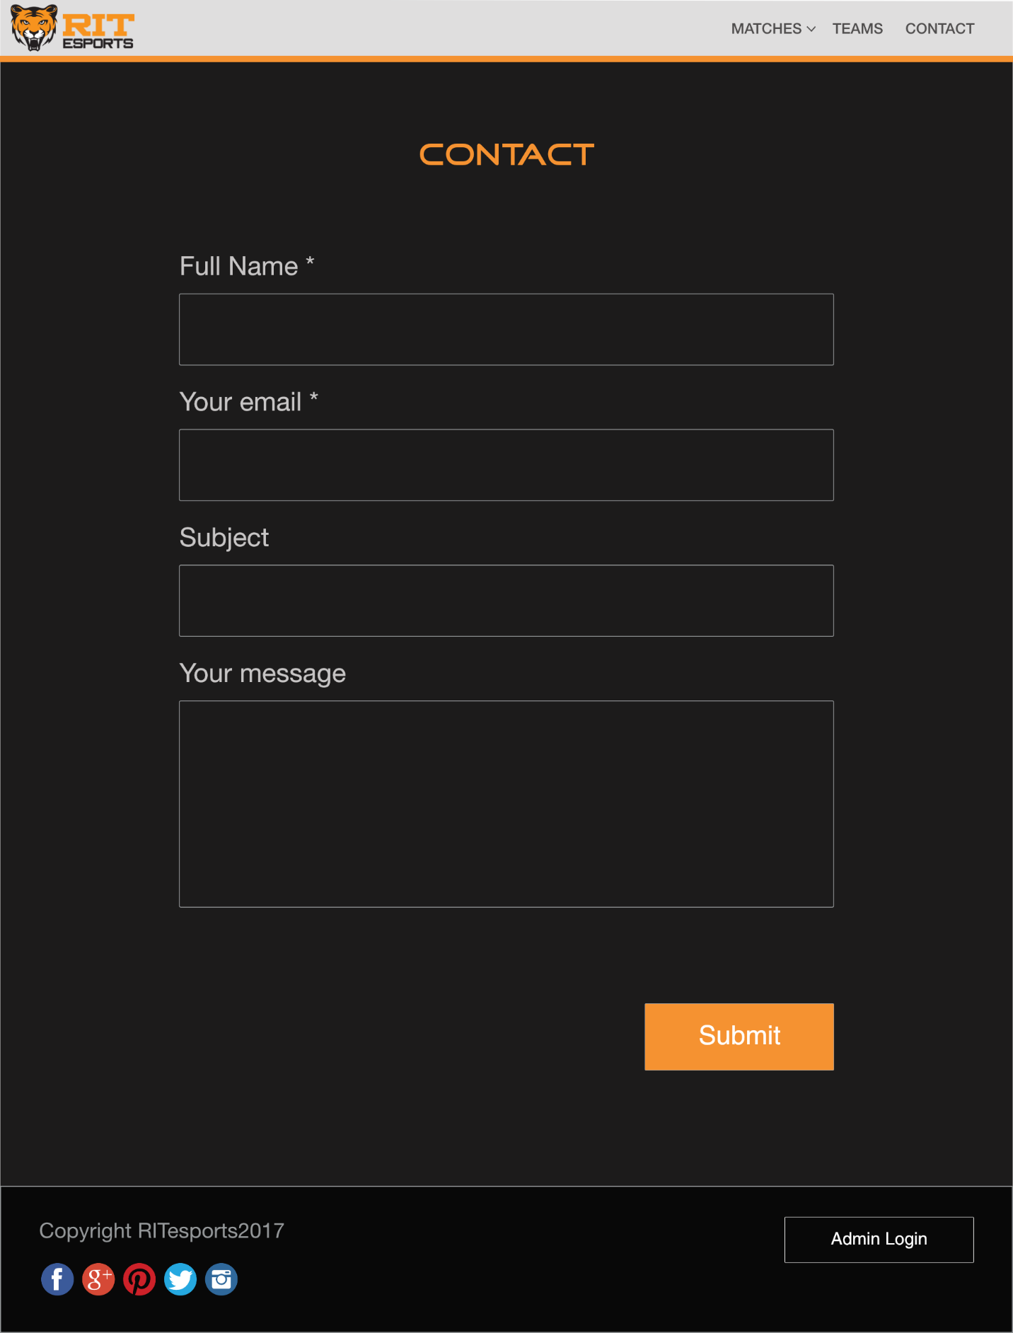

Figure 13: Contact Page