**PROJECT BASED LEARNING II ON**

### QR CODE

SUBMITTED TO THE SAVITRIBAI PHULE PUNE UNIVERSITY, PUNE IN THE PARTIAL FULFILLMENT OF THE REQUIREMENTS

FOR THE AWARD OF THE DEGREE OF

**Second Year (Computer Engineering)**

##### BY

|  |  |  |
| --- | --- | --- |
| **NAME** | **ROLL NO** | **SEAT NO** |
|  |  |  |
| Ayush Sinha | C22203 | S190364210 |
| Aman Kumar | C22204 | S190364212 |
| Shashank Athawale | C22206 | S190364221 |
| Pinak Dange | C22213 | S190364282 |

**Under the guidance of**

Prof. Varsha Gosavi



##### DEPARTMENT OF COMPUTER ENGINEERING

**STES’S SMT. KASHIBAI NAVALE COLLEGE OF ENGINEERING**

VADGAON BK, OFF SINHGAD ROAD, PUNE 411041

**SAVITRIBAI PHULE PUNE UNIVERSITY 2022 - 23**



##### DEPARTMENT OF COMPUTER ENGINEERING

**STES’S SMT. KASHIBAI NAVALE COLLEGE OF ENGINEERING VADGAON BK, OFF SINHGAD ROAD, PUNE 411041**

**CERTIFICATE**

This is to certify that the project report entitles

##### “QR CODE”

Submitted by

|  |  |  |
| --- | --- | --- |
| **NAME** | **ROLL NO** | **SEAT NO** |
|  |  |  |
| Ayush Sinha | C22203 | S190364210 |
| Aman Kumar | C22204 | S190364212 |
| Shashank Athawale | C22206 | S190364221 |
| Pinak Dange | C22213 | S190364282 |
|  |  |  |

##### Prof. R. H. Borhade Prof. Varsha Gosavi

HOD Guide

DEPARTMENT OF COMPUTER ENGINEERING

##### Prof. Vanita Gadekar Prof. Rohini Jadhav

External Examiner Class Teacher

##### Dr. A. V. Deshpande

Principal

Smt. Kashibai Navale College of Engineering, Pune - 41

##### ACKNOWLEDGEMENT

The satisfaction that accompanies the successful completion of any task would be incomplete without acknowledging those who have made it possible and to those whose constant encouragement and guidelines has been a source of inspiration throughout the course of this project.

We are very much thankful to our Project Guide **Prof. Varsha Gosavi** and Head of the Department **Dr. R. H. Borhade**, for providing their valuable suggestions and constant supervision without which carrying out this project would not have been possible.

We express our sincere gratitude to our **Principal Dr. A. V. Deshpande**

for helping us getting this project completed.

### Name of students

|  |
| --- |
|  |
| **Ayush Sinha**  **Aman Kumar**  **Shashank Athawale** |
| **Pinak Dange** |

**ABSTRACT**

QR i.e. "Quick Response" code is a 2D matrix code that is designed by keeping two points under consideration, i.e. it must store large amount of data as compared to 1D barcodes and it must be decoded at high speed using any handheld device like phones. QR code provides high data storage capacity, fast scanning, omnidirectional readability, and many other advantages including, error-correction (so that damaged code can also be read successfully) and different type of versions. Different varieties of QR code symbols like logo QR code, encrypted QR code, iQR Code are also available so that user can choose among them according to their need. Now these days, a QR code is applied in different application streams related to marketing, security, academics etc. and gain popularity at a really high pace. Day by day more people are getting aware of this technology and use it accordingly. The popularity of QR code grows rapidly with the growth of smartphone users and thus the QR code is rapidly arriving at high levels of acceptance worldwide.

|  |  |  |
| --- | --- | --- |
|  | **CONTENTS** |  |
| ACKNOWLEDGEMENT |  | I |
| ABSTRACT |  | II |
| LIST OF FIGURES |  | III |
| LIST OF TABLES |  | IV |
| LIST OF ABBREVATIONS |  | V |

##### LIST OF FIGURES

|  |  |  |
| --- | --- | --- |
| SR. NO. | NAME OF FIGURE | PAGE NO. |
| 01 | System Architecture | 21-22 |
| 02 | Results |  |
|  | I] Program | 28-29 |
|  | II] Output | 30 |

**LIST OF TABLES**

|  |  |  |
| --- | --- | --- |
| **SR NO** | **NAME** | **PAGE NO** |
| 01 | LITERATURE SURVEY | 12-14 |

##### LIST OF ABBREVIATIONS

|  |  |  |
| --- | --- | --- |
| **SR. NO.** | **ABBREVIATION** | **FULL-FORM** |
| 01 | URL | UNIFORM RESOURCE LOCATER |
| 02 | HTTP | HYPERTEXT TRANSFER PROTOCOL |

**INDEX**

|  |  |  |
| --- | --- | --- |
| **SR.NO** | **TITLE PAGE** | **PAGENO**. |
| **01** | **COVER PAGE** | 1 |
| **1.1** | **CERTIFICATE** | 2 |
| **02** | **ACKNOWLEDGMENT** | 3 |
| **03** | **ABSTRACT** | 4 |
| **04** | **INDEX** | 9 |
| **05** | **INTRODUCTION** | 10 |
| **06** | **LITERATURE SURVEY** | 12 |
| **07** | **PROBLEM STATEMENT** | 15 |
| **08** | **MOTIVATION** | 17 |
| **09** | **OBJECTIVES** | 19 |
| **10** | **SYSTEM ARCHITECTURE** | 21 |
| **11** | **SYSTEM REQUIREMENTS** | 24 |
| **12** | **IMPLEMENTATION** | 25 |
| **13** | **RESULTS** | 27 |
| **14** | **CONCLUSION AND FUTURE SCOPE** | 31 |
| **15** | **REFERENCES** | 33 |

# CHAPTER NO 01

**INTRODUCTION**

## INTRODUCTION

Quick Response codes or in brief QR Codes, are two dimensional (2D) matrix barcodes that is scanned using exploitation sensible and web capable smart mobile phones having camera, with QR Reader put in as default application, allows one to access some pre-written content such as a web site address, email address, details of things within the catalogue, phone numbers etc.

QR Code is a reasonably 2-D symbology developed by Toyota subsidiary Denso Wave in 1994 with the first aim of being a symbol that is easily decoded by scanner instrumentation at high speed with additional knowledge content than conventional barcodes. Conventional Universal Product Code contains decoded data in one direction i.e. vertically into bars and house in between; whereas QR Code contains decoded data in each the directions i.e. vertical and horizontal direction. QR code is capable of holding additional volume of information than barcode, which is even a whole bunch of times as abundant data .

# CHAPTER 02

**LITERATURE SURVEY**



**LITERATURE SURVEY**

|  |  |  |  |  |  |
| --- | --- | --- | --- | --- | --- |
| **Sr.No** | **Title of papers** | **Year** | **Authors of Papers** | **Description** | **Advantages** |
| 1 | QR code-based mobile learning system for smart education | 2020 | Lee, S., Lee, J., & Hong | This study explores the use of QR codes in education and presents a mobile learning system that uses QR codes to provide students with access to educational content**.** | Provide students with access to educational content**.** |
| 2 | QR code-based mobile application for attendance manageme-  -nt | 2018 | Shyamkumar, K. V., & Nithin, V | International Journal of Pure and Applied Mathematics, 119(16), 1213-1220. This paper presents a QR code-based mobile application that automates attendance management in educational institutions. | Attendance management in educational institutions.. |
| 3 | QR code-based mobile learning:A review of research | 2019 | Zhang, L., & Lu, Y. | This review article examines the use of QR codes in mobile learning and summarizes the findings of research studies that have investigated the effectiveness of QR code-based mobile learning | Effectiveness of QR code-based mobile learning |

# CHAPTER 03 PROBLEM STATEMENT



## PROBLEM STATEMENT

Develop a web-based QR code generator tool that allows users to generate QR codes for various types of data, such as URLs, text, email addresses, phone numbers, and more. The tool should be user-friendly and accessible on all devices. Users should be able to customize the size and color of the QR code, as well as choose between different encoding modes (numeric, alphanumeric, binary, and kanji). The generated QR code should be downloadable and printable. The project should utilize modern web technologies and adhere to industry standards for QR code generation.

# CHAPTER 04 MOTIVATION

#### MOTIVATION

QR codes are becoming increasingly popular in today’s world. By developing a QR code generator, we will be contributing to this trend and making it easier for people to use QR codes. You can customize your QR code generator to suit your needs. For example, you can add features such as color customization and image embedding. Developing a QR code generator will help you learn more about programming concepts such as image processing and data encoding.

QR codes are becoming increasingly popular in today’s world. They are used in various industries such as retail, hospitality, and government to provide easy access to information and content. QR codes offer several advantages over traditional print-based marketing. For example, they are quick and error-free compared to typing a URL on a mobile screen. Scanning a QR code is also much faster than typing a URL. QR codes can also be used to provide more informative content than print-based marketing. They can be used to engage with rich content such as videos and images.

QR codes are also actionable. They can be used to download an app or make a purchase. QR codes are trackable, which means that businesses can track where their customers have been and understand their purchasing patterns through QR codes. Finally, QR codes are easy to save. They can be saved on a smartphone or printed out for later use.

In summary, QR codes are important because they offer a simple way to connect consumers to online content and provide several advantages over traditional print-based marketing.

.

# CHAPTER 05 OBJECTIVES

#### OBJECTIVES

The objective of QR code generator project is to create a tool that can generate QR codes for various types of data, such as URLs, text, email addresses, phone numbers, and more. The tool should be easy to use and customizable so that users can create QR codes that meet their specific needs. Additionally, the tool should be able to generate QR codes that are compatible with different devices and platforms.

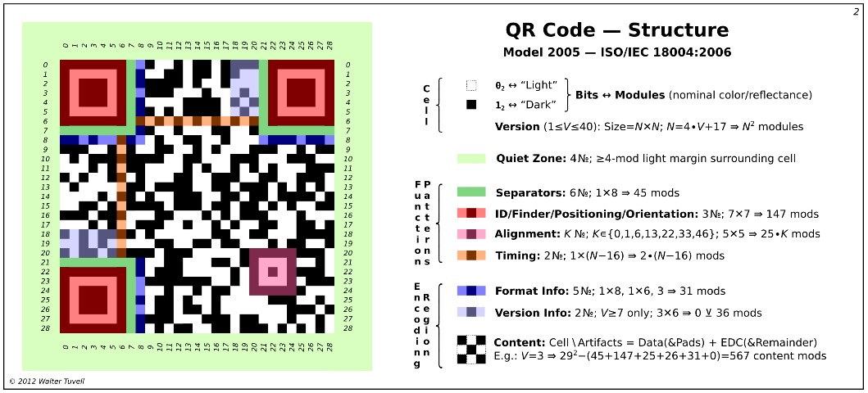

# CHAPTER 06 SYSTEM ARCHITECTURE

**SYSTEM ARCHITECTURE**

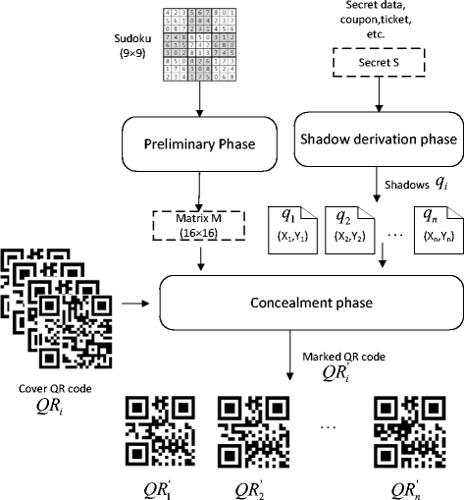

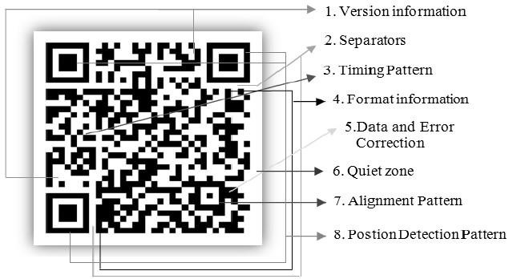

# CHAPTER 07 SYSTEM REQUIREMENTS



#### SOFTWARE AND HARDWARE REQUIREMENTS

* **Hardware Requirements:**
* Processor : Pentium i3 or higher
* RAM : 4 GB or higher
* Hard Disk Drive : 20 GB (free)
* Peripheral Devices : Monitor, Mouse and Keyboard

#### Software Requirements:

* Operating system : Windows 8/10.
* IDE Tool : VS Code
* Coding Language : HTML, CSS, Java Script

# CHAPTER 08 IMPLEMENTATION



**ALGORITHM**

Here is an algorithm for a QR code generator:

1. Get the data to be encoded in the QR code.

2. Choose the version of the QR code based on the amount of data to be encoded.

3. Choose the error correction level based on the desired level of redundancy.

4. Generate the data codewords using the selected version and error correction level.

5. Generate the error correction codewords using the selected version and error correction level.

6. Interleave the data and error correction codewords to create the final message codewords.

7. Add padding bits to the message codewords to fill out the final message length.

8. Generate the final bitstream by adding synchronization patterns, format information, and version information to the message codewords.

9. Generate the QR code matrix by mapping the bitstream to a grid of black and white modules.

10. Add quiet zones around the QR code matrix to ensure proper scanning.

# CHAPTER 09 RESULTS



#### RESULTS

##### Chapter 1. Program

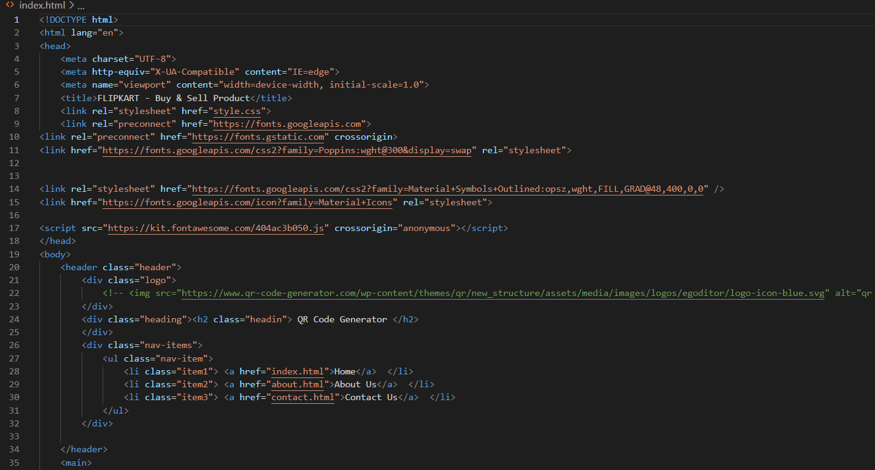



**Chapter 2 Output**

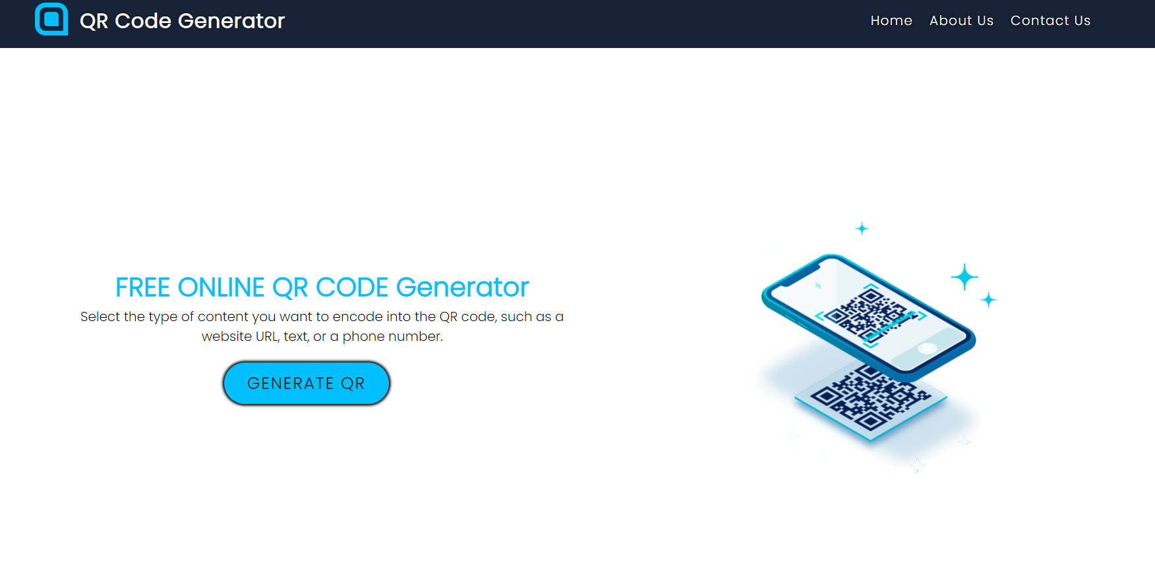

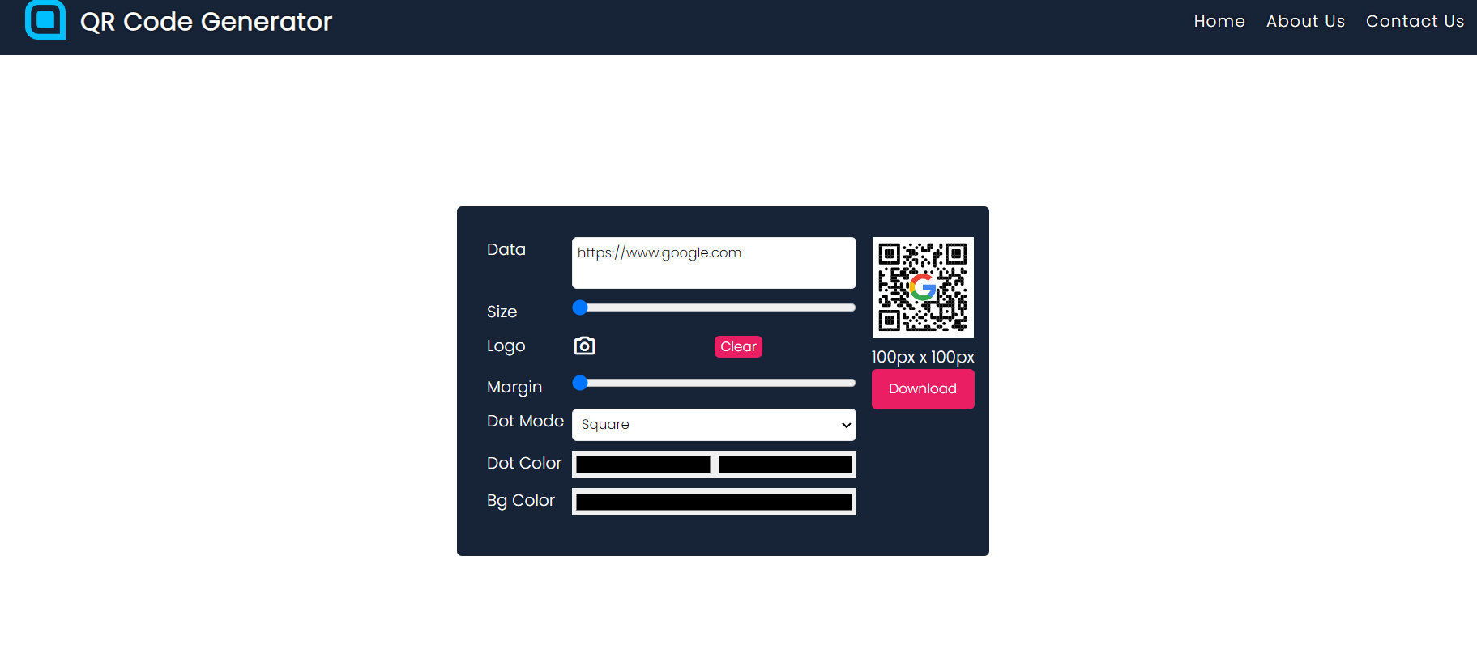

# CHAPTER 10 CONCLUSION AND FUTURE SCOPE

##### CONCLUSION AND FUTURE SCOPE

The QR code generator project has successfully developed a user-friendly web application that enables users to create customized QR codes. In conclusion, the project has demonstrated the feasibility and usefulness of using QR codes in various applications, including marketing, advertising, and product packaging. The application's simple and intuitive interface provides an easy way for users to generate QR codes with different designs, sizes, and formats.

Looking towards the future, there are several potential directions for further development of the project. One possible area of expansion is to integrate the application with other tools or platforms, such as social media or e-commerce websites, to enhance its functionality and reach a wider audience. Additionally, the project can explore new features such as analytics to provide users with insights into their QR code performance. Another potential direction is to develop a mobile application to allow users to generate QR codes on-the-go.

Overall, the QR code generator project has demonstrated its potential for creating customized and versatile QR codes, and has promising opportunities for further development and growth.

# CHAPTER 11 REFERENCES

##### REFERENCES

1. QR Code For A Survey: A Complete Step-by-Step Guide - Scanova Blog. (2022, January 31). Scanova Blog. <https://scanova.io/blog/qr-code-for-a-survey/>
2. What is the Future of QR Codes: 2022 And Beyond - Scanova Blog. (2022, January 31). Scanova Blog. <https://scanova.io/blog/qr-codes-future/>
3. QRCode Monkey - The free QR Code Generator to create custom QR Codes with Logo. (n.d.). QRCode Monkey. <https://www.qrcode-monkey.com/>
4. Pal, P., & Chakraborty, S. (2019). Intelligent QR code: A novel approach to secure QR code scanning. Journal of Ambient Intelligence and Humanized Computing.
5. Mokhtar, A. S., & Ahmad, S. Z. (2019). QR code generator: Android application. In 2019 IEEE 2nd International Conference on Computing, Mathematics and Engineering Technologies (iCoMET) (pp. 1-5). IEEE.

# THANKYOU