

Structured of Programming Language

EXERCISE
4

Name of Student | Name of Professor
Data Performed | Date Submitted

- PROGRAM OUTCOME/S (PO) ADDRESSED BY THE LABORATORY EXERCISE
- Apply knowledge of computing appropriate to the discipline [PO: A]
- COURSE LEARNING OUTCOME/S (CLO) ADDRESSED BY THE LABORATORY EXERCISE
- Apply fundamental principles of Python in creating possible solutions for computing problems. [CLO: 2]
- INTENDED LEARNING OUTCOME/S OF THE LABORATORY EXERCISE
At the end of this exercise, students must be able to:
- Solve the given problem
- Create documentation base on the given problem
- Create test cases for the problem
- Problem definition

Answer the following problems.

Write a Python program that implements OOP, create a class named Rectangle to compute the Area of a rectangle. The class must pass two arguments to compute for the area of a rectangle.

# Requirements

Add the following lines to your code editor.

#Name: TYPE YOURNAME
#School: FEU-TECH
#Machine Problem number - 1

Submit your codes to canvas.

Using MS Word
#Name: TYPE YOURNAME
#School: FEU-TECH
Take 3 screenshots of the output. (should include your name)
Paste the source code to MS Document file.

Paste the source code to the comment section in canvas upload submission.

# TEST DATA

`Enter Length value:-1`
`Input the width of the rectangle:-2`
`The number is not a positives integer:`

`Enter Length value:1.1`
`Enter the width of the rectangle:2.3`
`Input the correct data format is not a Positive integer:`

`Enter Length value:10`
`Enter the width of the rectangle:20`
`The Area of the Rectangle is:200`

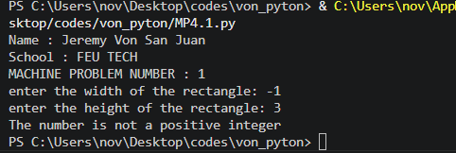
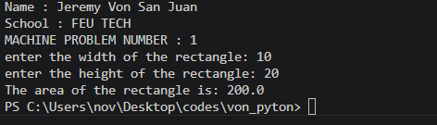
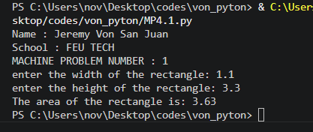

Source code:

#Name : Jeremy Von San Juan
#School : FEU TECH
#MACHINE PROBLEM NUMBER : 1

class Rectangle:
def __init__(self, width, height):
self.width = width
self.height = height

def area(self):
return f"{self.width * self.height}"

print("Name : Jeremy Von San Juan")
print("School : FEU TECH")
print("MACHINE PROBLEM NUMBER : 1")

width = float(input("enter the width of the rectangle: "))
height = float(input("enter the height of the rectangle: "))

if width <= 0 or height <= 0:
print ("The number is not a positive integer")
else:
areaR = Rectangle(width, height)
print(f"The area of the rectangle is: {areaR.area()}")

2. Write a Python program that implements OOP. Use the class name Circle. Solve for the Area and Perimeter.

# Requirements

Add the following lines to the editor.

#Name: TYPE YOURNAME
#School: FEU-TECH
#Machine Problem number - 2

Submit your codes to canvas.

Using MS Word
#Name: TYPE YOURNAME
#School: FEU-TECH
Take 3 screenshots of the output. (should include your name)
Paste the source code to MS Document file.

Paste the source code to the comment section in canvas upload submission.

# TEST DATA

`Enter radius:-1`
`You use enter positive number`

`Enter radius:1.1`
`You use input whole number value:`

`Enter radius:10`
`The answer is 314.0`
`Here is the Answer: 62.800000000000004`

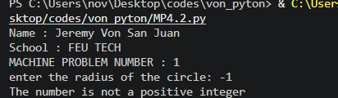
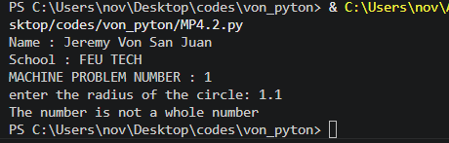
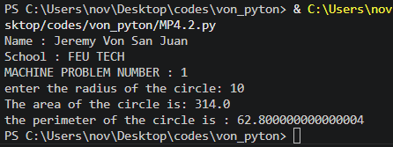
3. Write a program that accepts integer as input and display the equivalent roman numeral and vice-versa. The program should be written in OOP.

# SAMPLE GUIDE

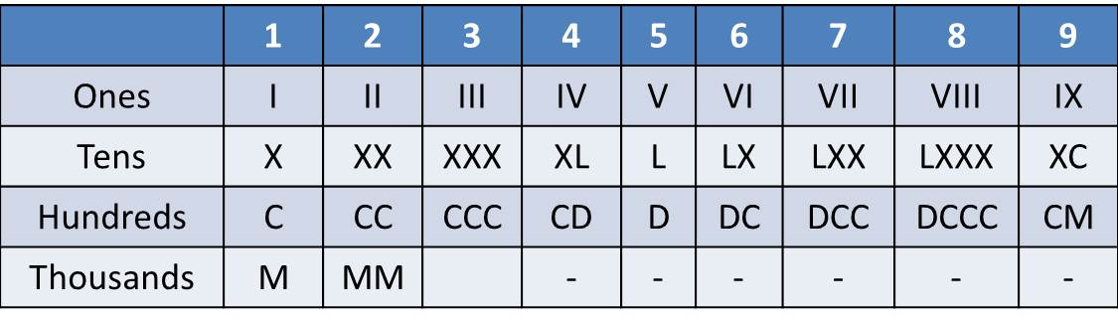

# Requirements

Add the following lines to the editor.

#Name: TYPE YOURNAME
#School: FEU-TECH
#Machine Problem number - 3

Submit your codes to canvas.

Using MS Word
#Name: TYPE YOURNAME
#School: FEU-TECH
Take 3 screenshots of the output . (should include your username)
Paste the source code to MS Document file.

Paste the source code to the comment section in canvas upload submission.

# TEST DATA

MENU

1. convert an integer to a roman numeral
2. convert a roman numeral to an integer
3. exit

Enter your choice:1

Enter Integer - 1
Output in Roman numerals is: I

Enter Integer - 3000
Output in Roman Numberals is MMM

MAX VALUE IS 5000, should only accept whole number value. provide the necessary error handling.

Enter your choice:2

Enter roman numeral - MMM
Output in Integer is - 3000

Enter roman numberals - I
Output in Integer is - 1

The conversion should accept uppercase and lowercase input.

After the output, the program should return to the menu choices.

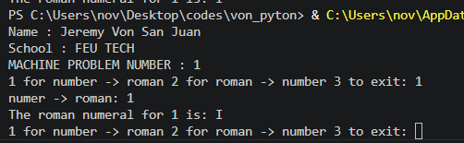

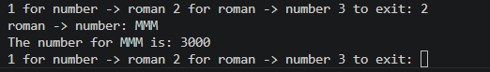

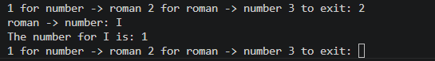

- ASSESSMENT

Department | Computer Science
Subject Code | CS00048
Description | Structured of Programming Language
Term/Academic Year

Note: The following rubrics/metrics will be used to grade students’ output in the lab exercise 1.

 |  | Program (50 pts) | (Excellent) | (Good) |  | (Fair) | (Poor)
 |  | Program execution (20pts) | Program executes correctly with no syntax or runtime errors (18 – 20) | Program executes with less than 3 errors (15 – 17 ) |  | Program executes with more than 3 errors (12 – 14) | Program does not execute (10 – 11)
 |  | Correct output  (20pts) | Program displays correct output with no errors (18 – 20) | Output has minor errors (15 – 17) |  | Output has multiple errors (12 – 14 ) | Output is incorrect (10 - 11)
 |  | Design of output  (10pts) | Program displays more than expected (10) | Program displays minimally expected output (8 – 9) |  | Program does not display the required output (6-7) | Output is poorly designed (5)
 |  | Design of logic  (20pts) | Program is logically well designed (18 – 20) | Program has slight logic errors that do no significantly affect the results (15 – 17) |  | Program has significant logic errors (12 – 14 ) | Program is incorrect (10 - 11)
 |  | Standards  (20pts) | Program is stylistically well designed (18 – 20) | Few inappropriate design choices (i.e. poor variable names, improper indentation) (15 – 17) |  | Several inappropriate design choices (i.e. poor variable names, improper indentation) (12 – 14 ) | Program is poorly written (10 - 11)
 |  | Delivery  (10pts) | The program was delivered on time. (10) | The program was delivered within a week of the due date. (8 – 9) |  | The code was within 2 weeks of the due date. (6 – 7) | The code was more than 2 weeks overdue (5)
Topic | Android Development
Lab Activity No | 1
Lab Activity | Welcome Message
CLO | 1 and 2

- REFERENCES

- Mueller(2018) Python for Data Science for dummies, Wiley
- Tuner (2018) Statistics For Machine Learning: Techniques For Exploring Supervised, Unsupervised, And Reinforcement Learning Models With Python And R
- Tuner(2018) Python Programming: 3 Books In 1: Beginner’s Guide + Intermediate Guide + Expert Guide To Learn Python Step-By-Step, Wiley
- Romano(2018) Learn Python Programming: The No-Nonsense, Beginner's Guide To Programming, Data Science, And Web Development With Python 3.7,Packt Publishing
- Morgan (2017), Data Analysis From Scratch With Python: Step-By-Step Guide , Createspace Independent Publishing Platform.
- Barry(2017), Head First Python: A Brain-Friendly Guide , O'reilly Media
- Guttag(2016), Introduction To Computation And Programming Using Python (2016), The Mit Press

Courseware Materials available at www.feu.instructure.com

