**Part 3:**

GitHub

What is GitHub? When was it created? Why? By who? What similar platforms exist? Why would you use such a platform?

GitHub is designed around Git. Git is an open-source a version control system. It means, when developers create an app, they make constant changes to the code to make it precise and up to the mark, resulting in the release of new versions up to and after the first official release. Version control systems use repositories for storage. This system keeps these revisions straight, storing the modifications in a central repository. This allows developers to easily collaborate, as they can download a new version of the software, make changes, and upload the newest revision. Every developer can see these new changes, download them, and contribute.

Now about the Hub, Git is a command-line tool, but the center around which all things involving Git revolves is the hub, i.e. GitHub.com, where developers store their projects and network with like minded people.

GitHub was developed by Chris Wanstrath, PJ Hyett, Tom Preston-Werner and Scott Chacon using Ruby on Rails, and started in February 2008. When developers develop the code in a team that means every team member has to have access to the code. As a result of this, the team will have to have a copy of the code on their respective systems. When the code is changed by any team member it gets tedious to maintain the progress of the code hence the solution is github! GitHub lets you save your code online. Also it allows all the developers of a project to see what changes the other one has made and let them discuss the issues in the code, if any, online. It save the storage space and add to the convenience.  There are other similar platforms like GitLab, BitBucket, Beanstalk, Launchpad, SourceForge, etc.Such platform is used because GitHub is a Git repository hosting service, and it adds many of its own features. While Git is a command line tool, GitHub provides a Web-based graphical interface which allows user to modify the existing code. It also provides access control and several collaboration features so that it is easier to discuss the issues regarding code and reduces storage consumption.

**Part 4:**

GitHub Tutorial:

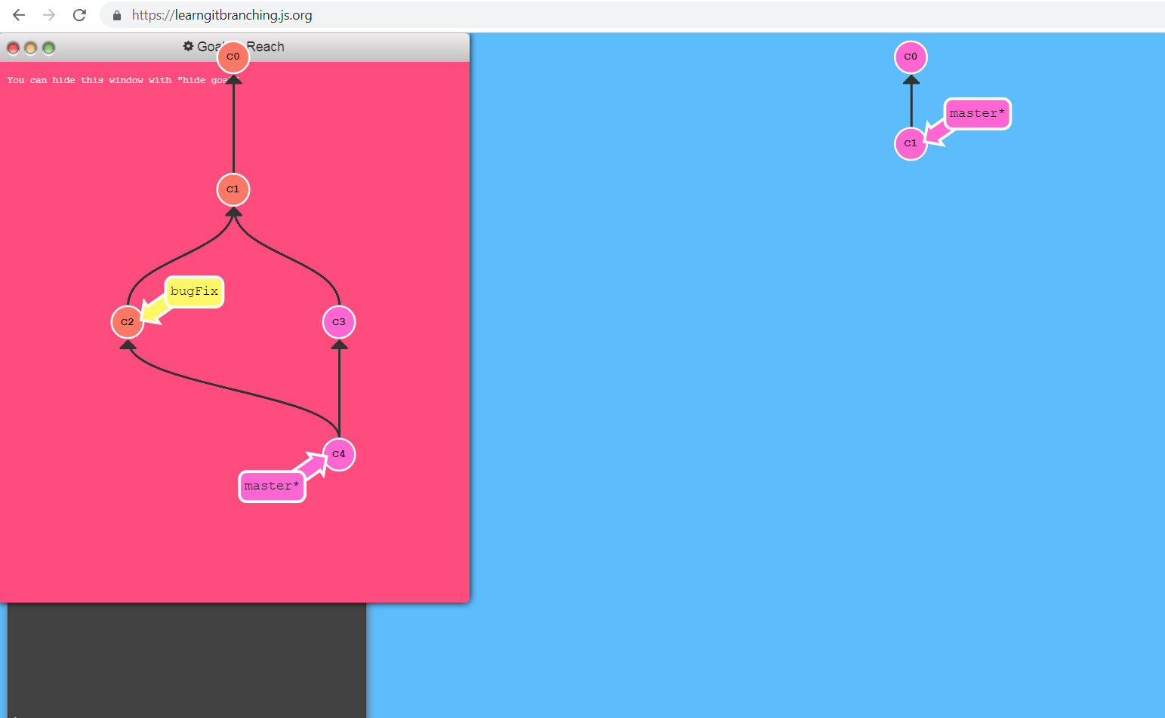

**Part 5:**

Define the following terms in the context of Git (2 lines maximum):

* Repository
* Repository is the location where all the files are stored for the particular project. Each project has its own repository and that unique repository can be accessed with the unique URL. Repositories can be Private or Public.

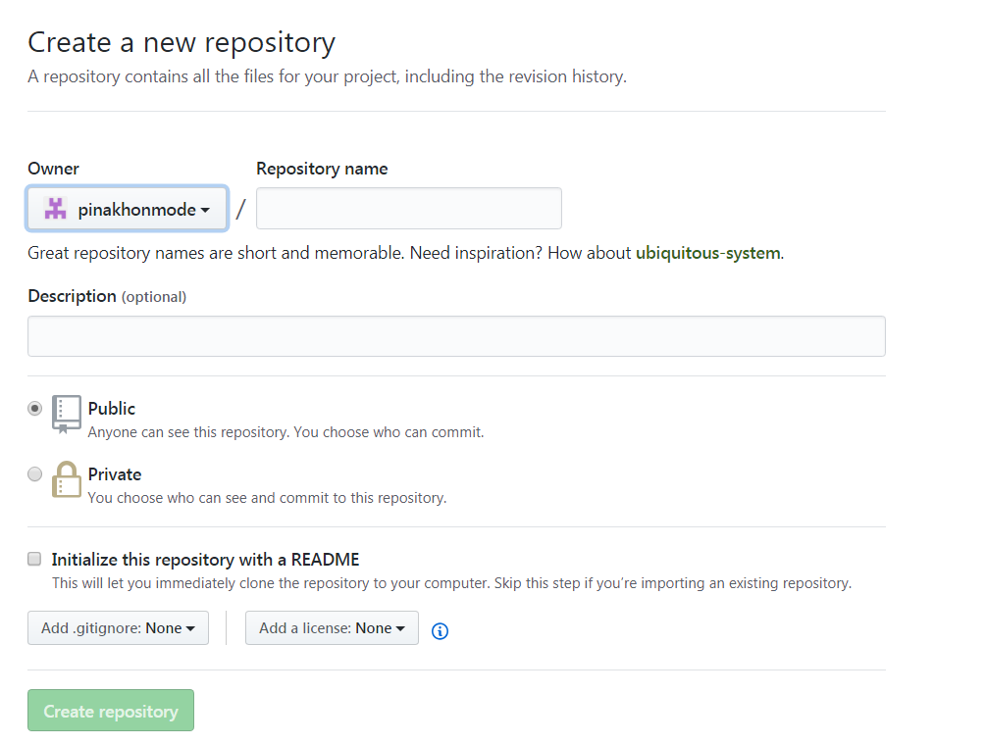

* Commit
* Commit is the command in Git with which we can revise the existing file in the repository. It allows us to keep record of the changes we have made. It can revise more than a single file.
* Push
* Push is a Git command which can be used to push the changes which are made in the project into the repository so that others can have access to the changes made in the project. It sends recent commit history from the local repository to the GitHub.
* Branch
* A branch in Git is a movable pointer to one of the commits. The default branch name is ‘master’. As you initially make commits, you're given a master branch that points to the last commit you made. Every time you commit, it moves forward automatically.
* Fork
* A fork generates a copy of a repository. Forks can be used to either propose changes to someone else's project or to use someone else's project as a starting point for your own idea. If a repository is forked then that forked repository allows you to make changes in the project without affecting the original project.
* Merge
* Git merge can be used to combine repositories, branches, etc. It creates special commit that has two unique parents. That means when those are commit together, both of the parent elements are combined.

* Clone
* Clone is the Git command which can copy an existing git repository. It manages its own files, it has its own separate history and it works in a complete different environment from the original repository. Once the repository is cloned there is no connection between the original repository and the cloned repository.
* Pull
* Pull is the git command which grabs changes from the Git repository and then merges into a local repository.
* Pull request
* Pull request lets us display the changes we have pushed in the repository on GitHub. Once a pull request is opened, the changes can be reviewed and the issues can be discussed with the other members.

**Part 6:**

**Creating the repository:**

[**https://github.com/pinakhonmode/CS6432018**](https://github.com/pinakhonmode/CS6432018)

