LAB ASSIGNMENT – 9

DATE – 06.04.2026

NAME : Pinaki Choudhuri
REGISTRATION NO. : AU/2023/0009351
ROLL NO. : UG/02/BTCSECSF/2023/012
SUBJECT : Unstructured Database Lab SEC: E

COLLECTION 1: members
{
member_id: Number, name: String,
plan: String, city: String, fee: Number
}

Table

member_id | name | plan | city | fee
1 | Aarav | Gold | Delhi | 5000
2 | Meera | Silver | Mumbai | 3000
3 | Rohan | Gold | Bangalore | 5500
4 | Sneha | Platinum | Delhi | 7000
5 | Kunal | Silver | Chennai | 3200

COLLECTION 2: sessions
{
session_id: Number, member_id: Number,

trainer: String,
duration: Number, calories: Number
}

Table

session_id | member_id | trainer | duration | calories
101 | 1 | Raj | 60 | 400
102 | 2 | Simran | 45 | 300
103 | 3 | Raj | 70 | 500
104 | 4 | Aman | 80 | 600
105 | 5 | Raj | 50 | 350

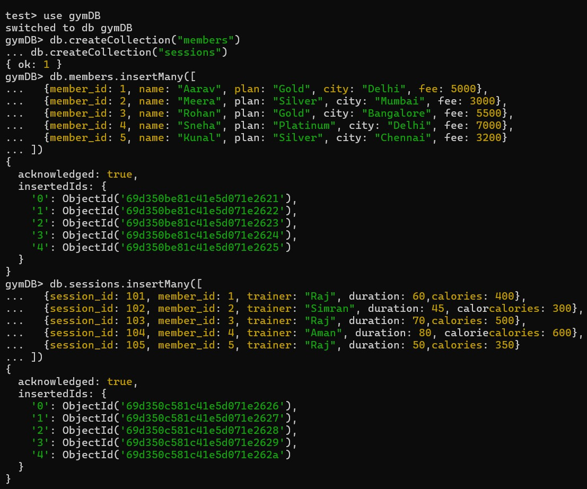
QUESTIONS

Q1. Display all members

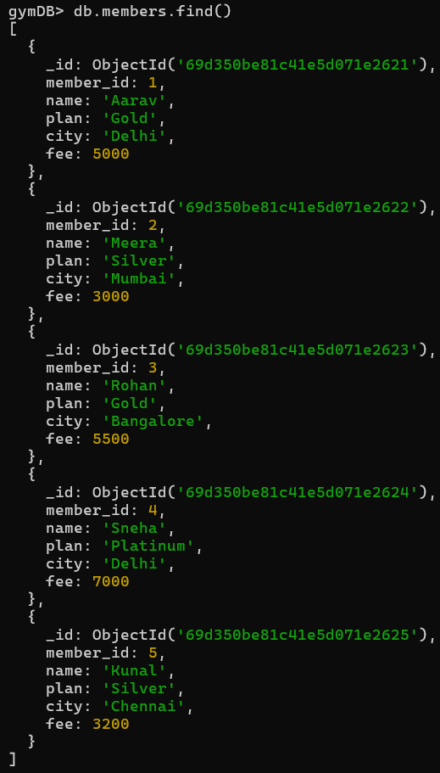

Q2. Show name and plan only.

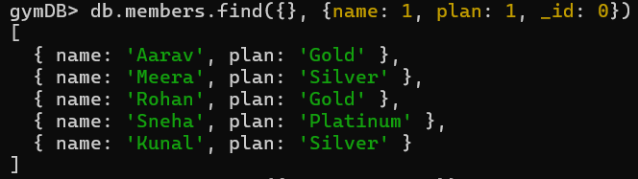

Q3. Find members from Delhi.

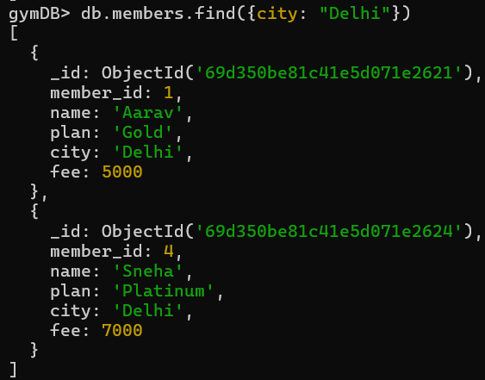

Q4. Find sessions with duration > 60.

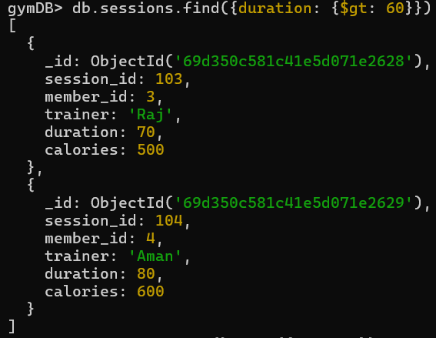

Q5. Sort members by fee descending.

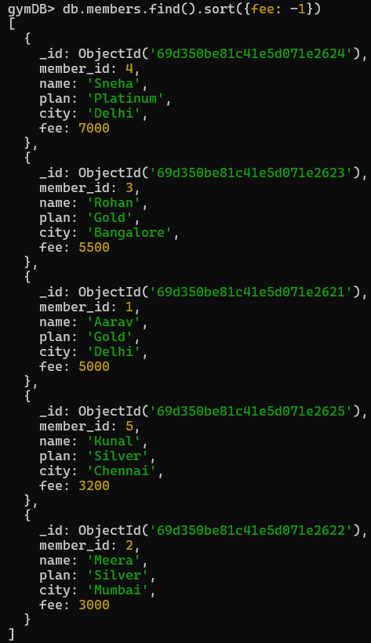

Q6. Update fee +500 for Gold members.

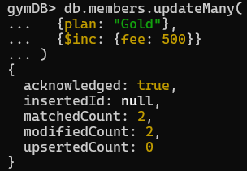

Q7. Delete members with fee < 3500.

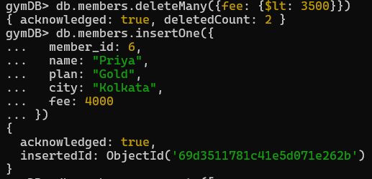

Q8. Insert a new member.

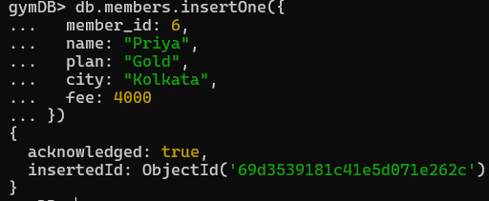

Q9. Average fee per plan.

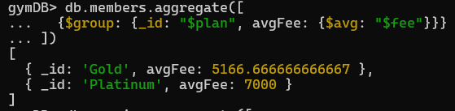

Q10. Total calories burned per trainer.

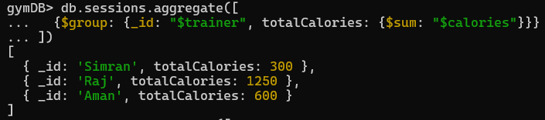

Q11. Maximum fee per city.
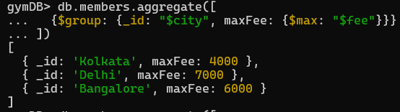

Q12. Count members per plan.

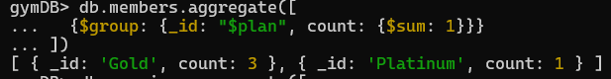

Q13. Trainers with avg calories > 400.

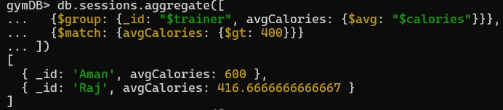

Q14. Total duration per member_id.

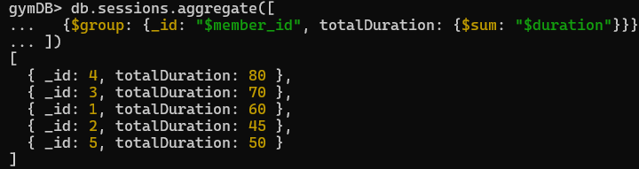

Q15. Join members with sessions.

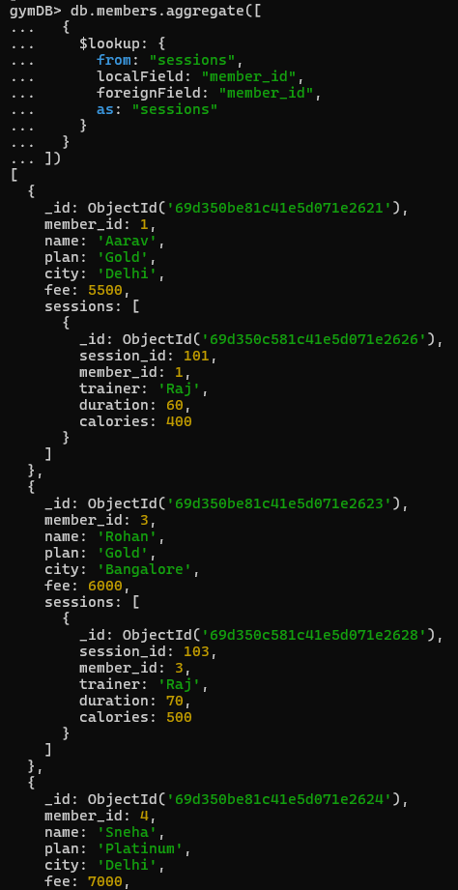

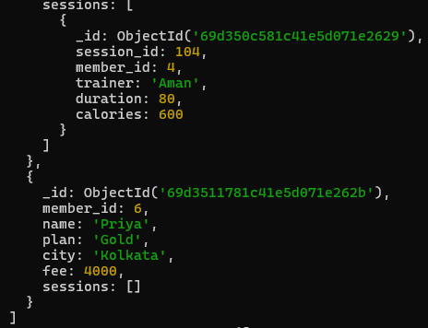
Q16. Show members who have sessions.

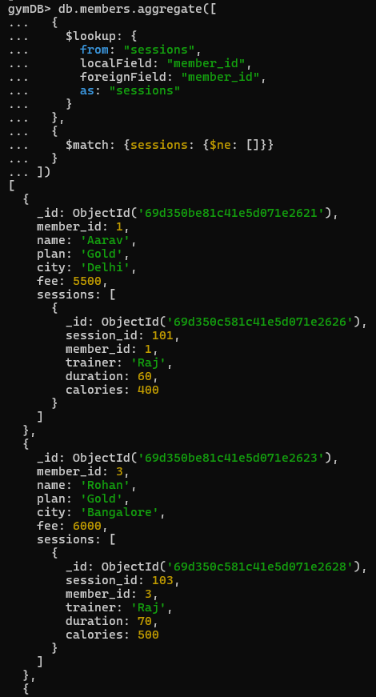

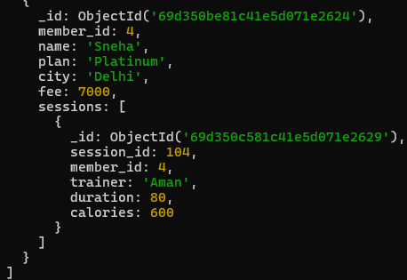

Q17. Create index on city.

Q19. Create compound index on plan and fee.

Q20. Display 2nd and 3rd highest fee members.

