**Think and Answer**

**<eYRC#2724>**

|  |  |
| --- | --- |
| **Team leader name** | PINAKI SEN |
| **College** | NATIONAL INSTITUTE OF TECHNOLOGY, AGARTALA |
| **Email** | pinakisen.eenita@gmail.com |
| **Date** | 25th Nov 2019 |

Please answer all the questions given below. You are allowed to use figures or diagrams to support your answer. Since these questions test your understanding of the whole subject, please refrain from directly asking for answers on Piazza.

**Section 1 - Simple Pendulum**

Q1) Find the eigenvalues of Simple Pendulum at equilibrium point (0,0). Is the system stable or unstable at this point? (2)

**ANS:**

` At equilibrium point (0,0), eigen values are **[ +((g/l)^0.5) i]** & **[ -((g/l)^0.5) i].**

As the value has no real part, the system will be marginally stable i,e the system will oscillate about the equilibrium point indefinitely.

Q2) Can the Pendulum be balanced at an arbitrary point such as (2π/3,0) using the Pole Placement or LQR controller? Why? Why Not? Justify your answer. (3)

**ANS:**

The pendulum can not be balanced at any arbitrary point such as (2π/3,0).

LQR and Pole Placement controller are linear controller, so the system can only be balanced at equilibrium point. The equilibrium point can be either stable or unstable.

**Here the system can be balanced at (0,0) and (π,0) points.**

**Section 2 - Mass Spring System**

Q3) Derive the equations of Mass Spring system. (3)

**ANS:**

Here is the derived state space equation of mass-spring system.

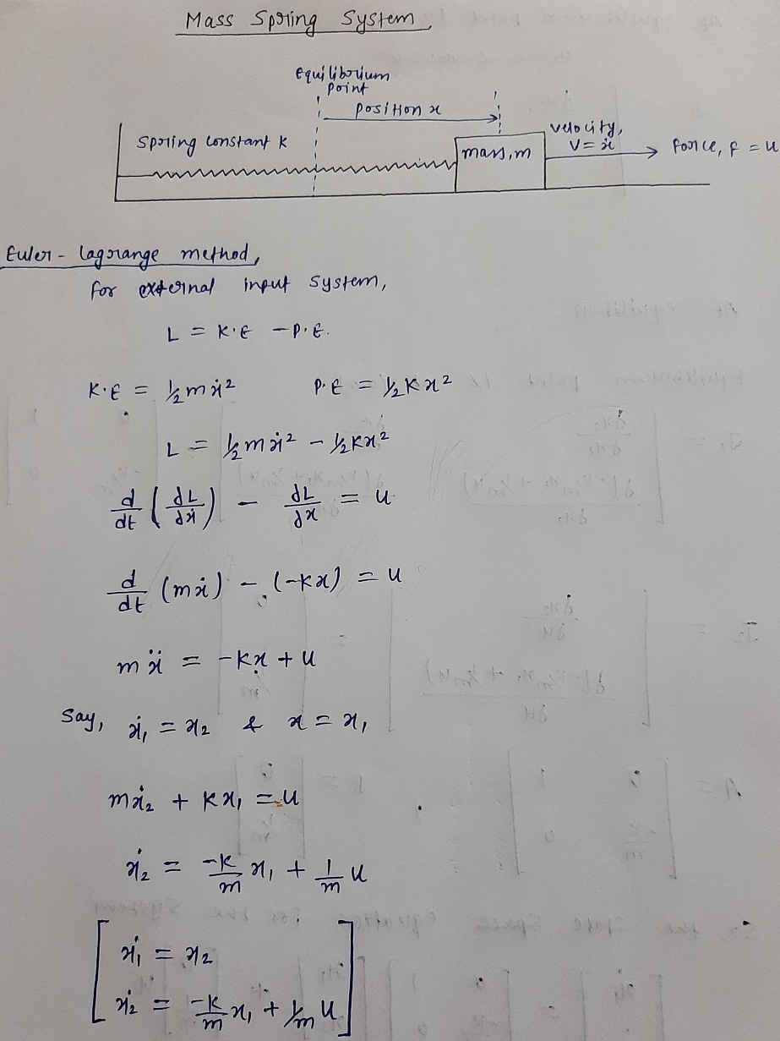

**P.T.O.**

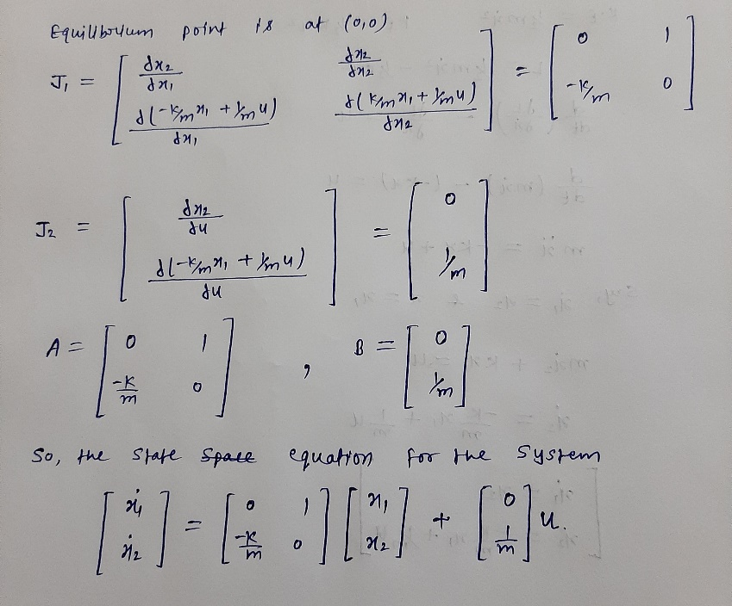

Q4) Is the mass spring system a linear system or non-linear? Justify your answer. (1)

**ANS:**

It is **Non Linear** because the equation of the mass spring system does not satisfy the **Superposition theorem** and it’s dynamics **can not be expressed in form of a linear differential equation**.

Q5) Can the mass spring system be driven to arbitrary state (0.8, 0) using pole placement controller? (Assuming 0.8 is the position and 0 is the velocity). (1)

**ANS:**

**Yes**, the mass spring system can be driven to arbitrary state (0.8,0) **applying variable external force** using pole placement controller.

**Section 3 - Simple Pulley**

Q6) Under what conditions, will the system remain perfectly at rest? Justify your answer. (1)

**ANS:**

**Firstly,** if there is no externally applied force, system will be stable if and only if two masses are equal i.e. m1 = m2.

**Secondly,** if there is externally applied force and the masses are not equal (say m2 > m1), then system will be perfectly at rest, if an external for of magnitude ((m2-m1)*g) will be applied in downward direction on the mass that has the lesser magnitude(here m1).

Q7) How many equilibrium points does the system have? Are they stable or unstable? Justify your answer. (2)

**ANS:**

Assuming that the pulley is an ideal one, Simple Pulley system will have equilibrium condition (in absence of any external force) if and only if the masses hanging in either side of the pulley have same magnitude. In that case there will be infinite no. of equilibrium point as the height of the masses hanging in either side of pulley will not affect the equilibrium condition of the system. As the height doesn’t affect, all the equilibrium points are stable.

On other hand, if the masses are not same, the system can never attain equilibrium without help of any external force.

**Section 4 - Complex Pulley**

Q8) Derive the equations of motion for the complex pulley system. (5)

**ANS:**

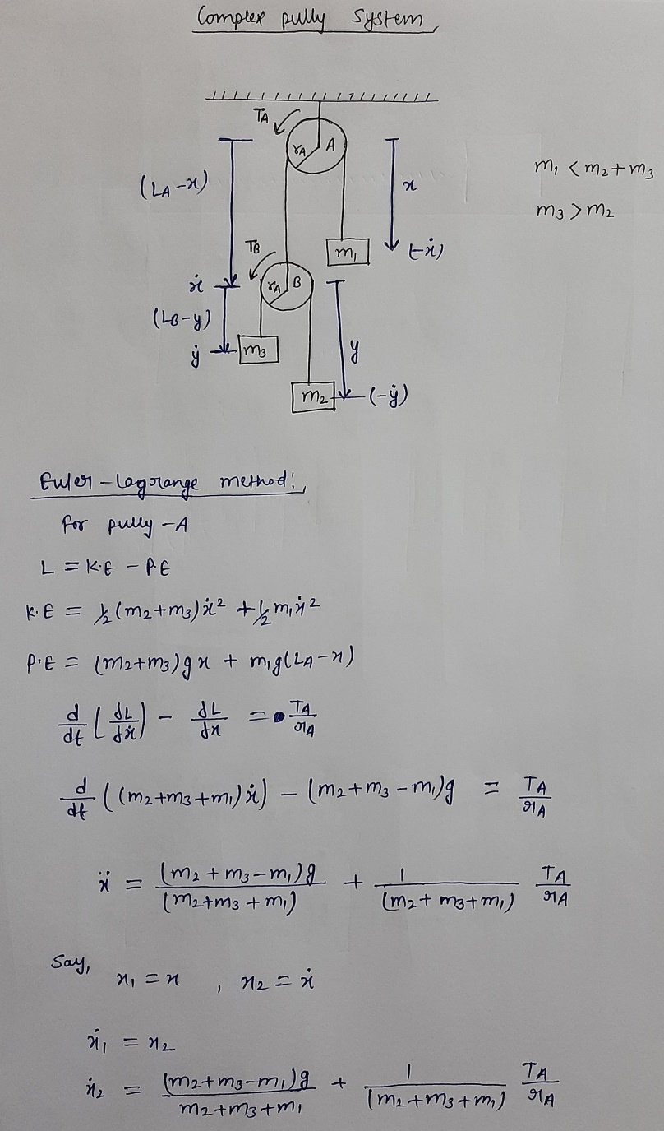

**P.T.O.**

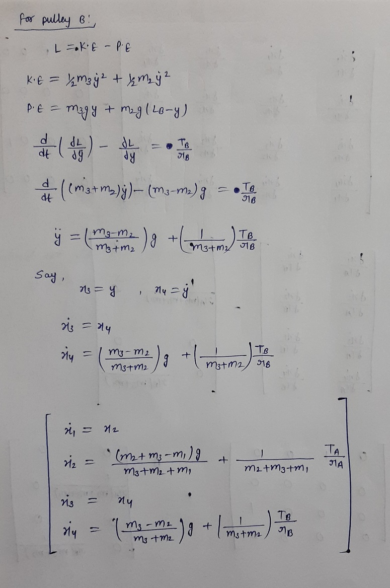

Q9) Derive the A and B matrices for the complex pulley system. Is the system linear or non linear? (4)

**ANS:**

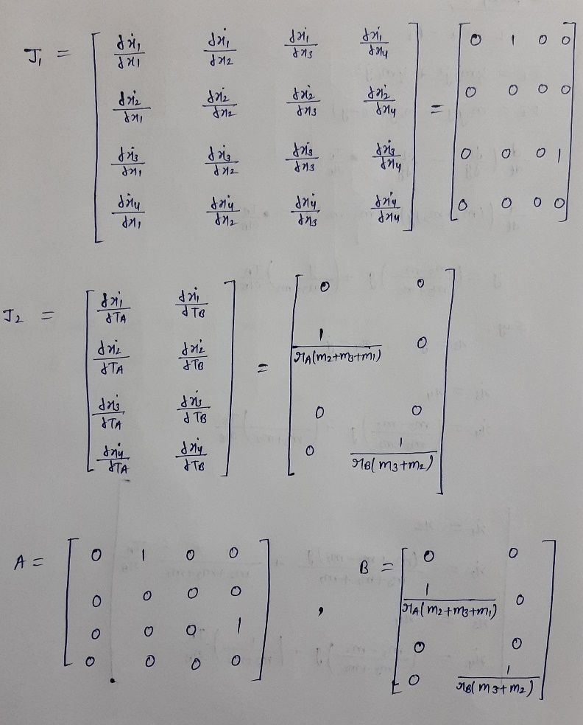

Complex pulley system is a non-linear system as it’s dynamics can not be described by linear differential equation.

As both Pole Placement and LQR are linear controller, we linearized the system. In the above attached picture we have calculated the A & B matrix. Hence the system can be expressed in form of linear differential equation, X_dot = Ax + Bu

Q10) Under what conditions, will the system remain perfectly at rest? Justify your answer. (3)

**ANS:**

**Firstly,** if there is no externally applied force, the system will be perfectly at rest, if and only if, (i)m1 = m2+m3 and (ii) m2 = m3. 1st condition is to make the Pulley A at rest and the 2nd one is to make the Pulley B at rest.

**Secondly,** if there is externally applied force and the masses are not equal (m1<m2+m3 & m3>m2), then the system will be perfectly at rest if force F1=((2*m3-m1)*g) will be applied on mass m1 in downward direction and force F2=((m3-m2)*g) will be applied on mass m2 in downward direction.

**Section 5 - Inverted Cart Pendulum**

Q11) Derive the equations of motion for the inverted cart pendulum system. Is this system linear or non-linear? Why?

**ANS:** (7)

Here is the state equations of cart pendulum system.

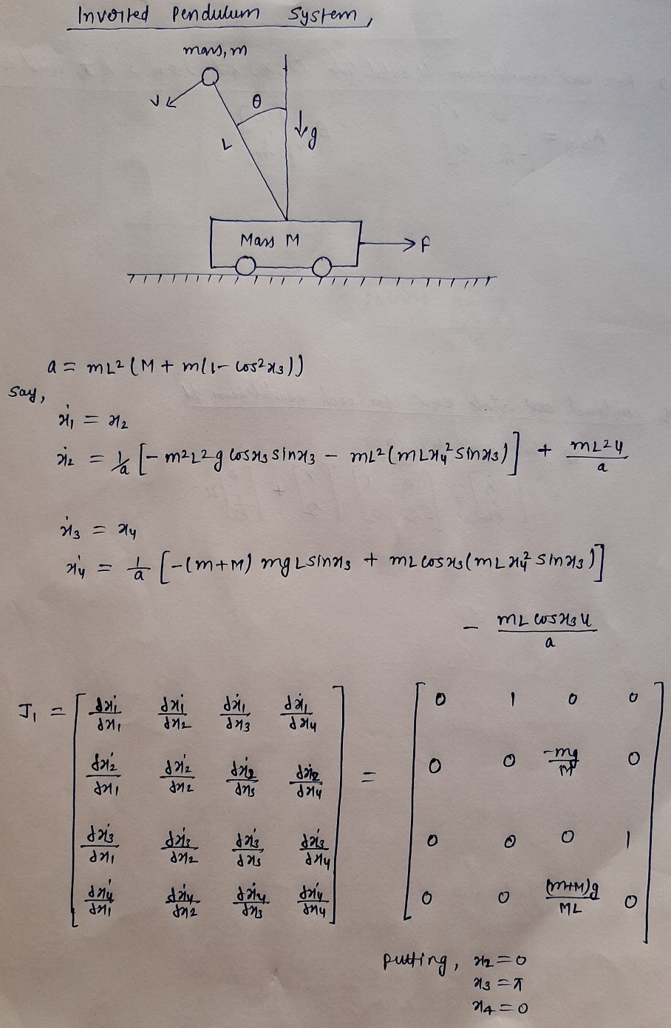

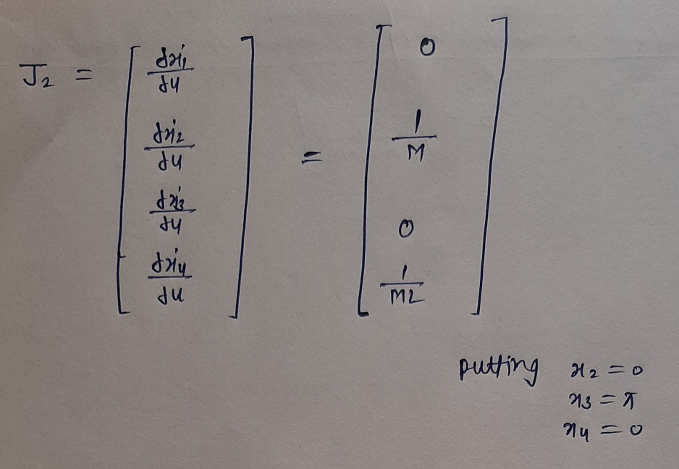

The cart pendulum system is a **non-linear system** as it’s dynamics can not be expressed in a form of linear differential equation, X_dot = Ax + Bu. And also it does not satisfy superposition theorem.

For controlling the system by applying external force on the cart we have linearize the system as both **Pole Placement** and **Linear Quadratic Regulator** are linear controller.

Q12) How many equilibrium points does the inverted cart pendulum system have? Categorize them as stable or unstable? (3)

**ANS:**

There are two equilibrium points in the inverted cart pendulum system, one is stable equilibrium and another is unstable.

**Stable Equilibrium**

When the pendulum will be at angular coordinate 0 with zero velocity and the cart velocity will also be zero, system will be at stable equilibrium.

Point to be noted, linear coordinate of cart will not affect the equilibrium state.

**Unstable Equilibrium**

When the pendulum will be at angular coordinate pi with zero velocity and the cart velocity will also be zero, system will be at stable equilibrium.

Point to be noted, linear coordinate of cart will not affect the equilibrium state.