**NAME:-Pinaki Subhra Bhatacharya**

**Roll no:-11500219053**

**Mod 10 Counter:-**

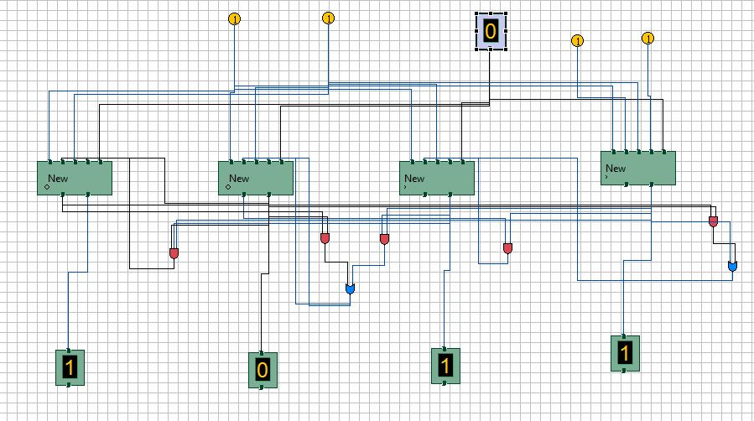

**Mod Counter With Specific State Diagram:-**

