**TREE TRAVERSAL:-(PINAKI-11500219053)**

**Code:-**

#include<stdio.h>

#include<stdlib.h>

struct node

{

int data;

struct node *left;

struct node *right;

};

//struct node *root=0;

struct node *insert()

{

struct node *newnode;

int data;

printf("Enter data(-1=no data):\n");

scanf("%d",&data);

if(data==-1)

return 0;

newnode=(struct node*)malloc(sizeof(struct node));

newnode->data=data;

printf("Enter left child of %d:\n",data);

newnode->left=insert();

printf("Enter right child of %d:\n",data);

newnode->right=insert();

return newnode;

}

void preorder(struct node *r)

{

if(r!=NULL)

{

printf("\n%d",r->data);

preorder(r->left);

preorder(r->right);

}

printf("\n");

}

void inorder(struct node *s)

{

if(s!=NULL)

{

inorder(s->left);

printf("\n%d",s->data);

inorder(s->right);

}

printf("\n");

}

void postorder(struct node *z)

{

if(z!=NULL)

{

postorder(z->left);

postorder(z->right);

printf("\n%d",z->data);

}

printf("\n");

}

int main()

{

int ch,n,i;

struct node *root;

while(1)

{

printf("Enter your choice:[1:insert][2:preorder][3:inorder][4:postorder][5:exit]\n");

printf("Enter your choice:\n ");

scanf("%d",&ch);

switch(ch)

{

case 1: root=insert();

break;

case 2: printf("The preorder traversal is:\n");

preorder(root);

break;

case 3: printf("The inorder traversal is:\n");

inorder(root);

break;

case 4: printf("The postorder traversal is:\n");

postorder(root);

break;

case 5: return 0;

break;

default: printf("Choose the right number.\n");

}

}

}

**OUTPUT:-**

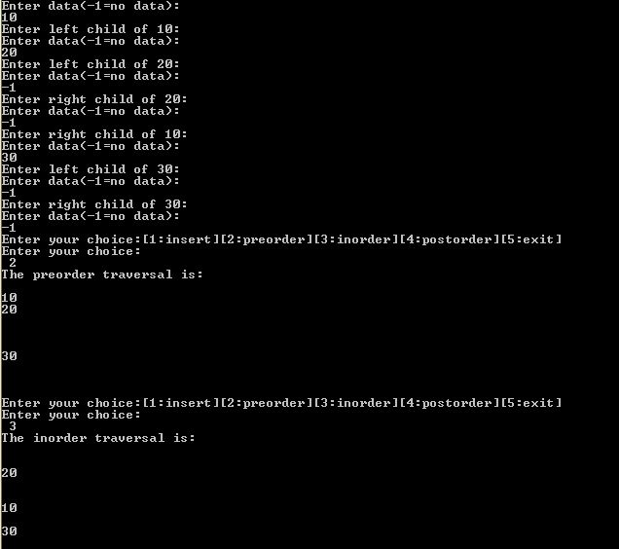

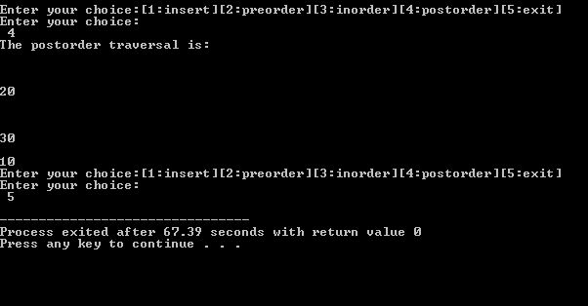

**TOWER OF HANOI:-**

**CODE:-**

#include<stdio.h>

void tower_of_hanoi(int N,char source,char destination,char middleman)

{

if(N==1)

{

printf("Move disk 1 from rod %c to rod %c\n",source,destination);

return;

}

tower_of_hanoi(N-1,source,middleman,destination);

printf("Move disk %d from rod %c to rod %c\n",N,source,destination);

tower_of_hanoi(N-1,middleman,destination,source);

}

int main()

{

int N;

printf("Enter the number of disk to be removed\n");

scanf("%d",&N);

tower_of_hanoi(N,'A','C','B');

}

**OUTPUT:-**

