**Name: pinaki Subhra Bhattacharya**

**Roll No:11500219053**

**Merge sort:-**

#include<stdio.h>

void mergesort(int a[],int i,int j);

void merge(int a[],int i1,int j1,int i2,int j2);

int main()

{

int a[30],n,i;

printf("Enter no of elements:");

scanf("%d",&n);

printf("Enter array elements:");

for(i=0;i<n;i++)

scanf("%d",&a[i]);

mergesort(a,0,n-1);

printf("\nSorted array is :");

for(i=0;i<n;i++)

printf("%d ",a[i]);

return 0;

}

void mergesort(int a[],int i,int j)

{

int mid;

if(i<j)

{

mid=(i+j)/2;

mergesort(a,i,mid);

mergesort(a,mid+1,j);

merge(a,i,mid,mid+1,j);

}

}

void merge(int a[],int i1,int j1,int i2,int j2)

{

int temp[50];

int i,j,k;

i=i1;

j=i2;

k=0;

while(i<=j1 && j<=j2)

{

if(a[i]<a[j])

temp[k++]=a[i++];

else

temp[k++]=a[j++];

}

while(i<=j1)

temp[k++]=a[i++];

while(j<=j2)

temp[k++]=a[j++];

for(i=i1,j=0;i<=j2;i++,j++)

a[i]=temp[j];

}

**Output:-**

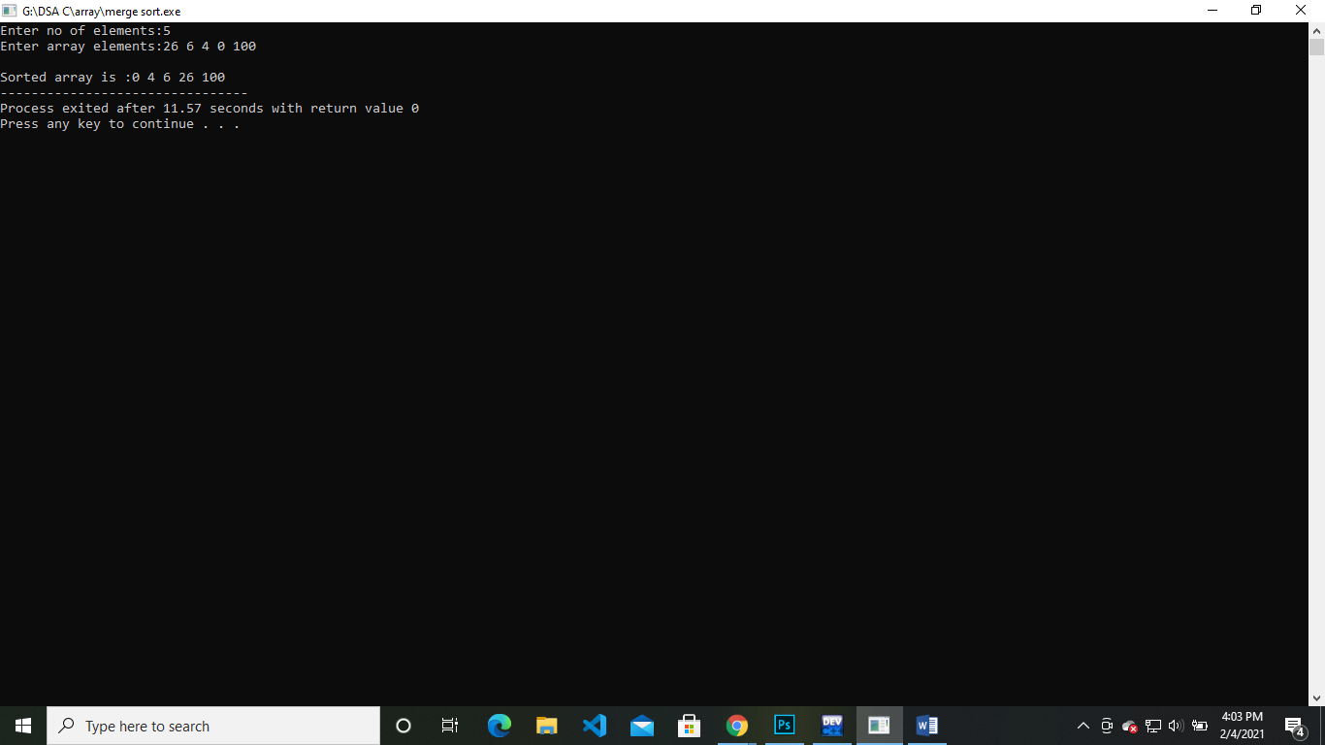

**Time Complexity:**

Time complexity of Merge Sort is O(n*Log n) in all the 3 cases (worst, average and best) as merge sort always divides the array in two halves and takes linear time to merge two halves.