**Experiment NO. -**

**Title**:-**Study of Class A power amplifier.**

**Objective:** To Study a class-A power amplifier in order to achieve max output ac power and efficiency.

**Equipment Required:**

|  |  |  |
| --- | --- | --- |
| Name | Make | Range |
|  |  |  |
|  |  |  |
|  |  |  |

**Theory-** The above circuit is called as “series fed” because the load RL is connected in series with transistor output. It is also called as direct coupled amplifier.

IC = Zero signal collector current

VCE = Zero signal collector to emitter voltage

Power amplifiers are mainly used to deliver more power to the load. To deliver more power it requires large input signals, so generally power amplifiers are preceded by a series of voltage amplifiers.

In class-A power amplifiers, Q-point is located in the middle of DC-load line. So output current flows for complete cycle of input signal. Under zero signal condition, maximum power dissipation occurs across the transistor. As the input signal amplitude increases power dissipation reduces. Efficiency is defined as the ratio of AC output power to DC input power. The maximum theoretical efficiency is 50%.

Efficiency is defined as the ratio of AC output power to DC input power

DC input power = Vcc x IC

AC output power = VP-P2 / 8RL

**Circuit Diagram:** 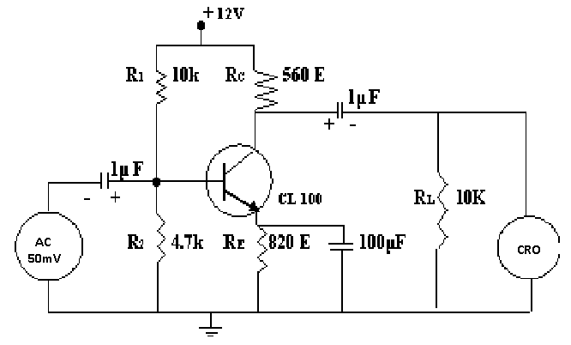

**Observations: -**

**Input voltage = 50 mV (p-p)**

|  |  |  |  |
| --- | --- | --- | --- |
| Sl. No. | Input signal frequency | Output signal amplitude | Gain = Output voltage / input voltage |
|  |  |  |  |

Power efficiency = **(AC output power / DC input power) x 100 %**

Bandwidth (***f*H-*f*L**) =

**Calculation:**

Under zero signal condition:-

IC = VC**/** RC

**GRAPH:**

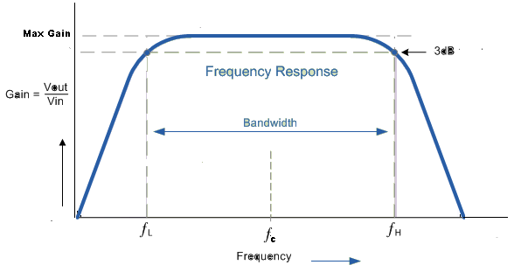

**Calculation:**

**Discussion:**

**Questionnaires:**

|  |  |
| --- | --- |
| **Grade awarded** | |
| **Lab record** |  |
| **Lab Performance** |  |
| **Viva** |  |
| **Teacher’s signature with date :-** | |